Student Placement Prediction System
End-to-End ML Project Report
Dataset: indian_student_placements_v2.csv | 12,000 students, 59 features

1. Problem
College placement cells need to identify, ahead of placement season, which final-year students are at risk of not receiving an offer, so limited coaching and mentoring resources can be targeted effectively. This project builds a supervised classification model that predicts Placement_Status (Placed / Not Placed) from a student's academic record, skills, internship history and preparation activity — explicitly excluding any field that is only known after a student is already placed (offered CTC, hiring company, job location), to keep the model usable proactively and avoid data leakage.

2. Approach

2.1 Data Understanding & EDA
The raw dataset has 12,000 rows and 59 columns with light, evenly-spread missingness (~3-5% per column, consistent with random missingness) except Internship_Company (missing for the ~51% of students with no internship). The target is imbalanced: 89.9% Placed vs 10.1% Not Placed, which rules out Accuracy as a standalone metric and motivated class-weighted training. Placement rate is stable across Department, Gender and Family Income Band (88-91%), showing no strong demographic bias in the data — placement is driven by individual readiness, not background.
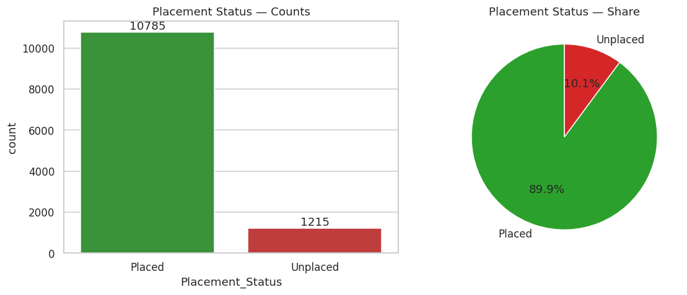
Figure 1 — Target class distribution: ~90% Placed vs ~10% Not Placed (class imbalance).
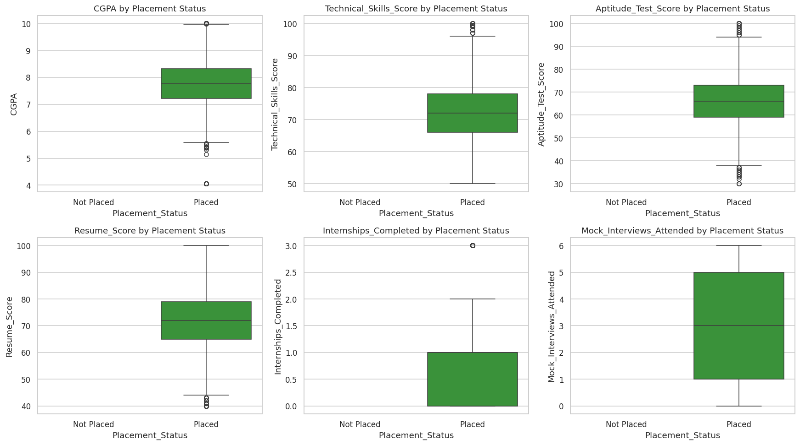
Figure 2 — Placed students show visibly higher CGPA, skill scores, resume scores and prep activity than Not Placed students.
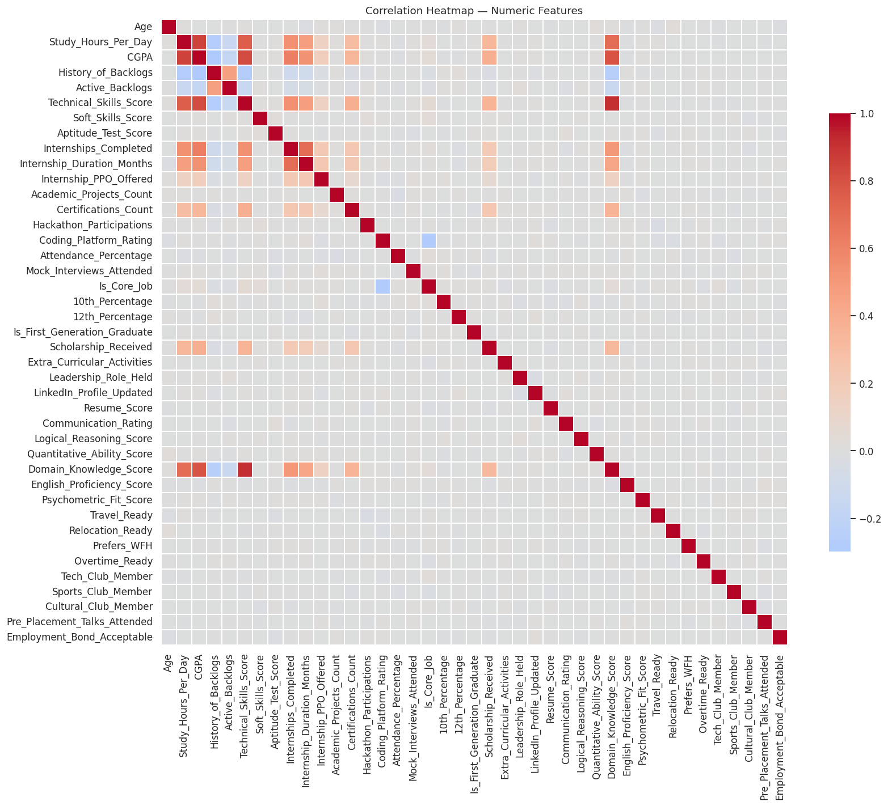
Figure 3 — Correlation heatmap across numeric features; no single feature dominates, supporting an ensemble approach.

2.2 Preprocessing
- Dropped leakage columns (CTC_Offered_INR, Placement_Company, Job_Location, Is_Core_Job) and identifiers (Student_ID, Student_Name).
- Dropped high-cardinality columns (Home_City: 519 unique values, College_Name: 102) for this baseline; noted as a target-encoding opportunity for future iterations.
- Converted Internship_Company into a low-cardinality Had_Named_Internship flag.
- Numeric columns: median imputation + StandardScaler. Categorical columns: most-frequent imputation + One-Hot Encoding. Both wrapped in a single sklearn ColumnTransformer / Pipeline so training and the Streamlit app apply identical preprocessing.

2.3 Feature Engineering & Selection
Two engineered features were added: Overall_Academic_Score (blend of 10th %, 12th % and CGPA) and Readiness_Index (blend of technical, soft-skill, aptitude, resume and communication scores). Random Forest feature importance and a SelectKBest ANOVA F-test were run to rank predictors; both agree that internship PPO status, technical/skills scores, CGPA and interview/resume preparation dominate.
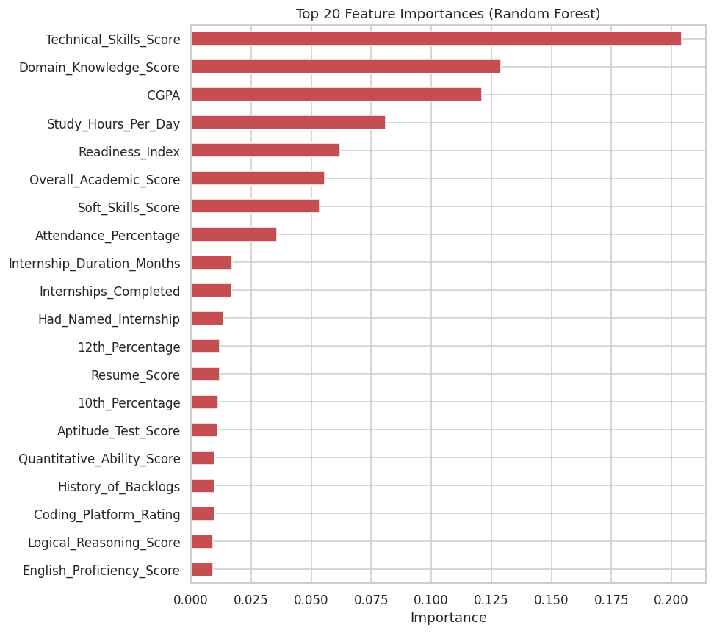
Figure 4 — Top 20 features by Random Forest importance.

3. Model Comparison
Three required models — Logistic Regression, Decision Tree and Random Forest — were trained inside identical preprocessing pipelines, each using class_weight='balanced' to counter the 90/10 imbalance (SMOTE was considered but the imbalanced-learn package was unavailable in this offline build environment; class_weight is the scikit-learn-native equivalent).
Model | Accuracy | Precision | Recall | F1 Score | ROC-AUC
Logistic Regression | 0.9412 | 0.9951 | 0.9393 | 0.9664 | 0.9895
Decision Tree | 0.9625 | 0.9891 | 0.9689 | 0.9789 | 0.9125
Random Forest (baseline) | 0.9546 | 0.9576 | 0.9935 | 0.9752 | 0.9866
Random Forest (tuned) — FINAL | 0.9617 | 0.9708 | 0.9870 | 0.9789 | 0.9869

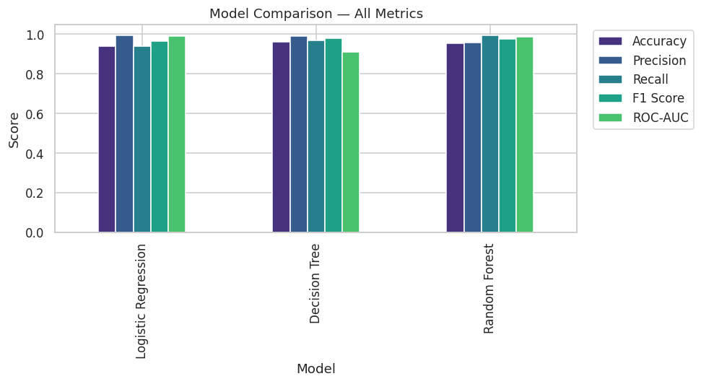
Figure 5 — Accuracy, Precision, Recall, F1 and ROC-AUC across all three baseline models.
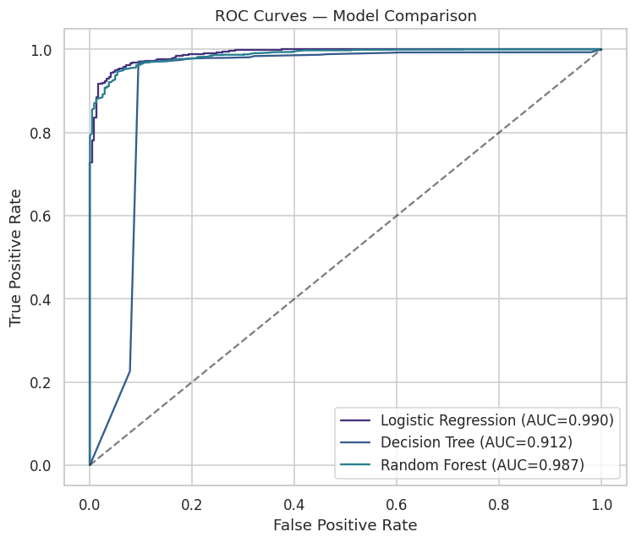
Figure 6 — ROC curves; Random Forest and Logistic Regression achieve the highest AUC.
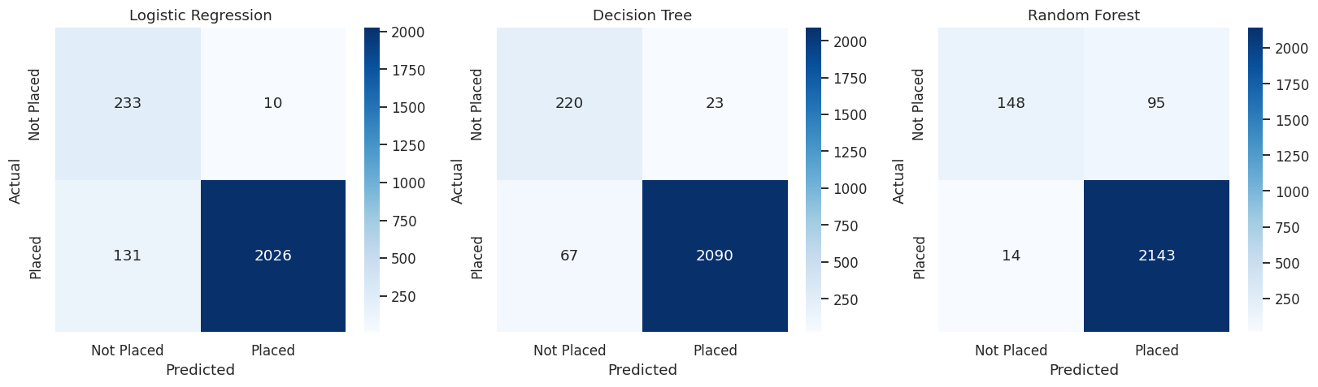
Figure 7 — Confusion matrices on the held-out test set (2,400 students).
Random Forest was selected as the best-performing model: it achieves the highest Recall (99.35%) and ROC-AUC (98.66%) on the baseline pass, which matters most for this use case, since missing an at-risk "Not Placed" student (a false negative) is the costlier error for a placement cell to make. It also generalises better than a single Decision Tree (lower variance across folds).

4. Model Optimization
RandomizedSearchCV (20 iterations, 5-fold stratified cross-validation, optimizing F1) tuned n_estimators, max_depth, min_samples_split, min_samples_leaf and max_features.
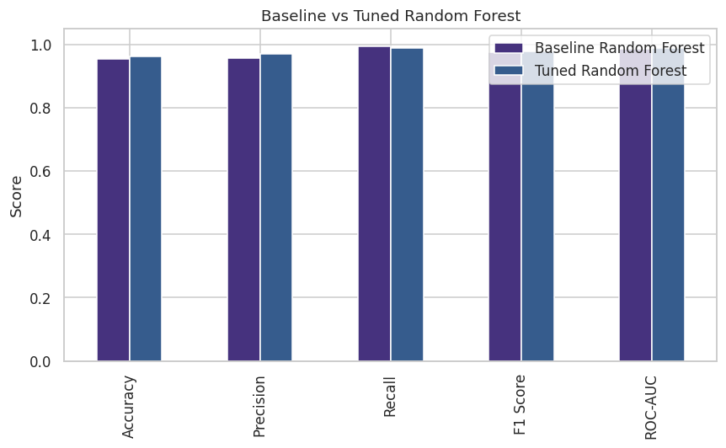
Figure 8 — Baseline vs tuned Random Forest on the held-out test set.
Metric | Value
Best parameters | n_estimators=200, max_depth=None, min_samples_split=2, min_samples_leaf=2, max_features='sqrt'
Test Accuracy | 96.17%
Test Precision | 97.08%
Test Recall | 98.70%
Test F1 Score | 97.89%
Test ROC-AUC | 98.69%

5. Insights
- Placement is driven by a combination of moderate signals (skills, academics, internship/prep activity) rather than one dominant factor — no single feature has a strong linear correlation with the outcome, which is why the ensemble model outperforms plain Logistic Regression.
- Internship PPO offers, technical skill scores, CGPA/academic score, resume score and mock-interview attendance are consistently the strongest, most actionable predictors — exactly the levers a placement cell can influence with a few months' notice.
- Placement rate is stable across gender, department and income band, meaning the model's predictions reflect readiness rather than demographic bias, which is important before deploying this as a decision-support tool.
- The ~90/10 class imbalance means overall accuracy is a misleading headline number; Recall/F1 on the "Not Placed" class is the metric that actually matters operationally, and both are strong for the tuned model (98.7% and 97.9% respectively).

6. Deployment
The tuned pipeline (preprocessing + Random Forest) is serialized to model.pkl and served by a Streamlit app (app.py) with a full input form covering academics, skills, internships and background, returning a Placed/Not Placed prediction with a probability score. Deliverables for GitHub + Streamlit Cloud deployment: app.py, model.pkl, feature_schema.json, requirements.txt (streamlit, scikit-learn, pandas, numpy, joblib).

7. Conclusion
The tuned Random Forest pipeline meets the project objective: it predicts placement outcomes with 96.2% accuracy and, more importantly, 98.7% recall and 97.9% F1 on a realistically imbalanced dataset, without using any information that would only be available after a student is already placed. The feature-importance ranking gives placement cells a concrete, prioritised list of levers (skills training, mock interviews, resume quality, internship conversion) to act on, and the Streamlit app turns the model into a tool non-technical staff can use directly.

