Real-Time Kitchen Hygiene and Safety Monitoring Using YOLO11 and TensorRT on NVIDIA Jetson Orin Nano
Rudram Dindorkar  Department of Electronics Engineering  Ramdeobaba University, Nagpur, India  24dindorkarr@rbunagpur.in |  | Nishika Deotale  Department of Electronics Engineering  Ramdeobaba University, Nagpur, India  24deotalen@rbunagpur.in |  | Namrata Thorat  Department of Electronics Engineering  Ramdeobaba University, Nagpur, India  24thoratn@rbunagpur.in
 | Revanshu Pusadkar  Department of Electronics Engineering  Ramdeobaba University, Nagpur, India  24pusadkarr@rbunagpur.in |  | Snehal Laddha  Department of Electronics Engineering  Ramdeobaba University, Nagpur, India  laddhasv1@rbunagpur.in

Abstract—In most restaurant kitchens, hygiene is checked only now and then, so a missing mask, hairnet or glove, or a cockroach, can remain unnoticed for a long period. In this work we built a system that monitors a camera feed and flags these violations immediately as they happen. We trained a YOLO11s detector with 9.4 million parameters for 150 epochs on a merged kitchen PPE and cockroach dataset using an NVIDIA DGX B200. On the validation set of 2,351 images it achieved a precision of 0.965, a recall of 0.957, a mAP@50 of 0.966 and a mAP@50:95 of 0.768. The model was exported to ONNX, converted to an FP16 TensorRT engine and run on an NVIDIA Jetson Orin Nano Developer Kit (Super). With a USB webcam and a live alert dashboard, the full pipeline operates at about 15 frames per second with each frame taking roughly 35 to 43 milliseconds. We also describe the library problems we encountered during training and deployment and how we resolved them. Our results show that a low-cost edge board is enough to monitor kitchen hygiene in real time without a separate server.
Index Terms—YOLO11, object detection, PPE detection, food safety, edge AI, TensorRT, Jetson Orin Nano.

I. Introduction
In a restaurant kitchen hygiene is largely governed by a handful of rules. Staff should wear a mask, gloves and a hairnet, and the kitchen should be free of pests. These rules are usually verified during inspections and foodsafety officials have noted that enforcement is limited by a shortage of manpower [1]. The stakes are high: the World Health Organization estimates that unsafe food causes about 600 million cases of foodborne illness and 420,000 deaths every year [2]. So if someone skips a hairnet between two inspections, nobody records it.
A camera coupled with an object detector can perform this inspection continuously. The detector examines each frame, determines whether a person is wearing the required items and also searches for cockroaches. The challenge lies in enabling this to work in real time on hardware that a small restaurant can afford. For this reason we selected an edge device, the NVIDIA Jetson Orin Nano, and execute everything locally instead of transmitting video to a cloud server.
This paper presents four contributions. First we train a YOLO11s detector on a merged dataset that includes mask, gloves, hairnet, their missing counterparts and cockroach. Second we establish a pipeline from PyTorch to ONNX to an FP16 TensorRT engine on the Jetson. Third, we build a live dashboard with a violation counter and a timestamped alert log. Finally, we record the software problems we encountered and how we resolved them potentially saving time for others employing the configuration.

II. Related Work

A. Object Detection
Deep learning detectors are usually grouped into two-stage and single-stage methods. Two-stage methods such as R-CNN [3] and Faster R-CNN [4] first propose regions and then classify them, which gives good accuracy but is slower. Single-stage detectors such as SSD [5] and YOLO [6] predict boxes and classes in one pass, so they suit live video better. The YOLO family has improved step by step, for example in YOLOv3 [7], YOLOv4 [8] and YOLOv7 [9], and these versions are reviewed in [10]. We use Ultralytics YOLO11 [11], [12], which comes in several sizes with the same training and export tools.

B. PPE and Hygiene Compliance Detection
Most work on PPE detection comes from construction sites. Fang et al. [13] used a Faster R-CNN based method to find workers who were not wearing hard hats in far-field surveillance video. Wang et al. [14] used YOLO detectors for several PPE classes on real construction sites and built a dataset of 1,330 images for this, and they also note that earlier PPE detectors cover only a limited range of PPE types. In teaching laboratories, Ali et al. [15] trained YOLOv5 and YOLOv7 models to check whether students wear PPE such as masks, gloves and goggles. In the food area, Chen et al. [16] used deep learning to check handwashing and the PPE of food handlers, such as hairnets, masks and gloves, before workers enter the production area of a food factory. Face mask detection also became a popular topic during the COVID-19 pandemic, for example the hybrid transfer learning approach of Loey et al. [17], but these studies usually focus on masks alone.

C. Edge Computing and Model Optimization
Running the detector next to the camera avoids sending video to a server and keeps latency low, which is the main idea of edge computing [18]. On small boards the model is normally optimised before use, for example by reduced-precision quantization [19] and by inference engines such as TensorRT. A tracker such as ByteTrack [20] can also link detections across frames and reduce false alerts, which we leave for future work.

D. Research Gap and Novelty
Looking at these studies, each one covers only a part of what a kitchen needs. The PPE studies deal mainly with construction and laboratory items such as helmets, vests, gloves and goggles, and the mask studies look at faces only. The closest work is the food-handler study [16], which checks handwashing and hairnets, masks and gloves at the entrance of a food factory, but as far as its abstract shows it does not cover pests or kitchen monitoring on a low-cost edge board. To the best of our knowledge, none of the works we found detects mask, gloves and hairnet, their missing counterparts and a cockroach in a single model and runs it on a low-cost edge board. Table I summarises this comparison.
TABLE I
Scope of Reviewed Studies Versus This Work
Aspect | Reviewed studies [13]–[17] | This work
Setting | Construction sites, labs, factory entrances | Restaurant kitchen
PPE items checked | Helmets, vests, masks, gloves, goggles, hairnets | Mask, gloves and hairnet
Pest detection | Not included | Cockroach
Application | PPE or hygiene check only | PPE and pest monitoring together

The novelty of our work is therefore as follows. (i) A single YOLO11s detector covers kitchen PPE violations and cockroach together. (ii) Explicit “without” classes (without_mask, without_gloves, without_hairnet) let a violation be a direct detection instead of something inferred from a missing item. (iii) The model is deployed as an FP16 TensorRT engine on a Jetson Orin Nano and runs at about 15 FPS on a live webcam. (iv) A live dashboard shows a violation counter and a timestamped alert log, so the output can be used by a kitchen supervisor straight away.

III. Dataset
We combined two open-source datasets from Roboflow Universe: the kitchen dataset (kitchen.v5-v5.yolov11) [21] and the cockroach dataset (Cockroach.v2i.yolov11) [22]. After cleaning and merging we standardized the annotations and resized all images to 640×640. Both open-source datasets are licensed under CC BY 4.0.
The final labels are cockroach, gloves, mask, hairnet, without_gloves, without_hairnet, without_mask, unused_1, and unused_6. Table IV lists these classes along with their instance counts.

IV. Methodology

A. System Overview
Fig. 1 shows the workflow. Training is done offline on a GPU server. After training we export the weights and then convert them into a TensorRT engine on the Jetson because the engine can only run with the GPU and TensorRT version it was built for. At run time we resize each webcam frame and feed it into the engine then we post-process the outputs. We use a simple rule to decide if there is a violation: whenever we detect without_mask, without_gloves, without_hairnet or cockroach we count one violation.
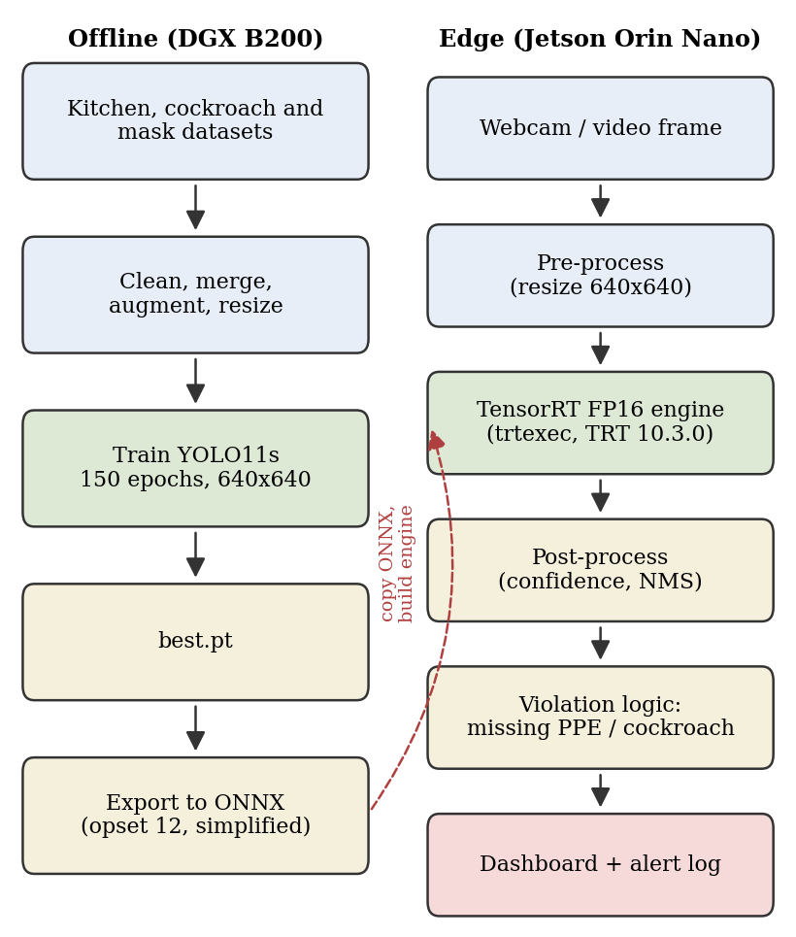
Fig. 1. Training and deployment pipeline of the system.

B. Detection Model
We used YOLO11s. After layer fusion the model contains 100 layers, 9,416,283 parameters and 21.4 GFLOPs; before fusion it has 181 layers and 21 GFLOPs. Our initial model was YOLO11n with 2.5 million parameters. We switched to the YOLO11s to achieve better accuracy because the Orin Nano can accommodate it. The loss function is the YOLO mix of an IoUbased box loss, binary crossentropy for classification and distribution focal loss.

C. Training Setup
We performed training on an NVIDIA DGX B200 at the RBU AI Center using Ultralytics 8.4.178, PyTorch 2.8.0 and Python 3.12.3. Table II lists the training settings. We passed lr0 = 0.01 with optimizer=auto, but with auto Ultralytics ignores lr0 and momentum and chooses the optimizer and learning rate itself, so Table II reports the values it actually used. Augmentation followed the default Ultralytics pipeline: mosaic (turned off for the last 10 epochs), HSV colour jitter (h 0.015, s 0.7, v 0.4), random translation (0.1) and scale (0.5), and horizontal flip (0.5).
TABLE II
Training Configuration
Parameter | Value
Model | YOLO11s
Input resolution | 640 × 640
Epochs | 150
Batch size / workers | 16 / 8
Learning rate (lr0) | 0.01
Optimizer | Auto (Adam)
Training hardware | NVIDIA DGX B200

V. Edge Deployment

A. Hardware
We deployed the model on an NVIDIA Jetson Orin Nano Developer Kit (Super) with JetPack 6.2.1. We used a USB webcam as the camera and a monitor displayed the dashboard. Table III lists the board specifications, and Figs. 2 and 3 show our setup.
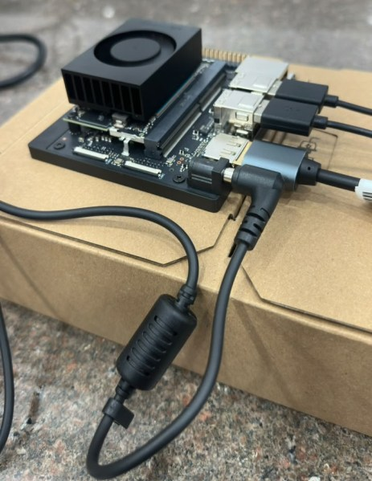
Fig. 2. Close-up of the Jetson Orin Nano developer kit with its cooling fan and cables.
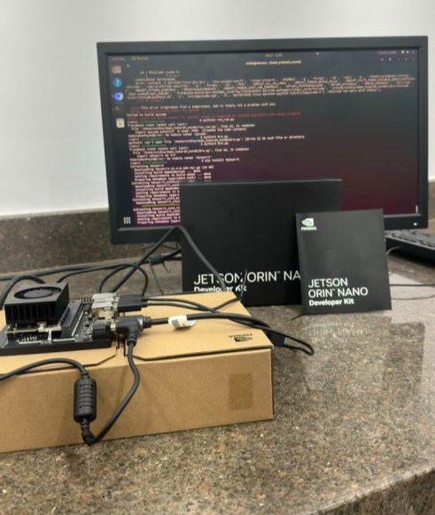
Fig. 3. Complete deployment setup with the monitor showing the inference terminal.
TABLE III
Jetson Orin Nano (Super) Specifications
Component | Specification
CPU | 6-core Arm Cortex-A78AE, 64-bit
GPU | NVIDIA Ampere, 1,024 CUDA cores, 32 Tensor cores
Memory | 8 GB LPDDR5, 128-bit, 102 GB/s
AI performance | Up to 67 TOPS
Power | 7–25 W
Storage | microSD and external NVMe SSD

B. Model Conversion and Inference
We exported the trained weights to ONNX using the Ultralytics export command specifying opset 12 and graph simplification. On the Jetson, the ONNX file was converted with trtexec using the --fp16 option, producing an engine (model_fp16.engine) of approximately 17.9 MB. The inference code is written in Python. It uses OpenCV to capture frames and draw bounding boxes and it calls the CUDA library bundled with JetPack directly so we did not need PyCUDA.
We ended up with a few versions of the inference script. One processes a video file, another processes the webcam and the last one incorporates the dashboard. We also experimented with a modified webcam version. It did not yield a noticeable improvement so we retained the simpler base version. The final script shows the count for each class, a red warning banner with the number of violations, the camera, inference and display FPS, and a list of recent alerts with timestamps.

VI. Results

A. Detection Accuracy
Table IV presents the validation results of the model (best.pt) evaluated on 2,351 images containing 3,936 labeled instances. Overall precision is 0.965, recall is 0.957, mAP@50 is 0.966 and mAP@50:95 is 0.768. From these values we compute an F1-score of 0.961. On the DGX B200 validation required 0.1 ms for pre-processing, 1.8 ms for inference and 0.3 ms for post-processing per image.
TABLE IV
Validation Results per Class
Class | Inst. | P | R | mAP50 | mAP50-95
all | 3936 | 0.965 | 0.957 | 0.966 | 0.768
cockroach | 160 | 0.967 | 0.925 | 0.940 | 0.797
gloves | 107 | 0.997 | 1.000 | 0.995 | 0.765
without_gloves | 92 | 0.978 | 0.981 | 0.994 | 0.884
mask | 388 | 0.989 | 0.953 | 0.980 | 0.889
hairnet | 825 | 0.958 | 0.982 | 0.988 | 0.632
without_hairnet | 1425 | 0.886 | 0.860 | 0.870 | 0.655
unused_1 (background) | 117 | 0.977 | 1.000 | 0.992 | 0.917
unused_6 (background) | 822 | 0.970 | 0.954 | 0.968 | 0.604

Most classes achieve an mAP@50 greater than 0.94. The weakest class is without_hairnet showing precision 0.886 recall 0.860 and mAP@50 0.870. A bare head probably appears differently for each person and in backgrounds while a hairnet appears fairly consistent each time. Hairnet also has a much lower mAP@50:95 (0.632) than mAP@50 (0.988), meaning the detection boxes are located but are not always tightly fitted.

B. Real-Time Performance on Jetson
Table V shows what we measured on the Jetson with the final dashboard script, using jtop for system load (Fig. 4). Both the camera and inference ran at 15 FPS and the dashboard was displayed at 30 FPS. The time per frame shown on the dashboard was between 35 and 43 ms across our test frames. The stage times in Table V (8.4 ms for pre-processing, 24.7 ms for the TensorRT engine and 0.7 ms for post-processing) were read from the log line under the video in the 15 ft test of Section VI-C. In the jtop reading the GPU load was 44.2%, the load on the six CPU cores was between 17.0% and 45.9%, and 2.6 GB of the 7.4 GB memory was in use. The python3 inference process itself used about 489 MB of RAM. The board was running in MAXN_SUPER power mode.
TABLE V
Measured Performance on Jetson Orin Nano
Metric | Observed
Camera / inference FPS | 15 / 15
Display FPS | 30
Per-frame latency (dashboard) | 35–43 ms
GPU load | 44.2% (408 MHz)
CPU load (per core) | 17.0–45.9%
Memory used | 2.6 GB of 7.4 GB
Pre / TensorRT / post time | 8.4 / 24.7 / 0.7 ms
Power mode | MAXN_SUPER

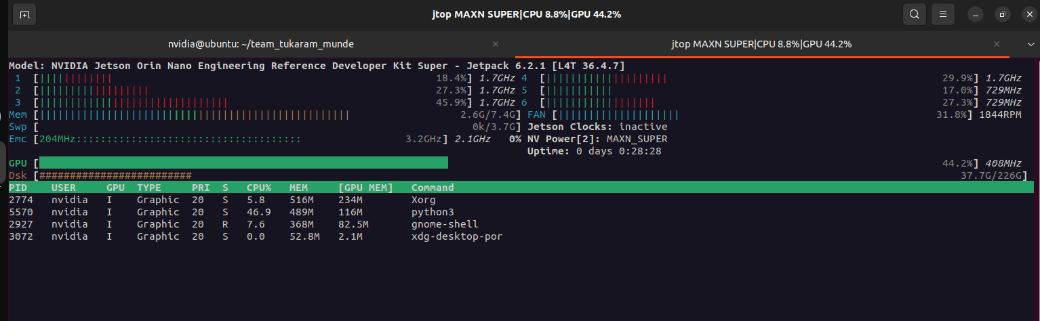
Fig. 4. jtop screen on the Jetson Orin Nano during live inference, showing 44.2% GPU load, memory use and the MAXN_SUPER power mode.

C. Qualitative Results
Figs. 5–13 show display frames captured from the webcam on the Jetson. Green boxes indicate that a required item is present while red boxes indicate a violation.
In Fig. 5 the person is wearing a mask (0.89), a hairnet (0.98) and a glove on one hand (class gloves, drawn as with_gloves on the box, 0.95), all in green. The other hand is bare, so it gets a red box as without_gloves (0.92). The dashboard records one violation and adds the alerts, with timestamps, to its recent alerts list.
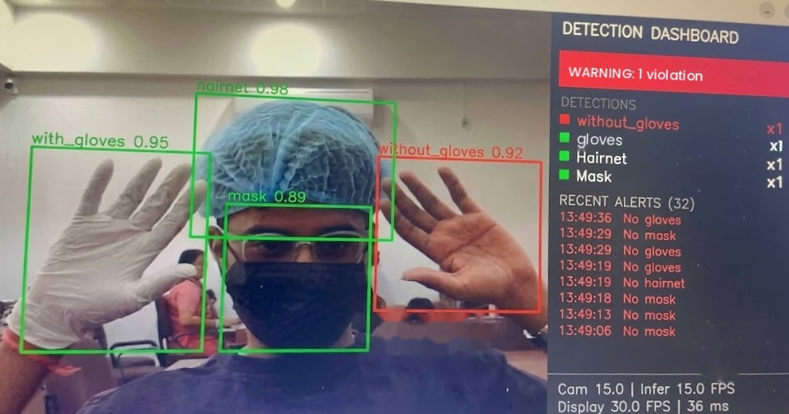
Fig. 5. Mask, hairnet and glove detected in green, with the missing glove on the other hand flagged in red.
In Fig. 6 a bare hand in front of the camera is reported as without_gloves, and people in the background are reported as without_mask in the same frame. The confidence values are lower here, between about 0.5 and 0.8, but the violations are still found.
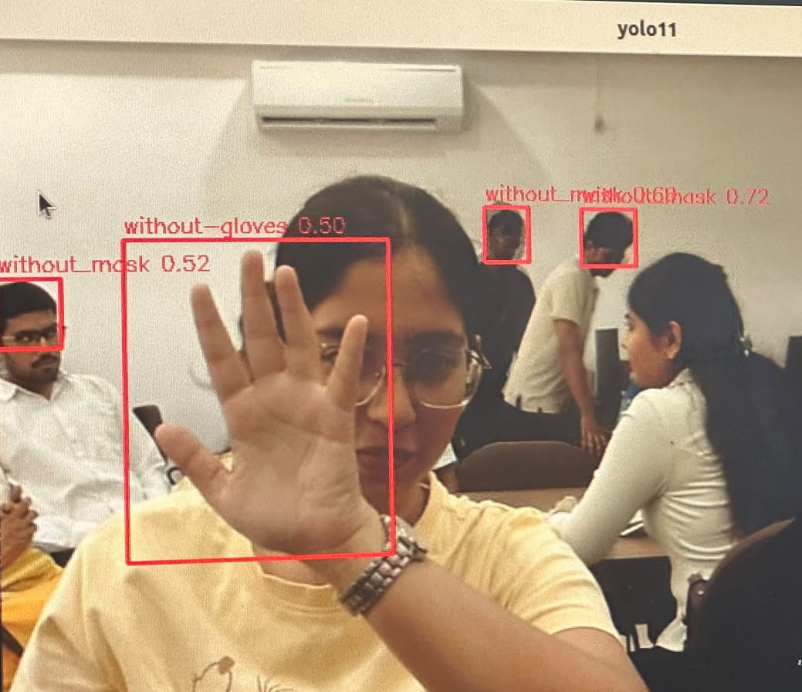
Fig. 6. Detection of without_mask and without_gloves in the same frame.
Fig. 7 compares a person wearing a mask (green, 0.93) with people in the background who are not (red, 0.37 and 0.42). The dashboard shows two no-mask detections and one mask.
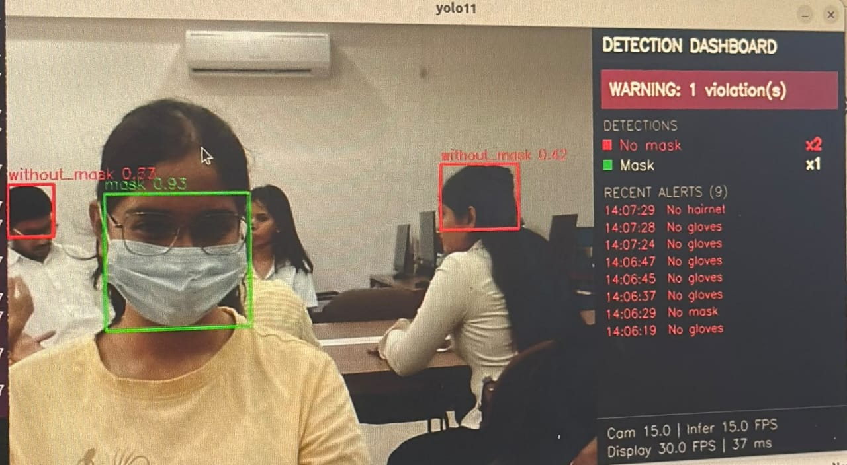
Fig. 7. Detection of mask versus without_mask.
Fig. 8 compares hairnet and without_hairnet. The person with a hairnet is in green and two people in the background without one are in red, so the dashboard shows two no-hairnet detections and one hairnet. This is also the class with the weakest validation score.
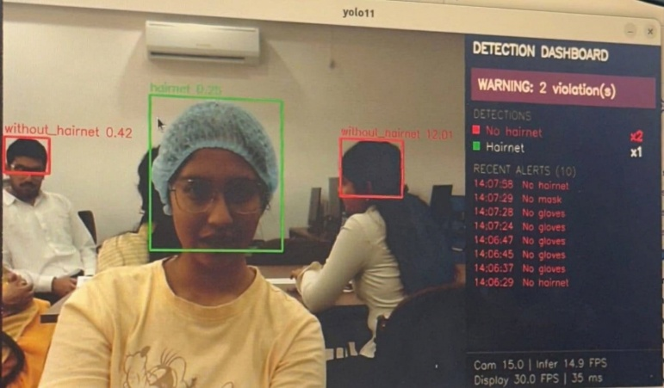
Fig. 8. Detection of hairnet versus without_hairnet.
Fig. 9 shows a single raised bare hand detected as without_gloves with high confidence. A person far behind is also flagged as without_mask, but with a low confidence of 0.34.
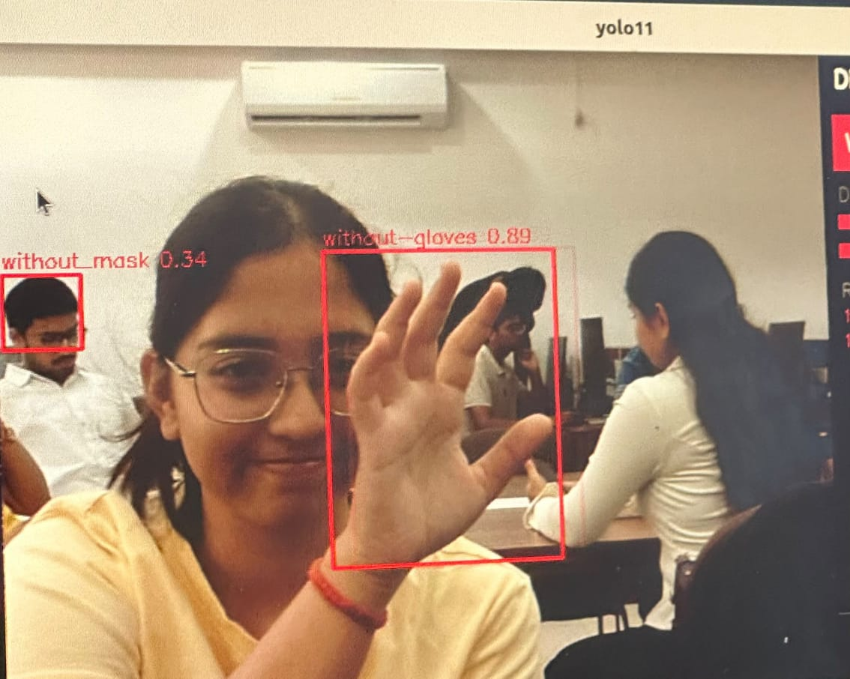
Fig. 9. Detection of without_gloves on a bare hand.
Fig. 10 shows a close-up mask detection with a confidence of 0.88. Here the mask is held in front of the face.
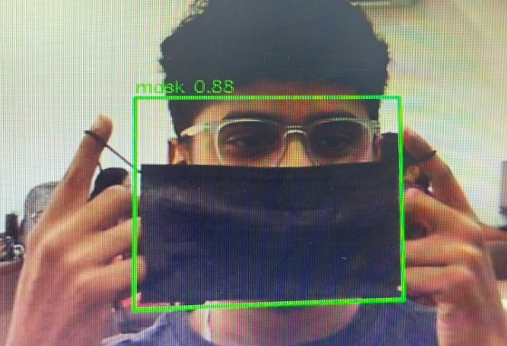
Fig. 10. Close-up mask detection.
In Fig. 11 two people sit far from the camera and their faces are only a few pixels wide. Both are still flagged as without_mask, one of them with a confidence of 0.72, which is useful when staff are far from the camera. The two labels overlap in the picture because the boxes are close together.
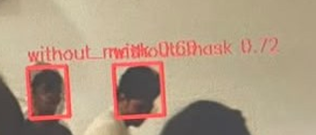
Fig. 11. Distant people detected without masks.
Fig. 12 shows the cockroach test. The cockroach was detected, but only with a confidence of 0.29, even though the validation mAP@50 for this class is 0.940. A distant person without a mask was also picked up in the same frame (0.69). This gap suggests that our camera scene differs from the validation images, so the cockroach class needs more training data from kitchen-like surroundings.
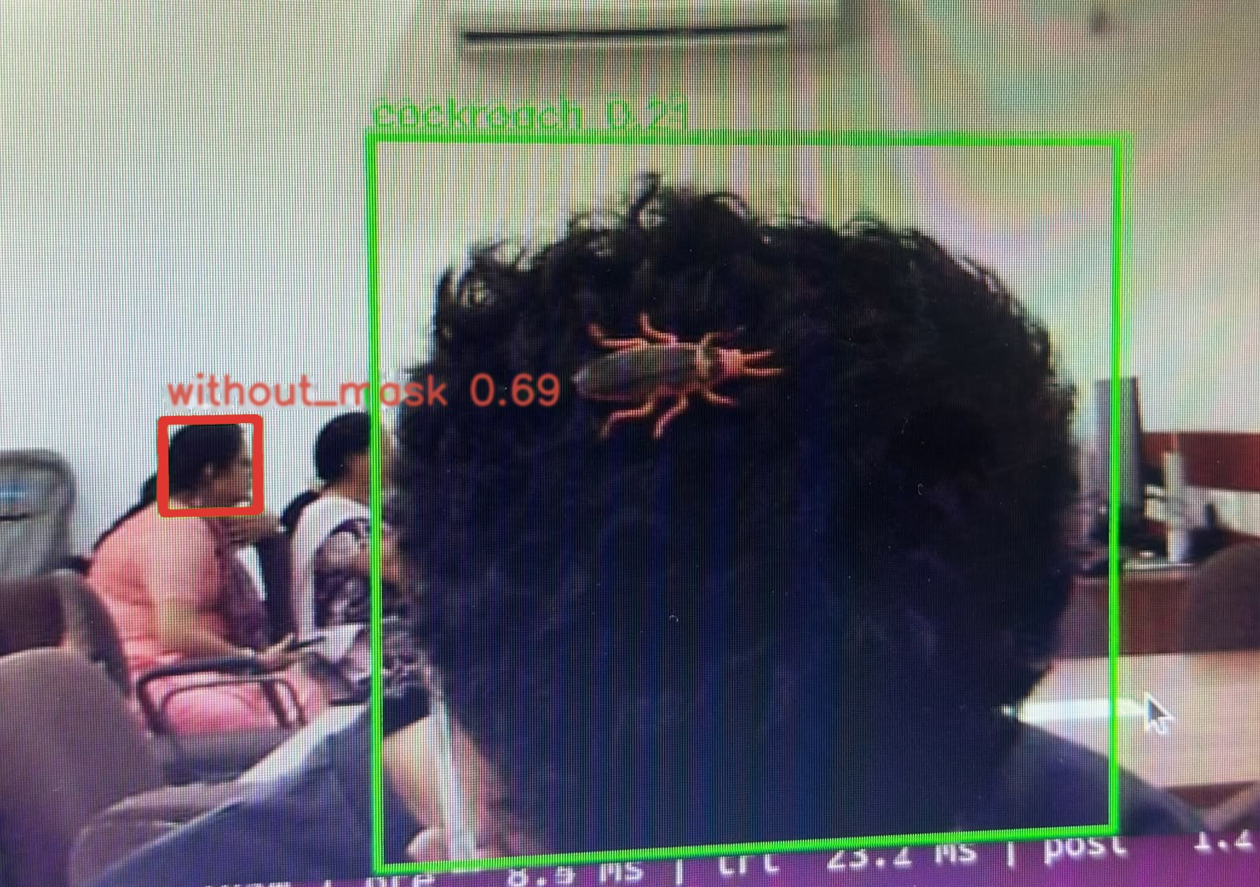
Fig. 12. Cockroach detection and a distant person without a mask.
Fig. 13 shows a test at a distance of about 15 ft (4.6 m) from the camera. The person's face is small in the frame, but the mask is still detected with a confidence of 0.88 and the dashboard shows ALL CLEAR with one mask detected. The alert list on the right also keeps the earlier no-mask alerts and the cockroach alert from 12:49:54. The log line under the video shows 8.4 ms for pre-processing, 24.7 ms for TensorRT inference and 0.7 ms for post-processing, with the camera and inference at about 15 FPS.
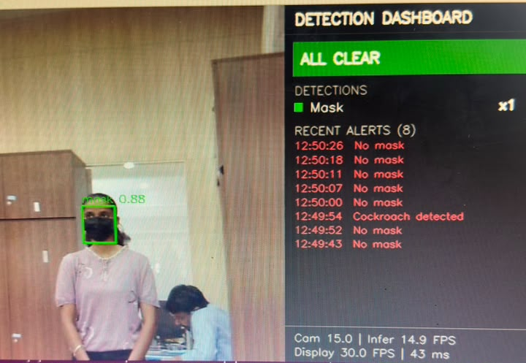
Fig. 13. Detection at a distance of about 15 ft: the mask is detected with a confidence of 0.88 and the dashboard shows ALL CLEAR.

VII. Practical Challenges

A. Library Conflict During Training
The PyTorch build in our training container was compiled for NumPy 1.x. However, a NumPy 2.5.4 copy sitting in the user folder was picked up first, and torch.from_numpy() failed with a “Numpy is not available” error. This copy most likely came in as a side effect of an earlier pip install. To fix it we installed NumPy 1.26.4 and replaced opencv-python 5.x, which needs NumPy 2, with a headless OpenCV 4.11 build. After that we restarted the kernel and installed ultralytics with --no-deps so pip would not upgrade NumPy again. In short, the PyTorch, NumPy and OpenCV versions have to match.

B. TensorRT Mismatch on the Jetson
On the Jetson, import tensorrt first failed inside our virtual environment because the module was not found. Installing it with pip pulled in TensorRT 11.4 built for CUDA 13, but JetPack 6 on our board only supports CUDA 12. This caused a “CUDA driver version is insufficient for CUDA runtime version” error followed by a segmentation fault. We solved the issue by using TensorRT 10.3.0 that already ships with JetPack, which is also the version that built our engine and by creating the virtual environment with --system-site-packages so Python could see it. Our final environment uses NumPy 1.26.4 and OpenCV 4.10.0.84, and TensorRT 10.3.0 comes from the system packages.

VIII. Conclusion and Future Work
We built and tested a system that detects mask, gloves, hairnet, their missing counterparts and cockroaches in real time. The YOLO11s model reached an mAP@50 of 0.966 on the validation set. After FP16 TensorRT conversion it ran on a Jetson Orin Nano at about 15 FPS with a live dashboard and alert log, and it still detected a mask on a person standing about 15 ft away. The weak points we found are the without_hairnet class and the low cockroach confidence in the live scene.
In the future we want to add an apron class and rodent detection, and collect more cockroach images from real kitchens. We also plan to confirm violations over several consecutive frames, or with a tracker [20], to reduce false alerts, to try INT8 quantization for higher FPS, and to send alerts remotely to managers. Finally, the system needs a trial in a working kitchen so that the false alarm rate can be measured properly.

Code and Data Availability
The inference scripts, the trained weights (best.pt and best.onnx) and the class label file will be released at https://github.com/rudramdindorkar/Real-Time-Kitchen-Hygiene-and-Safety-Monitoring-Using-YOLO11-and-TensorRT-on-NVIDIA-Jetson-Nano. The two datasets are available on Roboflow Universe under the licences stated in Section III.

Acknowledgment
The authors thank the RBU AI Center, Ramdeobaba University, for providing access to the NVIDIA DGX B200 used for training.

References
[1] T. Munde, “Needs to be strengthened: Maharashtra food regulator chief on manpower,” NDTV, Jul. 2026.
[2] World Health Organization, “WHO estimates of the global burden of foodborne diseases: Foodborne disease burden epidemiology reference group 2007–2015,” WHO, Geneva, Switzerland, 2015.
[3] R. Girshick, J. Donahue, T. Darrell, and J. Malik, “Rich feature hierarchies for accurate object detection and semantic segmentation,” in Proc. IEEE Conf. Comput. Vis. Pattern Recognit. (CVPR), 2014, pp. 580–587.
[4] S. Ren, K. He, R. Girshick, and J. Sun, “Faster R-CNN: Towards real-time object detection with region proposal networks,” IEEE Trans. Pattern Anal. Mach. Intell., vol. 39, no. 6, pp. 1137–1149, Jun. 2017.
[5] W. Liu et al., “SSD: Single shot multibox detector,” in Proc. Eur. Conf. Comput. Vis. (ECCV), 2016, pp. 21–37.
[6] J. Redmon, S. Divvala, R. Girshick, and A. Farhadi, “You only look once: Unified, real-time object detection,” in Proc. IEEE Conf. Comput. Vis. Pattern Recognit. (CVPR), 2016, pp. 779–788.
[7] J. Redmon and A. Farhadi, “YOLOv3: An incremental improvement,” arXiv:1804.02767, 2018.
[8] A. Bochkovskiy, C.-Y. Wang, and H.-Y. M. Liao, “YOLOv4: Optimal speed and accuracy of object detection,” arXiv:2004.10934, 2020.
[9] C.-Y. Wang, A. Bochkovskiy, and H.-Y. M. Liao, “YOLOv7: Trainable bag-of-freebies sets new state-of-the-art for real-time object detectors,” in Proc. IEEE/CVF Conf. Comput. Vis. Pattern Recognit. (CVPR), 2023, pp. 7464–7475.
[10] J. Terven, D.-M. Córdova-Esparza, and J.-A. Romero-González, “A comprehensive review of YOLO architectures in computer vision: From YOLOv1 to YOLOv8 and YOLO-NAS,” Mach. Learn. Knowl. Extr., vol. 5, no. 4, pp. 1680–1716, 2023.
[11] G. Jocher and J. Qiu, “Ultralytics YOLO11,” Ultralytics, 2024. [Online]. Available: https://docs.ultralytics.com
[12] R. Khanam and M. Hussain, “YOLOv11: An overview of the key architectural enhancements,” arXiv:2410.17725, 2024.
[13] Q. Fang et al., “Detecting non-hardhat-use by a deep learning method from far-field surveillance videos,” Autom. Constr., vol. 85, pp. 1–9, 2018.
[14] Z. Wang et al., “Fast personal protective equipment detection for real construction sites using deep learning approaches,” Sensors, vol. 21, no. 10, Art. no. 3478, 2021.
[15] L. Ali, F. Alnajjar, M. M. A. Parambil, M. I. Younes, Z. I. Abdelhalim, and H. Aljassmi, “Development of YOLOv5-based real-time smart monitoring system for increasing lab safety awareness in educational institutions,” Sensors, vol. 22, no. 22, Art. no. 8820, Nov. 2022, doi: 10.3390/s22228820.
[16] I.-C. Chen, C.-H. Chi, and H.-H. Ku, “Deep learning for the detection of good hygienic practices control measures for food handlers,” Food Control, vol. 171, Art. no. 111041, 2024, doi: 10.1016/j.foodcont.2024.111041.
[17] M. Loey, G. Manogaran, M. H. N. Taha, and N. E. M. Khalifa, “A hybrid deep transfer learning model with machine learning methods for face mask detection in the era of the COVID-19 pandemic,” Measurement, vol. 167, Art. no. 108288, 2021.
[18] W. Shi, J. Cao, Q. Zhang, Y. Li, and L. Xu, “Edge computing: Vision and challenges,” IEEE Internet Things J., vol. 3, no. 5, pp. 637–646, Oct. 2016.
[19] B. Jacob et al., “Quantization and training of neural networks for efficient integer-arithmetic-only inference,” in Proc. IEEE/CVF Conf. Comput. Vis. Pattern Recognit. (CVPR), 2018, pp. 2704–2713.
[20] Y. Zhang et al., “ByteTrack: Multi-object tracking by associating every detection box,” in Proc. Eur. Conf. Comput. Vis. (ECCV), 2022.
[21] Gunjan’s Workspace, “Kitchen Hygiene Monitor” (v1, YOLOv11 export), Roboflow Universe, Roboflow, 2024. [Online]. Available: https://universe.roboflow.com/gunjans-workspace-zqnbp/kitchen-hygiene-monitor-hlecs/dataset/1. License: CC BY 4.0.

[22] Safety Food System, “Cockroach” (v1, YOLOv11 export), Roboflow Universe, Roboflow, 2024. [Online]. Available: https://universe.roboflow.com/safety-food-system-39okc/cockroach-gkzut-sb3x5/dataset/1. License: CC BY 4.0.

