
TECHNICAL DOCUMENTATION • JUDGE EDITION
OneEye Application Flow
User journeys, state transitions, API integration points, and error boundaries
Project | OneEye
Version baseline | bb35a063386db2e59871e515ff60f9d7a437f13d
Prepared | 2 September 2026 | Asia/Kolkata
Coverage
1. Scope and evidence boundary • 2. Runtime entry points • 3. Application navigation • 4. Backend startup and shutdown • 5. Home journey

How to use this document
This edition is optimized for a live judging discussion and for implementation hand-off. Implemented project behavior is labelled CURRENT; unresolved design requirements and roadmap items are kept separate.
CURRENT | Directly evidenced by the project source baseline.
REQUIRED | Needed to complete, secure, or productionize the project.
PRESENTATION-ONLY | Planned project intent that is not implemented in the current source.

Document map
- Scope and evidence boundary
- Runtime entry points
- Application navigation
- Backend startup and shutdown
- Home journey
- Demand-driven inference and event creation
- Alerts journey
- Profile and Settings journeys
- AI Test journey
- Direct snapshot journey
- Configuration mutation
- API integration contract
- Frontend error-state matrix
- Requirement-derived transitions not present in CURRENT
- Source map

1. Scope and evidence boundary
This document describes the behavior of repository main at commit bb35a063386db2e59871e515ff60f9d7a437f13d (tree d4a85e41eae95062d9de311fff844931f7b6b71f). Remote HEAD was rechecked on 1 September 2026 and matched that commit.
Evidence labels used below:
- CURRENT — implemented by the audited repository, including its known defects.
- REPAIR — required by the PRD/TRD to make an advertised workflow function.
- PRESENTATION / FUTURE — supplied presentation intent that is not implemented by the repository.
The active application is a React single-page application plus one FastAPI/Uvicorn process. It has no authentication, database, durable queue, notification provider, background inference worker, or production deployment definition.

2. Runtime entry points
Entry point | Component | CURRENT behavior
python -m uvicorn inference_service.app.main:app --host 127.0.0.1 --port 8000 | FastAPI backend | Imports the module, creates filesystem state, loads three model files during startup, and opens one global cv2.VideoCapture.
npm start from frontend/ | React frontend | Starts the Create React App development server, normally at http://localhost:3000.
http://localhost:3000/ | Home | Mounts live alerts, the MJPEG viewer, 24-hour history, Leaflet/OpenStreetMap, and SnapshotGallery.
http://127.0.0.1:8000/health | FastAPI health | Reports model metadata but does not verify camera readiness.
/docs, /redoc, /openapi.json | FastAPI defaults | Publicly exposed because the app does not disable or protect them.

REACT_APP_API_BASE_URL is read by the frontend build/runtime and defaults to http://127.0.0.1:8000. The backend reads the root .env; it defaults CAMERA_STREAM_URL to http://10.123.120.135:8080/video.

3. Application navigation
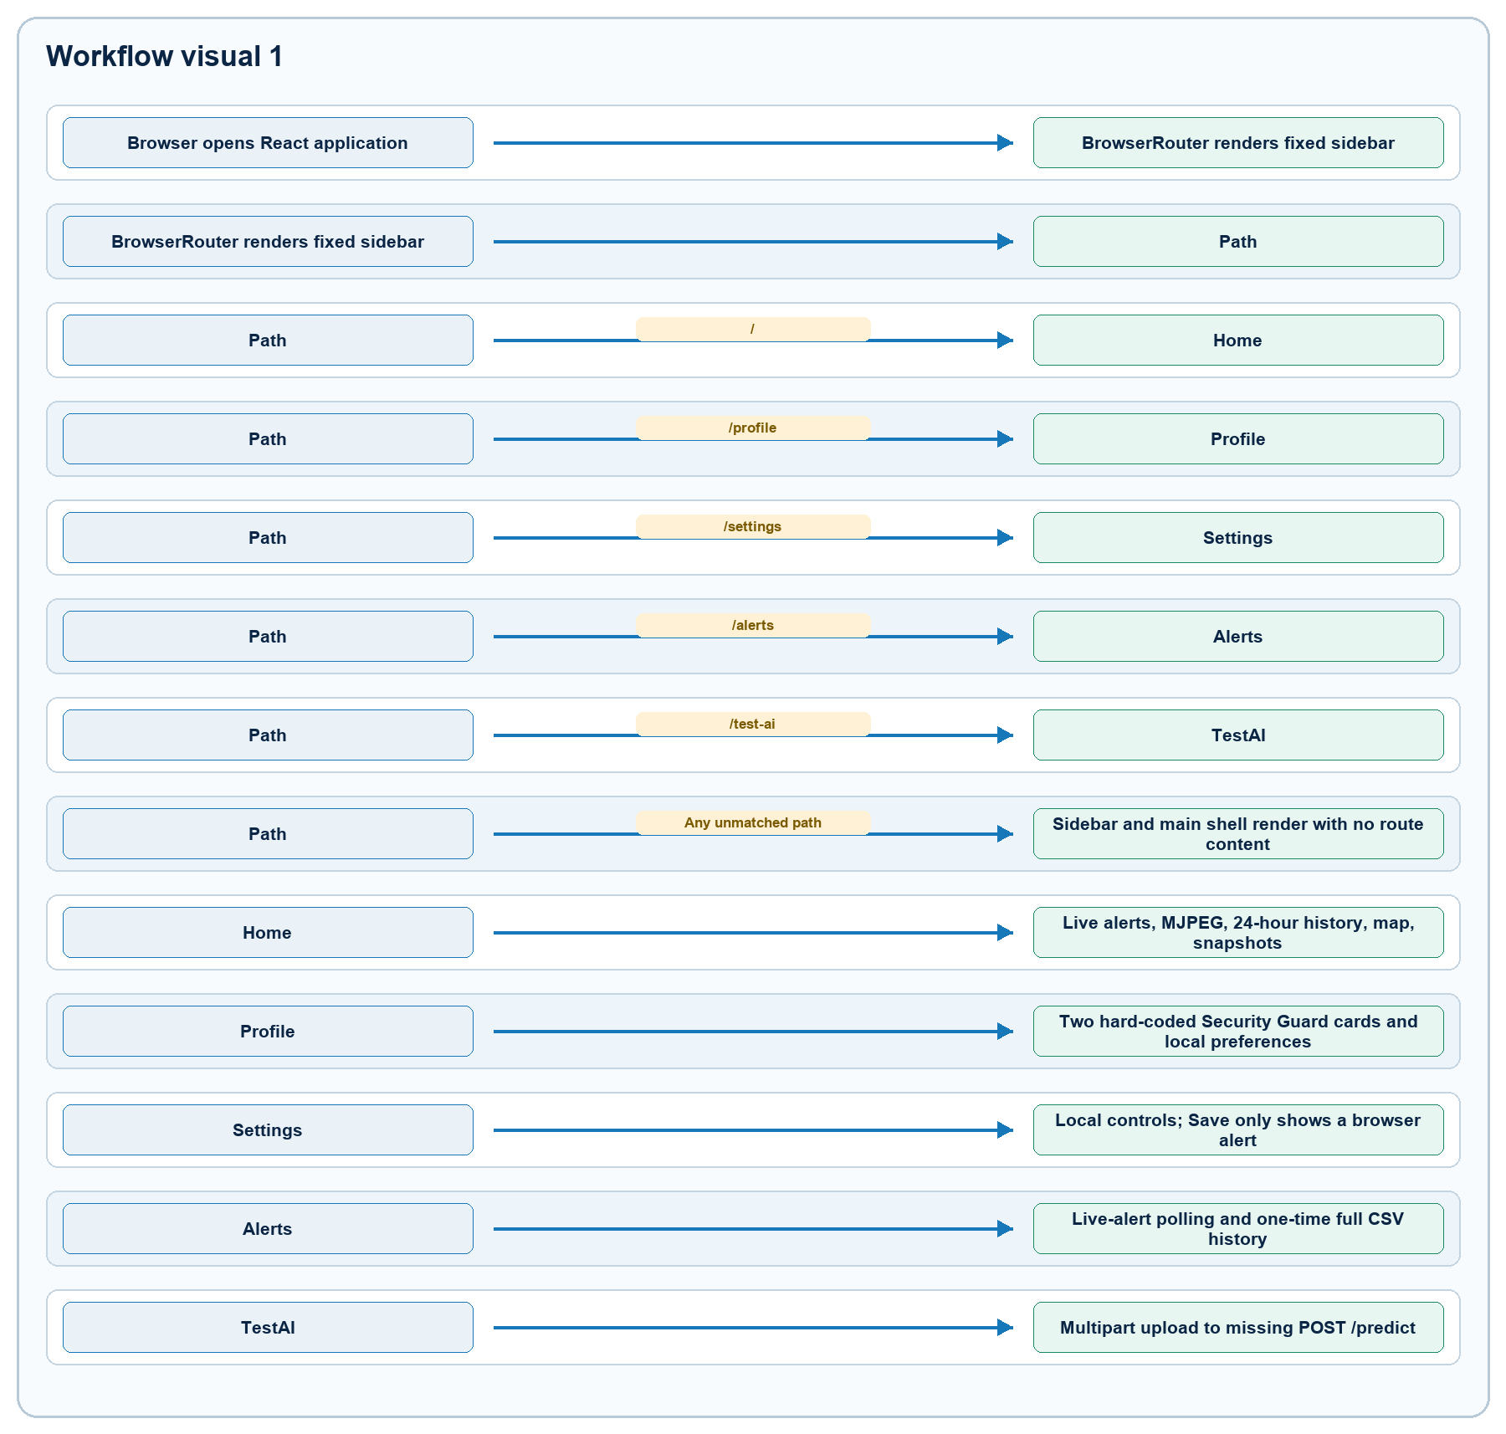
Figure 1. Rendered from the validated Mermaid definition in APP_FLOW.md.

Route lifecycle rules
- Route components hold only React component-local state.
- Navigating away unmounts the active route and discards its state.
- There is no wildcard/not-found route, route guard, loading boundary, or error boundary.
- GalleryPage.js exists but is not routed. MapView.js exists but is not routed and imports an undeclared Google Maps dependency; the active Home map uses react-leaflet instead.

4. Backend startup and shutdown
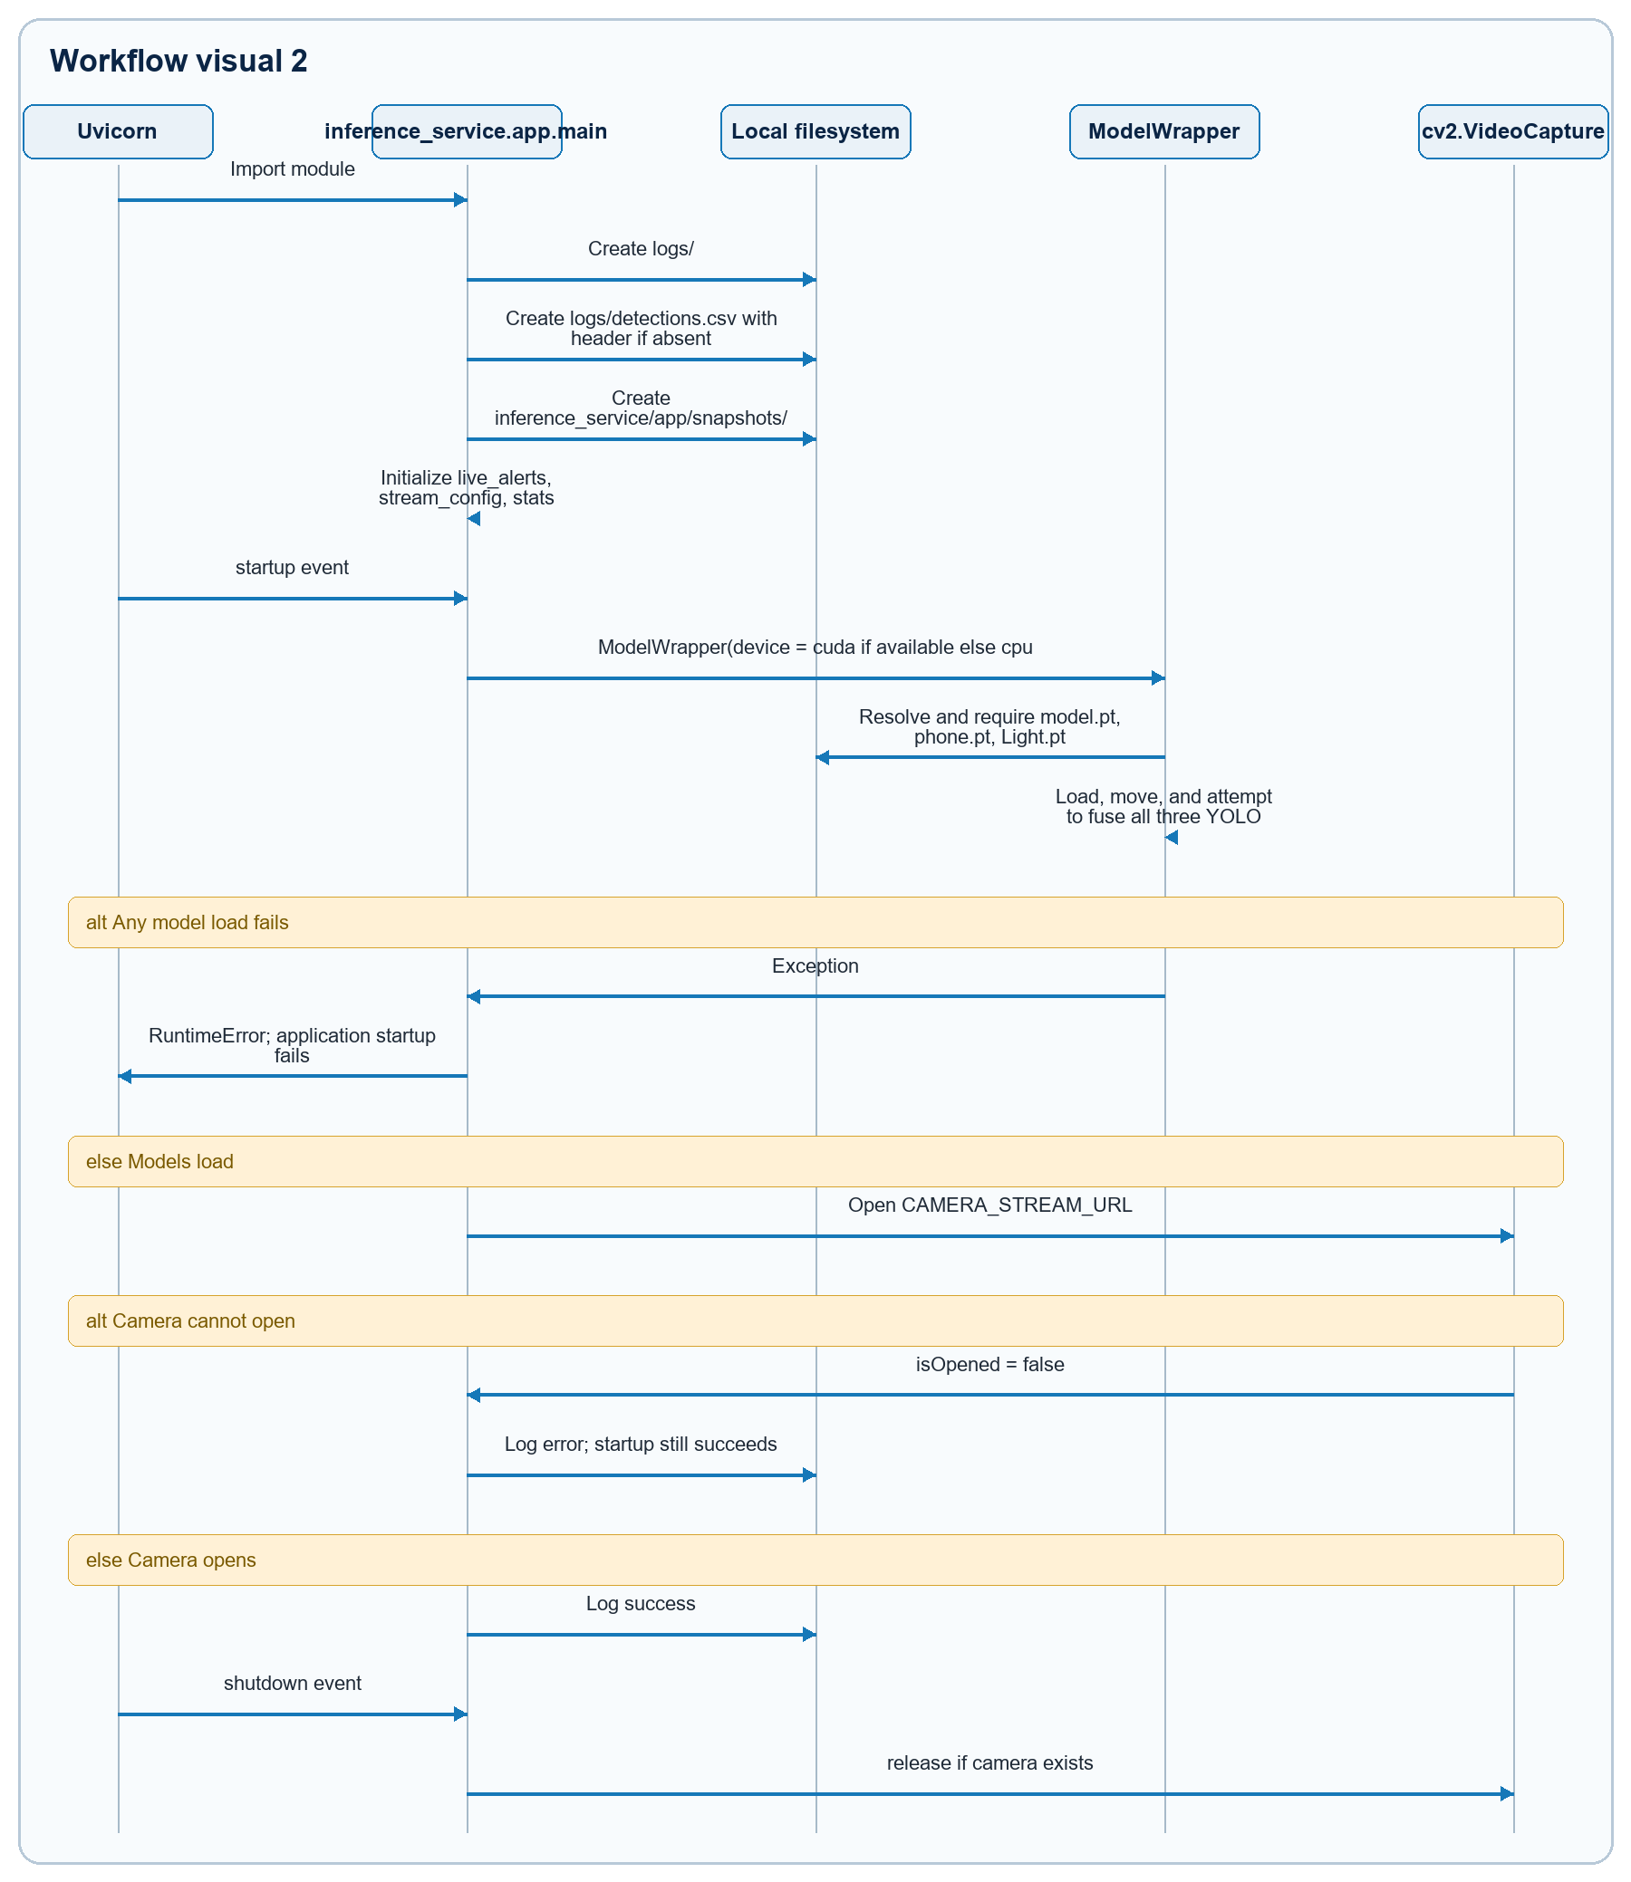
Figure 2. Rendered from the validated Mermaid definition in APP_FLOW.md.
Important boundary: /health returns status: "ok" after model startup even if the camera failed to open.

5. Home journey
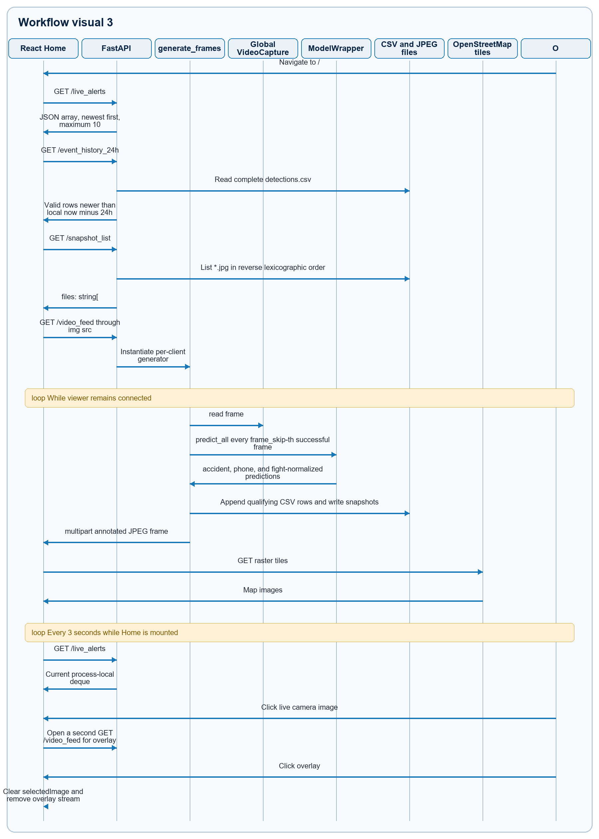
Figure 3. Rendered from the validated Mermaid definition in APP_FLOW.md.

Home state transitions
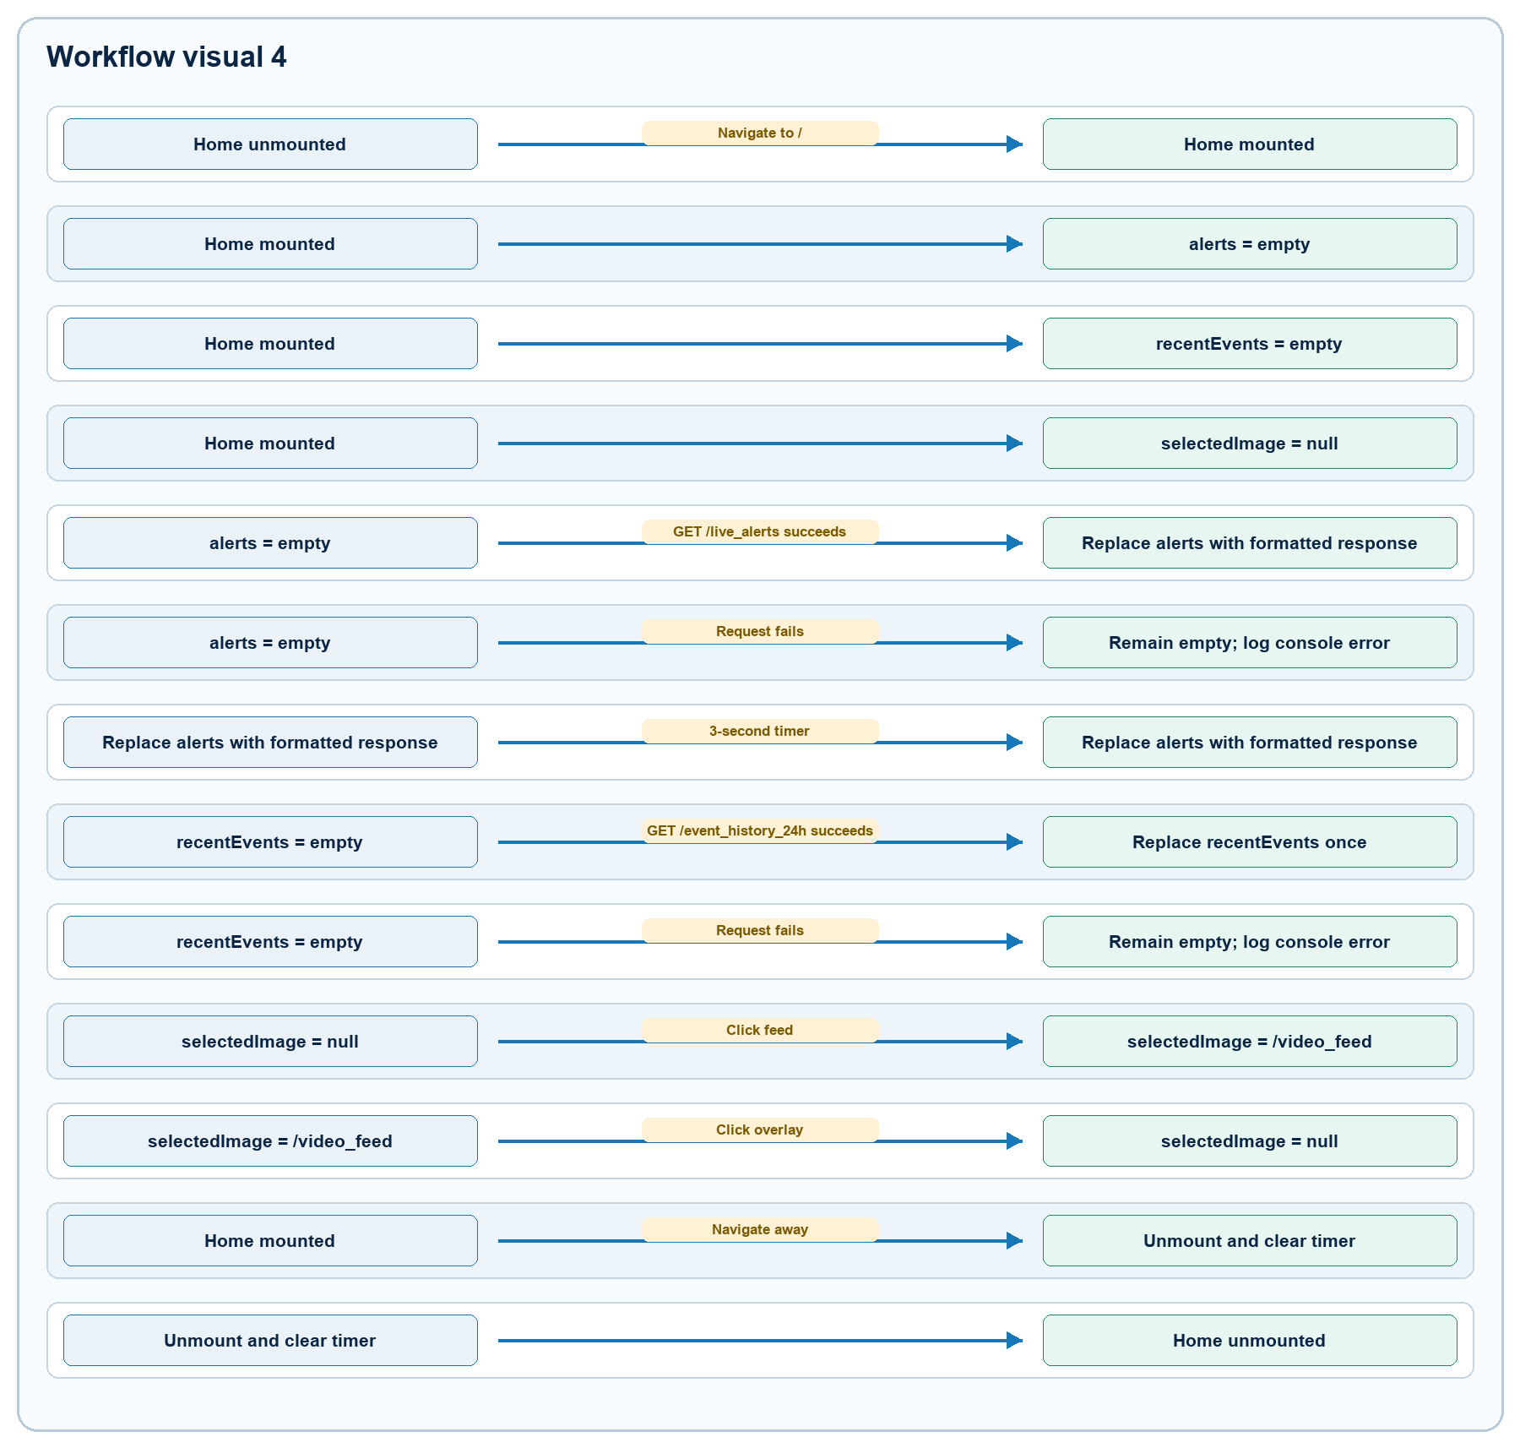
Figure 4. Rendered from the validated Mermaid definition in APP_FLOW.md.

Rendering rules
- Live-alert timestamp is expected as HH:MM:SS and displayed as 12-hour time rounded to minutes.
- Event colors are red for fight, orange for accident/fall, blue for phone, and yellow otherwise.
- The map is centered at 26.4499, 80.3319; markers render only when both coordinates are truthy.
- The 24-hour history and snapshot list are fetched only once per Home mount. New rows/files do not appear until remount.
- Failed API reads and valid empty responses use the same empty UI text.

6. Demand-driven inference and event creation
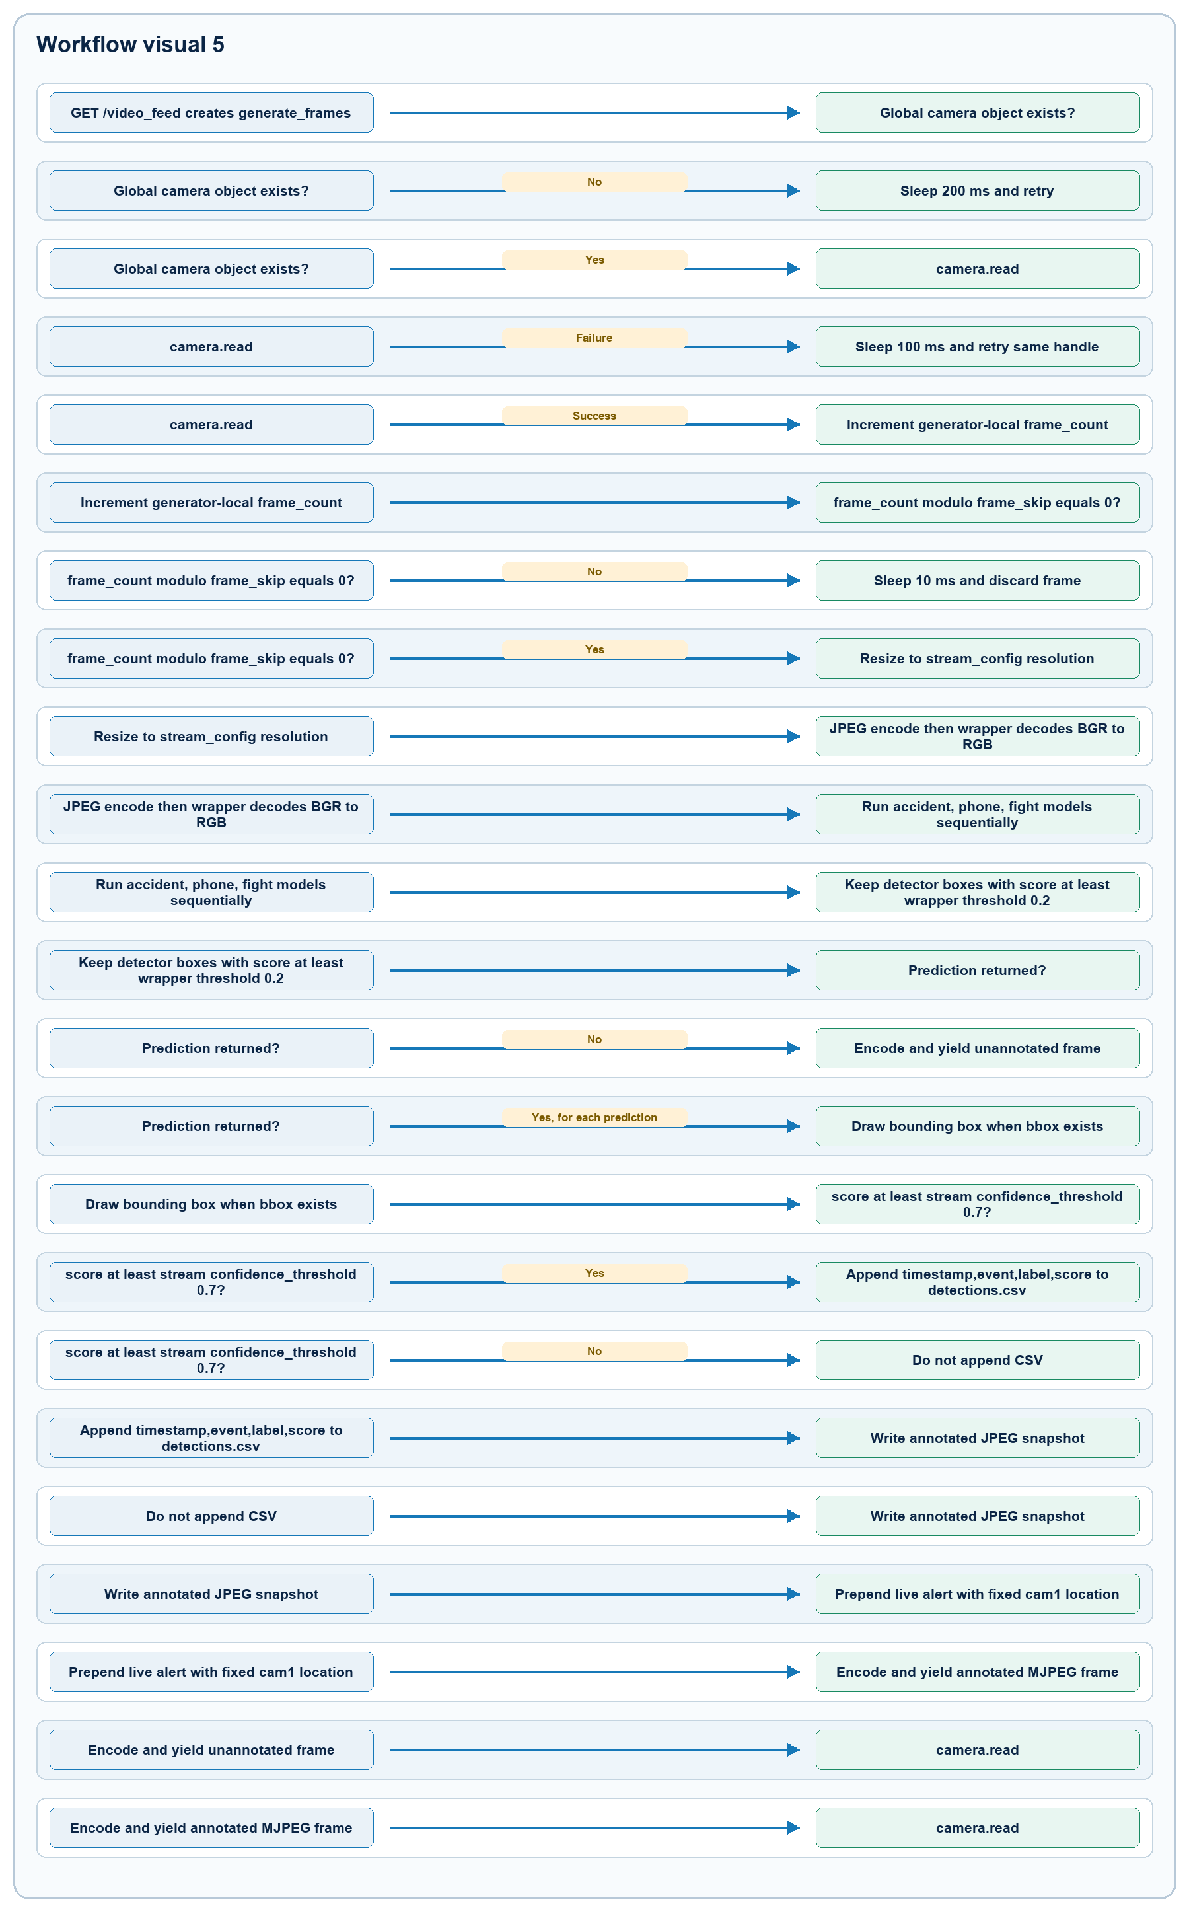
Figure 5. Rendered from the validated Mermaid definition in APP_FLOW.md.

Inference caveats
- Light.pt is a classification checkpoint, while predict_all() only consumes result.boxes. The current fight path therefore returns no normalized fight prediction.
- stream_config.confidence_threshold controls only CSV logging. Live alerts, annotations, snapshots, and stats.detections use predictions already filtered by the separate wrapper threshold 0.2.
- Inference runs only while a client consumes /video_feed or calls /snapshot. Navigating from Home to Alerts normally stops new detection generation.
- Each MJPEG client creates its own inference loop against the same global camera. Multiple tabs or the Home overlay can race on camera reads and duplicate inference work.
- Camera-read failure does not reopen the stream; the loop retries the failed handle indefinitely.
- Snapshot names have one-second time precision. Equivalent predictions in the same second can overwrite the same file.

7. Alerts journey
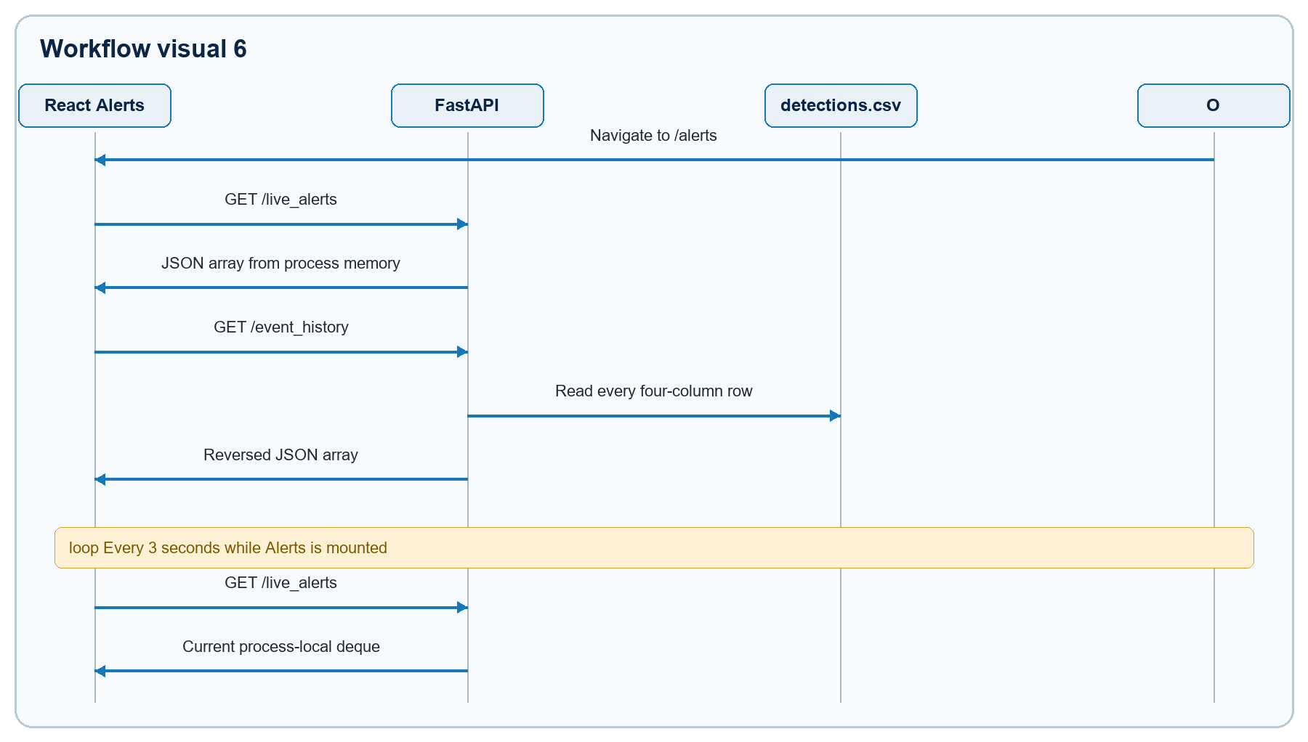
Figure 6. Rendered from the validated Mermaid definition in APP_FLOW.md.
GET /event_history includes the CSV header as a fake final record because the backend accepts every four-column row. GET /event_history_24h attempts timestamp parsing and therefore skips the header.

8. Profile and Settings journeys
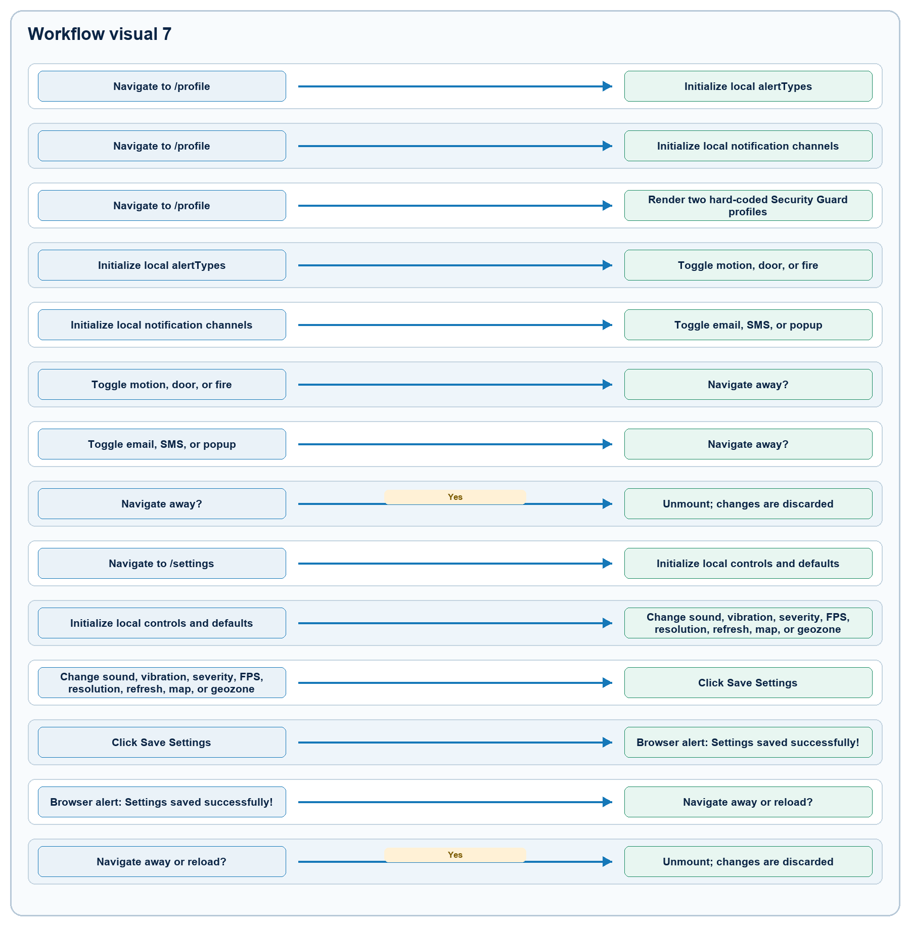
Figure 7. Rendered from the validated Mermaid definition in APP_FLOW.md.
Neither route calls /config, a persistence API, or a notification provider. The profile names, contacts, roles, login history, zones, global-alert badge, and preferences are mock UI data.

9. AI Test journey
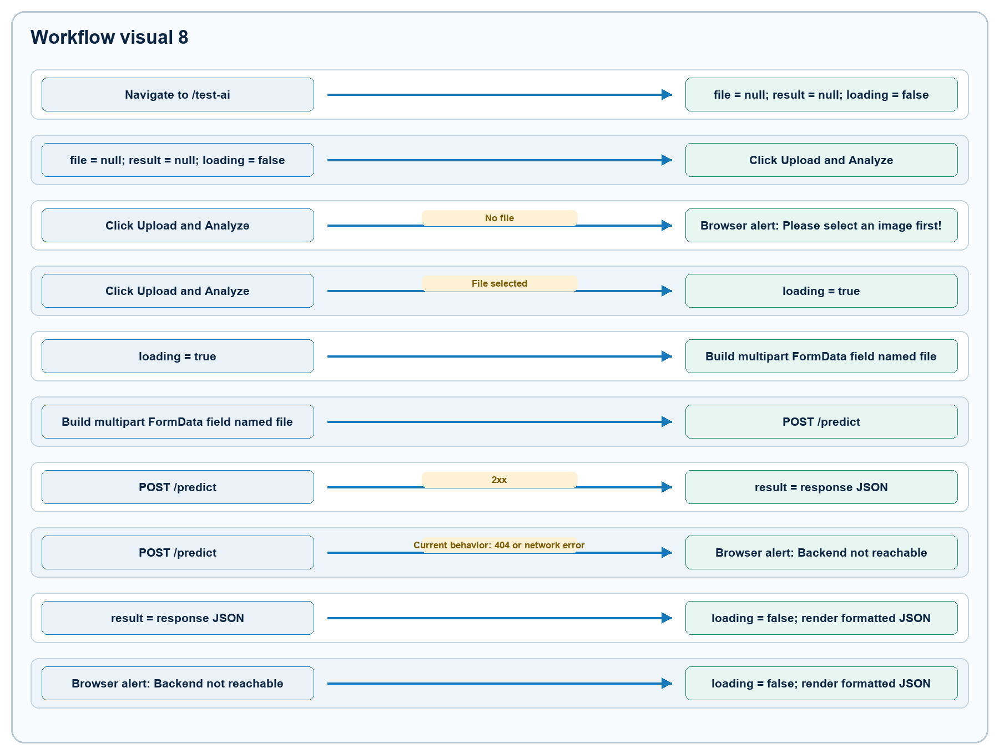
Figure 8. Rendered from the validated Mermaid definition in APP_FLOW.md.
The frontend route exists, but the active FastAPI application has no POST /predict. FastAPI therefore returns 404 {"detail":"Not Found"}; the UI incorrectly reports every error as backend unreachability.

10. Direct snapshot journey
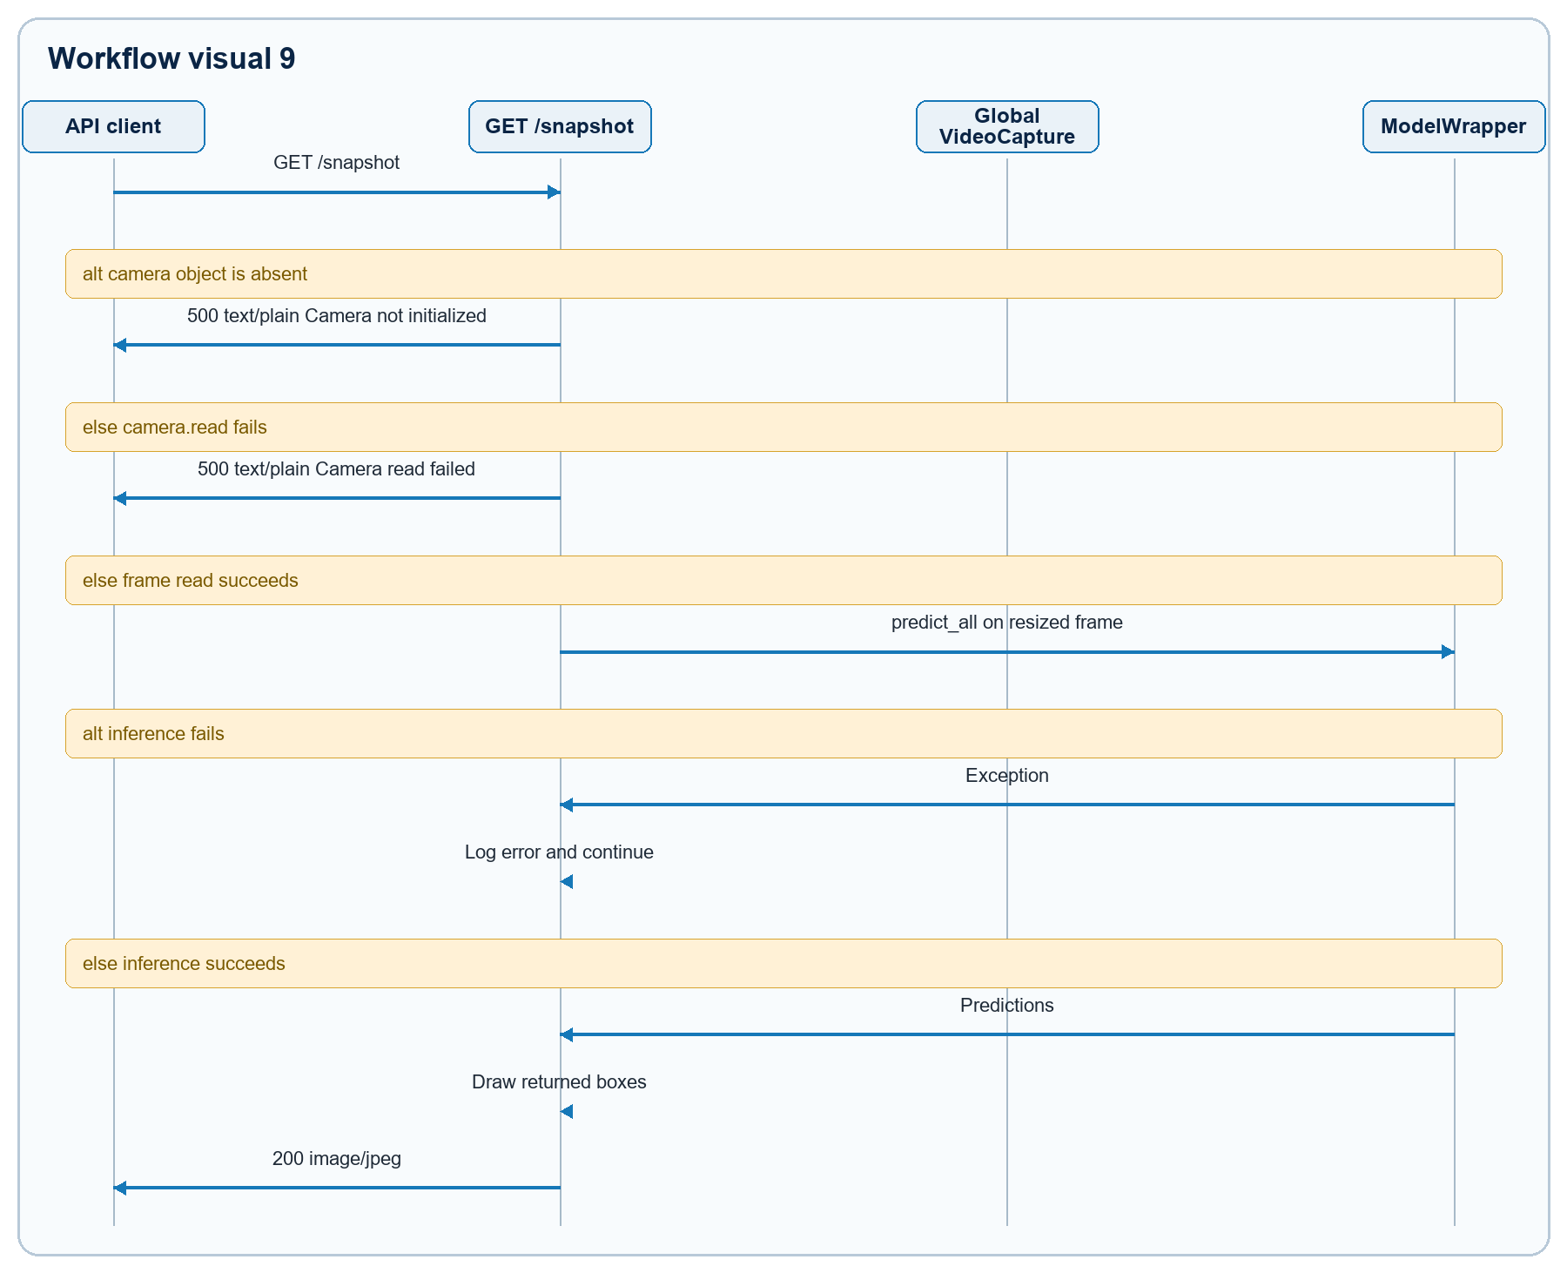
Figure 9. Rendered from the validated Mermaid definition in APP_FLOW.md.
This endpoint does not save a snapshot, append history, create a live alert, or update stats.

11. Configuration mutation
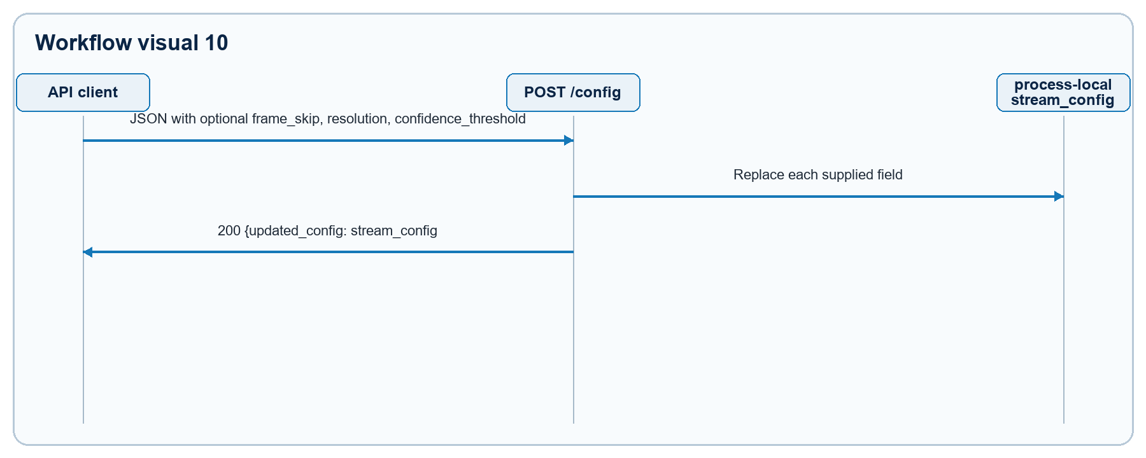
Figure 10. Rendered from the validated Mermaid definition in APP_FLOW.md.
Example CURRENT request:
JSON
{
"frame_skip": 4,
"resolution": [320, 240],
"confidence_threshold": 0.7
}
There are no semantic bounds, authentication, persistence, atomic update, or concurrency controls. frame_skip: 0 is accepted and later causes modulo-by-zero outside the inference try block.

12. API integration contract
Endpoint | Method | Active consumer | Request | CURRENT response | Error boundary / caveat
/health | GET | Manual/operations | None | JSON containing status and nested model metadata | Does not check camera; startup model failure prevents service start.
/video_feed | GET | Home <img> | None | multipart/x-mixed-replace; boundary=frame | Creates a per-client inference loop; can wait forever on camera failure.
/video_feed/cam1 | GET | None | None | Alias of /video_feed | Same concurrency and demand-driven behavior.
/live_alerts | GET | Home, Alerts | None | JSON array, newest first, max 10 | Process memory only; reset on restart; no stable IDs.
/event_history | GET | Alerts | None | Reversed JSON array; score is text | Includes CSV header as a fake record.
/event_history_24h | GET | Home | None | Reversed JSON array of parseable local timestamps within 24h | Full-file scan; malformed rows skipped silently.
/snapshot | GET | None | None | image/jpeg | Shares unlocked camera; no persistence side effects.
/snapshot_list | GET | SnapshotGallery | None | {"files":["..."]} | Unbounded directory scan; reverse filename ordering.
/snapshots/{path} | GET | SnapshotGallery image | URL-encoded filename | Static JPEG | Anonymous evidence access; missing file returns static 404.
/config | POST | None | Optional JSON fields shown above | {"updated_config":{...}} | Weak validation; global memory only; unsafe values accepted.
/predict | POST | TestAI | Multipart field file | Not implemented | Current result is 404, mapped by UI to a generic connectivity alert.
OpenStreetMap tile URL | GET | Home Leaflet map | Tile coordinates in URL | Raster tile image | Browser Internet dependency; no offline behavior or attribution UI.

13. Frontend error-state matrix
Workflow | Empty state | Request failure | Recovery available in UI
Home live alerts | No live alerts | Same empty result after console error | Automatic 3-second retry.
Home 24-hour history | No recent events | Same empty result after console error | Remount/reload only.
Snapshot gallery | No snapshots found | State reset to empty after console error | Remount/reload only.
Alerts live list | No live alerts | Same empty result after console error | Automatic 3-second retry.
Alerts full history | No event history found | Same empty result after console error | Remount/reload only.
AI Test | No result panel | Generic browser alert | User can retry; error cause is not distinguished.
Live camera | Browser broken/blank image behavior | No application status or retry control | Browser may keep stream request open; backend retries same handle.
Map | Empty/partial map depending on tile state | No application error handling | Browser/network behavior only.

14. Requirement-derived transitions not present in CURRENT
These are tracked requirements, not implemented flows:
- REPAIR: separate one camera/inference producer from browser viewers so monitoring continues off Home.
- REPAIR: consume Light.pt classification probabilities or replace it with a detector and define fight-event semantics.
- REPAIR: implement and version POST /predict, validate image type/size, and return a documented schema.
- REPAIR: persist Profile/Settings state and map approved UI fields to validated backend configuration.
- FUTURE: stable event IDs, acknowledgement, assignment, notes, filtering, evidence view, and export.
- PRESENTATION / FUTURE: illegal-dumping detection, pre/post-event video clips, external notification delivery, and policy-specific workflows.
- PRESENTATION / FUTURE: edge/NVR plus central application deployment and 100+ camera capacity; both require separate architecture and measured acceptance evidence.

15. Source map
- Routes and shell: frontend/src/App.js
- Home orchestration: frontend/src/pages/Home.js
- Alert route: frontend/src/pages/Alerts.js
- Snapshot gallery: frontend/src/pages/SnapshotGallery.js
- Local mock preferences: frontend/src/pages/Profile.js, frontend/src/pages/Settings.js
- Broken upload path: frontend/src/pages/TestAI.js
- Backend lifecycle, APIs, state, persistence: inference_service/app/main.py
- Model loading and normalization: inference_service/app/models/wrapper.py
- Product and technical requirements: OneEye_Product_Requirements_Document_PRD.docx, OneEye_Technical_Requirements_Document_TRD.docx
- Secondary intent: supplied OneEye[1].pptx; it does not override repository behavior.

