
TECHNICAL DOCUMENTATION • JUDGE EDITION
OneEye Backend Schema
Runtime state, persistence model, constraints, initialization, and migration requirements
Project | OneEye
Version baseline | bb35a063386db2e59871e515ff60f9d7a437f13d
Prepared | 2 September 2026 | Asia/Kolkata
Coverage
1. Schema status • 2. Implemented logical ERD • 3. Store inventory • 4. Data dictionary • 5. Initialization

How to use this document
This edition is optimized for a live judging discussion and for implementation hand-off. Implemented project behavior is labelled CURRENT; unresolved design requirements and roadmap items are kept separate.
CURRENT | Directly evidenced by the project source baseline.
REQUIRED | Needed to complete, secure, or productionize the project.
PRESENTATION-ONLY | Planned project intent that is not implemented in the current source.

Document map
- Schema status
- Implemented logical ERD
- Store inventory
- Data dictionary
- Initialization
- Implemented validation and constraint gaps
- Migration status and approved requirements
- Baseline data audit example
- Cascades, indexes, and deletion behavior
- Source map

1. Schema status
OneEye CURRENT has no database. There are no SQL/NoSQL migrations, ORM models, primary keys, foreign keys, indexes, transactions, cascade rules, object-store bindings, or backup protocol.
The implemented persistence/state surfaces are:
- logs/detections.csv — append-only detection history.
- logs/app.log — Python file log.
- inference_service/app/snapshots/*.jpg — annotated evidence images.
- live_alerts — process-local deque(maxlen=10).
- stream_config — process-local mutable dictionary.
- stats — process-local mutable dictionary, not exposed by an endpoint.
- CAMERA_LOCATION — process-local fixed dictionary for cam1.
This document models those exact stores. A physical production database schema is intentionally not invented because the PRD/TRD leaves the database technology, tenancy, data residency, and cloud/on-prem boundary as owner decisions.

2. Implemented logical ERD
This is a runtime/data-flow ERD, not a relational database ERD. FRAME and PREDICTION are ephemeral. The remaining entities correspond to in-memory or filesystem records.
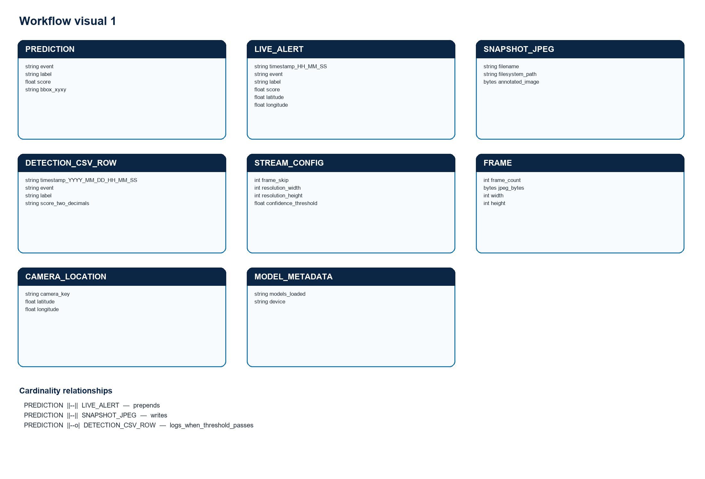
Figure 1. Rendered from the validated Mermaid definition in BACKEND_SCHEMA.md.

Cardinality notes
- One processed FRAME yields zero or more returned PREDICTION objects.
- Every returned PREDICTION triggers one live-alert prepend and one snapshot write attempt.
- A returned prediction creates zero or one CSV row: it is omitted when score < stream_config["confidence_threshold"].
- The current fixed cam1 location is copied into every live alert.
- Snapshot write attempts are one-to-one with predictions, but distinct files are not guaranteed because same-second filename collisions can overwrite an earlier JPEG.

3. Store inventory
Store / object | Physical location | Structure | Capacity / lifecycle | Concurrency and integrity
Detection history | <root>/logs/detections.csv | CSV header plus four text columns | Unbounded; survives process restart | Synchronous append; no lock, ID, index, transaction, checksum, quota, or rotation.
Application log | <root>/logs/app.log | Python formatted text lines | Unbounded; survives process restart | Synchronous file logger; no rotation or structured request/event identifiers.
Snapshot evidence | <root>/inference_service/app/snapshots/*.jpg | Annotated JPEG; metadata encoded in filename | Unbounded; survives process restart | Synchronous writes; one-second filenames can collide; no atomic metadata/image commit.
Live alerts | live_alerts | collections.deque of JSON-like dictionaries | Maximum 10; reset on process restart | Process-local, unsynchronized, divergent across multiple workers.
Stream configuration | stream_config | Mutable Python dictionary | One dictionary per process; reset on restart | Anonymous mutation; no lock, version, persistence, or atomic validation.
Runtime statistics | stats | Mutable Python dictionary | One dictionary per process; reset on restart | Updated during stream inference; not exposed through an endpoint.
Camera location | CAMERA_LOCATION | Fixed Python dictionary | One cam1 entry | Hard-coded demo data; all alerts use the same coordinates.
Model metadata | ModelWrapper.metadata() | Runtime dictionary | Three loaded model names and selected device | Available through /health; contains no checkpoint hash/version fields.

4. Data dictionary

4.1 DETECTION_CSV_ROW
Physical file: logs/detections.csv
Field | Runtime/storage type | Nullable | PK / FK / index | Write and validation rule
timestamp | CSV text | No for rows written by log_event | None | Server-local naive time formatted %Y-%m-%d %H:%M:%S.
event | CSV text | No for current writer | None | Copied from normalized prediction: intended values accident, phone, or fight. No schema enforcement.
label | CSV text | No for current writer | None | Model class name. No length or vocabulary validation.
score | CSV text | No for current writer | None | Written with two decimals only when numeric score is at least the mutable stream threshold.

The first file row is exactly timestamp,event,label,score. /event_history mistakenly returns it as a record; /event_history_24h rejects it during timestamp parsing.

4.2 LIVE_ALERT
Physical store: live_alerts = deque(maxlen=10)
Field | Runtime type | Nullable | PK / FK / index | Write and validation rule
timestamp | str | No | None | Server-local time formatted %H:%M:%S; date and timezone are absent.
event | str | No | None | Copied from prediction.
label | str | No | None | Copied from prediction.
score | float | No | None | Rounded to two decimals; may be below the CSV logging threshold.
location | dict or None | Yes in contract | None | Current cam1 lookup supplies {"lat":26.4499,"lon":80.3319}.

Ordering is newest first because the backend calls appendleft. Once the deque exceeds 10 items, the oldest item is evicted automatically. No stable alert/event ID exists.

4.3 SNAPSHOT_JPEG
Physical store: inference_service/app/snapshots/
Property | Type | Nullable | PK / FK / index | Rule
filename | Filesystem name | No | Filename is the only lookup key | Pattern: YYYY-MM-DD_HH-MM-SS_{event}_{label}_{round(score,2)}.jpg. Components are not sanitized or separately indexed.
filesystem_path | Path | No | None | SNAPSHOT_DIR / filename.
annotated_image | JPEG bytes | No on successful cv2.imwrite | None | The complete annotated frame is written once per returned prediction. The return value of cv2.imwrite is not checked.

/snapshot_list returns every case-insensitive .jpg filename in reverse lexicographic order. /snapshots/{path} serves files anonymously through StaticFiles.

4.4 STREAM_CONFIG
Field | Runtime type | Default | Nullable | Validation | Downstream effect
frame_skip | int | 4 | No in initial state | /config accepts any integer, including 0 and negatives. | Generator analyzes when frame_count % frame_skip == 0; zero causes runtime failure.
resolution | list[int] | [320, 240] | No in initial state | Only list length 2 is checked; signs, range, and element semantics are unchecked. | Passed to cv2.resize as width then height.
confidence_threshold | float | 0.7 | No in initial state | No numeric bounds. | Gates CSV logging only; does not change wrapper filtering, live alerts, annotations, or snapshots.

There is a separate ModelWrapper.conf_threshold default of 0.2. It filters returned model boxes and is not updated by /config.

4.5 STATS
Field | Runtime type | Default | Nullable | Meaning
frames_processed | int | 0 | No | Count of frames that completed the inference call.
detections | int | 0 | No | Count of returned predictions, regardless of CSV threshold.
last_inference_time | float | 0.0 | No | Latest predict_all wall time in seconds, rounded to three decimals.

No endpoint exposes this dictionary and no restart persistence exists.

4.6 CAMERA_LOCATION
Key / field | Runtime type | Nullable | Key / index | Value / rule
cam1 | dictionary key | No | Python dictionary key | Only defined camera identity.
lat | float | No | None | 26.4499.
lon | float | No | None | 80.3319.

The location is demo data and is not derived from CAMERA_STREAM_URL or persisted camera metadata.

4.7 PREDICTION contract
PREDICTION is ephemeral but drives every persisted side effect.
Field | Runtime type | Nullable | Rule
event | str | No | Model dictionary key: accident, phone, or fight.
label | str | No | model.names[cls].
score | float | No | Box confidence; filtered at wrapper threshold 0.2.
bbox | four-element integer list | No for returned current detector records | [x1,y1,x2,y2] relative to resized frame.

Light.pt is a classifier, so its probability output does not satisfy the current result.boxes contract. Fight predictions are therefore absent from CURRENT normalized output.

5. Initialization

5.1 Implemented filesystem initialization
Equivalent excerpt from inference_service/app/main.py:
PYTHON
LOGS_DIR = ROOT_DIR / "logs"
LOGS_DIR.mkdir(exist_ok=True)
DETECTION_LOG = LOGS_DIR / "detections.csv"
if not DETECTION_LOG.exists():
with open(DETECTION_LOG, mode="w", newline="") as file:
writer = csv.writer(file)
writer.writerow(["timestamp", "event", "label", "score"])
live_alerts = deque(maxlen=10)
SNAPSHOT_DIR = CURRENT_DIR / "snapshots"
SNAPSHOT_DIR.mkdir(exist_ok=True)
app.mount("/snapshots", StaticFiles(directory=str(SNAPSHOT_DIR)), name="snapshots")
Initialization occurs during module import. It requires write permission to both directories before the server is ready.

5.2 Project bootstrap
POWERSHELL
git checkout bb35a063386db2e59871e515ff60f9d7a437f13d
copy .env.example .env
copy frontend\.env.example frontend\.env
python -m venv venv
.\venv\Scripts\Activate.ps1
pip install -r requirements.txt
python -m uvicorn inference_service.app.main:app --host 127.0.0.1 --port 8000
The TRD requires an approved, hash-locked Python dependency resolution for reproducibility because fastapi, python-dotenv, and uvicorn are unpinned in the repository.

6. Implemented validation and constraint gaps
Surface | Implemented check | Missing constraint / resulting edge case
Model paths | All three files must exist; failure aborts startup. | Checkpoint hash, license, provenance, trusted source, and task/schema compatibility are not verified at load time.
Model boxes | Confidence must be at least 0.2. | Classifier probabilities are not handled; event vocabulary and bounding coordinates are not schema-validated.
CSV write | Score must meet mutable 0.7 default. | No ID, timezone, locking, atomicity, deduplication, retention, or full-disk behavior.
/config | Body types come from FastAPI annotations; resolution length must be 2. | No ranges, authentication, persistence, concurrency version, or atomic all-field validation.
Snapshot listing | Filename must end in .jpg, case-insensitive. | No pagination, access control, metadata index, integrity check, retention, or quota.
History 24h | Timestamp must parse with %Y-%m-%d %H:%M:%S. | Server-local time only; unparsable rows are silently skipped.
Live alerts | Deque bounds memory to 10. | No stable ID, acknowledgement, assignment, delivery, audit, or cross-worker consistency.

7. Migration status and approved requirements

7.1 CURRENT migration mechanism
There is no migration framework. Schema evolution would currently require manual handling of CSV rows, filenames, and process state. The repository contains no Alembic, Django migration, Prisma, SQL, NoSQL, or object-store configuration.

7.2 Required migration invariants from the PRD/TRD
These are approved requirements, not an implemented schema:
Requirement | Required invariant before a physical database is selected
Stable identity | Assign stable event ID and camera ID; preserve the original Track A CSV/JPEG fixtures.
Time | Store event timestamps with timezone; define conversion from existing server-local naive timestamps.
Event metadata | Preserve event family, model label, numeric score, model/version, severity, location reference, evidence URI, and acknowledgement state.
Evidence | Link event metadata and evidence atomically; prevent same-second collisions; define integrity metadata.
Durability | Select an indexed durable metadata store and an evidence/object store, or harden local storage with locking, paging, quotas, backup, and atomic writes.
Retention | Define retention and deletion by data class and make enforcement observable and testable.
Access | Define identity, least-privilege roles, live/history/evidence/config permissions, and an access audit.
Migration | Import CSV/JPEG state without changing Track A regression fixtures; record rejected/malformed rows explicitly.
Operations | Define backup, recovery, full-disk behavior, capacity alerts, and restore tests.

The owner must choose database technology, tenancy, data residency, cloud/on-prem boundaries, retention periods, and deletion/legal policy before tables and cascade actions can be specified without speculation.

8. Baseline data audit example
This non-mutating check illustrates the CURRENT CSV constraints and known header behavior:
PYTHON
from csv import reader
from datetime import datetime
from pathlib import Path
path = Path("logs/detections.csv")
with path.open(newline="") as handle:
rows = list(reader(handle))
assert rows[0] == ["timestamp", "event", "label", "score"]
for line_number, row in enumerate(rows[1:], start=2):
assert len(row) == 4, (line_number, "expected four columns")
timestamp, event, label, score = row
datetime.strptime(timestamp, "%Y-%m-%d %H:%M:%S")
float(score)
assert event != "", (line_number, "empty event")
assert label != "", (line_number, "empty label")
This check does not create missing IDs or infer camera identity; those values are absent from the stored baseline.

9. Cascades, indexes, and deletion behavior
Capability | CURRENT value
Primary keys | None.
Foreign keys | None.
Secondary indexes | None. Filename ordering is the only snapshot ordering mechanism.
Uniqueness | None. Snapshot filenames can collide and overwrite.
Cascades | None. History rows and JPEG files have no formal relationship.
Soft delete | None.
Hard delete API | None. Files can only be removed out of band.
Retention | None. CSV, logs, and snapshots grow without bound.
Transactions | None. CSV and JPEG side effects are separate synchronous writes.
Backup/restore | None.

10. Source map
- Filesystem state, runtime dictionaries, APIs, initialization: inference_service/app/main.py
- Prediction contract and model thresholds: inference_service/app/models/wrapper.py
- Environment path inputs: .env.example
- Persistence and security requirements: OneEye_Technical_Requirements_Document_TRD.docx
- Event/evidence product requirements: OneEye_Product_Requirements_Document_PRD.docx
- Database/object-storage language in the presentation is target intent only; it is not evidence of an implemented store.

