
PRD / V1.1

OneEye Product Requirements Document
  - A product-fidelity blueprint for recreating the AI-powered CCTV monitoring prototype
Clone baseline Repository main at commit bb35a063386db2e59871e515ff60f9d7a437f13d (tree d4a85e41eae95062d9de311fff844931f7b6b71f).

Source: https://github.com/Raghav-Kumar01/Hackthon_Project_OneEye
Secondary source: OneEye[1].pptx (10 slides, supplied 31 August 2026)
Analyzed: 27-31 August 2026
Status: Repository baseline and presentation intent reconciled; evidence levels remain explicit
Audience: Product, engineering, QA, security, and deployment teams
Fidelity rule: Facts describe the repository as implemented; recommendations are explicitly labeled and must not be mistaken for current behavior.
ONEEYE / REPOSITORY-DERIVED SPECIFICATION

Document map
This map is intentionally static so it renders consistently in Word, LibreOffice, and imported document viewers.
- Executive decision and fidelity contract
- 1. Problem
- 2. Target users
- 3. Product vision and USP
- 4. Goals and non-goals
- 5. Core features and current status
- 6. Detailed product requirements
- 7. User stories and acceptance criteria
- 8. User feedback and validation plan
- 9. Success matrix
- 10. UX, content, accessibility, and responsiveness
- 11. Risks, dependencies, and open decisions
- 12. Release strategy and clone acceptance
- Appendices: visual reference, repository evidence, and presentation reconciliation

Executive decision and fidelity contract
Recommended interpretation Treat the requested exact copy as a two-track program. Track A reproduces commit bb35a06 byte-for-byte and behavior-for-behavior, including its known prototype defects. Track B is an explicitly separate remediation branch that delivers the product implied by the UI and README. This prevents silent fixes from invalidating fidelity while still giving the team a path to a dependable product.
OneEye is an event-first CCTV dashboard. Its concept combines a live camera feed, three AI event families, operator alerts, time-based history, evidence snapshots, and a map in one browser interface. The repository is compact and cloneable, but it is a hackathon prototype: it has no database, authentication, notification delivery, production deployment, user research, or test suite.
The product documentation below uses three requirement labels:
- CURRENT — directly implemented at the audited commit and required for source-fidelity parity.
- REPAIR — necessary for the advertised workflow to function, but intentionally changes current behavior.
- FUTURE — production or scale requirement not present in the repository.
- PRESENTATION — intent or claim found only in the supplied deck; it is not implemented unless repository evidence independently confirms it.
Evidence hierarchy The Git repository remains authoritative for Track A. The supplied 10-slide presentation is a secondary statement of product intent. Where it adds users, features, architecture, or benefits that the source does not implement, this document records the gap and routes it to validation or a later track instead of treating the slide as proof.
Source baseline: https://github.com/Raghav-Kumar01/Hackthon_Project_OneEye, commit bb35a063386db2e59871e515ff60f9d7a437f13d; public repository showed one commit and no releases at analysis time. Open source

1. Problem

1.1 User problem
Security personnel must watch continuous video while simultaneously recognizing rare, high-consequence events. Manual observation is tiring, attention is divided across screens, and the evidence needed for follow-up can disappear by the time an operator reacts. A useful monitoring product should turn passive video into a short, prioritized stream of events with enough context to verify what happened.

1.2 Product problem
The OneEye prototype demonstrates that experience but leaves its critical loop fragile: AI processing occurs only while a client consumes the Home page video stream; alerts are transient; settings are presentation-only; fight detection is wired to an incompatible result type; and the AI upload page calls an endpoint that does not exist. An exact clone must reveal these facts, not disguise them.

1.3 Opportunity
- Reduce operator scanning burden by surfacing accident/fall, phone-use, and fight-related events.
- Place live evidence, alerts, history, snapshots, and location context in one view.
- Run inference locally with packaged model weights so a demo is not dependent on a hosted AI API.
- Create a clear prototype baseline that can be measured before introducing production architecture.
Evidence gap The repository contains no incident data, user interviews, model evaluation results, analytics, or field trial records. The problem is plausible and coherent, but its magnitude and product-market fit are not validated by the source.

2. Target users
Persona | Primary need | Repository evidence | Current support
Security guard / CCTV operator | See and assess events without watching every frame continuously. | Two named team profiles are labeled Security Guard. | Primary dashboard and alert/history views exist.
Security supervisor | Configure camera, alert threshold, zones, and response policy. | Settings and preference controls imply an administrator workflow. | UI only; no persistence, role, or backend binding.
Incident reviewer | Review event history and snapshots after an occurrence. | History tables and snapshot gallery are visible. | Read-only; no filtering, detail view, acknowledgement, or export.
Developer / hackathon evaluator | Run the stack, verify models, and demonstrate the concept. | README provides local setup and a health endpoint; AI Test route is exposed. | Setup is documented; AI Test is broken and backend versions are incomplete.
Facility manager | Monitor safety, cleanliness, and restricted-use policies across a site. | Supplied presentation names facility management and industrial/public-space deployment. | PRESENTATION only; cleanliness/illegal-dumping detection is absent.
Law-enforcement or campus administrator | Receive verifiable incident evidence and location context for escalation. | Supplied presentation names law enforcement and school/campus administration. | PRESENTATION only; no case workflow, clip export, notification delivery, or role model.

Evidence: frontend/src/pages/Profile.js:37-51; Settings.js:20-100; Home.js:63-148; README.md:50-119. Additional personas and deployment contexts come from slides 4 and 8 of the supplied presentation and require validation.

2.1 Access model
CURRENT: all users see the same five routes. There is no login, session, identity, authorization, role-based navigation, or protected endpoint. Names and contact details on Profile are hard-coded sample records. Any production role definition is therefore a new product decision, not clone parity.

3. Product vision and USP
Vision Enable a security operator to move from live video to a verifiable, location-aware event record in one workspace, with AI doing the first pass and the human retaining judgment.

3.1 Unique selling proposition
OneEye's differentiator is not any single detector. It is the compact event loop: local multi-model inference feeds an annotated live stream, newest-first alerts, a time-ordered record, geospatial context, and saved visual evidence in the same dashboard. For a hackathon-scale deployment, the three runtime checkpoints are already bundled, lowering demo setup friction.
- Event-first, not footage-first: the interface leads with alerts and evidence rather than only a camera wall.
- Local inference: no hosted inference API is required by the active backend.
- Multi-signal concept: fall/accident, phone, and fight concerns are presented through one operator vocabulary.
- Presentation expansion: the supplied deck positions the concept for illegal-dumping detection, recorded event clips, notifications, and broader public/campus/industrial use; these are future scope, not clone features.
- Traceable evidence: CSV history and timestamped JPEG snapshots provide a simple audit trail.
- Cloneable footprint: one React application, one FastAPI process, three small model files, and filesystem state.
Qualification The USP describes the product concept. The current fight path cannot emit results, event capture is viewer-dependent, and the evidence store is not suitable for regulated or multi-user production use.

4. Goals and non-goals

4.1 Track A — source-fidelity goals
- Reproduce the audited Git commit, file tree, model binaries, text, routes, styling, defaults, and API shapes.
- Reproduce the single-camera local workflow on Windows with a reachable OpenCV-compatible stream.
- Preserve the present 3-second alert polling, one-time history/gallery loads, 10-alert memory limit, fixed Kanpur location, and filesystem behavior.
- Make known defects explicit in acceptance evidence instead of silently repairing them.
- Provide repeatable build, launch, and verification instructions for the published snapshot.

4.2 Track B — functional-parity goals
- Keep inference running independently of whether a user is viewing Home.
- Implement a valid fight classification workflow and a defined image-upload prediction contract.
- Persist and enforce settings and user preferences.
- Protect surveillance data with identity, authorization, transport security, retention, and auditing.
- Add observability, reliable camera reconnection, test coverage, and a production deployment model.

4.3 Non-goals for the exact baseline
- Retraining any model: datasets, training scripts, and complete provenance are absent.
- Reconstructing previous runtime data: .env files, logs, snapshots, camera state, and archived prototype folders are intentionally excluded.
- Claiming production safety, regulatory compliance, or measured AI accuracy without independent validation.
- Introducing a database, cloud service, mobile application, multi-camera orchestration, or notification provider into Track A.

5. Core features and current status
ID | Feature | Requirement summary | Baseline status
CF-01 | Live camera | MJPEG stream from /video_feed, rendered on Home and clickable into an overlay. | CURRENT / camera-dependent
CF-02 | Fall/accident AI | YOLO detection weight emits event=accident and model label fallen_person. | CURRENT
CF-03 | Phone AI | YOLO detection weight emits event=phone and label phone. | CURRENT
CF-04 | Fight AI | Fight classifier is loaded, but wrapper expects bounding boxes and discards classification output. | REPAIR required
CF-05 | Live alerts | Newest-first, max 10, in-memory; Home and Alerts poll every 3 seconds. | CURRENT / viewer-dependent
CF-06 | Event history | CSV-backed full and 24-hour views; score is stored as text. | CURRENT / header defect
CF-07 | Snapshots | One annotated JPEG per prediction; gallery loads once per mount. | CURRENT / unbounded
CF-08 | Map | Leaflet/OSM centered on Kanpur; all alerts share a fixed location. | CURRENT / demo data
CF-09 | Team profile | Two static guards plus local-only alert/channel preferences. | CURRENT / mock
CF-10 | Settings | Alert, camera, map, and badge controls; Save only shows a browser alert. | CURRENT / mock
CF-11 | AI image test | Uploads multipart file to missing POST /predict and renders raw JSON on success. | REPAIR required
CF-12 | Health/config | Backend exposes /health and mutable /config; neither is surfaced in the UI. | CURRENT / unsafe
CF-13 | Illegal-dumping AI | Deck describes detection of disposal outside designated bins; no checkpoint, class, route, or code path exists. | PRESENTATION / FUTURE
CF-14 | Recorded event clips | Deck proposes approximately 10 seconds before and after an event; repository saves single annotated JPEGs only. | PRESENTATION / FUTURE
CF-15 | Notification delivery | Deck promises alerts to operators; UI contains email/SMS/popup preferences but no delivery provider or backend workflow. | PRESENTATION / REPAIR
CF-16 | Surety score | Deck calls for a confidence score with alerts; repository returns numeric live-alert scores and string CSV history scores without calibration. | CURRENT / uncalibrated

Evidence: README.md:19-27; frontend/src/App.js:19-37; Home.js:14-155; TestAI.js:15-60; inference_service/app/main.py:63-347; models/wrapper.py:64-201. Presentation-only rows derive from slides 4-6 and are deliberately not marked current.

6. Detailed product requirements

6.1 Global shell and navigation
Requirement | Track | Acceptance statement
PRD-SH-01 | CURRENT | Display a fixed 220 px sidebar with circular OneEye logo, OneEye heading, and Home, Profile, Settings, Live Alerts, and AI Test links.
PRD-SH-02 | CURRENT | Render routed content in a vertically scrollable main area offset 220 px from the left.
PRD-SH-03 | CURRENT | Use BrowserRouter paths /, /profile, /settings, /alerts, and /test-ai; unknown paths show the shell with no route content.
PRD-SH-04 | REPAIR | Add an active navigation state and a defined not-found experience in the functional-parity track.

6.2 Home dashboard
- PRD-HM-01 / CURRENT — On mount, request /live_alerts immediately and every 3 seconds. Render event name in uppercase, an em dash, model label, a severity-colored dot, and 12-hour time rounded to minutes.
- PRD-HM-02 / CURRENT — Render the /video_feed MJPEG response as the single live camera image. Clicking it opens a full-screen preview; clicking the overlay closes it.
- PRD-HM-03 / CURRENT — Request /event_history_24h once on mount and display Timestamp, Event, Label, and Score in a vertically scrolling card with a sticky header.
- PRD-HM-04 / CURRENT — Center Leaflet at latitude 26.4499, longitude 80.3319, zoom 13; render markers only when both coordinates are truthy and show event, label, score, and time in a popup.
- PRD-HM-05 / CURRENT — Request /snapshot_list once and show every filename as a labeled image card sourced from /snapshots/{encoded filename}.
- PRD-HM-06 / CURRENT — Use No live alerts, No recent events, and No snapshots found for both empty and failed-request states.
- PRD-HM-07 / REPAIR — Distinguish loading, empty, camera-offline, map-offline, and backend-error states; provide retry actions and last-success time.
- PRD-HM-08 / REPAIR — Do not create a second inference stream when the preview opens; enlarge the existing stream or subscribe to a shared stream producer.

6.3 Live Alerts
- PRD-AL-01 / CURRENT — Poll /live_alerts every 3 seconds using the same formatting and severity colors as Home.
- PRD-AL-02 / CURRENT — Request full /event_history once at mount and display its four columns without sorting, filtering, paging, or acknowledgement actions.
- PRD-AL-03 / REPAIR — Keep detection active when Home is not mounted; the Live Alerts route must not depend on another viewer to generate new events.
- PRD-AL-04 / FUTURE — Add stable event IDs, severity, acknowledgement, assignment, notes, filtering, evidence view, and export only after the baseline is frozen.

6.4 Profile and Settings
- PRD-PF-01 / CURRENT — Show the two hard-coded Security Guard cards and their exact sample contact/login-history strings.
- PRD-PF-02 / CURRENT — Default Motion on, Door off, Fire off; Email on, SMS off, Popup on; default zone Main Entrance. State lasts only while the component remains mounted.
- PRD-ST-01 / CURRENT — Default Sound on, Vibration off, severity All, frame rate 30fps, resolution 1080p, refresh 10s, map enabled, and empty geofence text.
- PRD-ST-02 / CURRENT — Show the hard-coded 3 Active Alerts badge. Save Settings displays Settings saved successfully! and does nothing else.
- PRD-ST-03 / REPAIR — Align UI taxonomy with actual AI events, map settings to validated backend fields, persist values, and report save errors.

6.5 AI Test
- PRD-AI-01 / CURRENT — Allow a single unconstrained file selection; require a file before upload; disable the button and show Analyzing... during the request.
- PRD-AI-02 / CURRENT — POST multipart form field file to /predict; show raw formatted JSON on success; show a generic backend-not-reachable alert for any error.
- PRD-AI-03 / REPAIR — Define accepted image types/size, choose which model(s) run, implement /predict, return a versioned schema, and distinguish validation, inference, and connectivity failures.

6.6 Presentation-derived workflows
- PRD-PT-01 / FUTURE — If illegal-dumping detection is approved, define the monitored zone, disposal action, temporal window, evidence needed to distinguish placement from littering, and a licensed representative dataset before model selection.
- PRD-PT-02 / FUTURE — If recorded clips are approved, maintain a bounded pre-event buffer and post-event window, store an event-linked clip with integrity metadata, and apply access, retention, redaction, and export controls.
- PRD-PT-03 / FUTURE — If external notifications are approved, define channel, recipient, severity, deduplication, escalation, acknowledgement, retry, quiet-hours, and delivery-audit semantics.
- PRD-PT-04 / FUTURE — Treat the deck's public-space, transport, school, industrial, and high-security contexts as discovery segments; each requires separate privacy, environmental, model-quality, and operational validation.

7. User stories and acceptance criteria
ID | Actor | Story | Acceptance
US-01 | Security guard | I want a live annotated camera feed so I can verify an AI alert immediately. | With a reachable camera and loaded models, Home displays multipart JPEG frames at 320×240 source resolution with returned boxes/text drawn.
US-02 | Security guard | I want the newest events summarized so I can prioritize my attention. | Home and Live Alerts show newest-first items from a maximum-10 list, polling immediately and every 3 seconds.
US-03 | Incident reviewer | I want recent events and snapshots so I can reconstruct what happened. | Home shows valid events from the last 24 hours and all snapshot filenames returned at mount; Alerts shows full CSV history.
US-04 | Security guard | I want a map marker so I know which location generated an event. | Alerts with non-zero lat/lon display on the Kanpur-centered Leaflet map and show event details in the popup.
US-05 | Team member | I want to set alert and notification preferences. | Track A changes checkbox state only for the mounted Profile component; Track B persists and applies it.
US-06 | Supervisor | I want to configure monitoring behavior. | Track A displays the exact controls and success alert; Track B validates, saves, and applies settings.
US-07 | Evaluator | I want to upload one image and inspect model output. | Track A reproduces the current 404-driven failure; Track B accepts a valid image and returns the agreed prediction schema.
US-08 | Incident reviewer | I want an event-linked video clip so I can assess what happened before and after an alert. | PRESENTATION/FUTURE: approved clip duration, integrity, access, retention, and export criteria pass; Track A remains snapshot-only.
US-09 | Facility or campus administrator | I want policy-specific alerts so I can respond to safety, cleanliness, or restricted-phone events. | PRESENTATION/FUTURE: each event family has a validated definition, dataset, model threshold, response owner, and false-alert target.

8. User feedback and validation plan
No actual feedback found Neither the repository nor the supplied presentation contains interviews, survey data, analytics, support tickets, field notes, or usability test results. The deck states intended users and benefits, but those statements are not user feedback. The hypotheses below are audit-derived and are not invented quotations.
Hypothesis | Why a user may say it | Validation task
I cannot tell whether monitoring is active. | Health ignores camera status; the UI has no connecting/offline state; inference stops away from Home. | Ask five guards to determine system state after camera loss and route changes.
My settings did not save. | Profile and Settings state resets on navigation/reload and no backend request occurs. | Change settings, navigate away, reload, and ask users what they expect.
AI Test says the server is down even when it is running. | A 404 from missing /predict is mapped to a connectivity alert. | Test valid, invalid, and unreachable cases; record diagnostic accuracy.
I see too many repeated alerts. | There is no event cooldown or deduplication; every eligible processed frame can create evidence. | Run staged persistent events and measure alerts per incident.
The dashboard is unusable on my phone. | The fixed 220 px sidebar remains at a 390 px viewport and content is clipped. | Complete primary tasks at 390×844 and 768×1024.

8.1 Recommended discovery study
- Interview 5-8 security guards and 2-3 supervisors about monitoring load, escalation, evidence, and false-alert tolerance.
- Run task-based usability sessions on Home, Alerts, settings persistence, and incident review using seeded events.
- Review at least 50 labeled clips per event family with operators and an ML evaluator; measure both model quality and operator trust.
- Define retention, location visibility, access, and incident-export expectations with the system owner and privacy/security stakeholders.
- Convert validated findings into prioritized requirements; do not treat this prototype's labels or defaults as user-approved policy.

9. Success matrix

9.1 Exact-clone acceptance
Goal | Measure | Track A acceptance target
Source integrity | Commit and Git tree | HEAD=bb35a063386db2e59871e515ff60f9d7a437f13d; tree=d4a85e41eae95062d9de311fff844931f7b6b71f; 48 tracked files; clean tracked status.
Model integrity | SHA-256 | All three checkpoint hashes match the TRD manifest exactly.
Build reproducibility | Frontend build | npm ci and CI=true npm run build complete successfully from a clean clone.
Route parity | Reachable views | All five routes render exact copy, defaults, empty text, and navigation labels; unknown route behavior also matches.
Visual parity | Golden screenshot diff | At 1280×720 on the named browser/OS, structural pixel diff is ≤3% after masking camera/map/network-dynamic regions.
API parity | Contract cases | Every implemented endpoint returns the documented status, content type, field names, ordering, and data types.
Camera smoke | Integrated flow | With a valid camera, Home receives MJPEG, creates eligible alerts/snapshots, and returns history under one backend worker.
Defect transparency | Known parity cases | Fight output absence and /predict 404 are recorded as expected Track A behavior, not misreported as passing product features.

9.2 Proposed functional-product KPIs
Owner approval required The following targets are proposals because the repository supplies no SLOs, accuracy study, hardware baseline, or user benchmark.
Outcome | Metric | Proposed Track B target
Monitoring continuity | Detection producer uptime while camera is reachable | >=99.5% during staffed monitoring windows
Alert latency | Frame capture to alert visible, p95 | <=5 seconds on approved hardware
AI precision | Confirmed true alerts / reviewed alerts | >=85% per high-severity event before rollout
AI recall | Detected labeled incidents / labeled incidents | Target to be set after representative dataset review; never infer from training checkpoint
Operator response | Median time from alert to evidence view | <=20 seconds in usability study
Reliability | Unacknowledged data-loss incidents | 0; durable event/evidence writes must be monitored
Security | Unauthenticated surveillance endpoints and unresolved critical dependency findings | 0 before production
Usability | Primary workflow completion | >=90% without facilitator help; SUS >=80 as a proposed launch gate

9.3 Presentation claim validation gates
Unverified claims The supplied presentation gives quantified benefits without citations, baselines, sample sizes, study design, hardware assumptions, or field evidence. They must remain hypotheses until independently validated.
Presentation claim | Evidence needed | Publication gate
60% lower monitoring cost | Named baseline, staffing model, deployment cost, period, sample and calculation. | Do not publish until replicated on the intended operating model.
40% lower emergency response time | Control/comparison design, alert-to-action definition, incident mix and confidence interval. | Do not publish until an approved field study supports it.
INR 1.5-2 lakh annual saving per zone | Zone definition, current cleanup cost, event frequency, intervention cost and attribution method. | Local business owner and finance approval required.
30-50% faster case resolution | Case start/end definitions, comparable cohorts, evidence-tagging workflow and confounder review. | Legal/operations validation required before external use.
Scales to 100+ cameras | Per-camera FPS/resolution, model mix, hardware topology, concurrency, network/storage load and sustained soak test. | Capacity report and SLO pass required; current prototype is single-camera.

10. UX, content, accessibility, and responsiveness

10.1 Visual fidelity tokens
Element | Implemented token / behavior
Shell | #121212 background, white text, viewport-height layout, hidden outer overflow.
Sidebar | 220 px fixed width; #0f172a→#1e293b vertical gradient; 25 px vertical padding.
Logo | oneeye_logo.jpg, displayed 80×80 px, circular crop.
Home cards | #2b2b2b, 15 px padding, 10 px radius, subtle dark shadow; two-column grid with 20 px gap.
Home breakpoint | At <=900 px, cards become one column; the sidebar remains fixed and content remains offset.
Alerts | Dark page, cyan table headings, red/orange/blue/yellow dots.
Profile | Dark navy gradient cards; #3b82f6 accents; fade-in and hover lift.
Settings | Light #f9fbff canvas, white cards, #004aad blue, #ff5252 badge.
Typography | System font stack; no bundled fonts, so emoji and metrics vary by OS/browser.

10.2 Accessibility baseline and repair requirements
- CURRENT positives: semantic aside/nav/main structure, heading hierarchy, table headers, image alt text, and labeled Profile checkboxes.
- REPAIR: expose nav state with aria-current; announce live updates; provide focus-visible styles; label Settings and file controls; support reduced motion.
- REPAIR: turn the clickable camera image into a keyboard-operable control and the preview into a dialog with focus management, close button, and Escape behavior.
- REPAIR: make the profile bell keyboard/touch accessible and provide persistent rather than hover-only content.
- REPAIR: add horizontal handling for history tables and a responsive/collapsible navigation pattern; test at 200% zoom and common mobile viewports.
- REPAIR: add OpenStreetMap attribution and define offline-map behavior.
Mobile finding At 390×844, the fixed sidebar consumes 220 px and the main cards are visibly clipped. Source parity reproduces this; product parity must redesign it.

11. Risks, dependencies, and open decisions
ID | Severity | Risk | Required response
R-01 | Critical | No project license and undocumented asset/model provenance. | Obtain owner authorization and complete code, weight, logo/image, map, and dependency review before redistribution.
R-02 | Critical | Fight checkpoint is a classifier but code consumes boxes. | Choose frame-level classifier semantics or a detector; add model contract tests.
R-03 | High | Monitoring is coupled to a Home video consumer. | Separate one producer from viewers in Track B; preserve behavior only in Track A.
R-04 | High | All surveillance/config endpoints are unauthenticated. | Add identity, RBAC, TLS, audit, and rate/semantic limits before production.
R-05 | High | No retention or capacity control for CSV and snapshots. | Define retention, quota, deletion, and evidence immutability policy.
R-06 | High | Frontend dependency audit reported 58 findings on 27 Aug 2026, including 2 critical. | Rebuild dependency baseline and verify compatibility in a remediation branch.
R-07 | Medium | Camera, map tiles, fonts, emoji, and OS affect exact appearance/behavior. | Declare validation environment and mask dynamic regions in screenshot tests.
R-08 | Medium | No tests, seeds, logs, snapshots, or golden event fixtures. | Create synthetic, licensed fixtures and API/visual regression baselines.
R-09 | High | Presentation promises features and quantified benefits absent from the repository and supplies no supporting citations. | Separate pitch intent from baseline scope; validate each feature, metric, architecture, and scale claim before publication or commitment.
R-10 | High | Illegal-dumping, temporal processing, recorded clips, notifications, and 100+ camera scale materially change product and architecture scope. | Require owner prioritization, privacy review, data/model plan, capacity design, and new acceptance criteria before implementation.

11.1 Decisions the repository cannot answer
- Does exact copy include mock/broken behavior, or should the first delivered build repair advertised workflows?
- Should fight events be frame-level alerts or require localized bounding boxes?
- Which camera protocols, codecs, FPS, camera count, and reconnect behavior are supported?
- What event severity, cooldown, deduplication, acknowledgement, escalation, and notification rules apply?
- Which users/roles may view live footage, snapshots, history, exact coordinates, and configuration?
- What retention, deletion, export, privacy, and legal requirements govern CCTV evidence?
- Which production platform, GPU/CUDA target, uptime target, and offline behavior are required?
- Which presentation-only items—illegal dumping, video clips, notification delivery, temporal analysis, edge/cloud tiers, and 100+ camera scale—are approved product commitments versus exploratory ideas?

12. Release strategy and clone acceptance
Milestone | Outcome | Exit gate
M0 — Evidence freeze | Tag audited source, commit/tree IDs, binary hashes, screenshots, API contracts, and known defects. | All facts trace to the audited commit; no hidden fixes.
M1 — Source-fidelity clone | Recreate source and current behavior in a controlled local environment. | Exact-clone success matrix passes; known defects reproduced and disclosed.
M2 — Functional parity | Repair demand-driven inference, fight path, /predict, settings persistence, history header, health, and concurrency. | Advertised workflows pass automated end-to-end tests.
M3 — Production hardening | Add auth, secure deployment, durable storage, retention, observability, scale, and verified AI quality. | Security, privacy, SLO, model, and operational launch gates pass.

12.1 Product acceptance checklist
- Product owner signs the Track A versus Track B boundary.
- Every visible route, string, default, interaction, empty state, and breakpoint is captured in a test case.
- API data types and ordering are verified, including string scores in history and numeric scores in live alerts.
- Camera/network-offline behavior is either reproduced for Track A or specified and repaired for Track B.
- AI limitations are communicated; no unmeasured accuracy or continuous-monitoring claim appears in launch material.
- Licensing/provenance and surveillance privacy approvals are complete before any distribution beyond the authorized team.

Appendix A — Current UI reference
These screenshots were captured from the audited frontend development build at 1280×720 without the backend. Dynamic camera, alert, snapshot, and map-network regions are not golden content; the shell and route layouts are the fidelity reference.
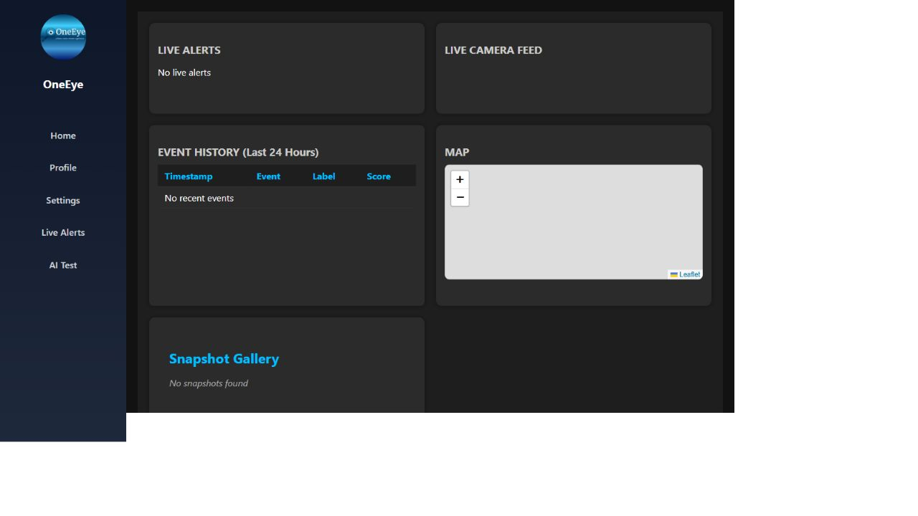
Figure A1. Home route in the empty/backend-unavailable state.
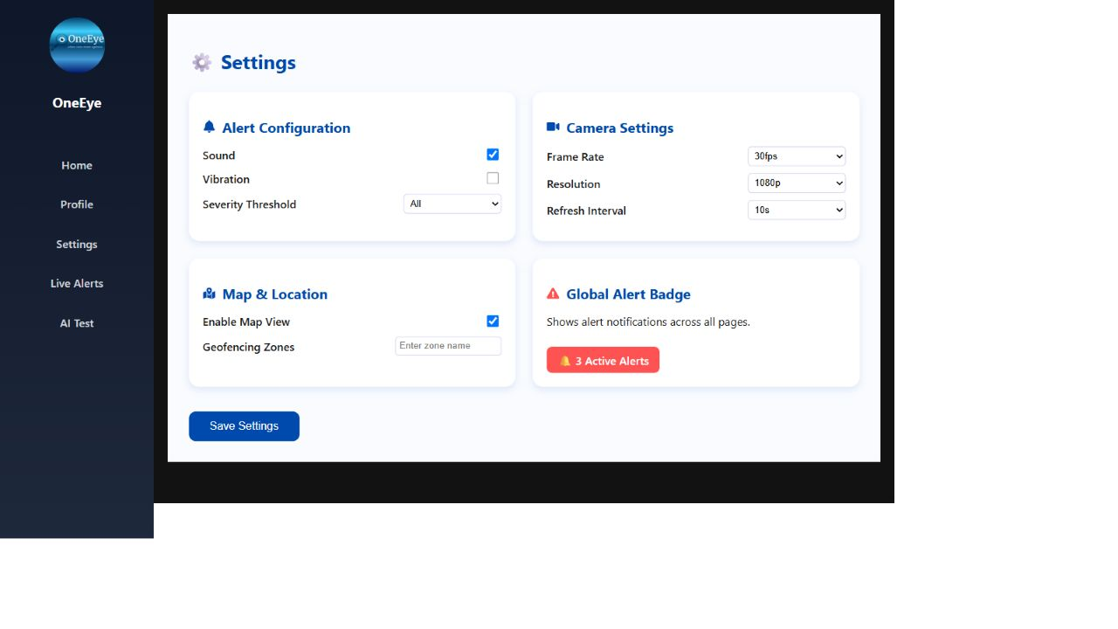
Figure A2. Settings route, showing the intentionally contrasting light visual system and default controls.
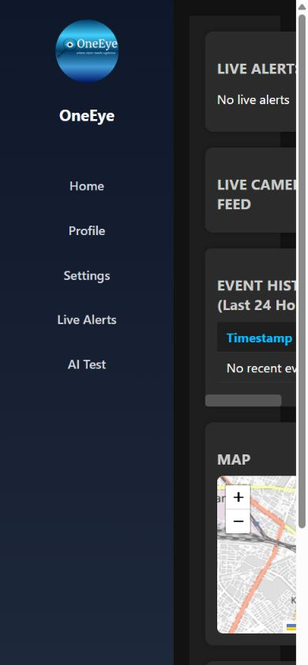
Figure A3. 390×844 viewport: fixed navigation leaves a narrow, clipped content column.

Appendix B — Evidence traceability
Area | Primary repository evidence
Product overview and setup | README.md:1-147; .env.example:1-7; frontend/.env.example:1
Routes and shell | frontend/src/App.js:1-44; App.css:1-69; index.css:1-17
Home | frontend/src/pages/Home.js:1-160; Home.css:1-161; SnapshotGallery.js/css
Alerts | frontend/src/pages/Alerts.js:1-99; Alerts.css:1-73
Profile / Settings | frontend/src/pages/Profile.js/css; Settings.js/css
AI Test | frontend/src/pages/TestAI.js:1-65; README.md:131-137
Backend/API/storage | inference_service/app/main.py:1-347
AI wrapper | inference_service/app/models/wrapper.py:1-211; checkpoint metadata and SHA-256 audit
Dependencies/build | frontend/package.json; package-lock.json; requirements.txt; recorded validation run 27 Aug 2026
Presentation intent | OneEye[1].pptx slides 4-10; inspected slide text and visuals; no speaker-note sources were present

Canonical source link pinned to commit: https://github.com/Raghav-Kumar01/Hackthon_Project_OneEye/tree/bb35a063386db2e59871e515ff60f9d7a437f13d Open source

Appendix C — Presentation-to-product reconciliation
The supplied deck is treated as a product-intent artifact. Its statements do not override the audited code. The crosswalk below records whether each material claim is implemented, partially represented, or requires a new product decision.
Presentation statement | Repository finding | Requirement disposition
Four anomaly families | Accident/fall and phone detectors are wired; fight classifier integration is broken; illegal dumping is absent. | Track A preserves three loaded checkpoints and the defect; Track B repairs fight; illegal dumping is FUTURE.
Real-time preventative warning | Alerts are created only while a client consumes /video_feed and have no delivery channel. | Track B separates inference from viewers; FUTURE notification workflow requires policy and delivery semantics.
High-specificity anomaly scoring | Scores are model outputs with separate 0.2 box and 0.7 CSV gates; no calibration or false-alert study exists. | Do not call scores certainty; validate calibration, precision, recall, and alert burden per event family.
Ten-second pre/post-event clip | Only single annotated JPEG snapshots are stored. | FUTURE clip buffer, event link, integrity, access, retention, redaction, and export requirements.
Facility, law-enforcement and campus users | Repository presents two static Security Guard profiles and no role model. | Use as discovery segments; validate needs and authorization separately.
Roboflow training dataset | No dataset, training script, Roboflow project reference, export manifest, or provenance record is tracked. | Treat as unverified provenance claim; obtain owner evidence before retraining or redistribution.
Pydantic validation | FastAPI is used, but /config accepts a generic dictionary with weak semantic validation. | Track B introduces explicit versioned request/response models and bounded validation.
Temporal plus spatial model | Active wrapper runs independent per-frame YOLO checkpoints sequentially; no temporal model exists. | FUTURE research option, not clone architecture.
Edge, central server, database and cloud clips | Prototype is one local FastAPI process with CSV/JPEG/process memory. | Track C target-architecture option requiring an approved deployment and data design.
100+ cameras and quantified savings | No multi-camera orchestration, capacity test, economics model, study or cited source exists. | Keep as hypotheses until capacity and business-impact validation gates pass.

Secondary source: OneEye[1].pptx, 10 slides supplied 31 Aug 2026. The deck contained no speaker-note citations or study methodology for its quantified claims.

