HOTELPRO
Technical Architecture & System Documentation
MERN Stack · Hotel Booking · Hospitality Operations · Role-Based Access Control
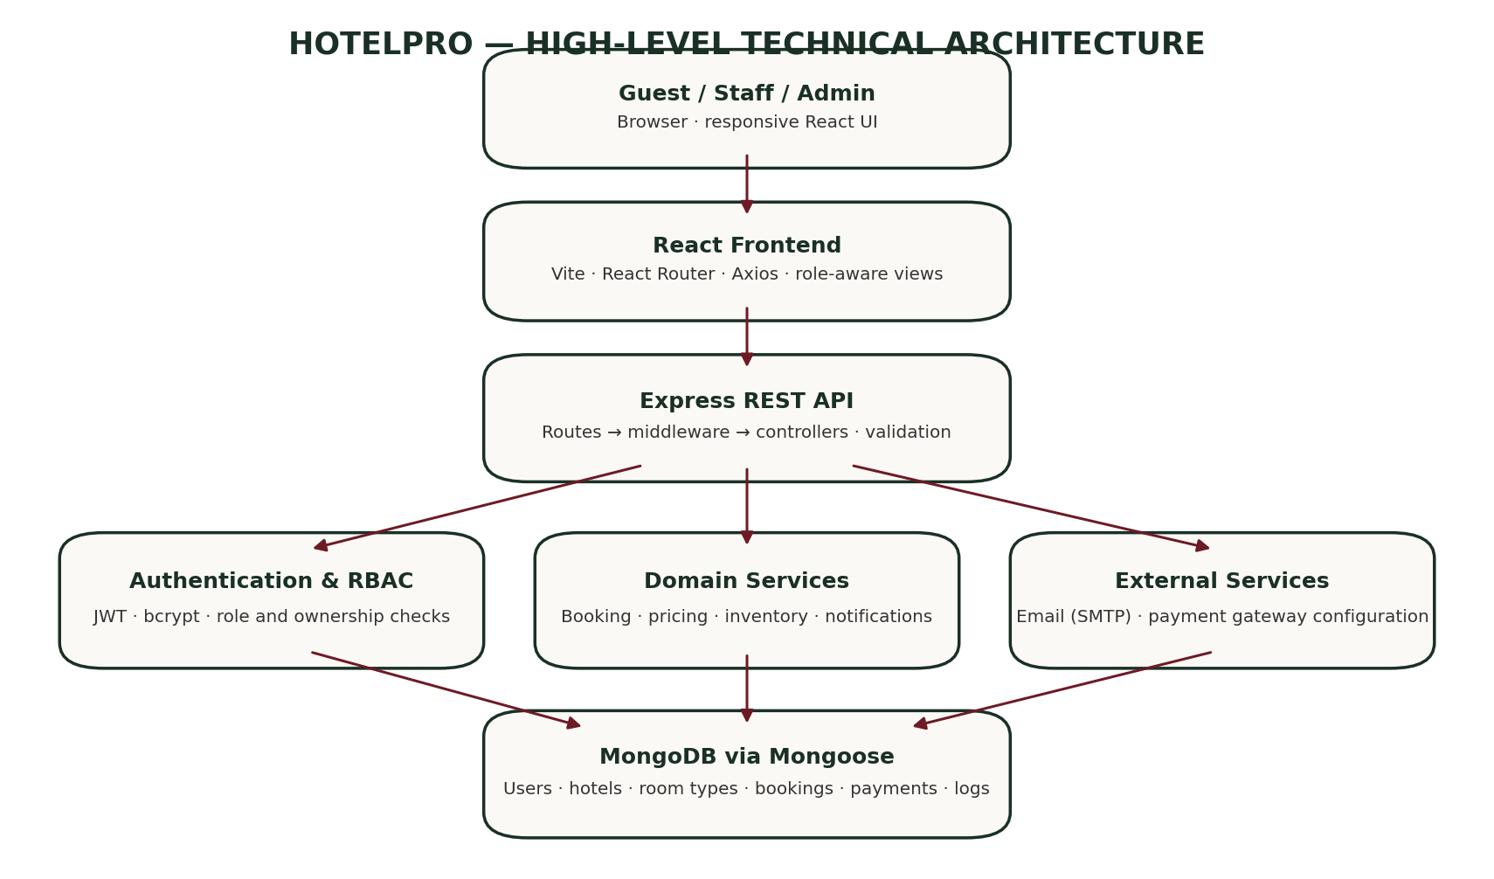
Prepared using the supplied project description and source archive

Document Control
Field | Details
Project | HotelPro — Hotel Booking and Management System
Document type | Technical architecture and system analysis
Primary stack | MongoDB, Express.js, React, Node.js
Document scope | Architecture, data model, modules, roles, workflows, API surface, security, testing and deployment
Implementation basis | User-provided requirements plus inspection of the supplied ANTI(3).zip archive
Important note | The source archive contains branding and payment integration inconsistencies; these are explicitly documented as gaps rather than assumed complete.

Executive Summary
HotelPro is a full-stack hotel booking and management application intended to support public hotel discovery, guest registration, reservations, payments, and hotel operations. The system uses a React-based client, an Express REST API, and MongoDB through Mongoose. Its backend separates routes, middleware, controllers, models, and utility/service logic.
The inspected source contains guest, staff, and administrator experiences; hotel and room-type catalogues; booking and inventory allocation logic; notifications; offers; reviews; favorites; support tickets; service requests; housekeeping tasks; audit logs; and payment-related models and endpoints.
Implementation accuracy note The uploaded archive's active payment controller and client payment modal use Stripe-oriented PaymentIntent flows and INR-to-GBP conversion. Although Razorpay environment variables and compatibility aliases appear in the project, this does not establish a complete Razorpay integration. The document therefore treats Razorpay as a required integration/verification item.

Table of Contents
- 1. Introduction and objectives
- 2. Scope and assumptions
- 3. Technical architecture
- 4. MVC pattern and request lifecycle
- 5. Functional modules and features
- 6. Roles and responsibilities
- 7. Database design and ER relationships
- 8. User flows
- 9. API architecture and endpoint catalogue
- 10. Authentication and security
- 11. Booking, inventory, pricing and payment workflows
- 12. Testing and quality assurance
- 13. Deployment and configuration
- 14. Implementation observations, risks and recommendations
- 15. Conclusion and glossary

1. Introduction and Objectives

1.1 Purpose
This document describes the technical design and functional behaviour of HotelPro. It is intended for developers, reviewers, project evaluators, testers, and maintainers who need to understand how the frontend, backend, database, security controls, and hotel workflows fit together.

1.2 Problem Statement
Manual hotel reservation workflows can create inconsistent availability records, fragmented guest information, slow check-in/check-out operations, and limited visibility into revenue and occupancy. HotelPro aims to centralize these activities through a single web platform.

1.3 Objectives
- Provide a responsive public interface to discover hotels, compare room types, and view prices.
- Allow registered guests to create, view, and cancel eligible reservations.
- Prevent overlapping room allocations and reduce the risk of overbooking.
- Provide hotel staff with operational tools for arrivals, departures, room status, housekeeping, and service requests.
- Provide administrators with hotel/user management, analytics, exports, and audit visibility.
- Protect guest and operational data through authentication, authorization, validation, and secure configuration.
- Integrate a payment provider through a verified server-side payment lifecycle.

1.4 Intended Users
The main actors are visitors, registered guests, hotel staff, and platform administrators. The code also supports assigning staff to a hotel, allowing staff permissions to be scoped to the property they serve.

2. Scope and Assumptions

2.1 In Scope
- Hotel and room-type discovery, hotel details, offers, and room quotes.
- Guest registration, login, email verification, password recovery, and profile management.
- Booking creation, booking history, cancellation, price breakdowns, inventory holds, and invoice-related data.
- Payment intent/order-related API surface, payment status, webhooks, and refund workflow.
- Guest favorites, reviews, notifications, support tickets, and service requests.
- Staff check-in/check-out, room status updates, and housekeeping tasks.
- Admin analytics, user role management, audit logs, and CSV export.

2.2 Out of Scope / External Dependencies
- Real email delivery requires valid SMTP credentials and a reachable email provider.
- Real payment processing requires a correctly configured payment gateway account, keys, webhook endpoint, and gateway-side testing.
- Production deployment requires a managed MongoDB deployment, HTTPS, secret management, backups, monitoring, and hosting configuration.
- Third-party map, geocoding, or image services are not assumed to be fully integrated unless configured in the running environment.

2.3 Design Assumptions
The application is a multi-property system. A hotel contains room types, and room types have inventory. A booking is associated with a guest, hotel, and room type. Check-out dates are treated as exclusive when calculating nights. Password confirmation is a form-validation value and should not be persisted as a separate password field.

3. Technical Architecture
HotelPro follows a client–server architecture. The React application communicates with an Express REST API over HTTP. The API applies validation and authentication middleware, invokes controllers and domain utilities, and reads or writes MongoDB records through Mongoose models.

3.1 Frontend Layer
- React 19 with Vite provides the client application and development/build tooling.
- React Router manages routes such as /stays, /hotel/:slug, /dashboard, /staff, and /admin.
- Axios-based API services centralize requests and attach bearer JWTs where required.
- Authentication and notification contexts provide shared client state.
- Lucide React supplies icons; Recharts is used for dashboard analytics.
- Custom CSS implements the hospitality-oriented visual system and responsive layouts.

3.2 Backend/API Layer
- Node.js runs the server using ES modules.
- Express defines REST endpoints and serves the production client bundle when configured.
- Middleware handles authentication, role restrictions, hotel scoping, request protection, rate limits, CORS, and security headers.
- Controllers orchestrate request validation, business rules, model operations, and HTTP responses.
- Utility modules handle availability, pricing, currency conversion, email, token handling, and catalogue population.

3.3 Data Layer
MongoDB stores application records. Mongoose models define schemas, field constraints, references, indexes, and timestamps. The inspected project has more than three collections; separate collections represent hotels, room types, physical room inventory, bookings, payment records, inventory allocations, users, reviews, and supporting operations.

3.4 External Services
Service | Purpose | Configuration / Status
MongoDB | Persistent application data | MONGODB_URI; local embedded MongoDB fallback is present for non-production evaluation.
Email / SMTP | Verification, reset and transactional email | SMTP_HOST, SMTP_PORT, SMTP_USER, SMTP_PASS and sender configuration.
Payment gateway | Create and verify payment, process refunds | Source currently contains Stripe-oriented active flow; Razorpay requires reconciliation and verification.
Hosting/CDN | Serve client and API in deployment | Environment-specific configuration and HTTPS are required.

3.5 High-Level Request Lifecycle
- A user action triggers a React component or API service request.
- Express matches the request to a route.
- Middleware validates authentication and required permissions.
- The controller validates input and calls relevant models or domain utilities.
- Mongoose executes database operations and applies schema/index rules.
- The controller returns a structured JSON response.
- The client updates the interface and displays success, loading, empty, or error states.

4. MVC Pattern and Request Lifecycle
The backend follows an MVC-inspired separation of concerns. In a REST API, the React frontend is the user-facing view, while Express routes define the API surface. Controllers coordinate the work and Mongoose models represent persisted data.
Layer | Responsibility | Examples in HotelPro
Model | Define database schemas, field validation, references, indexes and persistence. | User, Hotel, RoomType, Booking, Payment, Review, Notification.
View / Client | Present pages and forms, capture user input, and render API responses. | HomePage, StaysPage, HotelDetailsPage, GuestDashboardPage, StaffDashboardPage, AdminDashboardPage.
Routes | Map HTTP method and URL to middleware/controller functions. | authRoutes.js, bookingRoutes.js, hotelRoutes.js, paymentRoutes.js.
Controller | Apply business rules and orchestrate reads/writes. | bookingController.js, paymentController.js, adminController.js.
Middleware | Enforce cross-cutting rules before controller execution. | JWT authentication, role authorization, hotel-scoped staff authorization.
Utilities / services | Reusable domain logic that should not be duplicated across controllers. | availability.js, pricing.js, token.js, mailer.js, currency.js.

4.1 Why MVC Is Useful
- Separation of concerns improves readability and maintainability.
- Controllers can be tested independently from visual components.
- Models centralize data rules and indexes.
- Routes expose a predictable API surface.
- New modules can be added without placing all logic in one file.

5. Functional Modules and Features
Module | Key capabilities
Public website | Home/landing experience, hotel discovery, hotel details, offers, About and Support pages.
Authentication | Registration, login, logout, current-user lookup, profile update, email verification, resend verification, forgot password and reset password.
Hotel catalogue | List hotels, featured hotels, find by slug or ID, create/update hotel for authorized administrators.
Room types and inventory | List room types for a hotel, request a stay quote, create/update room types, track physical room status and allocate room-night inventory.
Bookings | Create pending reservation, list own bookings, retrieve booking by reference/ID with ownership checks, cancel eligible booking.
Payments | Gateway configuration endpoint, create payment intent/order alias, confirm/verify alias, webhook processing, payment status lookup, refund action.
Guest dashboard | Upcoming/past bookings, cancellation, invoice-related view, favorites, reviews, service requests and notifications.
Staff operations | Dashboard metrics, check-in/check-out, room status updates, housekeeping tasks, hotel-scoped service operations.
Administration | Analytics, user listing and role changes, audit logs, booking CSV export, hotel management.
Guest engagement | Reviews, favorites, notifications, offers/coupon validation, support tickets and service requests.

5.1 Public Pages
- Home / welcome page
- Hotel/stay listing page
- Hotel detail page
- Offers page
- About page
- Support page
- Login, registration, email verification and password recovery pages

5.2 Guest Features
- Create a guest account and authenticate using email/password.
- Browse stays and room types and request a date-based price quote.
- Create a reservation after the server validates hotel, room type, dates, capacity, price and inventory.
- View reservation history and inspect booking/payment status.
- Cancel eligible reservations subject to booking status and cancellation policy.
- Save favorite hotels, submit eligible reviews, receive notifications, and raise service requests.

5.3 Staff Features
- View operational metrics and arrivals/departures.
- Check guests in and out after authorization and validation.
- Update physical room status such as available, occupied, dirty or maintenance.
- View and update housekeeping tasks.
- Handle service requests for the assigned property.

5.4 Administrator Features
- View analytics, users, and audit logs.
- Manage user roles and account status subject to backend policy.
- Create and update hotel listings and room types.
- Export booking data to CSV.
- Inspect platform-level operational information.

6. Roles and Responsibilities
Capability | Visitor | Guest | Staff | Admin
Browse public hotels | Yes | Yes | Yes | Yes
Register publicly | Yes | Already registered | No public staff signup | Provisioned securely
Create booking | No | Own bookings | Permitted by API | Permitted by API
View own bookings | No | Yes | As permitted by property scope | Yes
View cross-guest booking | No | No | Assigned property only | Yes
Check-in / check-out | No | No | Assigned property only | Yes
Manage room status / housekeeping | No | No | Assigned property only | Yes
Manage hotels / room types | No | No | No | Yes
Manage users / roles | No | No | No | Yes
View global analytics / audit logs | No | No | No | Yes

6.1 Principle of Least Privilege
Role restrictions must be enforced in the API. Frontend route guards improve navigation and user experience, but they are not a security boundary. Staff access should be limited to the hotel assigned to their account; guests should only access their own reservations and personal records.

6.2 Administrator Provisioning
The project documentation describes a dedicated command-line administrator provisioning script rather than automatically creating a default administrator during server startup. This is safer than shipping a hardcoded admin email/password. Keep administrator credentials out of source control and rotate them if exposed.

7. Database Design and ER Relationships
The database is not limited to User, Room, and Booking. The inspected implementation uses a richer model to support multi-hotel inventory, payment reconciliation, reviews, staff workflows, and auditability.
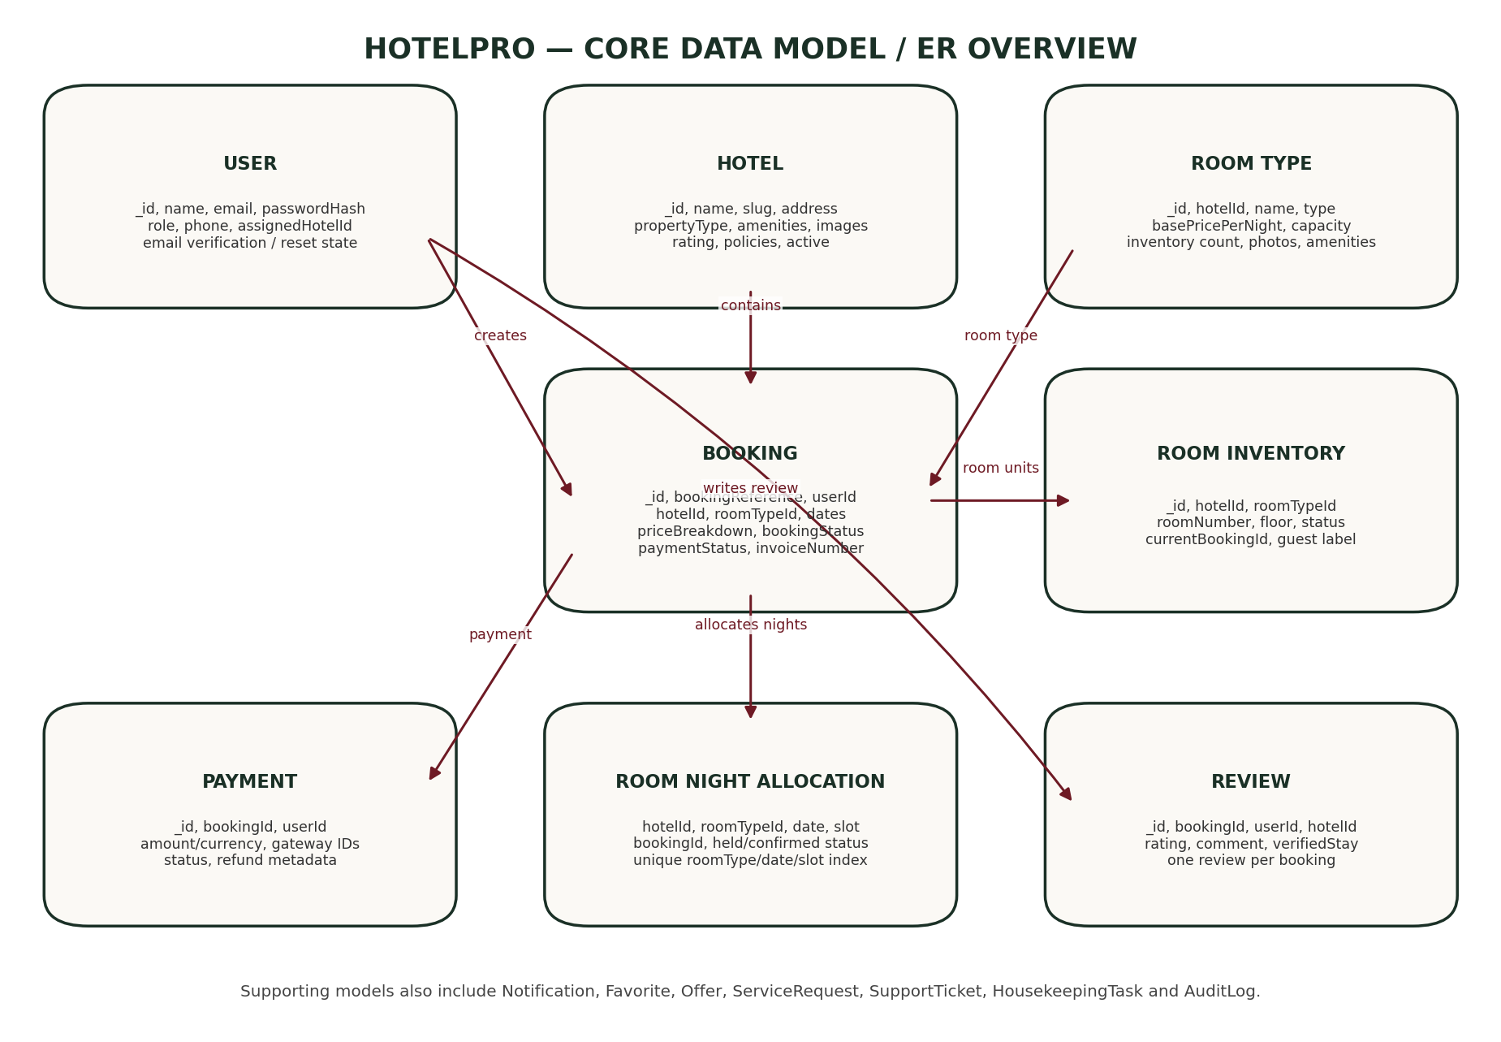

7.1 Core Entities
Entity / Collection | Purpose and important fields
User | name, email, password hash, role (guest/staff/admin), phone, assignedHotelId, isActive, email-verification and password-reset state.
Hotel | name, slug, description, address, coordinates, star rating, property type, amenities, images, check-in/out times, cancellation policy, manager IDs, active flag.
RoomType | hotelId, name/type, base price per night, capacity, total room count, bed type, size, amenities, photos, active flag.
RoomInventory | hotelId, roomTypeId, room number, floor, status, current booking reference, assigned guest label, notes.
Booking | booking reference, userId, hotelId, roomTypeId, dates, room count, guest details, price breakdown, booking/payment statuses, invoice number, cancellation/refund metadata.
Payment | bookingId, userId, amounts/currency, gateway identifiers, payment status, failure/refund metadata, webhook history.
RoomNightAllocation | hotelId, roomTypeId, date, slot, bookingId, allocation status, expiry time; unique index protects each inventory slot per date.
Review | bookingId, userId, hotelId, rating dimensions, comment and verified-stay flag; one review per booking.
Notification | userId, title, message, type, read state and link.
Favorite | user/hotel relationship for saved properties.
Offer | coupon code, discount percentage, maximum discount, minimum booking amount, validity window and active state.
ServiceRequest | guest request, property, status and operational ownership.
SupportTicket | support request and handling information.
HousekeepingTask | hotel, room, task type, assignment and completion state.
AuditLog | actor, role, action, entity, entity ID, details, IP address and timestamp.

7.2 Relationships
Relationship | Cardinality | Explanation
User → Booking | One-to-many | A guest can create multiple reservations; each booking has one owning user.
Hotel → RoomType | One-to-many | A hotel offers multiple room categories.
RoomType → RoomInventory | One-to-many | A room type can have multiple physical room units.
Hotel → Booking | One-to-many | A hotel can have many bookings.
RoomType → Booking | One-to-many | A room type can be reserved by many bookings across non-overlapping dates.
Booking → Payment | One-to-one or one-to-many over retries | Payment records should be associated with the booking and reconciled by gateway identifiers.
Booking → RoomNightAllocation | One-to-many | A multi-night reservation claims an inventory slot for each night.
Booking → Review | Zero-or-one | A completed eligible booking may have one review.
Hotel → ServiceRequest / HousekeepingTask | One-to-many | Operational records are associated with a property.
User → Notification / Favorite | One-to-many | Users can receive notifications and save multiple hotels.

7.3 Data Integrity Rules
- User email must be unique and normalized.
- Password hashes and verification/reset token material must not be included in API responses.
- A room type must belong to the hotel selected in a booking.
- Check-out must be later than check-in; past check-in dates are rejected.
- Requested guest count must not exceed room capacity.
- Server-side pricing is authoritative; client totals are never trusted.
- Inventory allocation uses a compound uniqueness constraint on room type, date, and slot to protect concurrent reservations.
- Booking status and payment status are separate fields and must be reconciled consistently.

7.4 Card Data Handling
Security rule Do not create or persist a CardDetails collection containing raw card number, CVV, or expiry credentials. Payment information should be handled by the payment provider's hosted/secure checkout and only gateway references, statuses, amounts, and permitted metadata should be stored.

8. User Flows

8.1 Guest Booking Flow
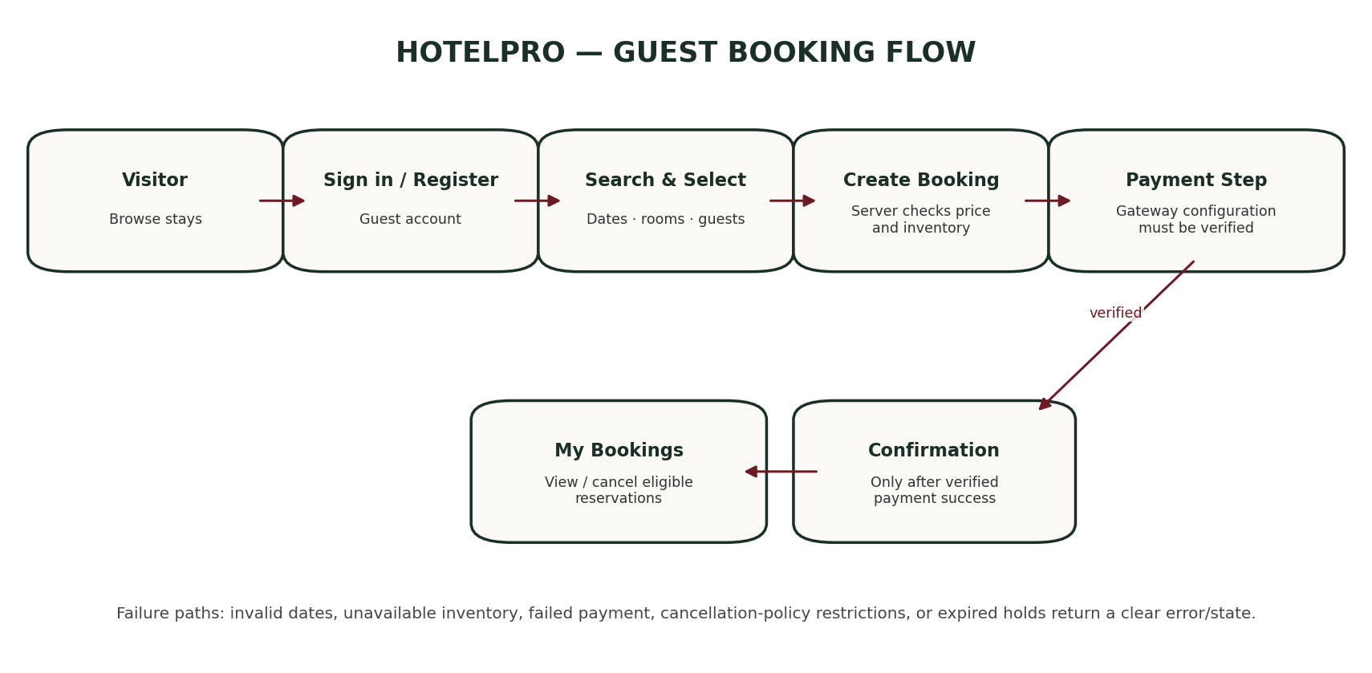
- Visitor opens the home page and browses hotels.
- Visitor signs in or registers as a guest.
- Guest searches by destination and dates, selects a hotel and room type, and checks the quote.
- Backend validates dates, guest capacity, room type ownership, offer eligibility, pricing and inventory.
- A pending booking is created and inventory is held atomically.
- Guest completes payment through the configured provider.
- Server verifies the payment through the provider-specific secure flow and/or signed webhook.
- Booking becomes confirmed only after verified success; failed/expired payment releases held inventory according to policy.
- Guest views the booking reference, invoice information and reservation status in the dashboard.

8.2 Registration and Login
- Registration collects name, email, password, and optional phone details.
- The server validates and normalizes input, hashes the password, and creates a guest account; public registration must not allow users to self-assign admin/staff roles.
- Email verification can be required before selected account actions, depending on configured product policy.
- Login verifies credentials and returns a signed JWT/session response.
- The client uses authentication state to render protected pages; the API independently verifies each protected request.
- Logout clears client session state and invalidates the server session where supported by the implementation.

8.3 Cancellation and Refund
- Guest selects an eligible booking and provides a cancellation reason.
- API checks booking ownership and current booking status.
- Refund eligibility and amount are calculated using the configured cancellation policy.
- Booking is marked cancelled and inventory allocations are released.
- A refund is marked pending when money needs to be returned.
- An authorized operator triggers the provider refund action; the record should remain pending until the gateway confirms the result.

8.4 Staff Check-In / Check-Out
- Staff signs in and accesses the staff dashboard.
- Backend checks staff role and assigned hotel.
- Staff searches/selects an arrival and confirms guest/room details.
- The API validates that the booking is in an eligible state and that the room is operationally available.
- Check-in records the state and timestamp; check-out records departure and enables post-stay operations where appropriate.

8.5 Admin Flow
- Administrator signs in through an authorized account provisioned securely.
- Admin reviews analytics, hotels, users, and audit logs.
- Admin creates or updates hotels and room types, assigns staff, or updates permitted account roles.
- Sensitive changes are validated on the backend and recorded in audit logs.

9. API Architecture and Endpoint Catalogue
The backend exposes JSON REST endpoints under the /api prefix. The catalogue below summarizes route groups observed in the supplied source. Exact request/response schemas should be checked in the corresponding validators and controllers before external API documentation is published.
Route group | Representative endpoints | Purpose / access
Health | GET /api/health | Server health/status.
Authentication | POST /api/auth/register, /login, /logout; GET /me; PUT /profile | Account lifecycle, verification and password recovery. Most account operations require auth as appropriate.
Hotels | GET /api/hotels, /featured, /slug/:slug, /:id; POST/PUT /api/hotels | Public discovery; create/update restricted to admin.
Rooms | GET /api/rooms/hotel/:hotelId; GET /api/rooms/:roomTypeId/quote; POST/PUT /api/rooms | Room discovery/quote; room-type create/update restricted to admin.
Bookings | POST /api/bookings; GET /my-bookings; GET /:reference; PUT /:id/cancel | Create, retrieve and cancel reservations; auth required.
Payments | GET /api/payments/config; POST /create-intent; POST /confirm; POST /webhook; GET /:paymentId/status; POST /refund | Payment lifecycle, webhook, status and refund. Exact provider integration must be reconciled.
Reviews | GET /api/reviews/hotel/:hotelId; GET /my-reviews; POST / | Read reviews and submit eligible reviews.
Favorites | GET /api/favorites/my-favorites; POST /toggle | Guest saved hotels.
Service requests | POST /api/service-requests; GET /my-requests; PUT /:id/status | Guest requests; staff/admin status updates.
Staff | GET /api/staff/metrics; POST /check-in; POST /check-out; PUT /rooms/:roomId/status; GET /housekeeping; PUT /housekeeping/:taskId | Property operations; staff/admin with hotel scope.
Admin | GET /api/admin/analytics; GET /users; PUT /users/:userId; GET /audit-logs; GET /export-bookings-csv | Platform administration; admin-only.
Offers | GET /api/offers; POST /validate | Active offers and coupon validation.
Notifications | GET /api/notifications; PUT /:id/read; PUT /mark-all-read | Authenticated user's notifications.
Support | POST /api/support/tickets; GET /api/support/tickets | Create support ticket; listing restricted to admin.

9.1 API Response Conventions
- Return a meaningful HTTP status code and a predictable JSON shape.
- Use 400 for invalid input, 401 for missing/invalid authentication, 403 for forbidden access, 404 for missing resources, 409 for inventory conflicts, and 500 for unexpected server errors.
- Do not leak stack traces, secrets, password hashes, raw verification tokens, or gateway secret data to clients.
- Use pagination for large collections and validate sort/filter parameters.
- Log correlation-relevant metadata without logging passwords, full payment credentials, or unnecessary personal data.

10. Authentication and Security

10.1 Authentication
- JWTs carry identity and role claims and are validated by authentication middleware.
- Passwords are hashed with bcrypt before persistence.
- The client API service attaches a bearer token to protected requests and handles unauthorized responses.
- Email verification and password-reset flows use time-limited, single-use token patterns according to the project security notes.
- The initial administrator is intended to be provisioned through a controlled CLI workflow, not a public signup option.

10.2 Authorization
- Role checks restrict admin and staff endpoints.
- Booking ownership checks prevent guests from reading or cancelling another guest's booking.
- Hotel-scoped authorization limits staff to their assigned property.
- Sensitive role changes, audit-log access, and global analytics are admin-only.
- Client-side route guards are convenience controls; the API is the final authority.

10.3 Additional Controls
Control | Purpose / notes
Helmet | Adds HTTP security headers.
CORS allow-list | Restricts browser origins to configured client origins.
Rate limiting | Reduces abuse of API and authentication endpoints.
Schema/request validation | Rejects malformed or invalid input before business logic.
Safe error handling | Avoids returning internal stack traces and implementation details.
Audit logging | Records important actions for security review.
Environment variables | Keep deployment-specific configuration and secrets out of source code.
CSV formula neutralization | Reduces spreadsheet formula injection risk in exported reports.
Inventory uniqueness index | Prevents concurrent bookings from claiming the same room-type/date/slot allocation.
Payment webhook verification | Must validate provider signatures using the provider's documented raw-body process.

10.4 Security Limitations to Verify
Security features must be verified against the running configuration. Development fallback secrets, example credentials, simulated payment paths, or an embedded in-memory database must never be treated as production-ready configuration. Ensure .env files are excluded from version control and rotate any real secret that may have been included in a shared archive.

11. Booking, Inventory, Pricing and Payment Workflows

11.1 Availability and Inventory
The project includes a RoomNightAllocation model with a unique compound index across roomTypeId, date, and slot. This is designed to prevent two concurrent reservations from claiming the same inventory slot on the same date. A booking hold should expire when payment is not completed, and released slots should become available for future guests.

11.2 Pricing
The booking controller recalculates price on the server using the room type's base price, check-in/check-out dates, number of rooms, and an eligible offer. The booking stores a price breakdown containing nightly price, night count, room count, base charge, tax, service fee, discount and final amount in INR. The frontend should display the server-provided breakdown rather than calculate a trusted total independently.

11.3 Booking State vs Payment State
Booking status | Meaning
pending_payment | Reservation created; payment has not yet been confirmed.
confirmed | Payment and reservation confirmation requirements have been satisfied.
checked_in | Guest has checked in.
checked_out | Stay has been completed.
cancelled | Reservation cancelled according to permitted workflow.
expired | Pending reservation/hold has expired.

Payment status examples | Meaning
created / pending | Payment initiation or provider result is pending.
requires_payment_method / failed | Payment needs another attempt or failed.
succeeded / captured | Provider confirms successful payment; exact terminology depends on gateway.
refund_pending | Eligible refund has been requested or is awaiting provider confirmation.
refunded / partially_refunded | Provider has confirmed all or part of the refund.

11.4 Razorpay Integration — Required Reconciliation
Current code observation The inspected server payment controller imports Stripe utilities, creates Stripe PaymentIntents, converts INR amounts to GBP, and the client contains a StripePaymentModal. The payment model stores Stripe-specific identifiers. Razorpay environment variables and compatibility fields/route aliases are present, but the active implementation is not a confirmed end-to-end Razorpay Checkout flow.

To meet the stated HotelPro requirement, implement or verify the following before describing Razorpay as complete:
- Replace or deliberately separate the Stripe-specific controller and client modal from the Razorpay flow.
- Create Razorpay orders server-side using the authoritative booking amount in integer paise (INR).
- Return the Razorpay order ID and public key ID to the client; never expose the key secret.
- Verify the Razorpay Checkout signature on the backend using the documented HMAC-SHA256 method.
- Verify webhook signatures against the exact raw request body and process webhook events idempotently.
- Store gateway name, order ID, payment ID, signature-verification result, status and refund references without storing card numbers/CVV.
- Handle duplicate, delayed, failed, cancelled and out-of-order events safely.
- Keep a booking pending until server-side verification confirms success; release inventory on expiry/failure according to policy.
- Test successful payment, wrong signature, duplicate webhook, failed payment, cancellation and refund scenarios using Razorpay test mode.
- Update environment validation and README instructions so they match the actual provider.

11.5 Refund Workflow
The current cancellation controller calculates a potential refund based on the configured policy and marks eligible amounts as pending. The refund controller uses Stripe-oriented refund logic in the inspected source. A production release must align cancellation calculations, payment provider, currency, refund idempotency, and provider status reconciliation. Never display a refund as completed until the gateway confirms it.

12. Testing and Quality Assurance

12.1 Recommended Test Layers
Test layer | Examples
Unit tests | Date/night calculations, price calculation, coupon validation, currency conversion and status-transition rules.
API integration tests | Register/login, protected routes, hotel discovery, quote, booking creation, cancellation, role restrictions and response codes.
Database/concurrency tests | Overlapping reservations, unique room-night allocation, concurrent booking conflicts, cleanup of expired holds.
Payment tests | Valid/invalid signatures, webhook authenticity, duplicate events, failed payments, refund states and amount consistency.
Frontend tests | Form validation, route guards, search filters, loading/error/empty states and responsive behaviour.
End-to-end tests | Register → search → reserve → pay in test mode → confirmation → booking history → cancellation/refund flow.
Security tests | Guest cannot access another guest's booking; staff cannot cross hotel boundaries; non-admin cannot access admin endpoints.

12.2 Existing Test Evidence
The supplied audit report states that the repository contains 58 automated tests across API, security/concurrency, and authentication/provisioning suites, and reports a successful frontend build. These claims are recorded as repository-provided evidence; they were not independently rerun as part of preparing this document.

12.3 Release Acceptance Criteria
- A clean install starts the frontend and backend using documented commands.
- A guest can search and create a reservation with server-calculated pricing.
- Inventory conflict tests prevent overbooking under concurrent requests.
- Role and ownership restrictions are enforced by the API.
- The chosen payment gateway's test flow is verified end-to-end before any production payment claim.
- No secret or raw card data is committed or returned in API responses.
- Mobile, tablet, and desktop layouts have been checked.
- Known limitations are documented rather than hidden.

13. Deployment and Configuration

13.1 Runtime Requirements
- Node.js 18+ is described in the supplied README; Node.js 20 LTS or another currently supported LTS release is preferable.
- npm or pnpm, depending on the chosen lockfile and install workflow.
- MongoDB Atlas or a managed/local MongoDB instance for persistent data.
- Configured environment variables for authentication, CORS, database, email, and the selected payment provider.

13.2 Environment Variables
Variable | Purpose | Required when
PORT | Express server port | Always; default is defined in server configuration.
NODE_ENV | development / test / production | Always.
CLIENT_URL | Allowed client origin / CORS | Always in deployment.
MONGODB_URI | MongoDB connection string | Mandatory in production.
JWT_SECRET | Signing secret for JWTs | Mandatory; use a unique high-entropy value in production.
JWT_EXPIRES_IN | Token lifetime | Optional/configurable.
SMTP_HOST / SMTP_PORT | Mail server address and port | When email delivery is enabled.
SMTP_USER / SMTP_PASS | SMTP credentials | When authenticated SMTP is used.
EMAIL_FROM | Sender identity | When email delivery is enabled.
Payment-provider keys | Provider secret/public key and webhook secret | Must match the actual selected gateway and implementation.

13.3 Deployment Checklist
- Set NODE_ENV=production and configure a managed MongoDB URI.
- Use a unique JWT secret of sufficient length and store secrets in the hosting platform's secret manager.
- Set the exact production CLIENT_URL and enforce HTTPS.
- Provision an administrator through the supported secure workflow.
- Configure payment gateway test keys first; switch to live keys only after successful end-to-end verification and policy review.
- Configure and test email delivery if required.
- Run automated tests and a production frontend build.
- Configure logs, uptime monitoring, backups, database access controls and recovery procedures.
- Verify .env and credential files are excluded from the deployment artifact.

14. Implementation Observations, Risks and Recommendations
Priority | Observation / risk | Recommended action
Critical | Payment integration mismatch: Stripe is active in controller/client, while Razorpay is specified in environment examples and requirements. | Choose one provider for the release. For Razorpay, implement real order creation, signature verification, webhook verification, payment persistence and refund handling; remove misleading Stripe aliases or document them clearly.
High | Branding is inconsistent: source README/server log strings reference “SHREE श्री” while the requested product is HotelPro. | Standardize product name, page title, README, package metadata, server logs, email sender, and documentation.
High | Payment currency path in source converts INR to GBP for Stripe. | For an India-first Razorpay implementation, keep checkout and stored amounts consistently in INR paise/rupees as appropriate; document tax and rounding rules.
High | A demo/simulator payment path may exist for evaluation. | Keep simulation disabled in production, visibly label it in development, and never represent a simulated result as a real gateway transaction.
High | Cancellation and refund state must agree with provider status. | Use idempotent refund requests and webhook/status reconciliation; don't mark a refund complete solely from a local action.
Medium | Embedded in-memory MongoDB fallback is useful for local evaluation but data is not durable. | Require persistent managed MongoDB in production and make development fallback behaviour explicit.
Medium | Public user registration must not permit role self-escalation. | Force the guest role at registration; provision staff/admin through authorized workflows only.
Medium | Source archive is large and contains node_modules and build output. | Exclude node_modules, dist output, .env files and local runtime files from source-control releases; include lockfiles and clean setup instructions.
Medium | Repository audit report contains claims that have not been independently rerun here. | Run tests and build in the intended environment before using the report as current release evidence.

14.1 Suggested Next Steps
- Resolve payment provider choice and make implementation, UI, environment validation and documentation consistent.
- Rename remaining SHREE branding to HotelPro where the product identity requires it.
- Run the test suite and production build from a clean install.
- Exercise guest, staff and admin workflows with separate accounts and verify API authorization directly.
- Test inventory conflicts and payment webhook idempotency before demonstrating the system as production-ready.
- Prepare a short viva demonstration covering architecture, one booking, one staff action, one admin action, and the payment verification flow.

15. Conclusion and Glossary
HotelPro is structured as a modular MERN application with separate client pages, REST API routes, controllers, Mongoose models, authentication middleware, and reusable business utilities. Its design supports guest reservations and hotel operations while incorporating role-based authorization and room-night inventory allocation. The main release-blocking documentation/implementation concern is payment-provider consistency: the requested Razorpay flow must be implemented and verified rather than inferred from environment variable names or legacy route aliases.
Term | Meaning
MERN | MongoDB, Express.js, React, Node.js.
REST API | HTTP-based interface that exposes application resources and actions.
JWT | Signed token used to convey authenticated identity/claims.
RBAC | Role-Based Access Control: permissions are determined by user role and scope.
MVC | Model–View–Controller separation of data, presentation, and request coordination.
Mongoose | ODM library that maps Node.js objects to MongoDB documents and schemas.
Webhook | Server-to-server event notification sent by a payment provider or external service.
Idempotency | Repeated processing of the same request/event does not duplicate the intended effect.
Room-night allocation | A reservation claim for a room inventory slot on a particular night.
CORS | Browser policy that controls which origins may make cross-origin requests.

Appendix A — Source Review Notes
This document was prepared from the project requirements provided in the conversation and a review of the supplied ANTI(3).zip archive. It reflects the source structure and implementation indicators observed in files such as server/src/app.js, server/src/routes, server/src/controllers, server/src/models, client/src/App.jsx, and the repository README/audit notes.
The archive includes implementation-specific references to SHREE श्री and Stripe even though the requested project identity is HotelPro and the stated payment requirement is Razorpay. This document uses HotelPro as the requested project name and explicitly flags the payment mismatch. It does not claim the current source has been fully executed, independently tested, or deployed during document preparation.
Before sharing the project publicly, remove real environment files from the archive, rotate any credentials that may have been exposed, and provide only .env.example with placeholder values.

