Project Design Phase-I
Solution Architecture

Date | 25 October 2026
Team ID | Individual project; official Team ID not provided
Project Name | Global Fuel Prices and Taxation Trends
Maximum Marks | 4 Marks

Solution Architecture:
Solution architecture is a complex process – with many sub-processes – that bridges the gap between business problems and technology solutions. Its goals are to:
- Find the best tech solution to solve existing business problems.
- Describe the structure, characteristics, behavior, and other aspects of the software to project stakeholders.
- Define features, development phases, and solution requirements.
- Provide specifications according to which the solution is defined, managed, and delivered.

Sample Solution Architecture Diagram:
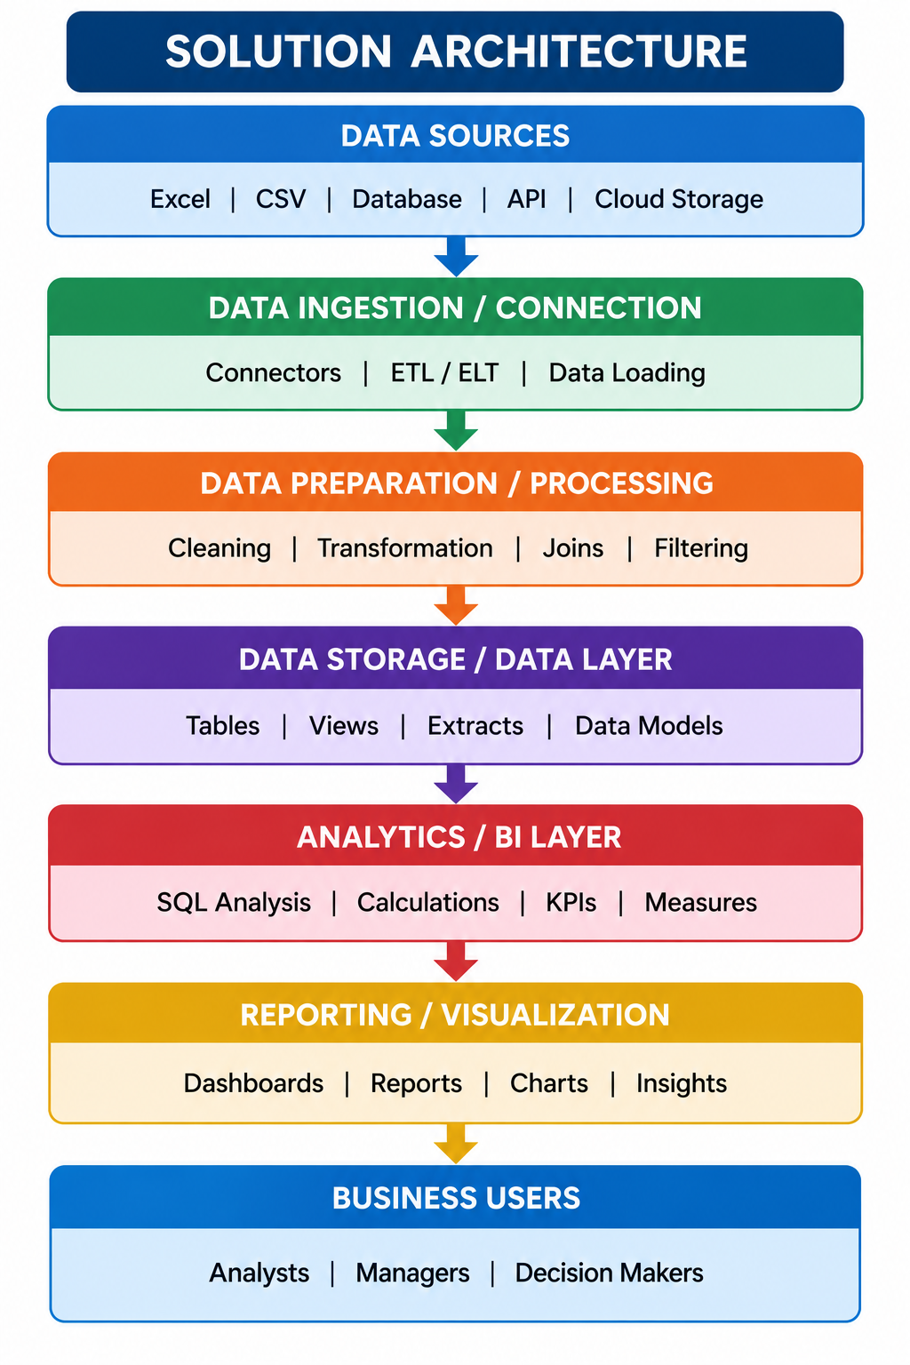

Component Description Table
Component Name | Description / Role in Architecture | Technology Used

Implemented architecture
The current implementation is a file-based analytical workflow. The source CSV is connected to Tableau Desktop; data-quality calculations and visualizations are authored in the workbook; the final dashboard and Story are published separately to Tableau Public; the project website provides a presentation layer with navigation and embedded views/direct links.
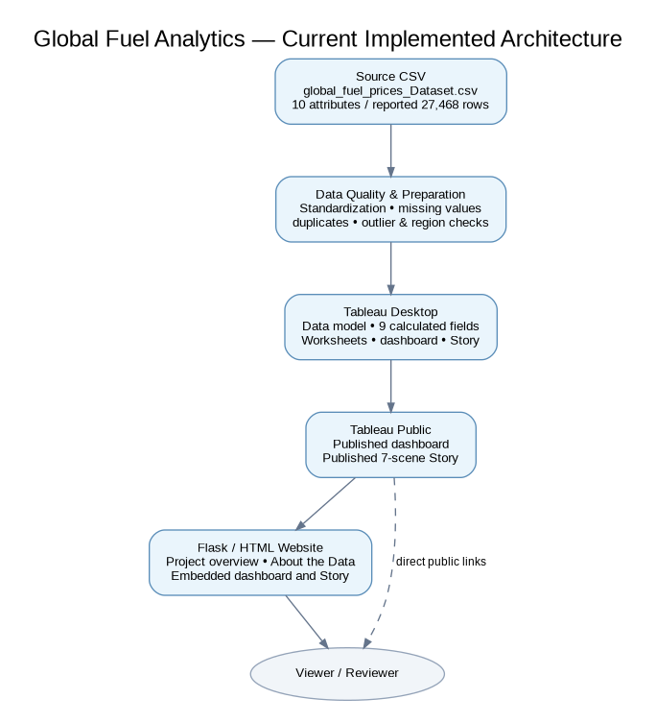
Figure 1. Current solution architecture (CSV → Tableau Desktop → Tableau Public → Flask/HTML presentation).
Component | Responsibility | Current status
CSV source | Stores fuel-price and taxation records | Used by Tableau workbook; external source URL not supplied.
Data quality checks | Flags missing values, possible country-date duplicates, region inconsistencies, outliers, temporal organization and category standardization | Diagnostic worksheets/calculated fields present in workbook.
Tableau Desktop | Builds calculations, sheets, dashboard and Story | Workbook file supplied and inspected.
Tableau Public | Hosts published dashboard and Story | Both public links provided by user and checked.
Flask/HTML interface | Project overview and embedded views/navigation | User has integrated website template and map hero; final local execution is user-verified.

Architecture boundary
No separate Snowflake/MySQL database or production ETL service is evidenced in the delivered workbook. The public views are static as to data freshness until the underlying data is refreshed and the relevant Tableau view is republished.

