
Dashboard Design

Date | 25 October 2026
Team ID | Individual project; official Team ID not provided
Project Name | Global Fuel Prices and Taxation Trends
Maximum Marks | 5 Marks

Activity 1: Interactive and visually appealing dashboards
Creating an effective Streamlit dashboard involves presenting business data stored in Snowflake through clear, interactive, and easy-to-understand visualizations. Students should design the dashboard so that users can quickly understand important KPIs, trends, comparisons, and business insights.
- Clear and Intuitive Layout
- Use Appropriate Visualizations
- Colour and Theming
- Interactive Filters and Slicers
- Drill-Down Capabilities
- Responsive Design
- Custom Visuals and Icons
- Use of Infographics

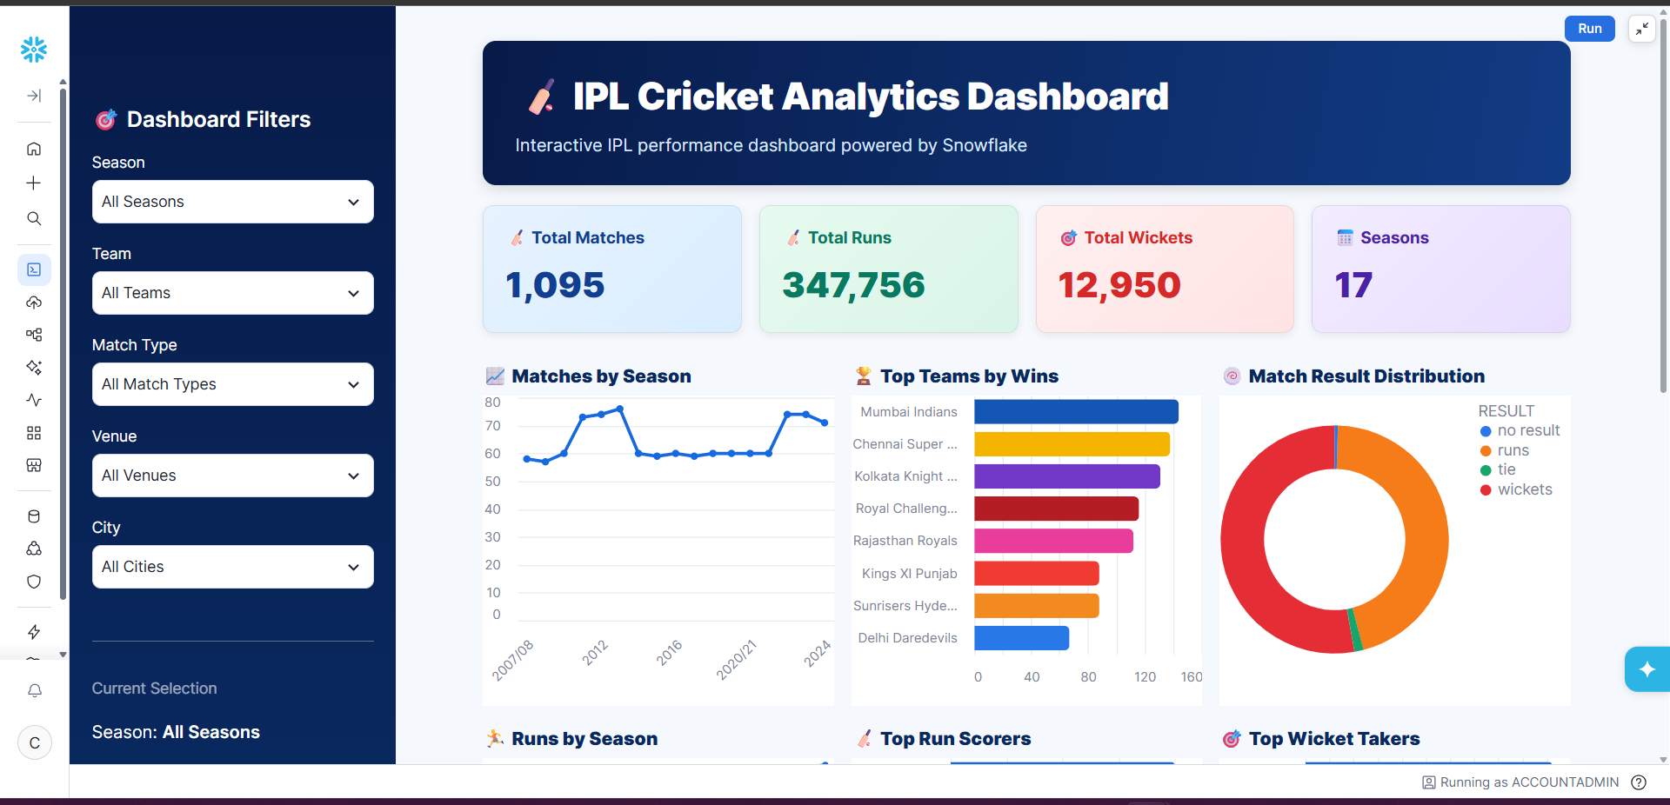
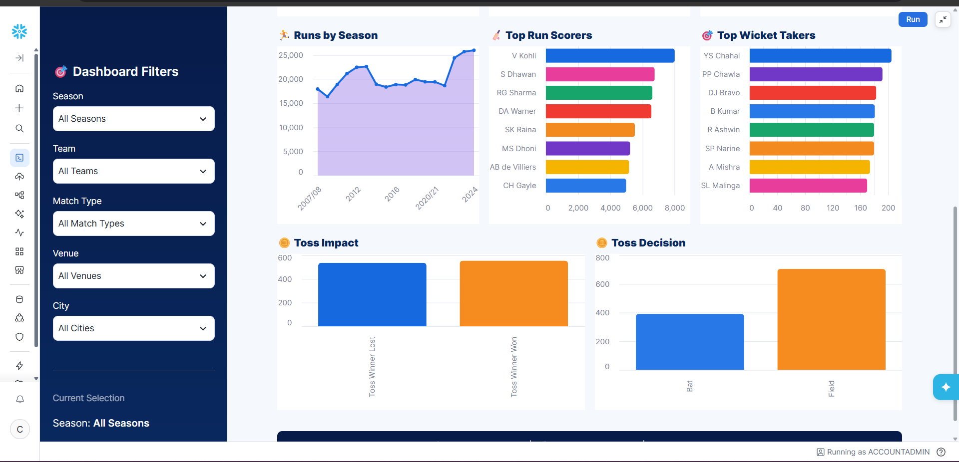
Note: Highlight the major outcomes in form of bullet points
Sample:
Here are five potential outcomes from the dashboard image provided:

- Fielding/toss decisions appear to have an impact on match outcomes
The Toss Impact and Toss Decision charts show differences between winning after winning the toss and choosing to bat vs. field. This can be used to investigate whether the toss provides a meaningful advantage.

Applicability note
Not applicable to the confirmed implementation. This project uses a CSV source with Tableau Desktop/Tableau Public and a Flask/HTML presentation layer. No Snowflake warehouse, Snowflake tables/views, Snowflake SQL scripts, Streamlit-on-Snowflake dashboard, or SQL query-history evidence was supplied. These requirements must not be marked completed unless a separate Snowflake implementation is actually built.

Current project alternative
The equivalent completed work is documented in the Tableau-specific development, dashboard/story, and performance-testing documents included in this pack. Do not substitute sample IPL/Sales examples for the actual fuel-prices project.

