
Dashboard Design

Date | 25 October 2026
Team ID | Individual project; official Team ID not provided
Project Name | Global Fuel Prices and Taxation Trends
Maximum Marks | 5 Marks

Creating an effective dashboard involves thoughtful design to ensure that the presented information is clear, relevant, and easily understandable for the intended audience. Here are some key principles and best practices for dashboard design
Activity 1: Interactive and visually appealing dashboards
Creating interactive and visually appealing dashboards involves a combination of thoughtful design, effective use of visual elements, and the incorporation of interactive features. Here are some tips to help you design dashboards that are both visually appealing and engaging for users so take care of below points
- Clear and Intuitive Layout
- Use Appropriate Visualizations
- Colour and Theming
- Interactive Filters and Slicers
- Drill-Down Capabilities
- Responsive Design
- Custom Visuals and Icons
- Use of Infographics

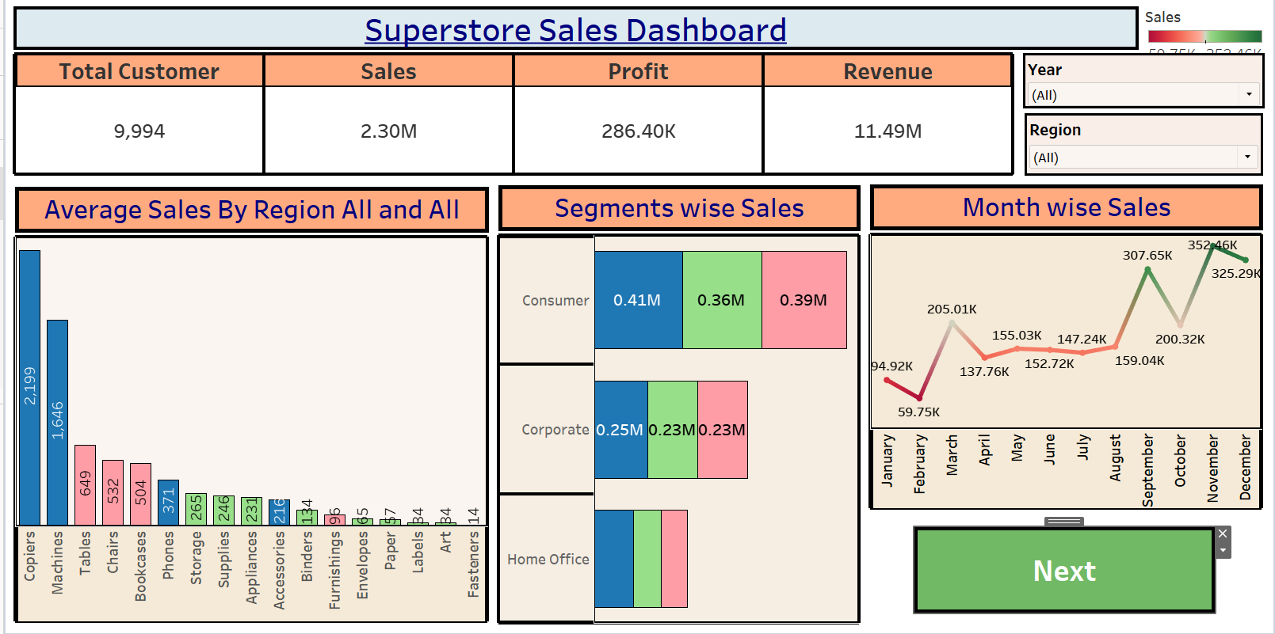
Note: Highlight the major outcomes in form of bullet points

Activity 2
Publish Dashboard on Tableau Public and Paste the Dashboard Public link below:

Dashboard implementation
The final Tableau dashboard combines KPI cards and geographic, temporal, taxation and country-comparison visualizations. The design uses a light-blue background, blue chart panels, dark/navy text, and compact labels. The target is a clear overview first, followed by detailed comparisons.

Design decisions

Clear layout: KPI strip at the top, country maps on the left, time-series views in the center, and taxation/comparison views on the right.

Appropriate visuals: maps for geography, lines for trends, pie chart for a compact regional comparison, bars for ranked country comparisons, and KPI cards for headline values.

Color theme: light blue panels with contrasting text to keep the visual system consistent with the project website.

Interactive filters: Date, Region, Income Level and Subsidy Level were tested and updated relevant charts; the measure/country filter controls were reported as not visible during the separate filter test, so do not claim them as tested controls without rechecking the final view.

Responsive presentation: dashboard is hosted in Tableau Public and embedded within the web page; verify on narrow screens because Tableau layout behaviour depends on the published view sizing.

Diagnostic support: hidden/helper worksheets support data quality checks but should not clutter the main presentation.

Major outcomes

The default dashboard view shown in the supplied screenshot reports average diesel price 2.135 USD/L, LPG 1.715 USD/L, petrol 2.285 USD/L, and average tax percentage 26.77%. These are screenshot-visible values for that displayed state, not independently recomputed aggregates.

The chart set supports comparison of country-level prices, price movements over time, regional tax percentages, and the crude-oil indicator.

The user measured an initial load of 5 seconds, a single-filter response of about 4 seconds, and a two-filter response of about 5 seconds, with all visible visualizations updating correctly and no blank charts/errors observed in that test session.

Published dashboard URL
https://public.tableau.com/app/profile/rudraraj.singh/viz/Global_Fuel_Prices_and_Taxation_Trends/GlobalFuelPricesandTaxationTrendsfinal
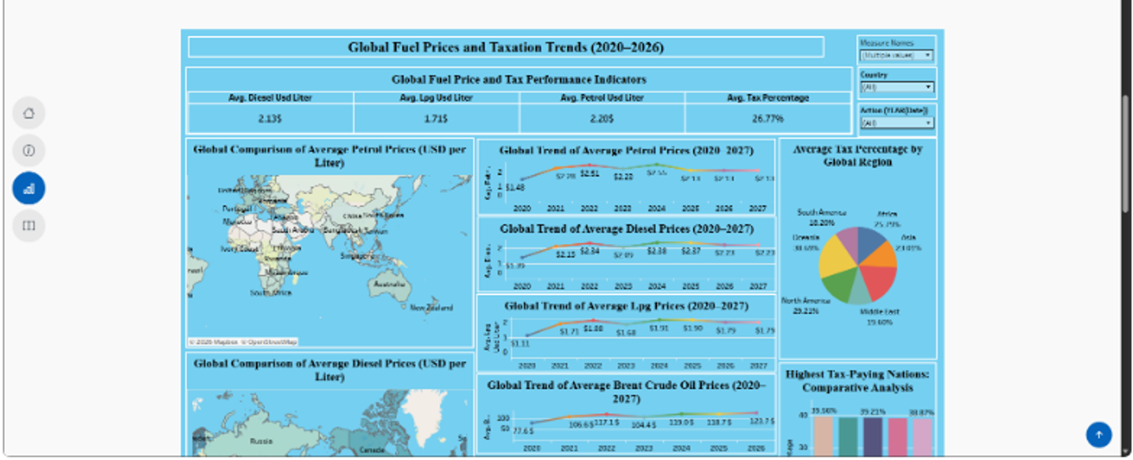
Figure: published dashboard screenshot supplied during project verification.

