
Story

Date | 25 October 2026
Team ID | Individual project; official Team ID not provided
Project Name | Global Fuel Prices and Taxation Trends
Maximum Marks | 5 Marks

By using stories in Tableau, you can effectively communicate complex data in a way that is both interactive and engaging, making it easier for the audience to follow along and understand the insights. It’s a tool for data storytelling, allowing you to present insights in a cohesive, engaging way that takes viewers through a logical progression of findings or analyses.
In Tableau, Story is a feature that allows you to create a sequence of dashboards, visualizations, and text to present data insights in a cohesive and narrative-driven way. It's like a slideshow within Tableau that guides the audience through a series of data points, helping them understand key insights, trends, or outcomes of your analysis.

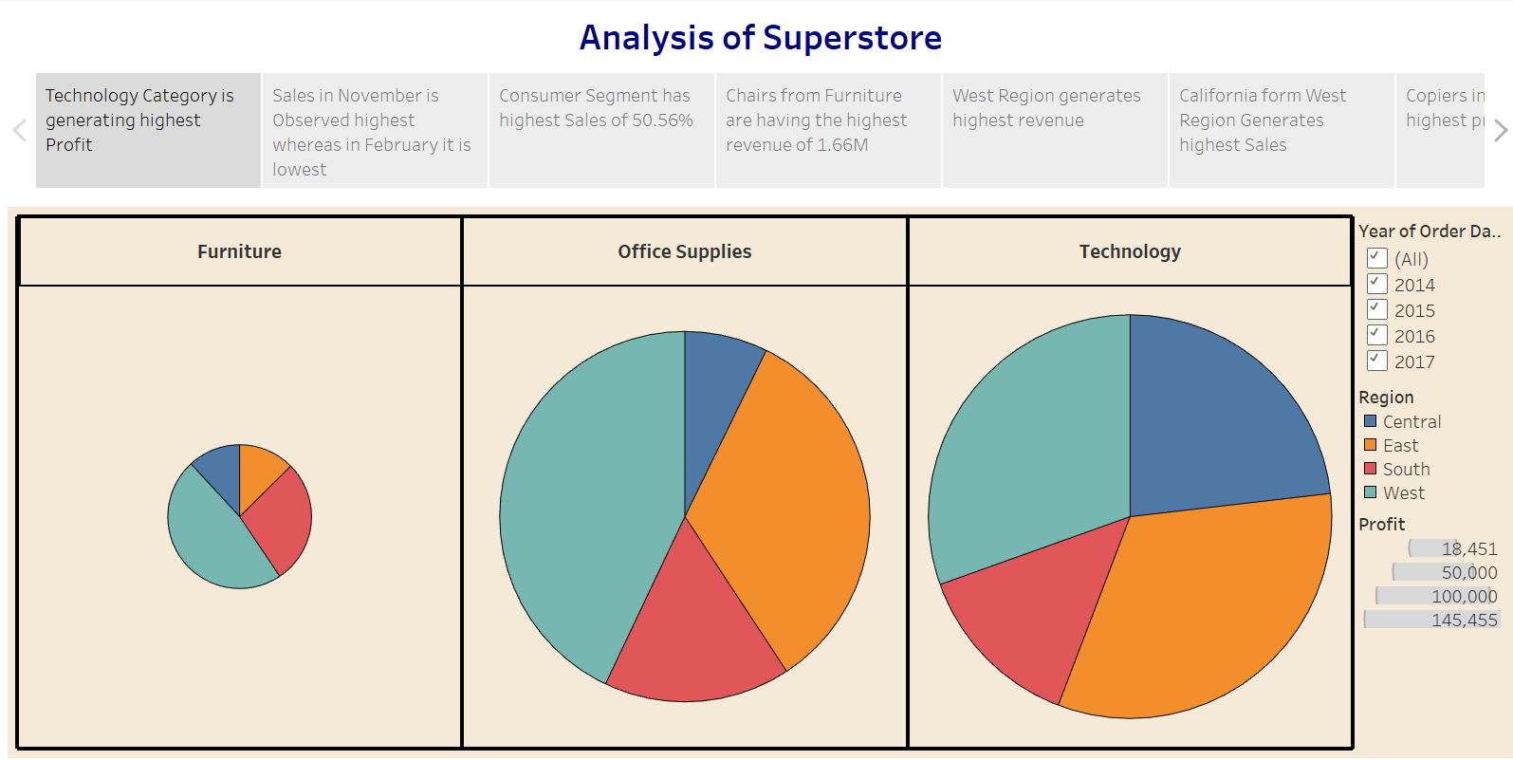

Publish Story on Tableau Public and Paste Public link below

Story narrative structure — seven scenes
Scene | Title / purpose | Content and takeaway
1 | Introduction — problem statement and research question | Explain why cross-country fuel-price and tax comparisons matter; state reported data coverage and core question.
2 | Geographic disparity — global price variation | Use country/region maps to show spatial variation in average petrol and diesel prices.
3 | Temporal trends — price movement over time | Use line charts for petrol, diesel, LPG and crude-price indicators; describe observed changes without causal claims.
4 | Taxation policy — global tax analysis | Compare displayed regional tax-percentage averages and identify geographic differences for further investigation.
5 | Economic impact — income-level comparison | Compare average fuel-price values across income-level categories; the chart snapshot suggested high-income values higher than middle/low categories, which should be interpreted descriptively.
6 | Subsidy assessment — government support analysis | Compare fuel prices across subsidy categories and discuss possible patterns, noting dataset categories alone cannot establish subsidy effects.
7 | Conclusions and recommendations | Summarize geographic and temporal variation; recommend transparent price/tax comparisons and further analysis with verified policy/economic context.

Narrative design principles
The Story follows a problem → evidence → comparison → interpretation → conclusion sequence. Text-only scenes are used for introduction and conclusions where extra charts would repeat the dashboard unnecessarily. The Story is published separately from the dashboard.

Published Story URL
https://public.tableau.com/app/profile/rudraraj.singh/viz/Global_Fuel_Prices_and_Taxation_Trends/Story1

