Global Fuel Prices and Taxation Trends: A Comprehensive Global Performance Intelligence Report
Final Project Report | Tableau and Web Integration
Project: Global Fuel Prices and Taxation Trends | Prepared: 25 October 2026 | Owner: Rudraraj Singh Bhati

Global overview of fuel prices and taxation trends, 2020–2026

Report purpose and scope
This report follows the mentor-provided Final Report Template order. It documents the problem, ideation, requirements, design, planning, Tableau development, testing, results, limitations, conclusion and future scope for the implemented fuel-prices project. Confirmed project details are distinguished from estimates or recommended future work.

Contents
- 1. Introduction
- 2. Ideation Phase
- 3. Requirement Analysis
- 4. Project Design
- 5. Project Planning & Scheduling
- 6. Functional and Performance Testing
- 7. Results and Output Screenshots
- 8. Advantages & Disadvantages
- 9. Conclusion
- 10. Future Scope
- 11. Appendix

1. INTRODUCTION

1.1 Project Overview
Global Fuel Prices and Taxation Trends is a business-intelligence project that uses Tableau to explore cross-country and regional fuel prices, taxation indicators, and trends over time. The published dashboard combines KPI cards, geographic maps, trend charts, tax comparisons and country rankings. A separate Tableau Story organizes the analysis into seven scenes, and a Flask/HTML presentation page provides a project homepage and access to the published views.

1.2 Purpose
The purpose is to transform a large structured dataset into a clear, interactive visual analysis that can be explored without manually scanning thousands of rows. The dashboard helps readers compare measures and categories, while the Story explains the findings in a logical sequence.
Project attribute | Details
Project name | Global Fuel Prices and Taxation Trends
Project owner | Rudraraj Singh Bhati
Implementation focus | CSV + Tableau Desktop + Tableau Public + Flask/HTML presentation layer
Dataset file | global_fuel_prices_Dataset.csv
Coverage | Project-reported: January 2020–April 2026, 84 countries and 7 regions
Dataset size | Project-reported: 27,468 rows, 10 attributes, approx. 2.7 MB
Public dashboard | https://public.tableau.com/app/profile/rudraraj.singh/viz/Global_Fuel_Prices_and_Taxation_Trends/GlobalFuelPricesandTaxationTrendsfinal
Public Story | https://public.tableau.com/app/profile/rudraraj.singh/viz/Global_Fuel_Prices_and_Taxation_Trends/Story1
GitHub repository | https://github.com/rudrarajsingh887/Tableau_viz

2. IDEATION PHASE

2.1 Problem Statement
Fuel-price and tax indicators vary by country, region and time. In a raw CSV, comparing these values manually is slow and can hide regional differences, trends, and category-level relationships. The project question is: how can global fuel-price and taxation data be prepared and presented through an interactive dashboard and guided Story so viewers can explore differences across geography, time, income groups and subsidy categories?

2.2 Empathy Map Canvas
Target users include policy analysts, researchers, students, journalists and informed readers. This persona is a design assumption rather than the outcome of formal interviews.
Empathy area | Likely user need / behaviour
Says | “Which regions have higher fuel prices or tax percentages?” “How have prices changed?”
Thinks | The raw data may contain useful patterns but needs to be summarized consistently.
Does | Changes date/category filters and compares maps, trend lines, tax charts and KPI cards.
Feels | Needs clarity and confidence in the quality of the information.
Pains | Large tables, inconsistent categories, unclear units, and charts that are hard to compare.
Gains | An overview, clear comparisons, interactive exploration and narrative conclusions.

2.3 Brainstorming
Idea | Feasibility | Importance | Decision
Global fuel-price and taxation dashboard | High | High | Selected
Time trends by fuel type | High | High | Selected
Income/subsidy category comparison | High | High | Selected
Crude-oil and petrol comparison | Medium | Medium | Included as context
Predictive forecasting model | Low/medium within scope | Medium | Not part of current implementation

3. REQUIREMENT ANALYSIS

3.1 Customer Journey Map
Stage | User action | Touchpoint | Acceptance goal
Discover | Open homepage and read overview | Flask/HTML site | Project goal, scope and navigation are clear.
Explore | Open dashboard and change filters | Tableau Public embed | Charts render and relevant visualizations update.
Understand/share | Navigate seven scenes and share links | Tableau Story/direct links | Narrative can be followed and published resources open.

3.2 Solution Requirements
Requirement | Implementation / acceptance
Data access | Read the CSV file with 10 fields through Tableau’s data connection.
Data preparation | Quality worksheets/calculated fields for missing values, duplicates, region mapping, standardization, outliers and temporal order.
Analysis | KPI averages, price difference, country/date counts and region/price comparisons.
Outputs | Maps, trend charts, tax comparison, country ranking, dashboard and seven-scene Story.
Interaction | Date, Region, Income Level and Subsidy Level filters; actual behaviour is detailed in the Performance Testing section.
Publishing | Dashboard and Story on Tableau Public, with a website wrapper/navigation layer.

3.3 Data Flow Diagram
The system flow is: source CSV → data-quality checks and standardization → Tableau Desktop calculations and visualizations → published Tableau Public dashboard and Story → Flask/HTML presentation page/direct public URLs → viewer. The implemented version does not include Snowflake, a MySQL database or a separate SQL pipeline.
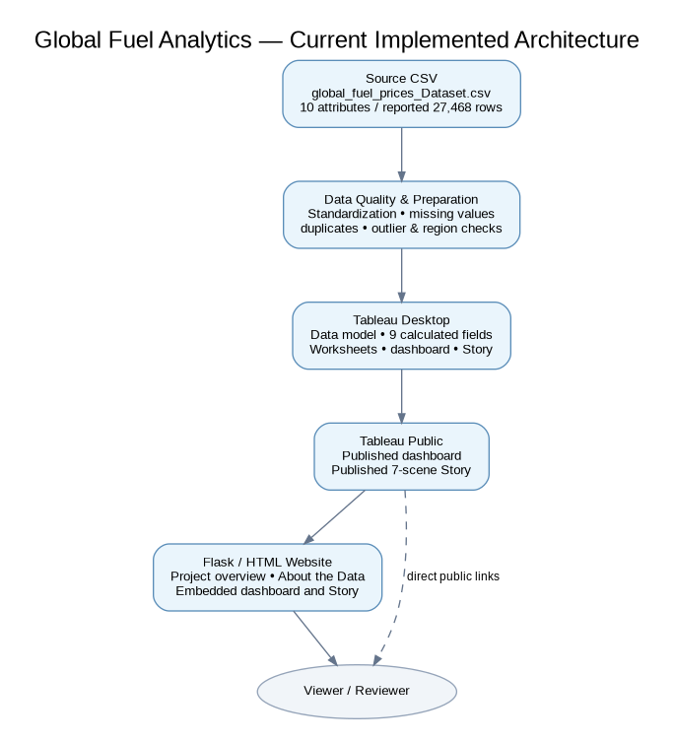
Figure 1. Current solution architecture.

3.4 Technology Stack
Layer | Tool / asset | Role
Source data | CSV: global_fuel_prices_Dataset.csv | Structured records for fuel prices, crude indicator, tax percentage and categories.
Analysis | Tableau Desktop | Connect to data, calculate fields, build checks and charts.
Publishing | Tableau Public | Host the dashboard and Story for public access.
Web presentation | Flask/HTML/CSS/JavaScript | Show project overview and embed/link published views.
Version control | GitHub repository | Repository for project phases; current online entries were observed to be placeholder files and need populated content.

4. PROJECT DESIGN

4.1 Problem–Solution Fit
The solution fits the primary need by replacing manual row-by-row comparison with KPI summaries, maps, time trends and category comparisons. The dashboard supports exploration, while the Story presents a guided narrative. Evidence of fit is technical/functional (published pages and tested filters), not a formal user study or measured business impact.

4.2 Proposed Solution
Connect the CSV to Tableau, inspect data quality, create calculated fields and diagnostic worksheets, assemble the visualization set into a dashboard, create a seven-scene Story, publish both on Tableau Public, then expose the results through a project-focused web page. A dedicated database or automated refresh pipeline is outside the confirmed scope.

4.3 Solution Architecture
The implementation is a file-based Tableau workflow with a thin web presentation layer. Because the Tableau workbook references a local CSV path, any new computer or repository checkout may require the source path to be relinked. Public Tableau views also require network access and data updates must be refreshed and republished as appropriate.

5. PROJECT PLANNING & SCHEDULING
The work was organized as a solo, phase-based project. Historical sprint dates, a formal velocity record, and a burndown chart were not supplied; the following backlog is a retrospective summary rather than a claim of a measured Agile sprint history.
Phase | Main tasks | Deliverables
1. Ideation and scope | Define user problem, scope and analysis questions. | Problem statements, empathy persona and idea selection.
2. Requirements/design | Identify functional requirements, architecture, data flow and stack. | Requirements, user stories and architecture diagram.
3. Development | Inspect CSV; create data-quality checks/calculations; build visuals, dashboard and Story. | Tableau workbook, dashboard and seven-scene Story.
4. Publishing/testing | Publish views; test rendering, filters and web links. | Tableau Public links and performance-test record.
5. Integration/documentation | Embed views in project site; prepare final report and demo. | Web homepage and submission documentation.

6. FUNCTIONAL AND PERFORMANCE TESTING

6.1 Performance Testing

Data rendered
The project-reported source has 27,468 records, 10 attributes and an approximate size of 2.7 MB. In the tested browser session, the dashboard initially loaded in 5 seconds, all visible visualizations rendered, and no blank charts, error messages or endless loading indicators were observed.

Filter utilization
Filter | User-observed result
Date | Updated correctly.
Region | Updated correctly.
Income Level | Updated correctly.
Subsidy Level | Updated correctly.
Country | Not visible during the separate filter test.
Measure/Fuel Type | Not visible during the separate filter test.

Observed response times
Test | Result
Initial load | 5 seconds
Single-filter response | Approximately 4 seconds
Two-filter response | Approximately 5 seconds
Two filters applied | Charts updated correctly
Blank charts/errors | None observed in this session

Calculation fields
Calculated field | Purpose
Rows With Missing Values | Flags rows with any NULL in the ten defined source fields.
Country-Date Record Count | Counts records for each country/date combination using a fixed LOD expression.
Duplicate Country-Date Flag | Flags country/date groups where count exceeds one.
Distinct Regions per Country | Counts distinct region values for each country.
Region Mapping Status | Labels country-region mapping as Review or Consistent based on distinct region count.
Average Fuel Price (USD/L) | Arithmetic mean of petrol, diesel and LPG price fields for each row.
Petrol-Diesel Price Difference (USD/L) | Calculates petrol price minus diesel price.
Unique Countries | Distinct country count.
Unique Dates | Distinct date count.

Visualization and Story count
Nine visualization worksheets were identified as referenced by the final dashboard in workbook inspection; the workbook also contains diagnostic worksheets. The mentor’s supplied visualization description says “9 distinct visualization types” but lists 10 bullets, so the report uses nine final-dashboard visualization worksheets as the count basis and records this wording discrepancy for review. The Story contains seven scenes.

7. RESULTS

7.1 Output Screenshots
The following screenshots were supplied during project verification. They document the published dashboard and the project website overview; final submission should also include a current screenshot of the Flask page showing both embeds in their working state.
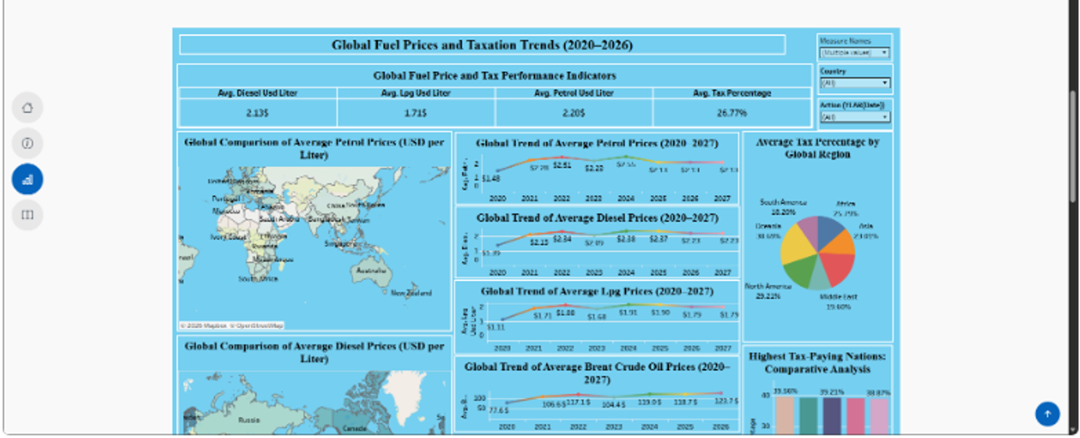
Figure 2. Published Tableau dashboard screenshot (supplied evidence).
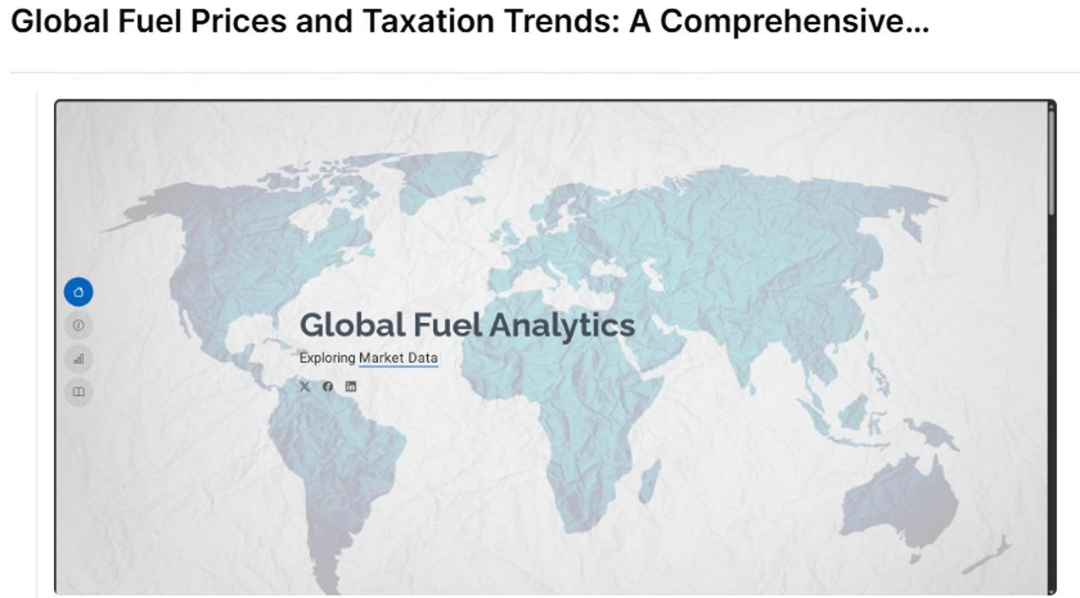
Figure 3. Project website screenshot showing map hero and About the Data section.

Observed default dashboard indicators
Indicator | Displayed value in supplied screenshot | Interpretation note
Average diesel price | 2.135 USD/L | Displayed KPI at captured dashboard state.
Average LPG price | 1.715 USD/L | Displayed KPI at captured dashboard state.
Average petrol price | 2.285 USD/L | Displayed KPI at captured dashboard state.
Average tax percentage | 26.77% | Displayed KPI at captured dashboard state.
These are values visible in a supplied screenshot, not a new independent aggregation. The dashboard screenshot labels some trend charts through 2027 although the source coverage is reported through April 2026; confirm whether 2027 is an axis artifact, placeholder or actual data point before making a strong claim about 2027 in the final presentation.

7.2 Key findings
- The visualizations make geographic differences in petrol and diesel prices easier to compare.
- Time-series views let a reader inspect movement in petrol, diesel, LPG and Brent crude indicators across the selected time range.
- Regional tax-percentage charts show variation among regions; exact rankings should be checked against the unfiltered chart because the screenshot does not make every label legible.
- Income-level and subsidy-level views provide descriptive comparisons across categories; they do not establish causal effects.
- The data-quality worksheets expose potential problems such as duplicate country-date keys, multiple region mappings, outliers, categorical variation and temporal ordering.

8. ADVANTAGES & DISADVANTAGES

Advantages
- Interactive visualization is easier to scan than raw rows.
- Maps and time trends serve different analytical questions.
- A separate seven-scene Story provides narrative context.
- Published Tableau Public links are easy to share.
- Nine calculated fields support data-quality checks and summary calculations.

Disadvantages / limitations
- The original dataset URL and provenance were not provided in the available project materials.
- The workbook connects to a local Windows file path, so the path may need to be updated on another machine.
- The published Tableau Public views are public; they are not appropriate for confidential data.
- Filter controls for Country and Measure/Fuel Type were not visible during the recorded filter test, even though some screenshots show similar controls; re-verify the exact final published view.
- The chart axis appears to include 2027 while reported data ends April 2026; validate that inconsistency.
- Observed timings are single-session timings rather than a formal benchmark across devices or networks.
- No formal causal or econometric analysis was implemented.
- No SQL database, Snowflake warehouse, automated data refresh, or predictive model is evidenced in the current scope.

9. CONCLUSION
The project demonstrates an end-to-end descriptive analytics workflow: define the problem, inspect and prepare a structured CSV, create calculation fields and diagnostic worksheets, build a Tableau dashboard and seven-scene Story, publish the views, and connect them to a web presentation. In the tested browser session, the dashboard loaded in about five seconds, visualizations appeared without observed errors, and single- and two-filter updates completed in about four and five seconds respectively. The solution improves access to comparisons but should be interpreted as a descriptive analytical aid rather than proof of causal policy effects.

10. FUTURE SCOPE
- Record the original dataset source URL, date of download, license and attribution.
- Relink the workbook to a portable path or governed shared data source.
- Verify the time axis and filter visibility on the final published views.
- If required, automate data refresh and quality checks with a documented pipeline.
- Add context variables and carefully scoped statistical analysis if the research question requires causal explanation.
- Conduct repeatable performance tests across more than one browser/device/network.
- Collect feedback from intended users and refine accessibility, labels and chart navigation.
- Deploy the Flask site to a suitable hosting platform if a shareable web URL is required; test it separately from the Tableau Public links.

11. APPENDIX

A. Source fields
Field | Type in workbook | Description
date | Date | Observation date.
country | String | Country.
region | String | Global region grouping.
income_level | String | Income-level category.
subsidy_level | String | Subsidy-level category.
petrol_usd_liter | Real | Petrol price in USD/liter.
diesel_usd_liter | Real | Diesel price in USD/liter.
lpg_usd_liter | Real | LPG price in USD/liter.
brent_crude_usd | Real | Brent crude indicator; unit should be confirmed from source documentation.
tax_percentage | Real | Tax percentage.

B. Public resources
Tableau Public dashboard: https://public.tableau.com/app/profile/rudraraj.singh/viz/Global_Fuel_Prices_and_Taxation_Trends/GlobalFuelPricesandTaxationTrendsfinal
Tableau Public Story: https://public.tableau.com/app/profile/rudraraj.singh/viz/Global_Fuel_Prices_and_Taxation_Trends/Story1
GitHub repository: https://github.com/rudrarajsingh887/Tableau_viz

C. Source code / implementation note
The supplied Tableau workbook is `Global_Fuel_Prices_and_Taxation_Trends.twb`. The Flask/HTML source is maintained locally by the project owner and should be added to GitHub with the required Static assets and instructions. The GitHub repository visible during preparation contains phase folders but several folder entries are empty placeholder files. This documentation package is prepared for manual upload; it has not been pushed to the repository from this session.

D. Dataset source link
The local workbook source is `C:/Users/Rudra/Downloads/global_fuel_prices_Dataset.csv`. The public download/original publisher URL was not included in the supplied materials and must be added by the project owner before final academic submission.

E. Evidence and verification caveats
Dataset size/row count and no-missing-values result are project-reported. Workbook structure, field names, calculated fields and worksheet names were inspected in the provided .twb file. Browser timings and filter outcomes are the user’s observed measurements. Public dashboard and Story URLs were previously verified by opening their Tableau Public pages, and the user confirmed that rendered charts and all seven Story scenes worked in their browser.

