NAND GATE

CASE 1

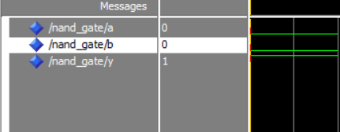

CASE 2

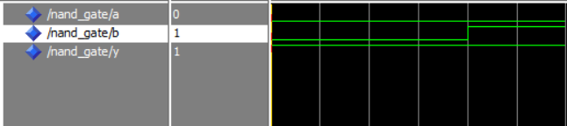

CASE 3

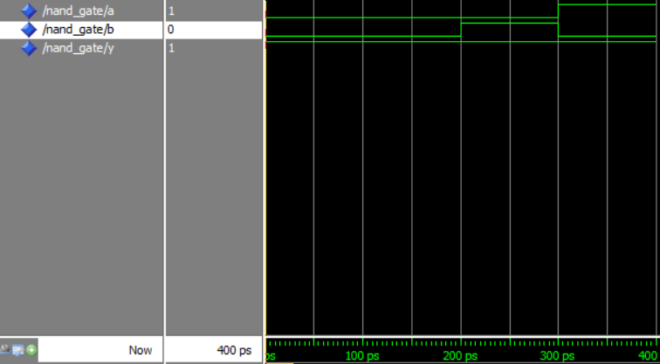

CASE 4

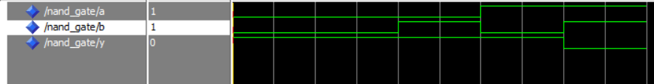

NOR GATE

CASE 1

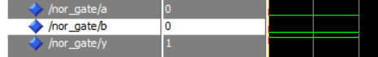

CASE 2

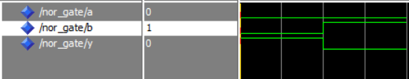

CASE 3

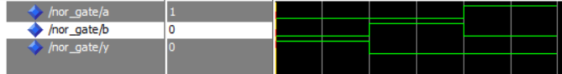

CASE 4

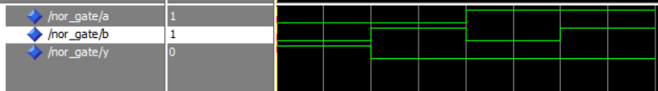

EXOR GATE

CASE 1

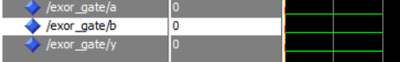

CASE 2

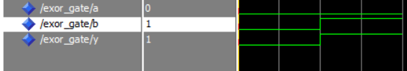

CASE 3

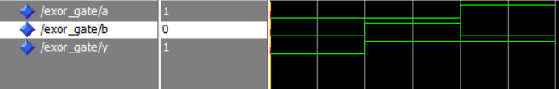

CASE 4

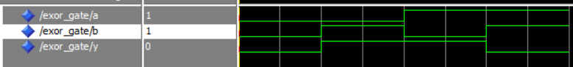

EXNOR GATE

CASE 1

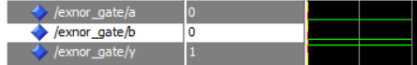

CASE 2

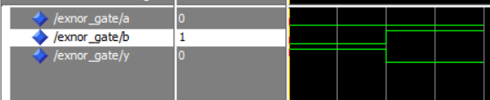

CASE 3

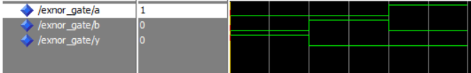

CASE 4

