Task 1: Grade Checker
1. Objective
The objective of this task is to create a Python program that accepts marks from the user and displays the corresponding grade using conditional statements (if, elif, and else).
2. Concepts Used
- input() – To accept marks from the user.
- int() – To convert the input into an integer.
- if – To check the first condition.
- elif – To check multiple conditions.
- else – To execute when none of the previous conditions are true.
- or – To check whether marks are greater than 100 or less than 0.
3. Program Explanation
First, the program takes marks as input from the user.
It then checks the entered marks using conditional statements:
- 90 or above: Grade A
- 80 to 89: Grade B
- 70 to 79: Grade C
- 60 to 69: Grade D
- Below 60: Grade F
If the user enters marks below 0 or above 100, the program displays "Invalid input".

4. Screenshots
Screenshot 1: Python Program and Execution
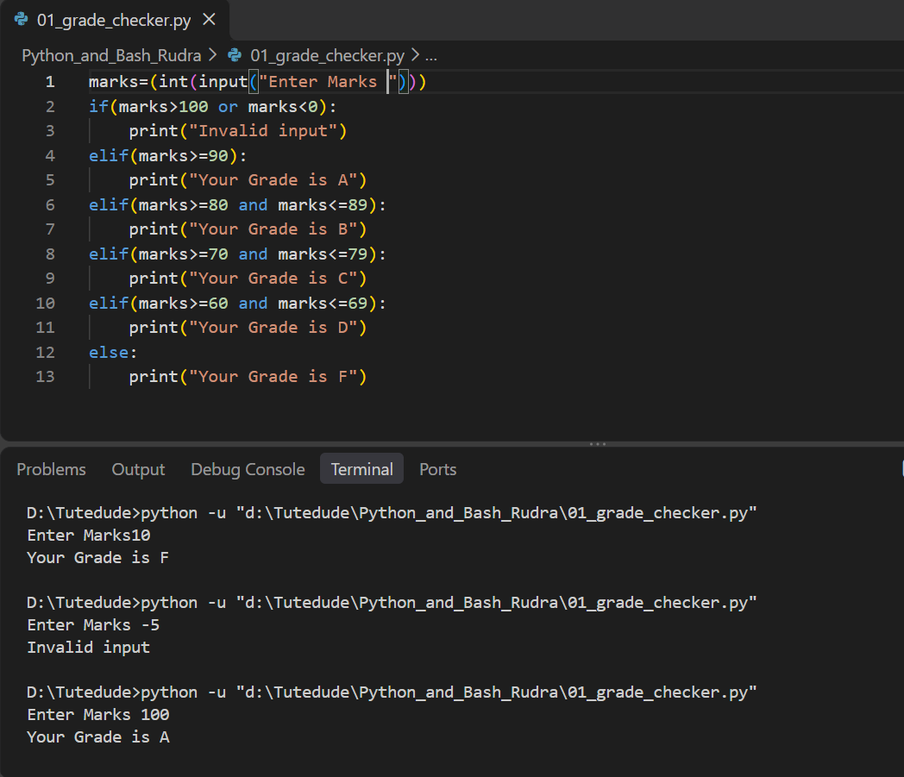
5. Test Results
Input Marks | Expected Output
100 | Grade A
85 | Grade B
75 | Grade C
65 | Grade D
40 | Grade F

Task 2: Student Grades Management System
1. Objective
The objective of this task is to create a Python program that stores student names and their grades using a dictionary. The program allows users to add new students, update existing student grades, and display all student records.
2. Concepts Used
- Dictionary: Used to store student names as keys and grades as values.
- While Loop: Used to display the menu repeatedly until the user exits.
- If-Elif-Else: Used to perform different operations based on the user's choice.
- Input(): Used to accept student names, grades, and menu choices.
- Membership Operator (in): Used to check whether a student already exists.
- Dictionary Items (.items()): Used to access and display all student names and grades.
- Break: Used to terminate the menu loop when the user selects Exit.
3. Program Explanation
First, a dictionary is created with three initial student records: Raj, Meet, and Sujal.
The program displays a menu with four options:
- Add Student: Accepts a student name and grade. Before adding, it checks whether the student already exists in the dictionary. If the student exists, it displays an appropriate message. Otherwise, the new student is added.
- Update Student Grade: Accepts the student's name and checks whether the student exists. If found, the program accepts a new grade and updates the existing record. Otherwise, it displays a message that the student does not exist.
- Display All Students: Uses the dictionary items() method to display all student names and their grades.
- Exit: Uses the break statement to terminate the while loop and exit the program.
A while loop keeps displaying the menu until the user selects the Exit option.
4. Screenshots
Screenshot 1: Python Source Code
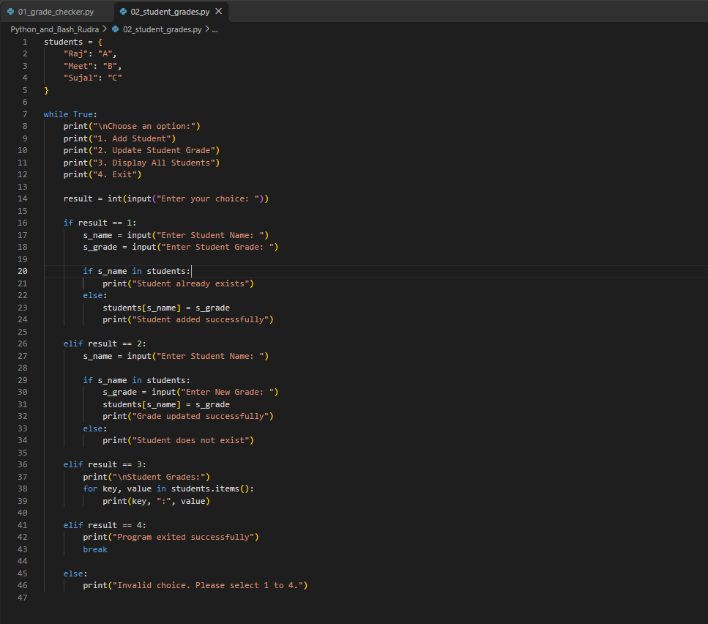
Screenshot 2: Adding and Displaying Students
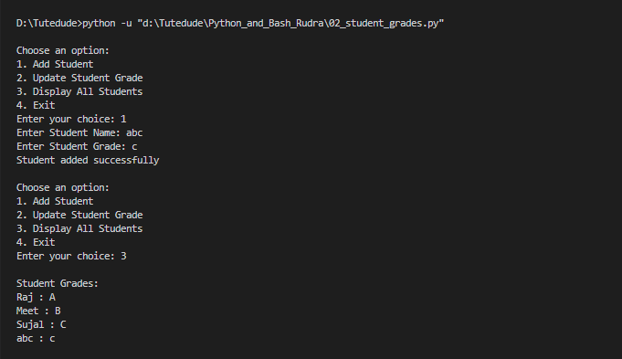
Screenshot 3: Updating Student Grade
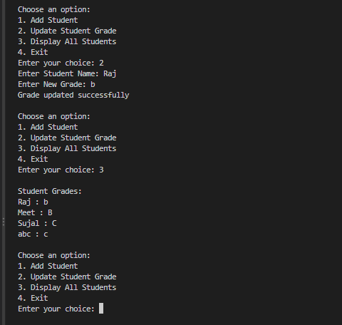
5. Test Results
Test Case | Operation | Result
1 | Add student abc with grade C | Successful
2 | Display all students | Successful
3 | Update Raj's grade from A to B | Successful
4 | Display updated student records | Successful

Task 3: Write to a File
1. Objective
The objective of this task is to create a text file and write some content into it using Python file handling functions such as open() and write().
2. Concepts Used
- open(): Used to open or create a text file.
- w+ Mode: Opens a file for both reading and writing. It creates the file if it does not exist and overwrites existing content.
- write(): Used to write text into the file.
- if-else: Used to check whether the writing operation was successful.
- seek(0): Moves the file cursor to the beginning of the file.
- read(): Reads the content stored in the file.
3. Program Explanation
First, the program opens a text file named student_data.txt using the open() function in w+ mode.
Next, the write() function writes the text "Hello World" into the file.
The program stores the return value of the write operation in a variable and uses an if-else statement to check whether the content was written successfully.
After writing the content, the seek(0) function moves the file cursor back to the beginning of the file.
Finally, the read() function reads the file content and displays it in the terminal.

4. Screenshots
Screenshot: Python Source Code and Terminal Execution
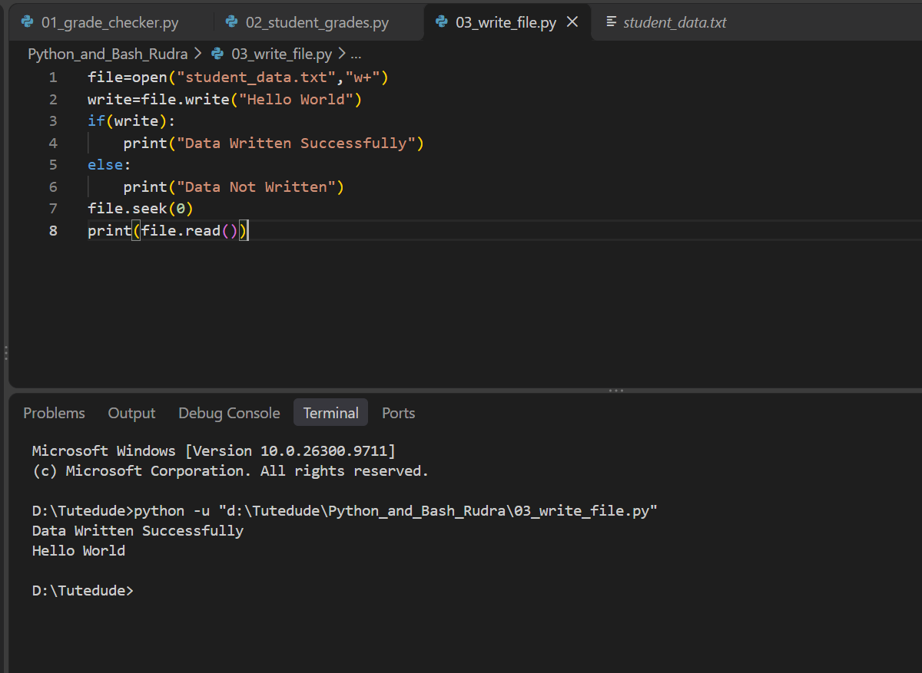

Task 4: Read from a File
1. Objective
The objective of this task is to open an existing text file, read its content using Python's file handling functions, and display the content in the terminal.
2. Concepts Used
- open(): Used to open an existing file.
- Read Mode (r): Used to open a file for reading only.
- read(): Used to read the complete content of a file.
- print(): Used to display the file content in the terminal.
- close(): Used to close the file after reading.
3. Program Explanation
First, the program opens an existing text file named student_data.txt using the open() function in read mode (r).
Next, the read() function reads the complete content of the file and stores it in a variable named data.
The print() function displays the stored content in the terminal.
Finally, the close() function closes the file after completing the reading operation.

4. Screenshots
Screenshot: Python Source Code and Terminal Execution
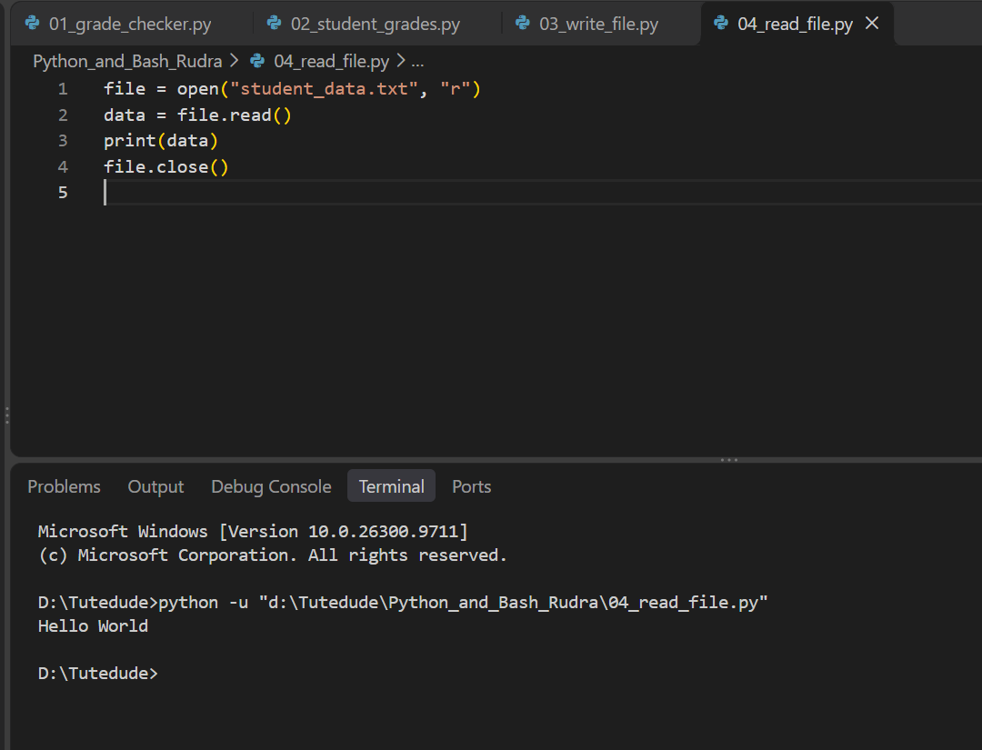

GitHub Repository
Project Name: Python and Bash Assignment
GitHub Repository: https://github.com/rudrashah1802/Python_and_Bash
The GitHub repository contains the complete source code and project files for all four assignment tasks.

