Visitor Management System
Comprehensive Project Documentation

Abstract
The Visitor Management System automates visitor registration, appointment approval, entry requests, gate pass generation, QR-based validation, check-in/check-out and reporting.

Introduction
The system replaces manual visitor registers with a secure digital workflow.

Objectives
Improve security, track visitors, automate approvals and maintain complete visitor history.

Scope
Used by Receptionists, Security Guards, Employees and Administrators.

Technology Stack
ASP.NET Core MVC, Entity Framework Core, PostgreSQL, Bootstrap, JavaScript, QR Code integration.

Modules
User Master, Role Master, Role Rights, Department Master, Employee Master, Visitor Master, Appointment Management, Entry Request Management, Visit Entry Management, Gate Pass Management and Reports.

Entity Relationship Diagram
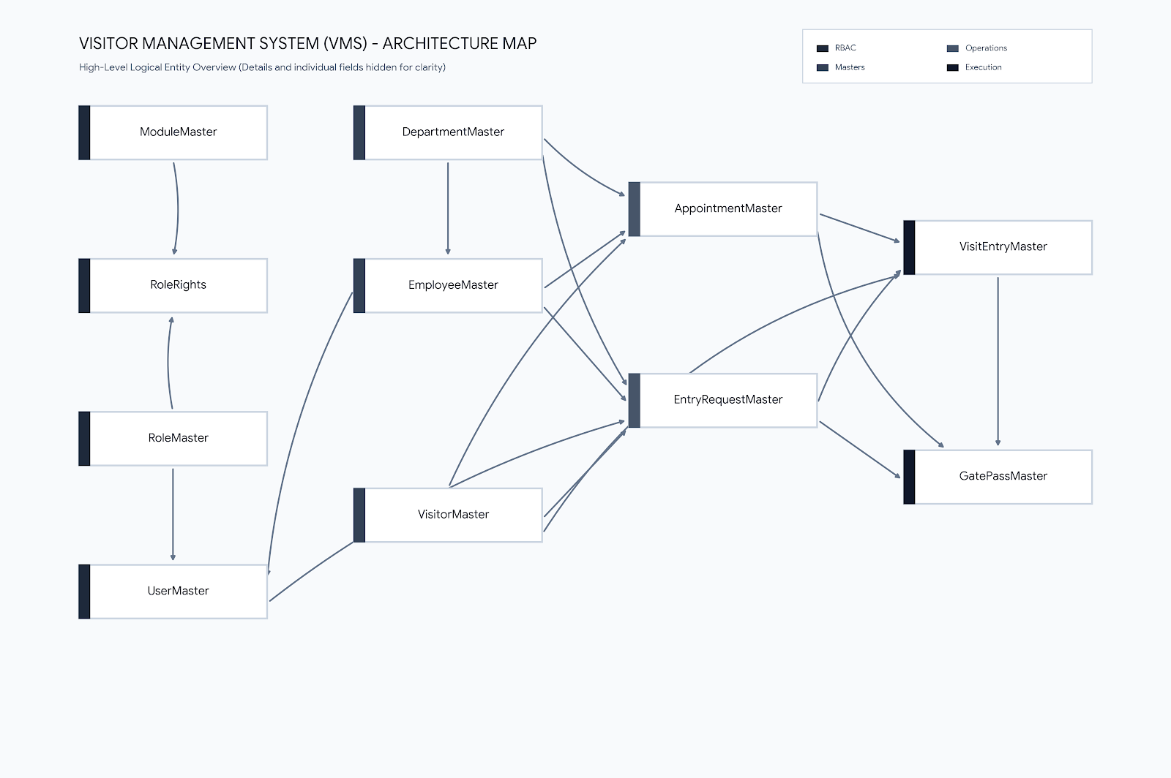

Database Tables

AppointmentMaster
Columns: AppointmentId, VisitorId, DepartmentId, EmployeeId, AppointmentDate, AppointmentTime, Purpose, Remarks, Status, CreatedDate

DepartmentMaster
Columns: DepartmentId, DepartmentName, Description, Status, CreatedDate

EmployeeMaster
Columns: EmployeeId, EmployeeCode, FirstName, LastName, Gender, Designation, Email, MobileNumber, Status, CreatedDate, DepartmentId

EntryRequestMaster
Columns: EntryRequestId, VisitorId, DepartmentId, EmployeeId, Purpose, RequestDateTime, ApprovalStatus, ApprovalRemarks, ApprovedByEmployeeId, ApprovalDateTime, CreatedByUserId, CreatedDate

GatePassMaster
Columns: GatePassId, GatePassNumber, VisitEntryId, VisitorId, EmployeeId, DepartmentId, IssueDateTime, ExpiryDateTime, QRCodePath, Status, CreatedDate, EntryRequestId, AppointmentId

ModuleMaster
Columns: ModuleId, ModuleName

RoleMaster
Columns: RoleId, RoleName, Description, Status, CreatedDate

RoleRights
Columns: RoleRightId, RoleId, ModuleId, CanView, CanAdd, CanEdit, CanDelete

UserMaster
Columns: UserId, Username, FullName, Email, MobileNumber, Password, RoleId, Status, CreatedDate, LastUpdatedDate, EmployeeId

VisitEntryMaster
Columns: VisitEntryId, AppointmentId, VisitorId, EmployeeId, DepartmentId, CheckInTime, CheckOutTime, VisitStatus, Remarks, CreatedDate, EntryRequestId

VisitorMaster
Columns: VisitorId, FirstName, LastName, Gender, MobileNumber, Email, Address, City, State, CompanyName, PhotoPath, IdProofType, IdProofNumber, Status, CreatedDate, LastUpdatedDate

System Analysis
Detailed discussion of System Analysis for the Visitor Management System.

Feasibility Study
Detailed discussion of Feasibility Study for the Visitor Management System.

Functional Requirements
Detailed discussion of Functional Requirements for the Visitor Management System.

Non Functional Requirements
Detailed discussion of Non Functional Requirements for the Visitor Management System.

Role Based Access Control
Detailed discussion of Role Based Access Control for the Visitor Management System.

Appointment Workflow
Detailed discussion of Appointment Workflow for the Visitor Management System.

Entry Request Workflow
Detailed discussion of Entry Request Workflow for the Visitor Management System.

Gate Pass Workflow
Detailed discussion of Gate Pass Workflow for the Visitor Management System.

QR Validation
Detailed discussion of QR Validation for the Visitor Management System.

Testing Strategy
Detailed discussion of Testing Strategy for the Visitor Management System.

Security Features
Detailed discussion of Security Features for the Visitor Management System.

Conclusion
Detailed discussion of Conclusion for the Visitor Management System.

Future Scope
Detailed discussion of Future Scope for the Visitor Management System.

