An Internship Report
Of
Artificial Intelligence
Submitted
To
School of Computer Science and Engineering
IILM University, Greater Noida, U.P.
In partial fulfilment of the requirement of degree of
B.Tech (CSE - Artificial Intelligence & Machine Learning)

By
Roll Number of Student:- 25SCS1003003601
Name of Student: RUDRA AKASH
Batch: 2025-29

CANDIDATE'S DECLARATION
I, RUDRA AKASH, do hereby declare that the internship report titled "Artificial Intelligence" has been completed by me to fulfil the requirement for the award of the degree of Bachelor of Technology in Computer Science and Engineering (Artificial Intelligence & Machine Learning). All the references have been quoted and I have not taken as such any material from any other source. I affirm that this report is my own and has not been submitted to any other institute for any degree/diploma requirement, and further I shall be solely responsible for any kind of copyright violation in this regard.
Signature:-
Student Name: RUDRA AKASH
Roll No.: 25SCS1003003601

ACKNOWLEDGEMENT
I am using this opportunity to express my gratitude to everyone who supported me throughout the Internship Program. I am thankful for their aspiring guidance, invaluably constructive criticism and friendly advice during this work. I am sincerely grateful to them for sharing their truthful and illuminating views on a number of issues related to this work.
I would like to thank the CodSoft Team for providing me the opportunity and the structured platform to learn and gain hands-on exposure in the domain of Artificial Intelligence. I am also thankful to my institute, IILM University, Greater Noida, and the faculty of the School of Computer Science and Engineering for their continuous support and encouragement.
I express my gratitude to my parents for their blessings.
Signature:
Student Name: RUDRA AKASH
Roll No.: 25SCS1003003601

TABLE OF CONTENTS
1. Candidate's Declaration i
2. Acknowledgement ii
3. Internship Completion Certificate -
4. Project Description 1
4.1 Introduction 1
4.2 Organization Profile 2
4.3 Problem Statement 2
4.4 Project Objectives 3
4.5 Scope of the Project 3
4.6 Technologies and Tools Used 4
4.7 Task-wise Project Work 4
4.8 Methodology 7
4.9 Expected Outcomes 8
4.10 Certificate of Completion 8
5. Bibliography/References 9

3. INTERNSHIP COMPLETION CERTIFICATE
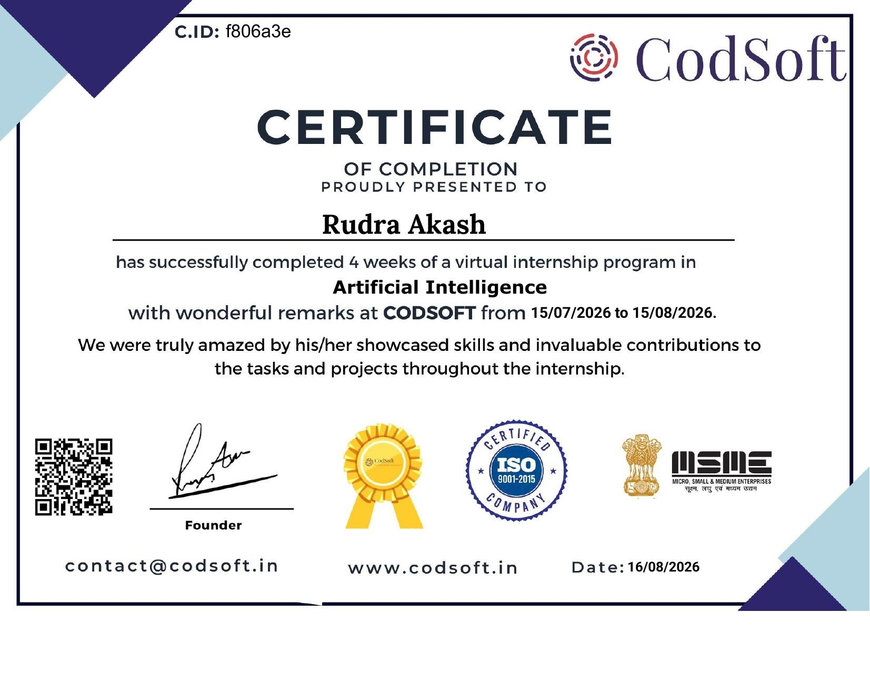

4. PROJECT DESCRIPTION

4.1 Introduction
This report presents a detailed account of the 4-week Virtual Internship undertaken at CodSoft, in the domain of "Artificial Intelligence". The internship was carried out from 15 July 2026 to 15 August 2026 as part of the requirement of the Bachelor of Technology (Computer Science and Engineering - Artificial Intelligence & Machine Learning) programme at IILM University, Greater Noida. The primary aim of this internship was to bridge the gap between theoretical understanding of Artificial Intelligence concepts and their practical, hands-on implementation through independent, project-based work.
The internship followed a project-based structure in which the intern was required to independently design, build, and test a minimum of three AI projects drawn from a prescribed list, spanning classical search algorithms, natural language pattern matching, and recommendation techniques. On successful completion of the required tasks, a Certificate of Completion was awarded by CodSoft.

4.2 Organization Profile
CodSoft is a technology education and software development platform focused on helping aspiring developers convert theoretical knowledge into practical, industry-relevant skills. It offers virtual internships, project-based learning curriculums, and AI-driven career tools such as resume building, ATS scoring, interview coaching, and portfolio building. Through its structured internship programs, CodSoft enables students to gain real, demonstrable project experience across domains including Artificial Intelligence, Web Development, and Software Engineering, supported by placement assistance and networking opportunities with peers.

4.3 Problem Statement
While academic coursework introduces the theoretical foundations of Artificial Intelligence - including search algorithms, natural language processing, and recommendation techniques - students often have limited opportunity to independently design and implement complete, working AI systems from first principles. The problem addressed by this internship was to translate core AI concepts (adversarial search, rule-based pattern matching, and similarity-based recommendation) into fully functional, testable applications without relying on pre-built high-level libraries that abstract away the underlying logic.

4.4 Project Objectives
- To understand and implement adversarial search using the Minimax algorithm with Alpha-Beta Pruning.
- To design a rule-based conversational system using pattern matching and regular expressions.
- To implement and compare two recommendation paradigms: content-based filtering and collaborative filtering.
- To apply data structures and vectorization techniques (TF-IDF, cosine similarity) to real-world-style datasets.
- To build command-line AI applications with clean, modular, well-documented Python code.
- To gain practical exposure to the complete workflow of designing, testing, and validating an AI system independently.

4.5 Scope of the Project
The scope of this internship spans three independent AI projects, each targeting a distinct sub-area of Artificial Intelligence: game-playing agents and adversarial search, natural language pattern matching for conversational agents, and recommendation systems using content-based and collaborative filtering techniques. Each project was implemented, tested, and validated as a standalone Python application, with sample datasets used where real-world data collection was outside the scope of a virtual internship setting.

4.6 Technologies and Tools Used
- Programming Language: Python 3
- Libraries: pandas, NumPy, scikit-learn (TF-IDF vectorization, cosine similarity)
- Core AI Techniques: Minimax algorithm, Alpha-Beta Pruning, regular-expression-based pattern matching, TF-IDF vectorization, item-based collaborative filtering
- Development Environment: Visual Studio Code / command-line Python interpreter
- Version Control: Git and GitHub (for task submission and project hosting)

4.7 Task-wise Project Work

Task 1: Chatbot with Rule-Based Responses
A conversational chatbot was built using pattern matching over regular expressions rather than machine learning, to build a foundational understanding of conversational flow and intent recognition. The chatbot maintains an ordered list of rules, each pairing one or more regex patterns with a set of candidate responses; the first matching rule is used to generate a reply, with randomized response selection to avoid repetitive phrasing.
- Recognizes greetings, farewells, questions about itself, requests for the time or date, and simple small talk.
- Extracts the user's name from phrases such as "my name is X" using a regex capture group, and personalizes subsequent responses.
- Falls back to a generic clarification response when no rule matches, avoiding a hard failure.
- Implemented entirely with Python's built-in re module - no external NLP libraries required.

Task 2: Tic-Tac-Toe AI
An unbeatable Tic-Tac-Toe AI agent was implemented using the Minimax algorithm enhanced with Alpha-Beta Pruning, allowing the AI to play optimally against a human opponent. The AI explores the full game tree of remaining moves, scoring terminal states (win/loss/draw) and propagating those scores back up the tree to select the move that maximizes its own guaranteed outcome while assuming the opponent plays optimally against it.
- Board state represented as a flat 9-element array; win conditions checked across all rows, columns, and diagonals.
- Score function rewards faster wins and slower losses by factoring in search depth, so the AI prefers immediate wins over delayed ones.
- Alpha-Beta Pruning discards branches that cannot influence the final decision, significantly reducing the number of game states evaluated without changing the result.
- The resulting agent never loses - it either wins or forces a draw against any opponent.

Task 4: Recommendation System
A movie recommendation system was built implementing two complementary approaches. The content-based approach vectorizes each movie's genre tags using TF-IDF (Term Frequency - Inverse Document Frequency) and measures similarity between movies using cosine similarity, recommending movies with the closest genre profile to a movie the user already likes. The collaborative filtering approach instead builds a user-item ratings matrix and computes item-to-item similarity based on how similarly different users rated each pair of movies, then predicts a user's likely rating for an unseen movie as a similarity-weighted average of their existing ratings.
- Content-based filtering: TF-IDF vectorization of genre text + cosine similarity between movie vectors.
- Collaborative filtering: user-item ratings matrix, item-item cosine similarity, weighted-average rating prediction.
- Both approaches share the same underlying dataset (a small sample catalogue of movies and user ratings) so their recommendations can be directly compared.
- Implemented as a command-line tool supporting both recommendation modes, plus utility commands to list available movies and users.

4.8 Methodology
Each project followed the same development methodology: (1) understanding the underlying AI concept and algorithm from first principles, (2) designing a clean, modular program structure, (3) implementing the core algorithm in Python, (4) testing the implementation against representative inputs and edge cases, (5) documenting the code and its design decisions, and (6) preparing a short demonstration of the working system. This iterative, project-based methodology mirrors real-world AI development practice, where correctness is validated through systematic testing rather than assumed from the design alone.

4.9 Expected Outcomes
- Practical understanding of adversarial search and the Minimax algorithm with Alpha-Beta Pruning.
- Ability to design rule-based pattern-matching systems for simple conversational agents.
- Hands-on experience with TF-IDF vectorization, cosine similarity, and collaborative filtering for recommendation systems.
- Improved proficiency in writing clean, modular, well-tested Python code.
- A completed portfolio of three independent AI projects suitable for demonstration to prospective employers.

4.10 Certificate of Completion
The Internship Completion Certificate issued by CodSoft, confirming successful completion of the 4-week Virtual Internship Program in Artificial Intelligence (15 July 2026 to 15 August 2026), is attached in Chapter 3 of this report.

5. BIBLIOGRAPHY/REFERENCES
1. CodSoft, "Artificial Intelligence Virtual Internship," Certificate ID: f806a3e, Issued on 16 August 2026.
2. Russell, S. & Norvig, P., "Artificial Intelligence: A Modern Approach," Pearson Education. (Minimax and Alpha-Beta Pruning)
3. Python re module documentation, https://docs.python.org/3/library/re.html
4. scikit-learn documentation - TF-IDF Vectorizer and Cosine Similarity, https://scikit-learn.org/stable/
5. pandas documentation, https://pandas.pydata.org/docs/
6. CodSoft, www.codsoft.in

