Practical - 1
Practical Title: Project Initiation, Requirement Analysis, Sitemap, Wireframe, and GitHub Setup
Problem Definition: Initiate the semester-long StudentHub portal by identifying the problem scope, user roles, key modules, navigation flow, and minimum 10 pages. Create a sitemap, low-fidelity wireframe, project folder structure, README file, and GitHub repository.
- Theory
- What is URL and parts of URL?
Answer:

A URL (Uniform Resource Locator) is a unique address used to locate and access resources on the internet.
- Identifies the location of a resource online.
- Specifies the protocol (e.g., HTTP or HTTPS).
- Includes the domain name or IP address.
- May contain a path to a specific resource.
- Used to access web pages, files, images, and other online resources.
Parts of URL
A URL is composed of multiple parts, each defining how and where a resource can be accessed.
- Scheme: Defines the protocol used to access the resource (e.g., http, https, ftp).
- Subdomain: Specifies a subdivision of the main domain (e.g., www).
- Domain: Identifies the main website name (e.g., example).
- Top-Level Domain (TLD): Indicates the domain extension (e.g., .com, .org).
- Port Number: Specifies the server port (default: 80 for HTTP, 443 for HTTPS).
- Path: Points to the resource location on the server.
- Query String Separator: The ? symbol that starts query parameters.
- Query String / Parameters: Passes data as key–value pairs using &.
- Fragment: Refers to a specific section within the resource using #.

https://www.geeksforgeeks.org/computer-networks/components-of-a-url/

- How does HTML file process in web browser?
Answer:

Web browsers process an HTML file through 5 simple steps:
1. Conversion
The browser downloads raw bytes and turns them into text characters. [1, 2]
2. Tokenization
The browser converts the text into distinct code tags (like <html> and <body>). [1, 2, 3]
3. DOM Construction
The browser links these tags into a tree-like hierarchy called the Document Object Model (DOM). [1, 2, 3]
4. Style & Merge
The browser downloads the CSS, builds the style rules (CSSOM), and merges them with the DOM to create a Render Tree of visible elements. [1]
5. Layout & Painting
The browser calculates the exact screen position for each element and paints the final pixels onto your screen.

https://www.geeksforgeeks.org/javascript/explain-the-process-of-document-loading/

3. How will page navigation flow managed among all HTML pages?
Answer:

Navigation elements are an important part of web design. Proper navigation, always helps users in finding what they are looking for in a website. Navigation elements are buttons, menus, links, and breadcrumbs which makes it easier for the user to navigate through the website and find information. In this article, we are going to understand what are navigation elements, and what are the types and benefits of using proper navigation elements.

https://www.geeksforgeeks.org/websites-apps/navigation-element-in-web-design/

4. How will GitHub commits be maintained after each practical?
Answer:

Git commit creates a commit, which is like a snapshot of your repository. These commits are snapshots of your entire repository at specific times. You should make new commits often, based around logical units of change. Over time, commits should tell a story of the history of your repository and how it came to be the way that it currently is. Commits include lots of metadata in addition to the contents and message, like the author, timestamp, and more.
Commits are the building blocks of "save points" within Git's version control.
https://github.com/git-guides/git-commit/

- Implementation
StudentHub portal was planned and designed using Figma. First, the requirements, user roles, modules, and navigation flow were identified. A sitemap was created to show the connection between different pages. Low-fidelity wireframes were then designed for the main pages.
A total of 10 pages were designed in Figma, including Login, Registration, Dashboard, Courses, Assignments, Notes, Profile, and other required pages. A suitable project folder structure was also planned for organizing HTML, CSS, images, and other files.

- Evidence of Work (Screenshots)
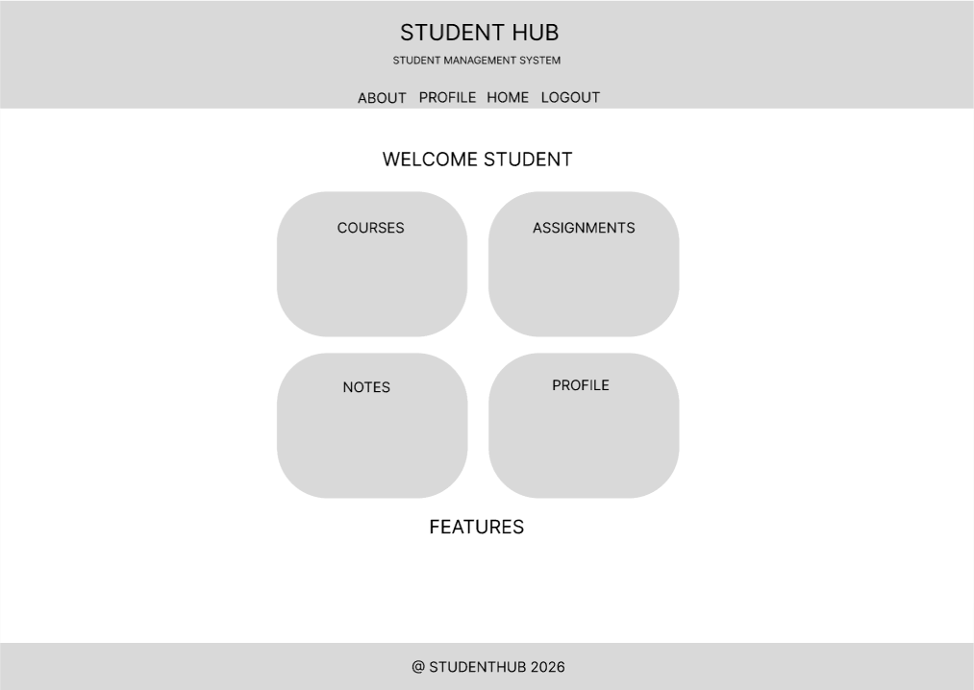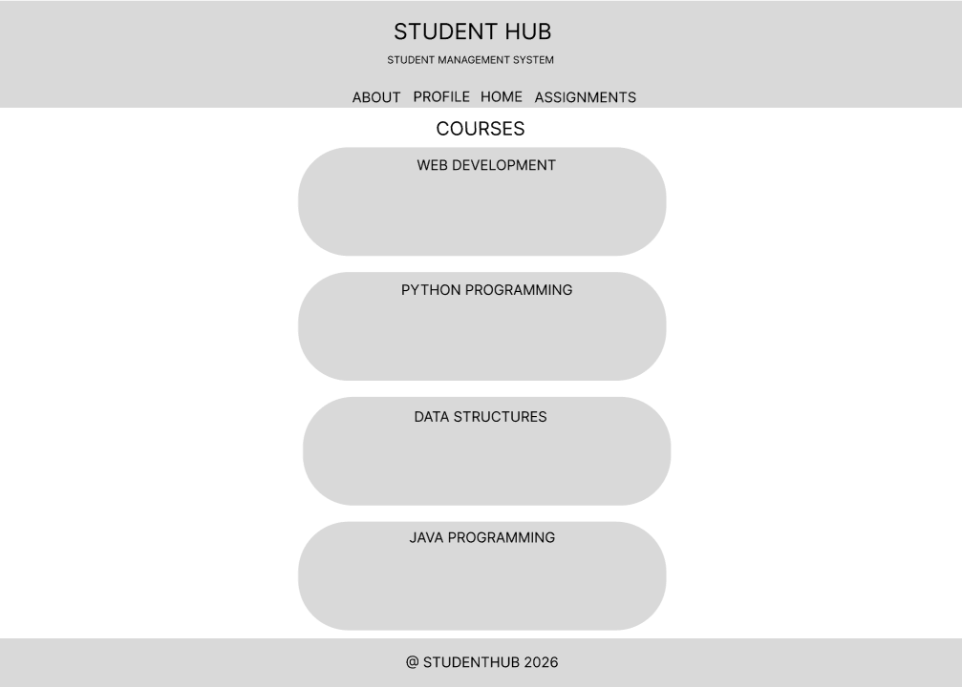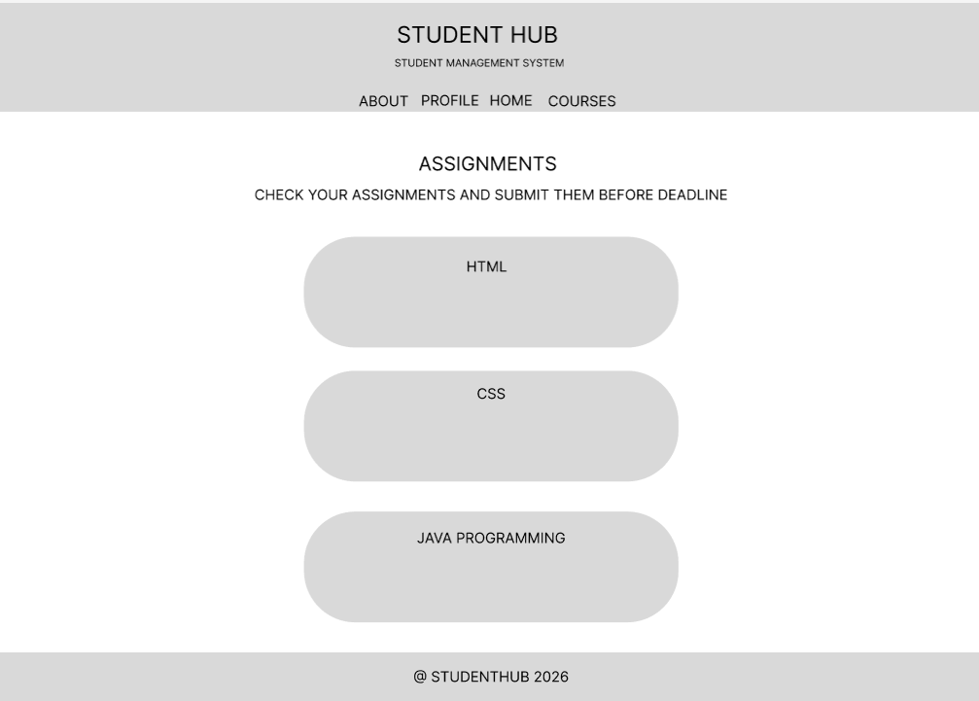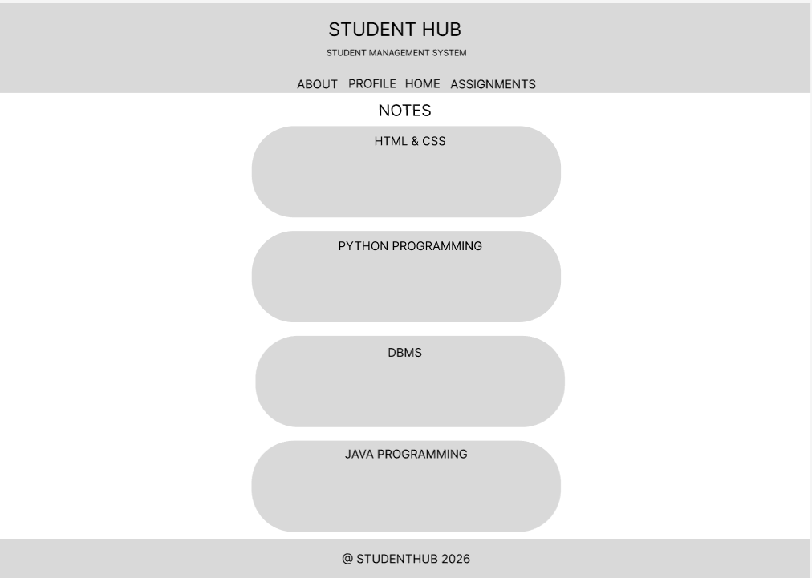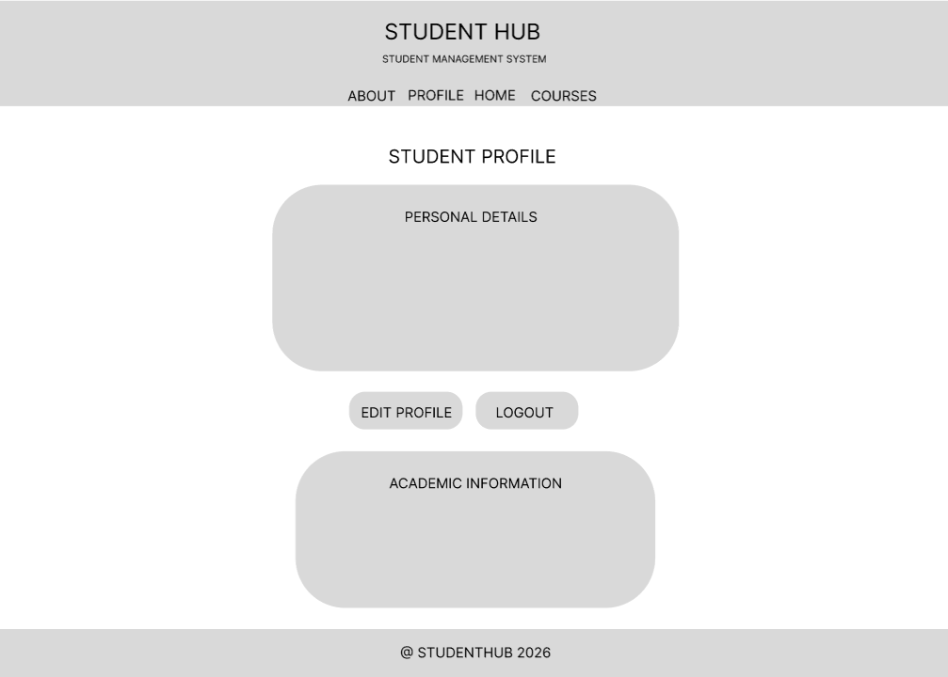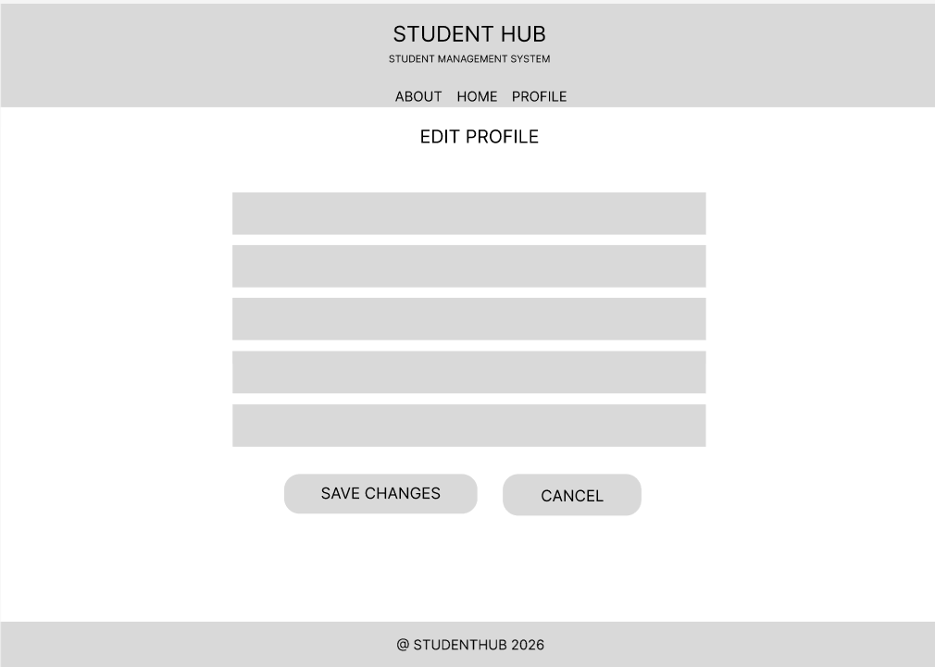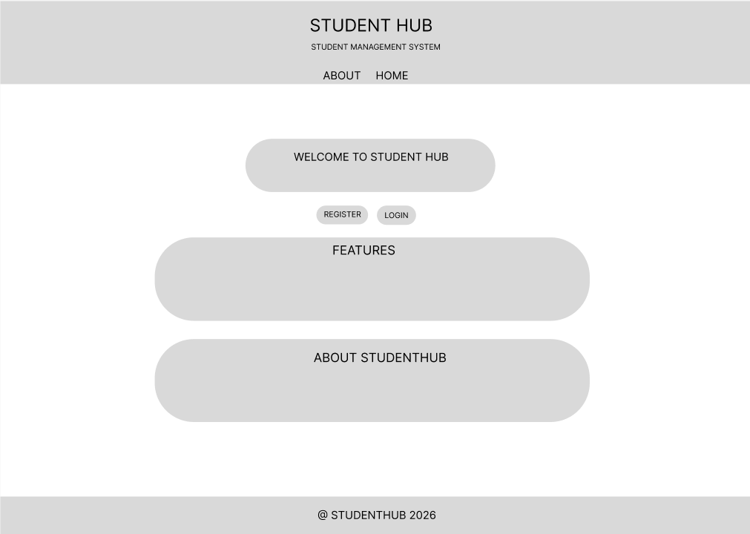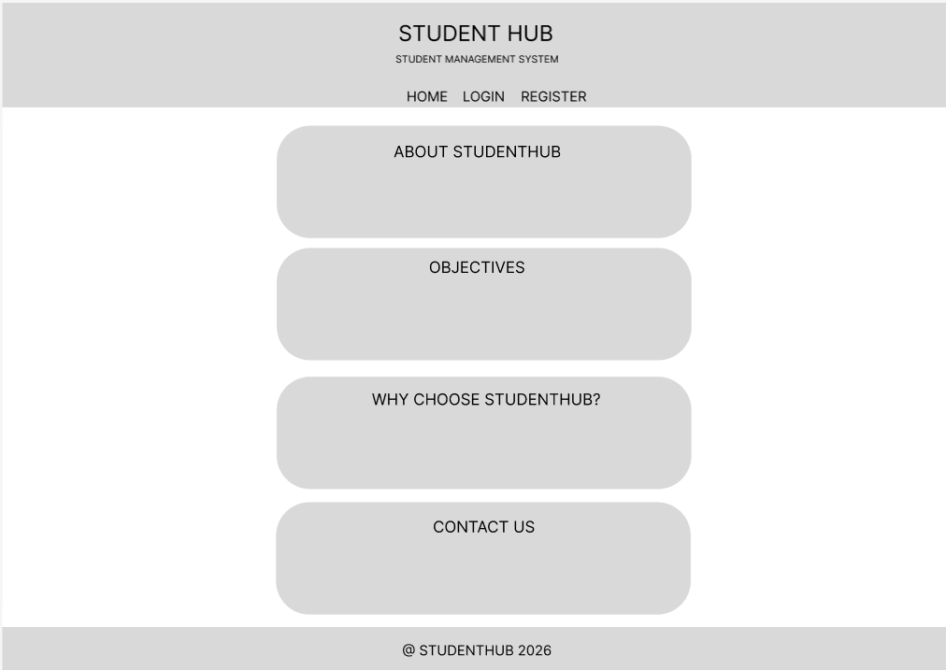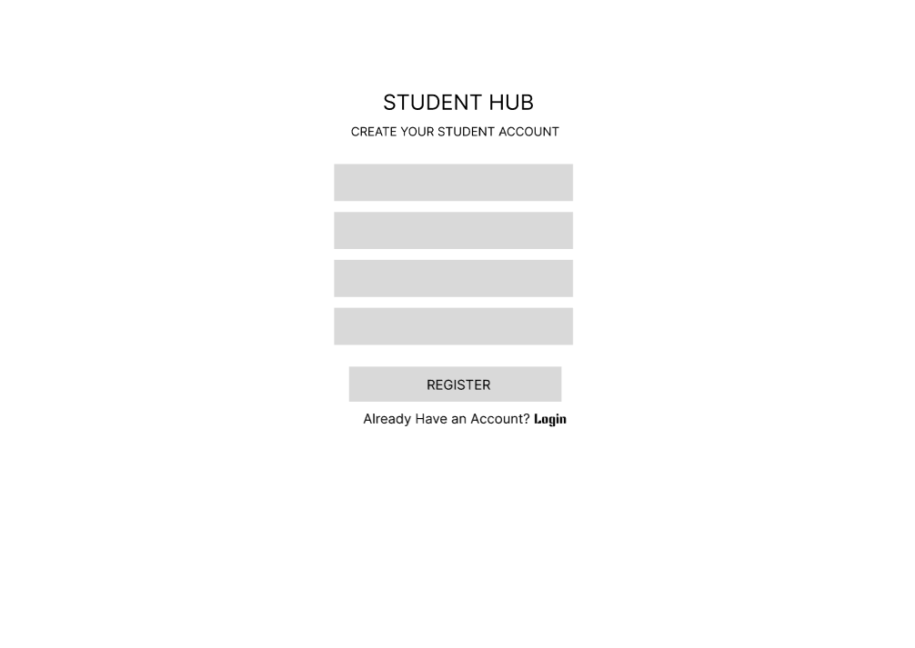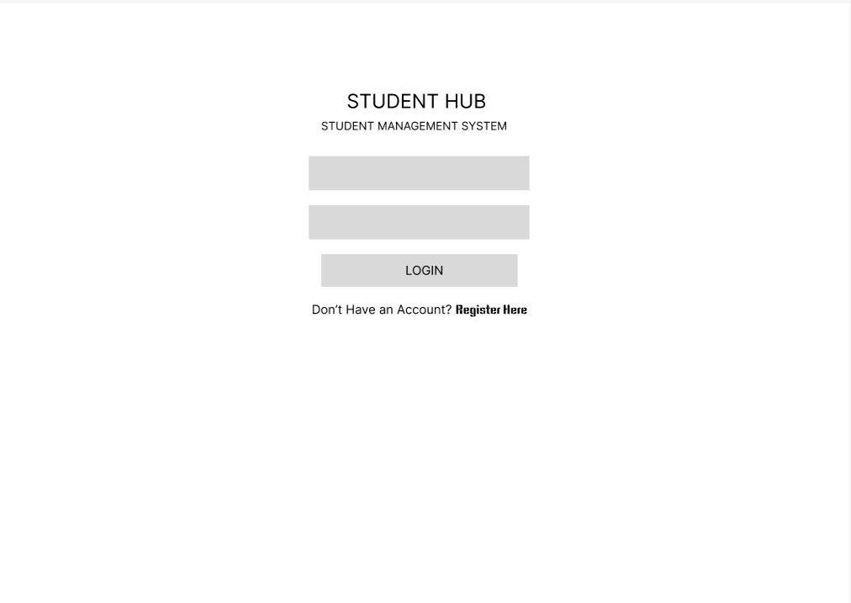

- GitHub Repository Link:
https://github.com/rudratopiwala31/StudentHub

- Challenges Faced:
• Deciding the proper layout and placement of elements on each page.
• Maintaining the same design and style across all 10 pages.
• Creating a simple and easy-to-use navigation flow.
• Managing different sections like Courses, Assignments, Notes, and Profile.
• Making the design attractive while keeping it simple and user-friendly.

- Learning Outcomes:
• Learned how to plan and design a complete website layout using Figma.
• Understood how different pages are connected through navigation and sitemap.
• Improved knowledge of creating wireframes and arranging UI elements properly.
• Learned to maintain consistency in fonts, colors, buttons, and page layouts.
• Got practical experience in designing a multi-page StudentHub portal.

Faculty Remarks:

