HealthClinicApp
Database Design Document
A Relational Database System for Clinic & Hospital Management
Version 1.0
August 2026

Table of Contents

1. Introduction

1.1 Purpose
HealthClinicApp is a relational database system designed to support the end-to-end operations of a clinic or small hospital. It manages patient records, doctor and staff information, appointments and visits, admissions, prescriptions and medicines, laboratory testing, billing and payments, insurance, inventory, and supporting administrative data. This document describes the database design: the entities (tables), their attributes, relationships, and the reporting views built on top of the schema.

1.2 Scope
The schema covers the full patient journey — from registration and appointment booking, through clinical visits, diagnosis, prescriptions, lab testing, and (where required) inpatient admission — as well as the operational and financial functions that support the clinic: staffing and departments, medicine inventory and suppliers, billing and payments, insurance claims, and feedback and audit logging.

1.3 Design Overview
The database is organized as a normalized relational schema of 25 core tables grouped into seven functional modules, supported by 15 reporting views that pre-aggregate or join data for common reporting and dashboard needs. Primary keys are surrogate integer identifiers (e.g. patient_id, doctor_id) and relationships are enforced through foreign keys, most following one-to-many patterns radiating from core entities such as patient, doctor, and department.

2. Functional Modules
The 25 tables in HealthClinicApp are grouped into the following seven functional modules:
Patient Management | patient, emergency_contact, medical_history, insurance, disease, patient_disease
Staff & Organization | staff, doctor, department, room
Appointments & Care Visits | appointment, visit, admission
Clinical Records | prescription, prescription_item, medicine, lab_test, lab_report
Billing & Finance | billing, payment
Inventory & Supply Chain | inventory, supplier
Feedback & System Logs | feedback, activity_log, audit_log

3. Patient Management Module
This module holds the master patient record and everything directly tied to patient identity and clinical background: contacts to notify in an emergency, historical medical conditions, insurance coverage, the master disease/condition catalog, and the link table that records which diseases a patient has been diagnosed with.

patient
The master record for every person registered with the clinic. Nearly every other module (appointments, visits, billing, prescriptions) links back to this table.
Field | Type | Description
patient_id | INT (PK) | Unique identifier for the patient.
first_name | VARCHAR(50) | Patient's given name.
last_name | VARCHAR(50) | Patient's family name.
date_of_birth | DATE | Used to calculate age and for identity verification.
gender | ENUM | Patient's gender.
blood_group | VARCHAR(5) | Blood group, e.g. O+, AB-.
phone | VARCHAR(15) | Primary contact number.
email | VARCHAR(100) | Contact email address.
address | TEXT | Street address.
city | VARCHAR(50) | City of residence.
is_active | TINYINT(1) | Flags whether the patient record is active.
registered_at | TIMESTAMP | Date/time the patient was registered.
updated_at | TIMESTAMP | Date/time the record was last updated.

emergency_contact
One or more people to contact on a patient's behalf in an emergency.
Field | Type | Description
contact_id | INT (PK) | Unique identifier for the contact record.
patient_id | INT (FK) | The patient this contact belongs to.
name | VARCHAR(100) | Emergency contact's full name.
relationship | VARCHAR(50) | Relationship to the patient (e.g. spouse, parent).
phone | VARCHAR(15) | Contact phone number.

medical_history
A running log of pre-existing or historical medical conditions for a patient, independent of any single visit.
Field | Type | Description
history_id | INT (PK) | Unique identifier for the history entry.
patient_id | INT (FK) | The patient the history entry belongs to.
condition_name | VARCHAR(200) | Name of the medical condition.
diagnosed_date | DATE | Date the condition was first diagnosed.
notes | TEXT | Free-text clinical notes.

insurance
Insurance policy details linked to a patient, used for claims and coverage checks during billing.
Field | Type | Description
insurance_id | INT (PK) | Unique identifier for the insurance record.
patient_id | INT (FK) | The insured patient.
provider_name | VARCHAR(200) | Name of the insurance provider.
policy_number | VARCHAR(100) | The policy's identifying number.
coverage_amount | DECIMAL(10,2) | Maximum amount covered by the policy.
valid_from | DATE | Policy coverage start date.
valid_to | DATE | Policy coverage end date.
is_active | TINYINT(1) | Flags whether the policy is currently active.

disease
Master catalog of diseases/conditions the clinic can diagnose, referenced by patient_disease.
Field | Type | Description
disease_id | INT (PK) | Unique identifier for the disease.
name | VARCHAR(200) | Disease or condition name.
icd_code | VARCHAR(20) | Standardized ICD diagnostic code.
description | TEXT | Description of the disease.
category | VARCHAR(100) | Broad category the disease belongs to.

patient_disease
Link table recording each diagnosis of a patient with a specific disease.
Field | Type | Description
pd_id | INT (PK) | Unique identifier for the diagnosis record.
patient_id | INT (FK) | The diagnosed patient.
disease_id | INT (FK) | The diagnosed disease.
diagnosed_date | DATE | Date of diagnosis.
notes | TEXT | Clinical notes about the diagnosis.

4. Staff & Organization Module
This module models the clinic's organizational structure: departments, the general staff roster, doctors specifically (who carry clinical responsibilities and are linked to appointments and admissions), and physical rooms used for admissions.

department
A clinical or administrative department (e.g. Cardiology, Radiology), each with a designated head doctor.
Field | Type | Description
department_id | INT (PK) | Unique identifier for the department.
name | VARCHAR(100) | Department name.
description | TEXT | Description of the department's function.
head_doctor_id | INT (FK) | The doctor heading the department.
created_at | TIMESTAMP | Record creation timestamp.
updated_at | TIMESTAMP | Record last-updated timestamp.

staff
General clinic staff (non-doctor roles such as nurses, receptionists, technicians), each assigned to a department.
Field | Type | Description
staff_id | INT (PK) | Unique identifier for the staff member.
first_name | VARCHAR(50) | Staff member's given name.
last_name | VARCHAR(50) | Staff member's family name.
role | VARCHAR(100) | Job role/title.
department_id | INT (FK) | Department the staff member belongs to.
phone | VARCHAR(15) | Contact phone number.
email | VARCHAR(100) | Contact email address.
salary | DECIMAL(10,2) | Monthly or annual salary.
join_date | DATE | Date the staff member joined the clinic.
is_active | TINYINT(1) | Flags whether the staff member is currently employed.

doctor
Clinical practitioners who see patients, hold appointments, and can head a department.
Field | Type | Description
doctor_id | INT (PK) | Unique identifier for the doctor.
first_name | VARCHAR(50) | Doctor's given name.
last_name | VARCHAR(50) | Doctor's family name.
specialization | VARCHAR(100) | Medical specialization (e.g. Cardiologist).
department_id | INT (FK) | Department the doctor is attached to.
phone | VARCHAR(15) | Contact phone number.
email | VARCHAR(100) | Contact email address.
salary | DECIMAL(10,2) | Doctor's salary.
join_date | DATE | Date the doctor joined the clinic.
is_active | TINYINT(1) | Flags whether the doctor is currently active.
created_at | TIMESTAMP | Record creation timestamp.
updated_at | TIMESTAMP | Record last-updated timestamp.

room
Physical rooms/beds available for inpatient admission, tied to a department.
Field | Type | Description
room_id | INT (PK) | Unique identifier for the room.
room_number | VARCHAR(10) | Room/bed number.
room_type | ENUM | Type of room (e.g. General, ICU, Private).
department_id | INT (FK) | Department the room belongs to.
capacity | INT | Number of beds/patients the room can hold.
is_available | TINYINT(1) | Flags whether the room is currently free.
daily_rate | DECIMAL(8,2) | Daily charge for occupying the room.

5. Appointments & Care Visits Module
This module tracks a patient's interactions with the clinic over time: scheduled appointments, the resulting clinical visit record, and — where the patient needs to stay — an inpatient admission tied to a room and attending doctor.

appointment
A scheduled meeting between a patient and a doctor.
Field | Type | Description
appointment_id | INT (PK) | Unique identifier for the appointment.
patient_id | INT (FK) | The patient booking the appointment.
doctor_id | INT (FK) | The doctor being seen.
appointment_date | DATE | Date of the appointment.
appointment_time | TIME | Time of the appointment.
status | ENUM | Status (e.g. Scheduled, Completed, Cancelled).
reason | TEXT | Reason for the visit.
notes | TEXT | Additional notes.
created_at | TIMESTAMP | Record creation timestamp.
updated_at | TIMESTAMP | Record last-updated timestamp.

visit
The clinical record produced once an appointment takes place — vitals, symptoms, diagnosis and treatment.
Field | Type | Description
visit_id | INT (PK) | Unique identifier for the visit.
appointment_id | INT (FK) | The appointment this visit fulfills.
visit_date | DATE | Date of the actual visit.
symptoms | TEXT | Reported symptoms.
diagnosis | TEXT | Doctor's diagnosis.
treatment | TEXT | Treatment provided or recommended.
follow_up_date | DATE | Recommended follow-up date, if any.
weight | DECIMAL(5,2) | Patient's recorded weight.
blood_pressure | VARCHAR(20) | Recorded blood pressure reading.
temperature | DECIMAL(4,1) | Recorded body temperature.
notes | TEXT | Additional clinical notes.
created_at | TIMESTAMP | Record creation timestamp.

admission
Records an inpatient stay: the room and doctor assigned, and admission/discharge dates.
Field | Type | Description
admission_id | INT (PK) | Unique identifier for the admission.
patient_id | INT (FK) | The admitted patient.
room_id | INT (FK) | The room the patient is assigned to.
doctor_id | INT (FK) | The attending doctor.
admission_date | DATE | Date the patient was admitted.
discharge_date | DATE | Date the patient was discharged.
reason | TEXT | Reason for admission.
status | ENUM | Admission status (e.g. Admitted, Discharged).

6. Clinical Records Module
This module covers prescriptions and the medicines prescribed, and laboratory tests ordered along with their reported results.

prescription
A prescription issued during a visit, containing general instructions; individual medicines are listed in prescription_item.
Field | Type | Description
prescription_id | INT (PK) | Unique identifier for the prescription.
visit_id | INT (FK) | The visit during which the prescription was issued.
prescribed_date | DATE | Date the prescription was issued.
instructions | TEXT | General instructions for the patient.
created_at | TIMESTAMP | Record creation timestamp.

prescription_item
An individual medicine line item within a prescription, with dosage and duration.
Field | Type | Description
item_id | INT (PK) | Unique identifier for the prescription line item.
prescription_id | INT (FK) | The parent prescription.
medicine_id | INT (FK) | The prescribed medicine.
dosage | VARCHAR(100) | Dosage instructions (e.g. 500mg).
frequency | VARCHAR(100) | How often the medicine should be taken.
duration_days | INT | Number of days the medicine should be taken.
quantity | INT | Total quantity prescribed.

medicine
Master catalog of medicines the clinic stocks and can prescribe, including pricing and stock levels.
Field | Type | Description
medicine_id | INT (PK) | Unique identifier for the medicine.
name | VARCHAR(200) | Brand/trade name of the medicine.
generic_name | VARCHAR(200) | Generic/chemical name.
category | VARCHAR(100) | Medicine category (e.g. Antibiotic).
unit | VARCHAR(20) | Unit of measure (e.g. tablet, ml).
unit_price | DECIMAL(8,2) | Price per unit.
stock_quantity | INT | Current quantity in stock.
min_stock_level | INT | Threshold that triggers a low-stock alert.
description | TEXT | Description of the medicine.
is_active | TINYINT(1) | Flags whether the medicine is currently offered.

lab_test
Master catalog of laboratory tests the clinic offers, with their normal reference range and price.
Field | Type | Description
test_id | INT (PK) | Unique identifier for the lab test.
test_name | VARCHAR(200) | Name of the test.
description | TEXT | Description of what the test measures.
normal_range | VARCHAR(100) | Normal reference range for results.
unit | VARCHAR(50) | Unit of measure for the result.
price | DECIMAL(8,2) | Price charged for the test.

lab_report
The result of a lab test ordered during a patient visit.
Field | Type | Description
report_id | INT (PK) | Unique identifier for the lab report.
visit_id | INT (FK) | The visit the test was ordered during.
test_id | INT (FK) | The lab test performed.
test_date | DATE | Date the test was carried out.
result | VARCHAR(200) | Recorded result value.
is_normal | TINYINT(1) | Flags whether the result falls within the normal range.
remarks | TEXT | Additional remarks from the lab.
created_at | TIMESTAMP | Record creation timestamp.

7. Billing & Finance Module
This module handles invoicing patients for visits and services rendered, and recording payments made against those invoices.

billing
An invoice generated for a patient, typically tied to a specific visit, with totals, discounts, tax and payment status.
Field | Type | Description
bill_id | INT (PK) | Unique identifier for the bill.
patient_id | INT (FK) | The billed patient.
visit_id | INT (FK) | The visit the bill relates to.
bill_date | DATE | Date the bill was generated.
total_amount | DECIMAL(10,2) | Total amount billed.
paid_amount | DECIMAL(10,2) | Amount paid so far.
discount | DECIMAL(8,2) | Discount applied.
tax | DECIMAL(8,2) | Tax applied.
status | ENUM | Bill status (e.g. Paid, Pending, Partial).
notes | TEXT | Additional notes.
created_at | TIMESTAMP | Record creation timestamp.

payment
An individual payment transaction made against a bill; a bill may have multiple payments.
Field | Type | Description
payment_id | INT (PK) | Unique identifier for the payment.
bill_id | INT (FK) | The bill being paid.
amount | DECIMAL(10,2) | Amount paid in this transaction.
payment_date | DATE | Date the payment was made.
payment_method | ENUM | Method of payment (e.g. Cash, Card, Insurance).
reference_number | VARCHAR(100) | External reference/transaction number.

8. Inventory & Supply Chain Module
This module tracks medicine suppliers and stock batches purchased from them, supporting reorder and expiry monitoring.

supplier
A vendor the clinic purchases medicines and supplies from.
Field | Type | Description
supplier_id | INT (PK) | Unique identifier for the supplier.
name | VARCHAR(200) | Supplier company name.
contact_person | VARCHAR(100) | Primary contact person's name.
phone | VARCHAR(15) | Contact phone number.
email | VARCHAR(100) | Contact email address.
address | TEXT | Supplier's business address.
is_active | TINYINT(1) | Flags whether the supplier is currently used.

inventory
A purchased batch of a medicine from a supplier, tracked for cost, quantity, and expiry.
Field | Type | Description
inventory_id | INT (PK) | Unique identifier for the inventory record.
medicine_id | INT (FK) | The medicine this batch contains.
supplier_id | INT (FK) | The supplier the batch was purchased from.
quantity | INT | Quantity purchased in this batch.
purchase_date | DATE | Date the batch was purchased.
unit_cost | DECIMAL(8,2) | Cost per unit for this batch.
expiry_date | DATE | Expiry date of the batch.
batch_number | VARCHAR(100) | Manufacturer batch/lot number.

9. Feedback & System Logs Module
This module captures patient feedback on doctors and clinical service, along with general and audit-level system activity logs.

feedback
Patient-submitted feedback and rating for a doctor.
Field | Type | Description
feedback_id | INT (PK) | Unique identifier for the feedback entry.
patient_id | INT (FK) | The patient giving feedback.
doctor_id | INT (FK) | The doctor being rated.
rating | INT | Numeric rating given.
comments | TEXT | Free-text comments.
created_at | TIMESTAMP | Record creation timestamp.

activity_log
A general log of notable activities occurring within the system.
Field | Type | Description
activity_id | INT (PK) | Unique identifier for the activity entry.
activity_type | VARCHAR(100) | Type/category of the activity.
description | TEXT | Description of what occurred.
created_at | TIMESTAMP | Timestamp the activity was logged.

audit_log
A low-level audit trail of database changes (inserts/updates/deletes) for compliance and troubleshooting.
Field | Type | Description
log_id | INT (PK) | Unique identifier for the audit entry.
table_name | VARCHAR(100) | Name of the table that was changed.
operation | VARCHAR(20) | Type of operation (INSERT, UPDATE, DELETE).
record_id | INT | Primary key of the affected record.
description | TEXT | Description of the change.
created_at | TIMESTAMP | Timestamp the change was logged.

10. Key Relationships
The schema is fully normalized, with one-to-many relationships radiating from a small set of core entities. The table below summarizes the primary foreign-key relationships between tables.
patient → appointment, visit (via appointment), admission, billing, insurance, emergency_contact, medical_history, patient_disease, feedback | One patient has many appointments, admissions, bills, contacts, and diagnoses.
doctor → appointment, admission, department (as head), feedback | One doctor handles many appointments and admissions, and may head a department.
department → staff, doctor, room | One department contains many staff members, doctors, and rooms.
appointment → visit | One appointment produces one clinical visit record.
visit → prescription, lab_report, billing | One visit can generate a prescription, lab reports, and a bill.
prescription → prescription_item | One prescription contains many medicine line items.
medicine → prescription_item, inventory | One medicine appears in many prescriptions and inventory batches.
supplier → inventory | One supplier provides many inventory batches.
lab_test → lab_report | One lab test type is used across many lab reports.
disease → patient_disease | One disease can be diagnosed in many patients.
room → admission | One room can be used across many (sequential) admissions.
billing → payment | One bill can be settled through multiple payments.

11. Reporting Views
In addition to the 25 base tables, the schema defines 15 database views. Views join and pre-aggregate data from the base tables to simplify reporting, dashboards, and common lookups without duplicating data.
v_patient_history | Consolidated view of a patient's visits, diagnoses, and treatment history over time.
v_patient_summary | Snapshot summary of a patient's key details and activity.
v_appointment_details | Appointment records joined with patient and doctor information for easy lookup.
v_prescription_details | Prescriptions joined with their line items and medicine details.
v_medicine_inventory | Current stock levels per medicine, joined with inventory batch data.
v_low_stock | Medicines whose stock_quantity has fallen at or below their min_stock_level.
v_billing_details | Bills joined with patient and visit information for a full billing picture.
v_paid_bills | Bills that have been fully paid.
v_pending_bills | Bills that are outstanding or only partially paid.
v_insurance_summary | Patients' insurance coverage summarized for claims processing.
v_revenue_report | Aggregated revenue figures, typically by period and/or department.
v_department_statistics | Departmental statistics such as staff counts, doctor counts, and activity volume.
v_doctor_performance | Doctor-level metrics such as appointment volume and average feedback rating.
v_doctor_summary | Summary profile of each doctor, including department and specialization.
v_daily_visits | Count and details of patient visits grouped by day.

12. Entity-Relationship Diagram
The diagram below shows the complete HealthClinicApp schema: all 25 base tables, their fields, and the 15 reporting views (shown in yellow), with connecting lines indicating foreign-key relationships.
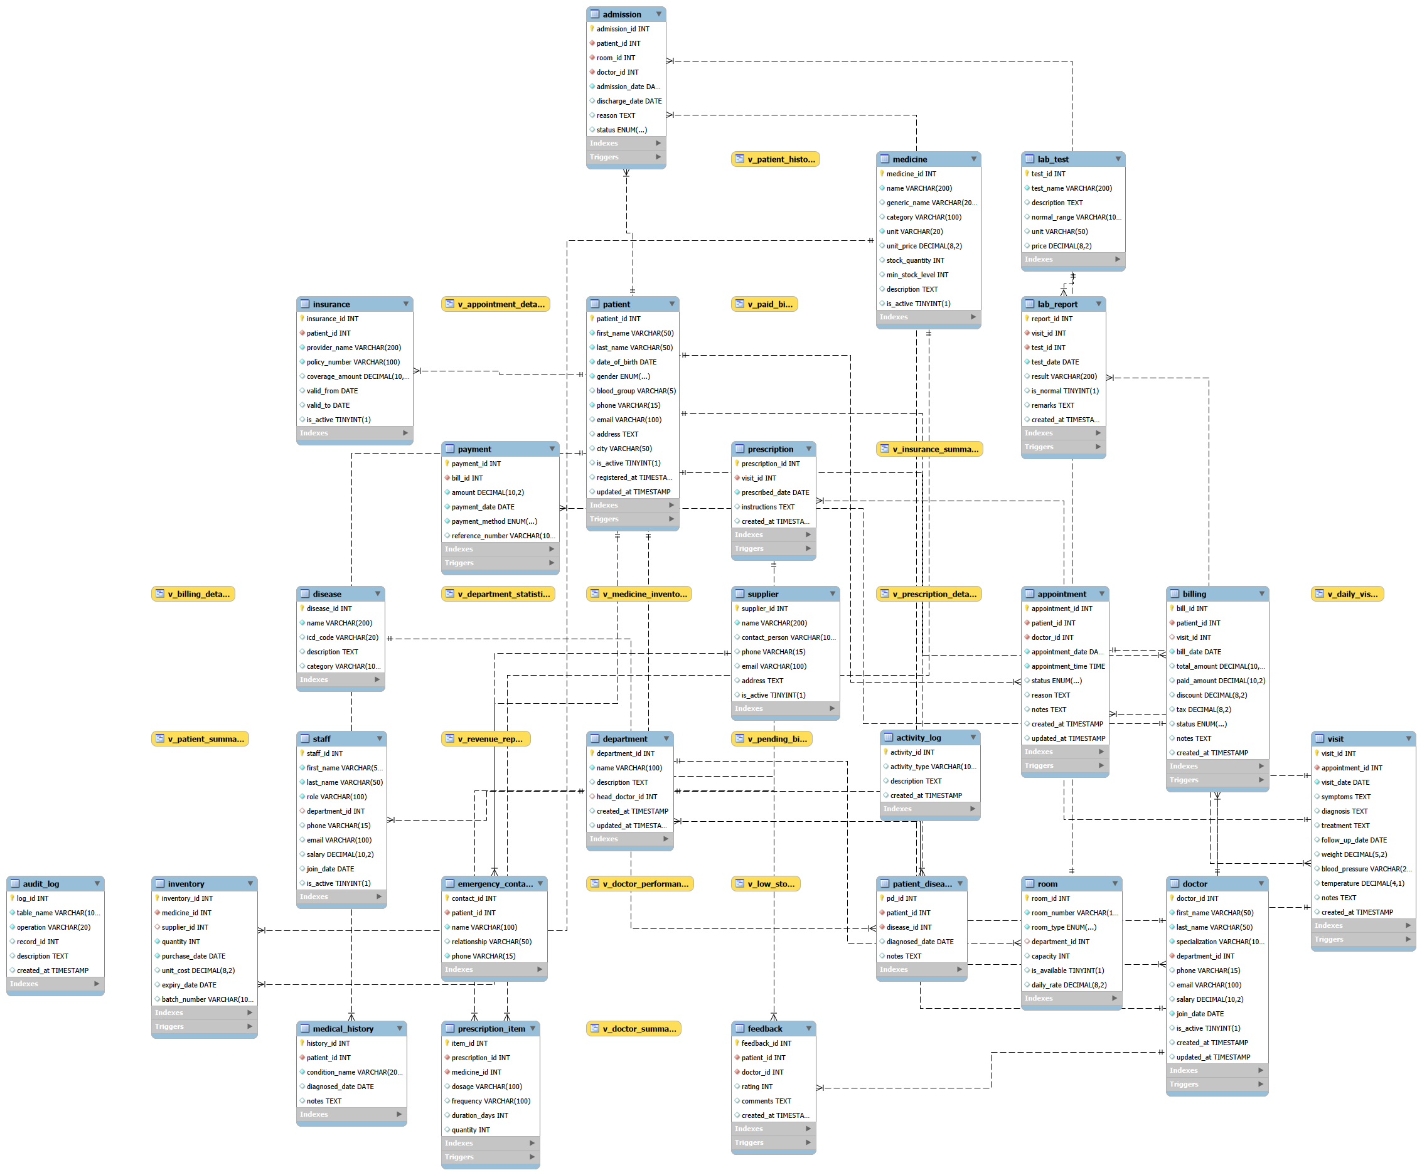

13. Summary
HealthClinicApp's database is a normalized 25-table schema organized around seven functional modules — patient management, staff & organization, appointments & visits, clinical records, billing & finance, inventory & supply, and feedback & logs — supported by 15 reporting views. This design keeps clinical, administrative, and financial data cleanly separated while preserving the relationships needed to reconstruct a complete patient journey from registration through diagnosis, treatment, billing, and follow-up.

