Question 1 - AWS EC2

Answer:

Port Scanning. Unauthorized port scans by Amazon EC2 customers are a violation of the AWS Acceptable Use Policy. Violations of the AWS Acceptable Use Policy are taken seriously, and every reported violation is investigated.

Port scans of Amazon EC2 instances are generally ineffective because, by default, all inbound ports on Amazon EC2 instances are closed and are only opened by the customer. Customers strict management of security groups can further mitigate the threat of port scans. If the Customer configure the security group to allow traffic from any source to a specific port, then that specific port will be vulnerable to a port scan. In these cases, the customer must use appropriate security measures to protect listening services that may be essential to their application from being discovered by an unauthorized port scan. For example, a web server must clearly have port 80 (HTTP) open to the world, and the administrator of this server is responsible for the security of the HTTP server software, such as Apache. You may request permission to conduct vulnerability scans as required to meet your specific compliance requirements.

These scans must be limited to customer own instances and must not violate the AWS Acceptable Use Policy.

Question 2 - AWS EBS

Answer:

AWS Storage Gateway transparently backs up data off-site to Amazon S3 in the form of Amazon EBS snapshots. Amazon S3 redundantly stores these snapshots on multiple devices across multiple facilities, detecting and repairing any lost redundancy. The Amazon EBS snapshot provides a point-in-time backup that can be restored on-premises or used to instantiate new Amazon EBS volumes. Data is stored within a single region that you specify.

AWS Storage Gateway offers three options:

- Gateway-Stored Volumes (where the cloud is backup). In this option, your volume data is stored locally and then pushed to Amazon S3, where it is stored in redundant, encrypted form, and made available in the form of Elastic Block Storage (EBS) snapshots. When you use this model, the on-premises storage is primary, delivering low-latency access to your entire dataset, and the cloud storage is the backup.
- Gateway-Cached Volumes (where the cloud is primary). In this option, your volume data is stored encrypted in Amazon S3, visible within your enterprise's network via an iSCSI interface. Recently accessed data is cached on- premises for low-latency local access. When you use this model, the cloud storage is primary, but you get low- latency access to your active working set in the cached volumes on premises.
- Gateway-Virtual Tape Library (VTL). In this option, you can configure a Gateway-VTL with up to 10 virtual tape drives per gateway, 1 media changer and up to 1500 virtual tape cartridges. Each virtual tape drive responds to the SCSI command set, so your existing on-premises backup applications (either disk-to-tape or disk-to-disk-to- tape) will work without modification.

No Matter which option you choose, data is asynchronously transferred from your on-premises storage hardware to AWS over SSL. The data is stored encrypted in Amazon S3 using Advanced Encryption Standard (AES) 256, a symmetric- key encryption standard using 256-bit encryption keys. The AWS Storage Gateway only uploads data that has changed, minimizing the amount of data sent over the Internet.

Question 3 - AWS S3

Answer:

Access to data stored in Amazon S3 is restricted by default; only bucket and object owners have access to the Amazon S3 resources they create (note that a bucket/object owner is the AWS Account owner, not the user who created the bucket/object). There are multiple ways to control access to buckets and objects:

- Identity and Access Management (IAM) Policies. AWS IAM enables organizations with many employees to create and manage multiple users under a single AWS Account. IAM policies are attached to the users, enabling centralized control of permissions for users under your AWS Account to access buckets or objects. With IAM policies, you can only grant users within your own AWS account permission to access your Amazon S3 resources.
- Access Control Lists (ACLs). Within Amazon S3, you can use ACLs to give read or write access on buckets or objects to groups of users. With ACLs, you can only grant other AWS accounts (not specific users) access to your Amazon S3 resources.
- Bucket Policies. Bucket policies in Amazon S3 can be used to add or deny permissions across some or all of the objects within a single bucket. Policies can be attached to users, groups, or Amazon S3 buckets, enabling centralized management of permissions. With bucket policies, you can grant users within your AWS Account or other AWS Accounts access to your Amazon S3 resources.

Question 4 - AWS SES

Answer:

DKIM, DomainKeys Identified Mail, is the newest and the most advanced method for authenticating email. Using DKIM, a sender signs the message body and certain headers using the private part of a key-pair. The signature (a hash code) is then transmitted along with the message. The receiver validates the message (and thus authenticates the sender and the integrity of the message) by fetching a public key from a TXT (or, in the case of Amazon SES, a CNAME) record in the sender’s DNS information.

DKIM signing has been possible with SES for a while now, but it was fairly difficult to implement programmatically. AWS simplified the process of DKIM signing with new Easy DKIM support.

Question 5 - AWS EMR

Answer:

When launching job flows on your behalf, Amazon EMR sets up two Amazon EC2 security groups: one for the master nodes and another for the slaves. The master security group has a port open for communication with the service. It also has the SSH port open to allow you to SSH into the instances, using the key specified at startup. The slaves start in a separate security group, which only allows interaction with the master instance. By default both security groups are set up to not allow access from external sources, including Amazon EC2 instances belonging to other customers. Since these are security groups within your account, you can reconfigure them using the standard EC2 tools or dashboard. To protect customer input and output datasets, Amazon EMR transfers data to and from Amazon S3 using SSL.

Question 6

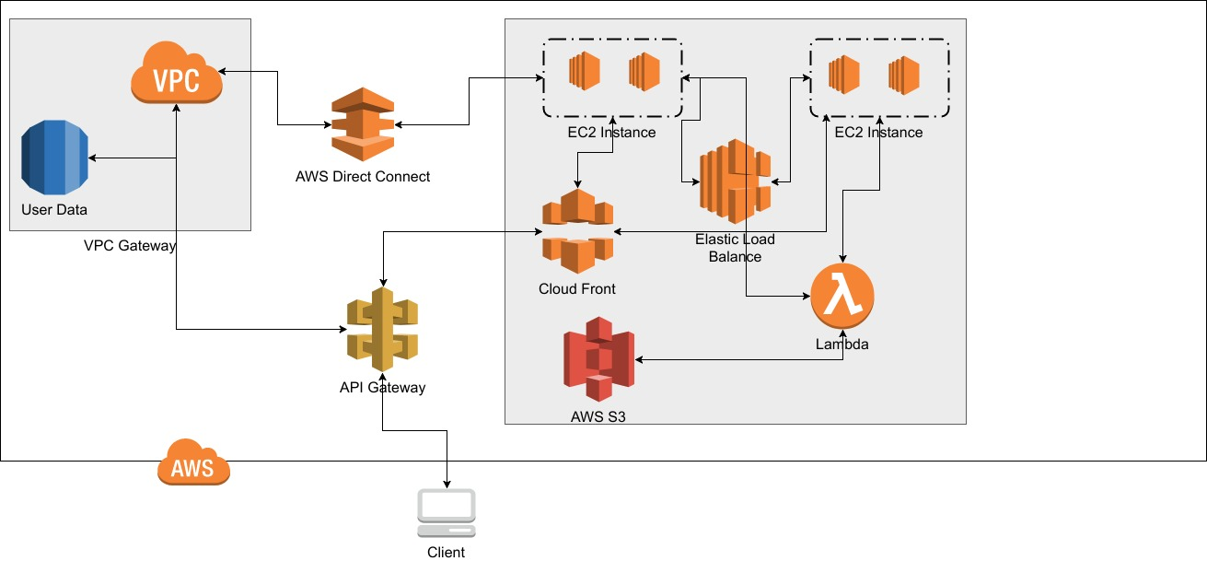

Amazon VPC
Amazon Virtual Private Cloud (Amazon VPC) lets you provision a logically isolated section of the AWS Cloud where you can launch AWS resources in a virtual network that you define. You have complete control over your virtual networking environment, including selection of your own IP address range, creation of subnets, and configuration of route tables and network gateways. Additionally, you can create a Hardware VPN connection between your corporate data center and your VPC to leverage the AWS Cloud as an extension of your corporate data center.
AWS Direct Connect
AWS Direct Connect makes it easy to establish a dedicated network connection from your premises to AWS. Using AWS Direct Connect, you can establish private connectivity between AWS and your data center, office, or colocation environment, which in many cases can reduce your network costs, increase bandwidth throughput, and provide a more consistent network experience than Internet-based connections. This dedicated connection can be partitioned into multiple virtual interfaces to maintain network separation between public and private environments.

Amazon S3
Amazon Simple Storage Service (Amazon S3), provides developers and IT teams with secure, durable, highly-scalable cloud storage. Amazon S3 is easy to use object storage, with a simple web service interface to store and retrieve any amount of data from anywhere on the web. Amazon S3 offers a range of storage classes designed for different use cases including Amazon S3 Standard for general-purpose storage of frequently accessed data, Amazon S3 Standard - Infrequent Access (Standard - IA) for long-lived, but less frequently accessed data, and Amazon Glacier for long-term archive. Amazon S3 also offers configurable life-cycle policies for managing your data throughout its life-cycle.

