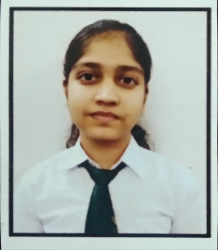

**ANUSHKA MISHRA**

Singrauli,Madh

.

● anushkamishra2309@gmail.com

●

+91 7860254396

**EDUCATION**

Bachelor of Technology in Computer Science and Engineering, GLA University May 2026

Delhi Public School, Vindhyanagar (passed with 89.8%) March 2022

Nirmala Convent High School, Renukoot (passed with 95.3%) March 2020

## PROJECTS

**PORTFOLIO**

### 

* This website describes the overview of my professional journey and contains a brief description of my skills and capabilities.
* It is implemented using HTML and CSS.

**CATCH ME GAME**

* This is a classic fun game. The objective of this game is to hit the emoji that occurs on the hole and acquiring the points.
* It is implemented using HTML, CSS, and Javascript.

## SKILLS

**TECHNICAL SKILLS**

* **Programming Languages:** C, Basics of Python, Java , HTML, CSS , Javascript, Node JS basics,Express JS , MongoDB, and SQL.
* **Familiar with development Environment:** Visual Studio Code

**PROFESSIONAL SKILLS**

* Communication Skills
* Leadership Quality
* Critical Thinking
* Problem-Solving
* Time Management

## ACHIEVEMENTS

* Achieved 2-star rating on Codechef
* Solved 150+ questions on Leetcode
* Participated in Coding competitions held at GLA University.
* Stars achieved on Hackerrank: 4 stars in Python, 4 stars in Java

# DECLARATION________________________________________________________________________________________

I hereby declare that all the above-mentioned information is true and correct to the best of my knowledge.