Problem 1 :

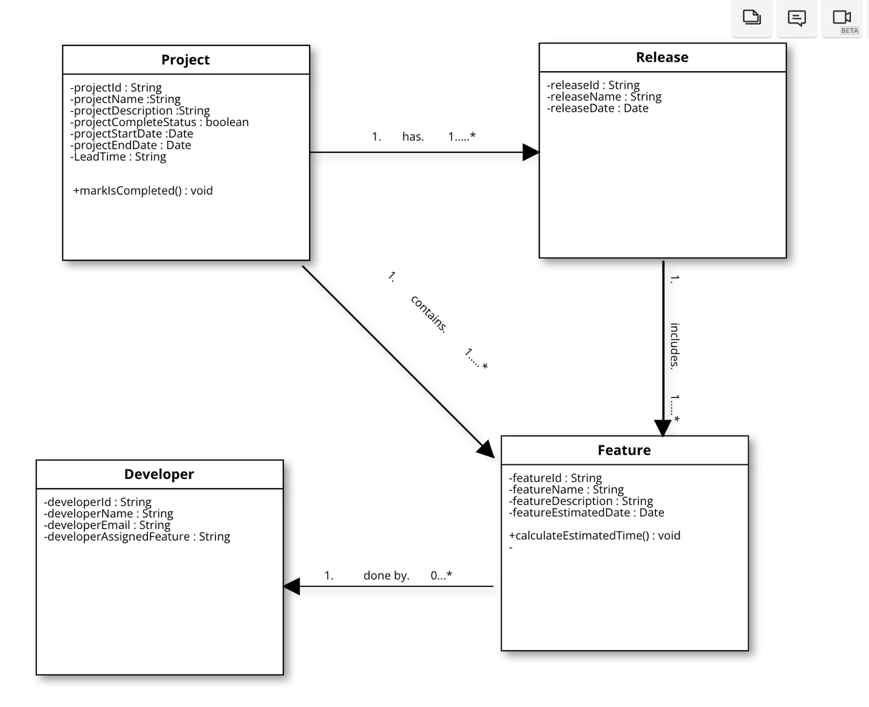

Problem 2A:

https://github.com/rudro54/MPPLabTwo

Problem 2B :

https://github.com/rudro54/MPPLabTwo

Problem 3A :

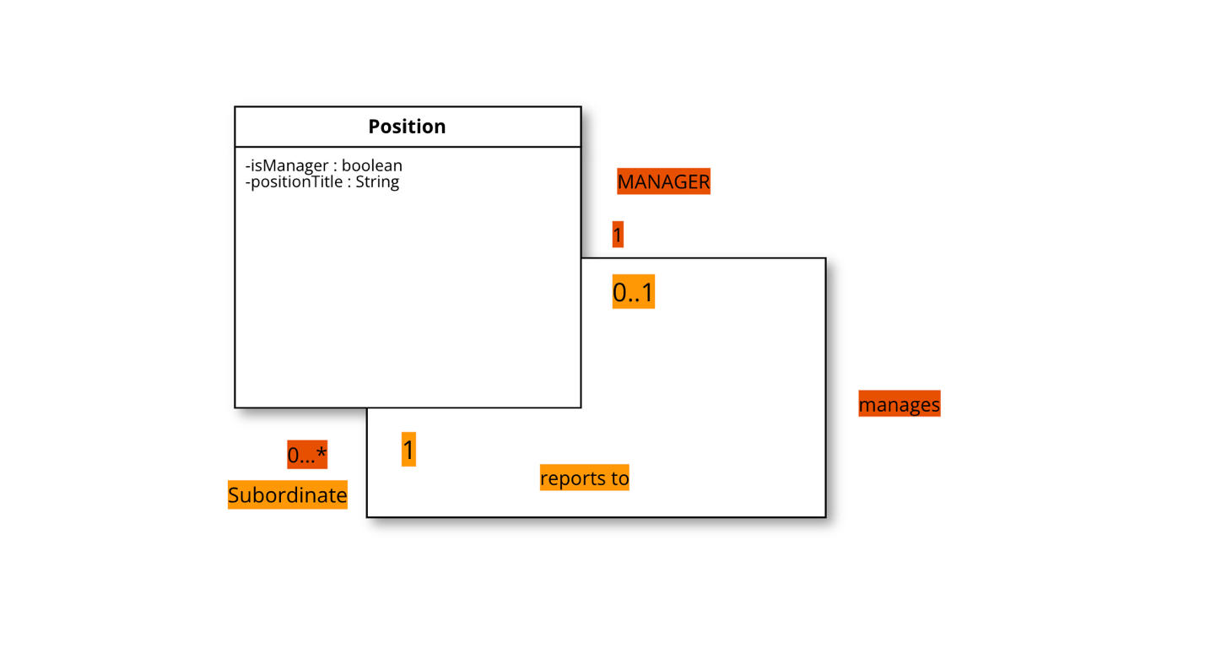

Problem 3B :

