Select \*

Into #T1 -- in tempDB

From ….

-------------------------

Select \*

Into #T2

From #T1 inner join ….

Select \*

From #T2 inner join #T1

\*\*\*\*\*\*\*\*\*\*\*\*\*\*\*\*\*\*\*\*\*\*\*\*\*\*\*\*\*\*\*\*\*\*\*\*\*\*\*\*\*

Anomaly - unusual situation in this case creating something bad.

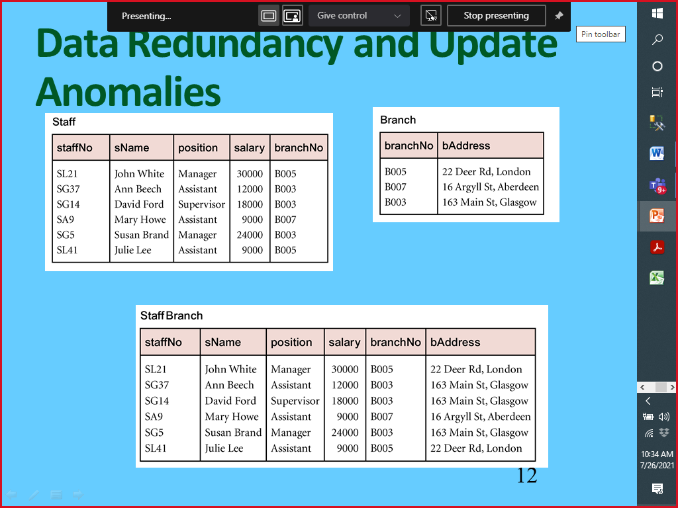

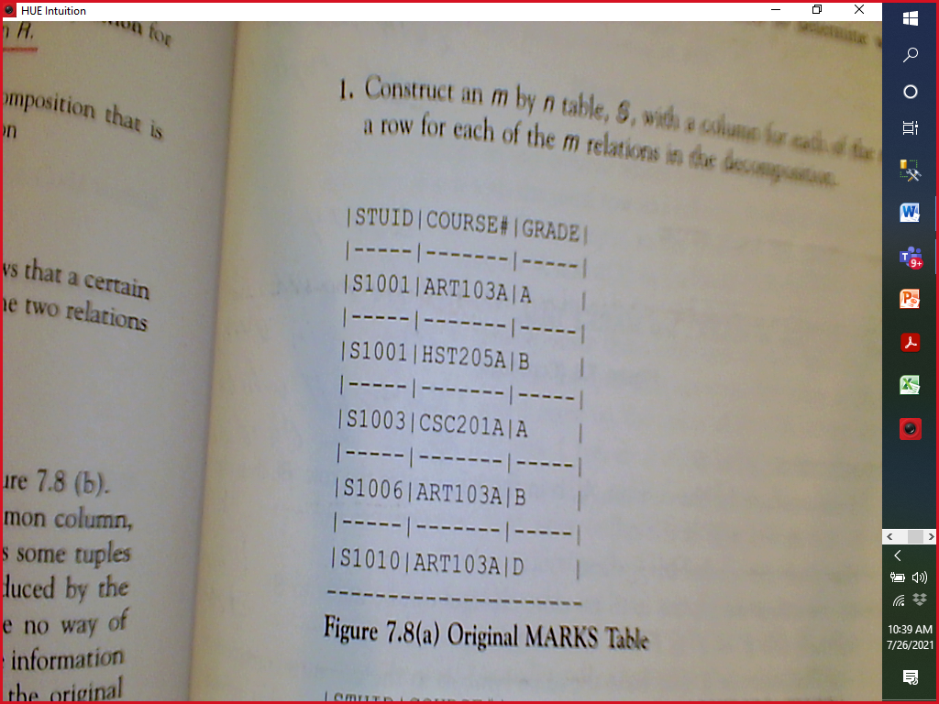

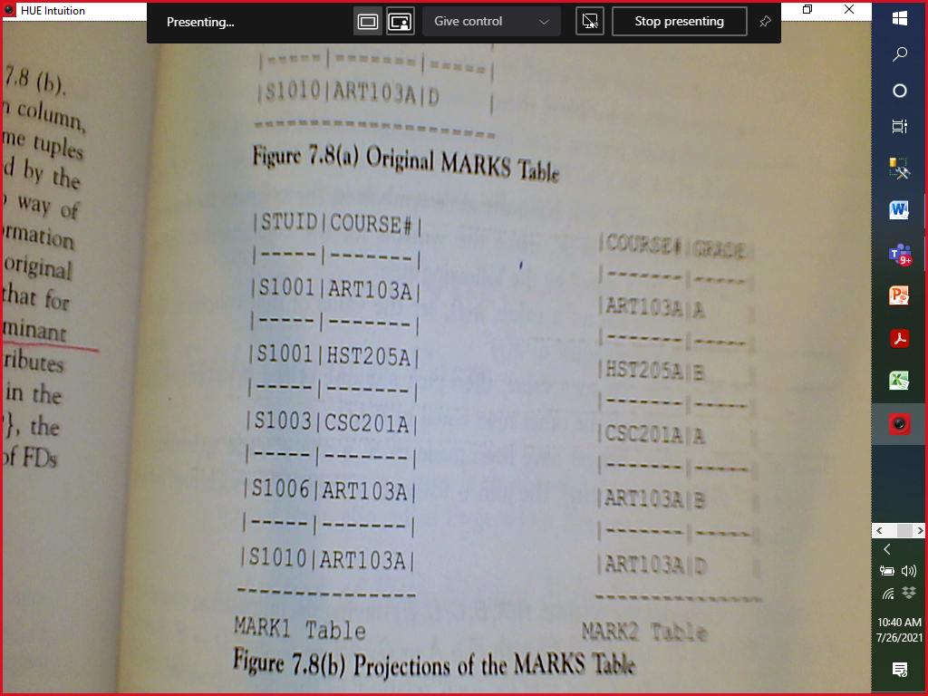

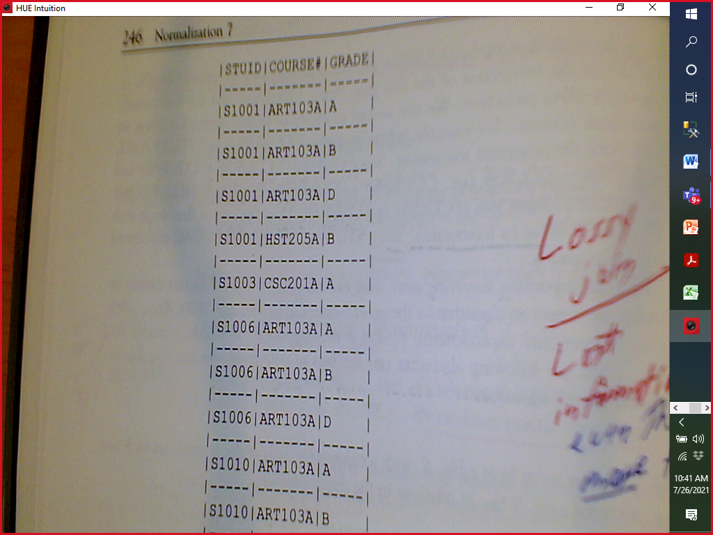

staffNo, address -> branchNo

staffNo -> branchNo