#moharishiSolveWithExplanations :

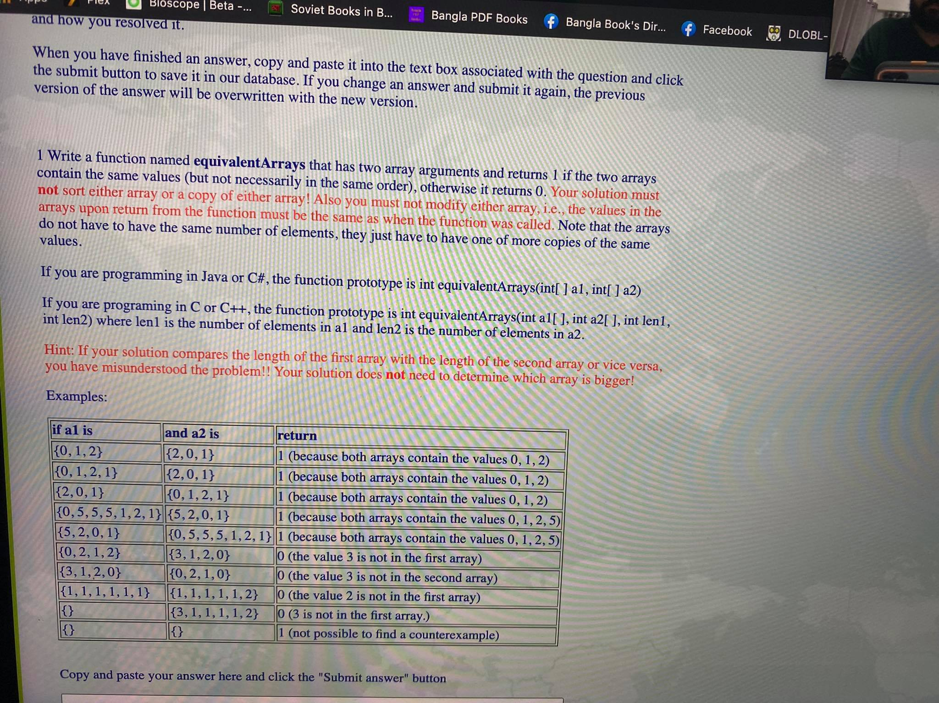

Brute Force :

package com.test;  
  
public class equivalentArraysFirstQuestion {  
  
 public static int equivalentArrays(int[]a1, int[]a2){  
  
 for(int i=0; i<a1.length; i++){  
 boolean matched = false;  
 for(int j=0; j<a2.length; j++){  
 if(a1[i]==a2[j]){  
 matched=true;  
 break; // so that no more checking is needed anymore for a1[i] with a2[j]  
  
 }  
 }  
 if(!matched){ // we kept this inside this loop of i cause if any of j not matched only then this will be needed and no further checking is required.  
 return 0;  
 }  
 }  
  
 for(int i=0; i<a2.length; i++){  
 boolean matched =false;  
 for(int j=0; j<a1.length; j++){  
 if(a2[i]==a1[j]){  
 matched=true;  
 break;  
 }  
  
 }  
 if(!matched){  
 return 0;  
 }  
 }  
 return 1;  
  
 }  
 public static void main(String[] args) {  
  
 System.*out*.println(*equivalentArrays*(new int[]{0,1,2}, new int[]{2,0,1}));  
 System.*out*.println(*equivalentArrays*(new int[]{0,1,2,1}, new int[]{2,0,1}));  
 System.*out*.println(*equivalentArrays*(new int[]{2,0,1}, new int[]{0,1,2,1}));  
 System.*out*.println(*equivalentArrays*(new int[]{0,5,5,5,1,2,1}, new int[]{5,2,0,1}));  
 System.*out*.println(*equivalentArrays*(new int[]{5,2,0,1}, new int[]{0,5,5,5,1,2,1}));  
 System.*out*.println(*equivalentArrays*(new int[]{0,2,1,2}, new int[]{3,1,2,0}));  
 System.*out*.println(*equivalentArrays*(new int[]{3,1,2,0}, new int[]{0,2,1,0}));  
 System.*out*.println(*equivalentArrays*(new int[]{1,1,1,1,1,1}, new int[]{1,1,1,1,1,2}));  
 System.*out*.println(*equivalentArrays*(new int[]{}, new int[]{3,1,1,1,1,2}));  
 System.*out*.println(*equivalentArrays*(new int[]{}, new int[]{}));  
  
  
 }  
  
}

/Library/Java/JavaVirtualMachines/jdk-17.0.1.jdk/Contents/Home/bin/java -javaagent:/Users/zayedabdullah/Library/Application Support/JetBrains/Toolbox/apps/IDEA-C/ch-0/213.6461.79/IntelliJ IDEA CE.app/Contents/lib/idea_rt.jar=54743:/Users/zayedabdullah/Library/Application Support/JetBrains/Toolbox/apps/IDEA-C/ch-0/213.6461.79/IntelliJ IDEA CE.app/Contents/bin -Dfile.encoding=UTF-8 -classpath /Users/zayedabdullah/IdeaProjects/moharishiProblems/out/production/moharishiProblems com.test.equivalentArraysFirstQuestion

1

1

1

1

1

0

0

0

0

1

Process finished with exit code 0

package com.test;  
import java.util.HashMap;  
  
public class equivalentArraysFirstQuestionOptimized {  
  
 public static int equivalentArrays(int[]a1, int[]a2){  
  
 HashMap<Integer,Boolean>memory1 = new HashMap<Integer,Boolean>();  
 HashMap<Integer,Boolean>memory2 = new HashMap<Integer,Boolean>();  
 int counter1=0,counter2=0;  
  
 for(int i=0; i<a1.length; i++){  
 if(!memory1.containsKey(a1[i])){  
 counter1++;  
 memory1.put(a1[i],true);  
 }  
 }  
 for(int i=0; i<a2.length; i++){  
 if(!memory1.containsKey(a2[i])){  
 return 0;  
 }  
 else {  
 if(!memory2.containsKey(a2[i])){  
  
 counter2++;  
 }  
 }  
 memory2.put(a2[i],true);  
  
 }  
 if(counter1!=counter2){  
 return 0;  
 }  
 return 1;  
 }  
 public static void main(String[] args) {  
  
 System.*out*.println(*equivalentArrays*(new int[]{0,1,2}, new int[]{2,0,1}));  
 System.*out*.println(*equivalentArrays*(new int[]{0,1,2,1}, new int[]{2,0,1}));  
 System.*out*.println(*equivalentArrays*(new int[]{2,0,1}, new int[]{0,1,2,1}));  
 System.*out*.println(*equivalentArrays*(new int[]{0,5,5,5,1,2,1}, new int[]{5,2,0,1}));  
 System.*out*.println(*equivalentArrays*(new int[]{5,2,0,1}, new int[]{0,5,5,5,1,2,1}));  
 System.*out*.println(*equivalentArrays*(new int[]{0,2,1,2}, new int[]{3,1,2,0}));  
 System.*out*.println(*equivalentArrays*(new int[]{3,1,2,0}, new int[]{0,2,1,0}));  
 System.*out*.println(*equivalentArrays*(new int[]{1,1,1,1,1,1}, new int[]{1,1,1,1,1,2}));  
 System.*out*.println(*equivalentArrays*(new int[]{}, new int[]{3,1,1,1,1,2}));  
 System.*out*.println(*equivalentArrays*(new int[]{}, new int[]{}));  
  
  
 }  
  
}

/Library/Java/JavaVirtualMachines/jdk-17.0.1.jdk/Contents/Home/bin/java -javaagent:/Users/zayedabdullah/Library/Application Support/JetBrains/Toolbox/apps/IDEA-C/ch-0/213.6461.79/IntelliJ IDEA CE.app/Contents/lib/idea_rt.jar=55108:/Users/zayedabdullah/Library/Application Support/JetBrains/Toolbox/apps/IDEA-C/ch-0/213.6461.79/IntelliJ IDEA CE.app/Contents/bin -Dfile.encoding=UTF-8 -classpath /Users/zayedabdullah/IdeaProjects/moharishiProblems/out/production/moharishiProblems com.test.equivalentArraysFirstQuestionBruteForce

1

1

1

1

1

0

0

0

0

1

Process finished with exit code 0

package com.test;  
  
public class equivalentArrayThirdWay {  
  
 public static int equivalentArrays(int[]a1, int[]a2){  
 int[] flag = new int[a2.length];  
 for(int i=0; i<flag.length; i++){  
 flag[i]=0;  
 }  
  
 for(int i=0; i<a1.length; i++){  
 int temp=0;  
 for(int j=0; j<a2.length; j++){  
 if(a1[i]==a2[j]){  
 flag[j]=1;  
 temp=1;  
 }  
 }  
 if(temp==0){  
 return 0;  
 }  
 }  
 for( int i=0; i<flag.length; i++){  
 if(flag[i]==0){  
 return 0;  
 }  
 }  
 return 1;  
  
 }  
 public static void main(String[] args) {  
  
 System.*out*.println(*equivalentArrays*(new int[]{0,1,2}, new int[]{2,0,1}));  
 System.*out*.println(*equivalentArrays*(new int[]{0,1,2,1}, new int[]{2,0,1}));  
 System.*out*.println(*equivalentArrays*(new int[]{2,0,1}, new int[]{0,1,2,1}));  
 System.*out*.println(*equivalentArrays*(new int[]{0,5,5,5,1,2,1}, new int[]{5,2,0,1}));  
 System.*out*.println(*equivalentArrays*(new int[]{5,2,0,1}, new int[]{0,5,5,5,1,2,1}));  
 System.*out*.println(*equivalentArrays*(new int[]{0,2,1,2}, new int[]{3,1,2,0}));  
 System.*out*.println(*equivalentArrays*(new int[]{3,1,2,0}, new int[]{0,2,1,0}));  
 System.*out*.println(*equivalentArrays*(new int[]{1,1,1,1,1,1}, new int[]{1,1,1,1,1,2}));  
 System.*out*.println(*equivalentArrays*(new int[]{}, new int[]{3,1,1,1,1,2}));  
 System.*out*.println(*equivalentArrays*(new int[]{}, new int[]{}));  
  
 }  
  
}

/Library/Java/JavaVirtualMachines/jdk-17.0.1.jdk/Contents/Home/bin/java -javaagent:/Users/zayedabdullah/Library/Application Support/JetBrains/Toolbox/apps/IDEA-C/ch-0/213.6461.79/IntelliJ IDEA CE.app/Contents/lib/idea_rt.jar=56331:/Users/zayedabdullah/Library/Application Support/JetBrains/Toolbox/apps/IDEA-C/ch-0/213.6461.79/IntelliJ IDEA CE.app/Contents/bin -Dfile.encoding=UTF-8 -classpath /Users/zayedabdullah/IdeaProjects/moharishiProblems/out/production/moharishiProblems com.test.equivalentArrayThirdWay

1

1

1

1

1

0

0

0

0

1

Process finished with exit code 0

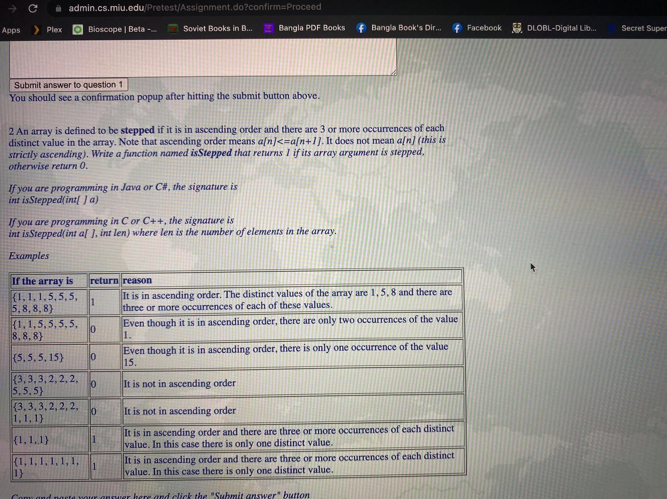

package com.test;  
  
public class isSteppedArraySecondQuestion {  
  
 public static int isStepped(int[] a){  
 int firstElement =a[0];  
 int counter =1;  
  
 for(int i=1; i<a.length; i++){  
 if(firstElement==a[i]){  
 counter++;  
 firstElement=a[i];  
 }  
 else if(counter>=3 && firstElement<a[i]){  
 counter=1;  
 firstElement=a[i];  
 }  
 else {  
 return 0;  
 }  
 }  
 if(counter<3){  
 return 0;  
 }  
 return 1;  
  
 }  
  
 public static void main(String[] args) {  
  
 System.*out*.println(*isStepped*(new int[]{1,1,1,5,5,5,5,8,8,8}));  
 System.*out*.println(*isStepped*(new int[]{1,1,5,5,5,5,5,8,8,8}));  
 System.*out*.println(*isStepped*(new int[]{5,5,5,5,15}));  
 System.*out*.println(*isStepped*(new int[]{3,3,3,2,2,5,5,5,5,5}));  
 System.*out*.println(*isStepped*(new int[]{3,3,3,2,2,2,1,1,1}));  
 System.*out*.println(*isStepped*(new int[]{1,1,1,1}));  
 System.*out*.println(*isStepped*(new int[]{1,1,1,1,1,1,1}));  
  
  
 }  
}

/Library/Java/JavaVirtualMachines/jdk-17.0.1.jdk/Contents/Home/bin/java -javaagent:/Users/zayedabdullah/Library/Application Support/JetBrains/Toolbox/apps/IDEA-C/ch-0/213.6461.79/IntelliJ IDEA CE.app/Contents/lib/idea_rt.jar=56410:/Users/zayedabdullah/Library/Application Support/JetBrains/Toolbox/apps/IDEA-C/ch-0/213.6461.79/IntelliJ IDEA CE.app/Contents/bin -Dfile.encoding=UTF-8 -classpath /Users/zayedabdullah/IdeaProjects/moharishiProblems/out/production/moharishiProblems com.test.isSteppedArraySecondQuestion

1

0

0

0

0

1

1

Process finished with exit code 0

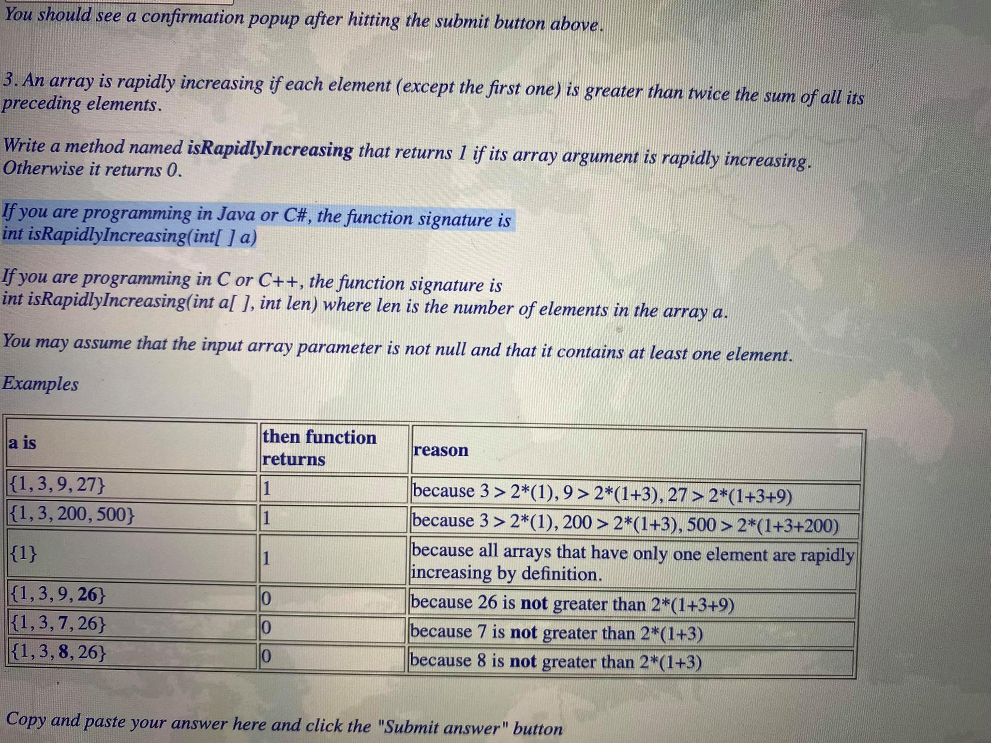

package com.test;  
  
public class isRapidlyIncreasing {  
  
 public static int isRapidlyIncreasing(int[] a){  
 int firstElement =a[0];  
 int sum=0;  
  
 for(int i=1; i<a.length; i++){  
 if(a[i]>2*(firstElement+sum)){  
 sum=sum+firstElement;  
 firstElement=a[i];  
 }  
 else {  
 return 0;  
 }  
 }  
 return 1;  
  
 }  
 public static void main(String[] args) {  
  
 System.*out*.println(*isRapidlyIncreasing*( new int[]{1,3,9,27}));  
 System.*out*.println(*isRapidlyIncreasing*( new int[]{1,3,200,500}));  
 System.*out*.println(*isRapidlyIncreasing*( new int[]{1}));  
 System.*out*.println(*isRapidlyIncreasing*( new int[]{1,3,9,26}));  
 System.*out*.println(*isRapidlyIncreasing*( new int[]{1,3,7,26}));  
 System.*out*.println(*isRapidlyIncreasing*( new int[]{1,3,8,26}));  
  
  
 }  
}

/Library/Java/JavaVirtualMachines/jdk-17.0.1.jdk/Contents/Home/bin/java -javaagent:/Users/zayedabdullah/Library/Application Support/JetBrains/Toolbox/apps/IDEA-C/ch-0/213.6461.79/IntelliJ IDEA CE.app/Contents/lib/idea_rt.jar=56559:/Users/zayedabdullah/Library/Application Support/JetBrains/Toolbox/apps/IDEA-C/ch-0/213.6461.79/IntelliJ IDEA CE.app/Contents/bin -Dfile.encoding=UTF-8 -classpath /Users/zayedabdullah/IdeaProjects/moharishiProblems/out/production/moharishiProblems com.test.isRapidlyIncreasing

1

1

1

0

0

0

Process finished with exit code 0