#moharishiSolveWithExplanations :

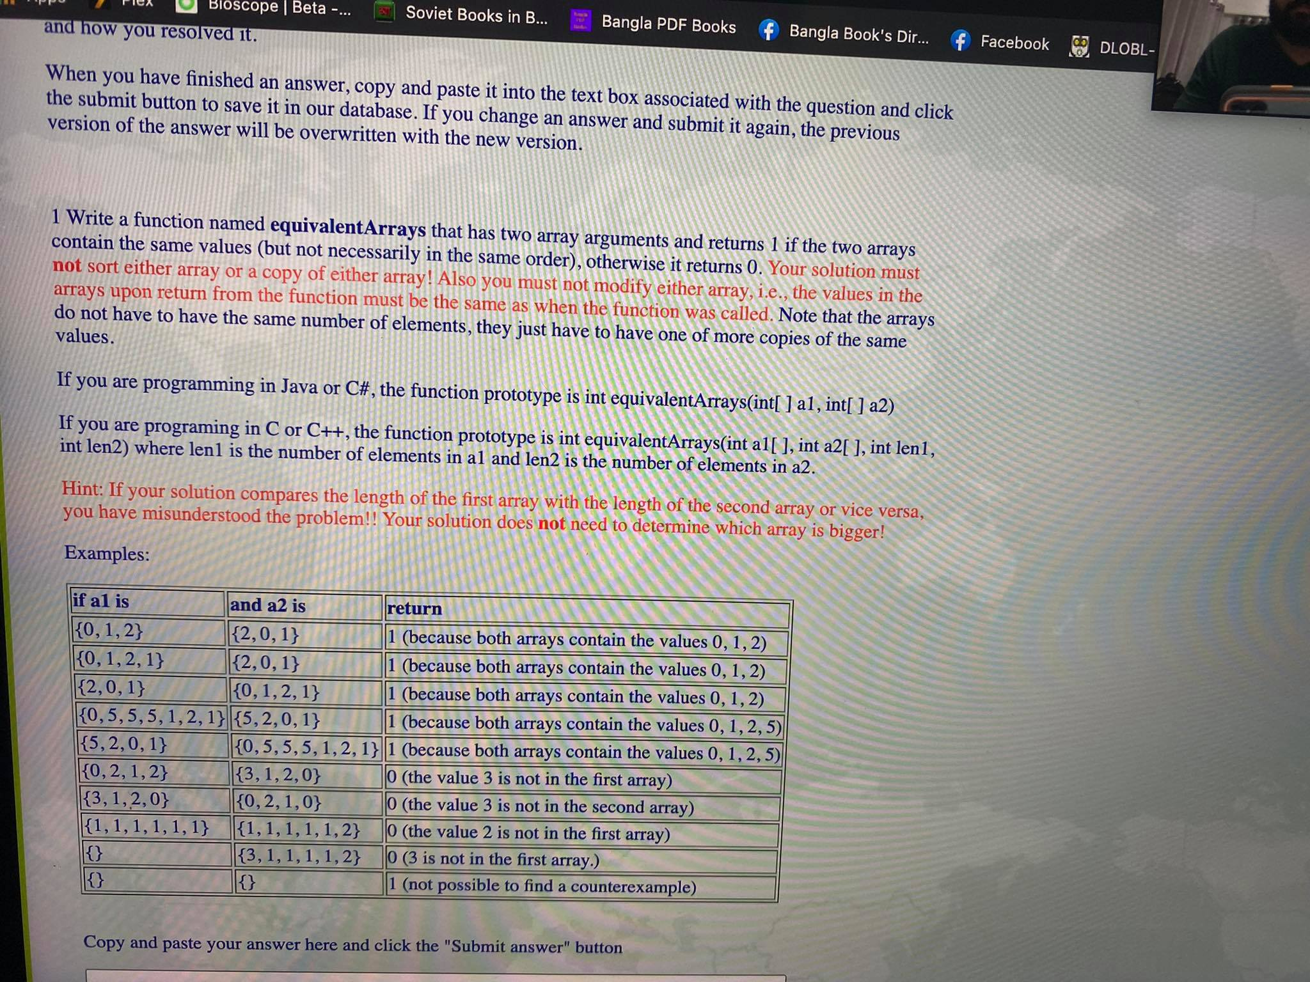

Brute Force :

package com.test;  
  
public class equivalentArraysFirstQuestion {  
  
 public static int equivalentArrays(int[]a1, int[]a2){  
  
 for(int i=0; i<a1.length; i++){  
 boolean matched = false;  
 for(int j=0; j<a2.length; j++){  
 if(a1[i]==a2[j]){  
 matched=true;  
 break; // so that no more checking is needed anymore for a1[i] with a2[j]  
  
 }  
 }  
 if(!matched){ // we kept this inside this loop of i cause if any of j not matched only then this will be needed and no further checking is required.  
 return 0;  
 }  
 }  
  
 for(int i=0; i<a2.length; i++){  
 boolean matched =false;  
 for(int j=0; j<a1.length; j++){  
 if(a2[i]==a1[j]){  
 matched=true;  
 break;  
 }  
  
 }  
 if(!matched){  
 return 0;  
 }  
 }  
 return 1;  
  
 }  
 public static void main(String[] args) {  
  
 System.*out*.println(*equivalentArrays*(new int[]{0,1,2}, new int[]{2,0,1}));  
 System.*out*.println(*equivalentArrays*(new int[]{0,1,2,1}, new int[]{2,0,1}));  
 System.*out*.println(*equivalentArrays*(new int[]{2,0,1}, new int[]{0,1,2,1}));  
 System.*out*.println(*equivalentArrays*(new int[]{0,5,5,5,1,2,1}, new int[]{5,2,0,1}));  
 System.*out*.println(*equivalentArrays*(new int[]{5,2,0,1}, new int[]{0,5,5,5,1,2,1}));  
 System.*out*.println(*equivalentArrays*(new int[]{0,2,1,2}, new int[]{3,1,2,0}));  
 System.*out*.println(*equivalentArrays*(new int[]{3,1,2,0}, new int[]{0,2,1,0}));  
 System.*out*.println(*equivalentArrays*(new int[]{1,1,1,1,1,1}, new int[]{1,1,1,1,1,2}));  
 System.*out*.println(*equivalentArrays*(new int[]{}, new int[]{3,1,1,1,1,2}));  
 System.*out*.println(*equivalentArrays*(new int[]{}, new int[]{}));  
  
  
 }  
  
}

/Library/Java/JavaVirtualMachines/jdk-17.0.1.jdk/Contents/Home/bin/java -javaagent:/Users/zayedabdullah/Library/Application Support/JetBrains/Toolbox/apps/IDEA-C/ch-0/213.6461.79/IntelliJ IDEA CE.app/Contents/lib/idea_rt.jar=54743:/Users/zayedabdullah/Library/Application Support/JetBrains/Toolbox/apps/IDEA-C/ch-0/213.6461.79/IntelliJ IDEA CE.app/Contents/bin -Dfile.encoding=UTF-8 -classpath /Users/zayedabdullah/IdeaProjects/moharishiProblems/out/production/moharishiProblems com.test.equivalentArraysFirstQuestion

1

1

1

1

1

0

0

0

0

1

Process finished with exit code 0

package com.test;  
import java.util.HashMap;  
  
public class equivalentArraysFirstQuestionOptimized {  
  
 public static int equivalentArrays(int[]a1, int[]a2){  
  
 HashMap<Integer,Boolean>memory1 = new HashMap<Integer,Boolean>();  
 HashMap<Integer,Boolean>memory2 = new HashMap<Integer,Boolean>();  
 int counter1=0,counter2=0;  
  
 for(int i=0; i<a1.length; i++){  
 if(!memory1.containsKey(a1[i])){  
 counter1++;  
 memory1.put(a1[i],true);  
 }  
 }  
 for(int i=0; i<a2.length; i++){  
 if(!memory1.containsKey(a2[i])){  
 return 0;  
 }  
 else {  
 if(!memory2.containsKey(a2[i])){  
  
 counter2++;  
 }  
 }  
 memory2.put(a2[i],true);  
  
 }  
 if(counter1!=counter2){  
 return 0;  
 }  
 return 1;  
 }  
 public static void main(String[] args) {  
  
 System.*out*.println(*equivalentArrays*(new int[]{0,1,2}, new int[]{2,0,1}));  
 System.*out*.println(*equivalentArrays*(new int[]{0,1,2,1}, new int[]{2,0,1}));  
 System.*out*.println(*equivalentArrays*(new int[]{2,0,1}, new int[]{0,1,2,1}));  
 System.*out*.println(*equivalentArrays*(new int[]{0,5,5,5,1,2,1}, new int[]{5,2,0,1}));  
 System.*out*.println(*equivalentArrays*(new int[]{5,2,0,1}, new int[]{0,5,5,5,1,2,1}));  
 System.*out*.println(*equivalentArrays*(new int[]{0,2,1,2}, new int[]{3,1,2,0}));  
 System.*out*.println(*equivalentArrays*(new int[]{3,1,2,0}, new int[]{0,2,1,0}));  
 System.*out*.println(*equivalentArrays*(new int[]{1,1,1,1,1,1}, new int[]{1,1,1,1,1,2}));  
 System.*out*.println(*equivalentArrays*(new int[]{}, new int[]{3,1,1,1,1,2}));  
 System.*out*.println(*equivalentArrays*(new int[]{}, new int[]{}));  
  
  
 }  
  
}

/Library/Java/JavaVirtualMachines/jdk-17.0.1.jdk/Contents/Home/bin/java -javaagent:/Users/zayedabdullah/Library/Application Support/JetBrains/Toolbox/apps/IDEA-C/ch-0/213.6461.79/IntelliJ IDEA CE.app/Contents/lib/idea_rt.jar=55108:/Users/zayedabdullah/Library/Application Support/JetBrains/Toolbox/apps/IDEA-C/ch-0/213.6461.79/IntelliJ IDEA CE.app/Contents/bin -Dfile.encoding=UTF-8 -classpath /Users/zayedabdullah/IdeaProjects/moharishiProblems/out/production/moharishiProblems com.test.equivalentArraysFirstQuestionBruteForce

1

1

1

1

1

0

0

0

0

1

Process finished with exit code 0

package com.test;  
  
public class equivalentArrayThirdWay {  
  
 public static int equivalentArrays(int[]a1, int[]a2){  
 int[] flag = new int[a2.length];  
 for(int i=0; i<flag.length; i++){  
 flag[i]=0;  
 }  
  
 for(int i=0; i<a1.length; i++){  
 int temp=0;  
 for(int j=0; j<a2.length; j++){  
 if(a1[i]==a2[j]){  
 flag[j]=1;  
 temp=1;  
 }  
 }  
 if(temp==0){  
 return 0;  
 }  
 }  
 for( int i=0; i<flag.length; i++){  
 if(flag[i]==0){  
 return 0;  
 }  
 }  
 return 1;  
  
 }  
 public static void main(String[] args) {  
  
 System.*out*.println(*equivalentArrays*(new int[]{0,1,2}, new int[]{2,0,1}));  
 System.*out*.println(*equivalentArrays*(new int[]{0,1,2,1}, new int[]{2,0,1}));  
 System.*out*.println(*equivalentArrays*(new int[]{2,0,1}, new int[]{0,1,2,1}));  
 System.*out*.println(*equivalentArrays*(new int[]{0,5,5,5,1,2,1}, new int[]{5,2,0,1}));  
 System.*out*.println(*equivalentArrays*(new int[]{5,2,0,1}, new int[]{0,5,5,5,1,2,1}));  
 System.*out*.println(*equivalentArrays*(new int[]{0,2,1,2}, new int[]{3,1,2,0}));  
 System.*out*.println(*equivalentArrays*(new int[]{3,1,2,0}, new int[]{0,2,1,0}));  
 System.*out*.println(*equivalentArrays*(new int[]{1,1,1,1,1,1}, new int[]{1,1,1,1,1,2}));  
 System.*out*.println(*equivalentArrays*(new int[]{}, new int[]{3,1,1,1,1,2}));  
 System.*out*.println(*equivalentArrays*(new int[]{}, new int[]{}));  
  
 }  
  
}

/Library/Java/JavaVirtualMachines/jdk-17.0.1.jdk/Contents/Home/bin/java -javaagent:/Users/zayedabdullah/Library/Application Support/JetBrains/Toolbox/apps/IDEA-C/ch-0/213.6461.79/IntelliJ IDEA CE.app/Contents/lib/idea_rt.jar=56331:/Users/zayedabdullah/Library/Application Support/JetBrains/Toolbox/apps/IDEA-C/ch-0/213.6461.79/IntelliJ IDEA CE.app/Contents/bin -Dfile.encoding=UTF-8 -classpath /Users/zayedabdullah/IdeaProjects/moharishiProblems/out/production/moharishiProblems com.test.equivalentArrayThirdWay

1

1

1

1

1

0

0

0

0

1

Process finished with exit code 0

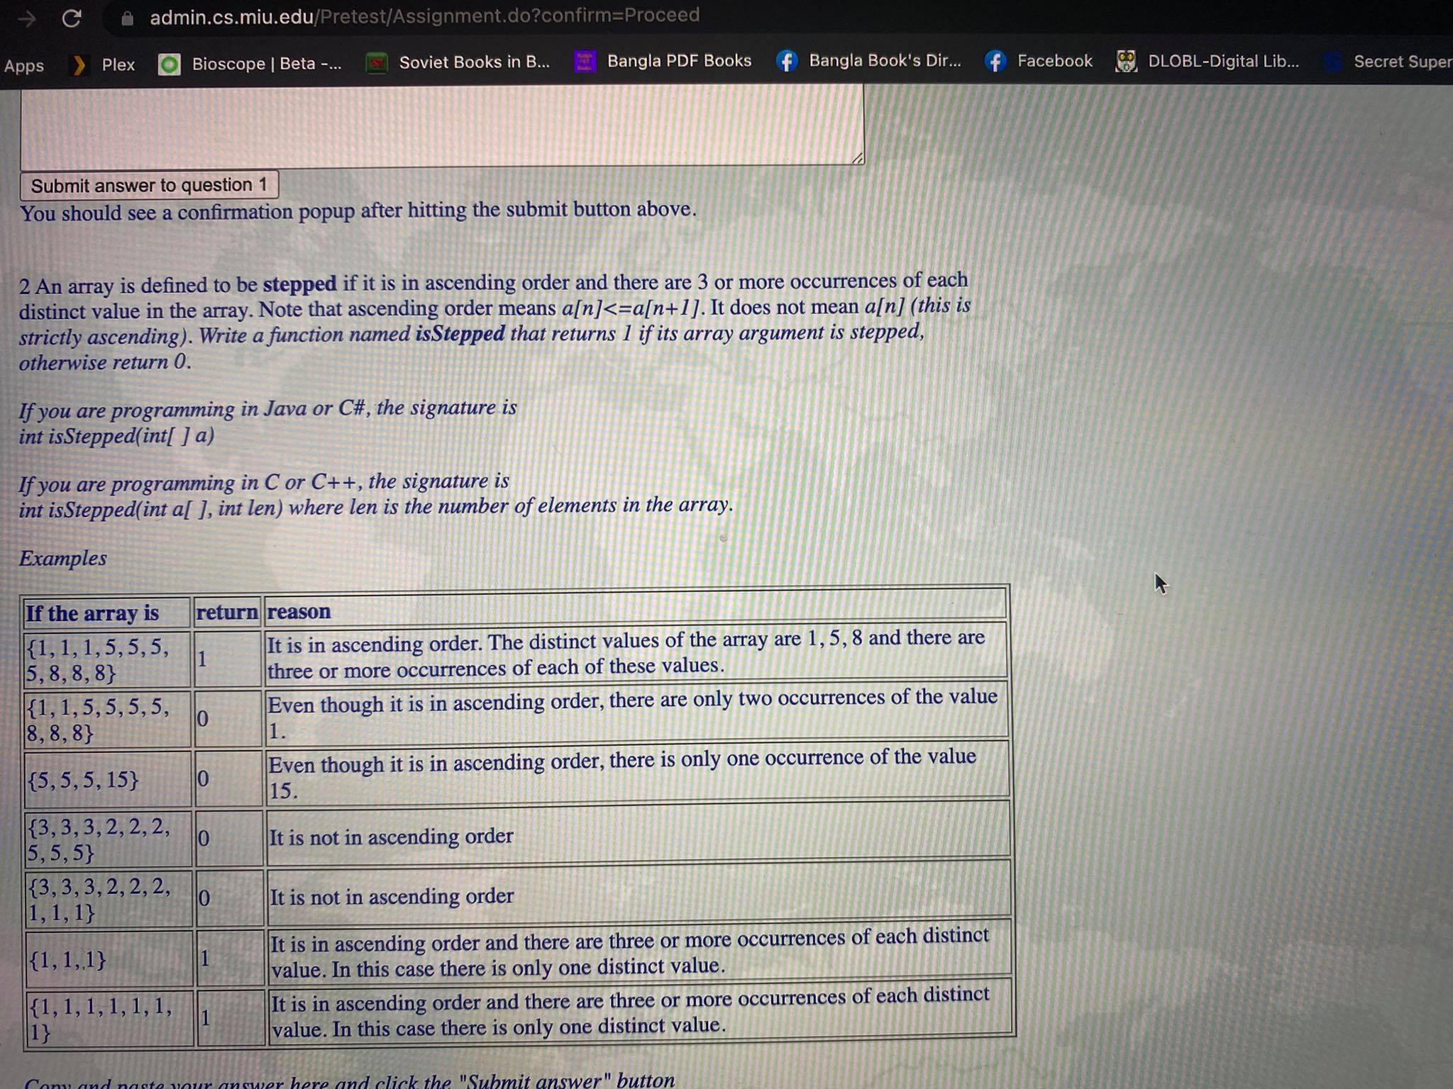

package com.test;  
  
public class isSteppedArraySecondQuestion {  
  
 public static int isStepped(int[] a){  
 int firstElement =a[0];  
 int counter =1;  
  
 for(int i=1; i<a.length; i++){  
 if(firstElement==a[i]){  
 counter++;  
 firstElement=a[i];  
 }  
 else if(counter>=3 && firstElement<a[i]){  
 counter=1;  
 firstElement=a[i];  
 }  
 else {  
 return 0;  
 }  
 }  
 if(counter<3){  
 return 0;  
 }  
 return 1;  
  
 }  
  
 public static void main(String[] args) {  
  
 System.*out*.println(*isStepped*(new int[]{1,1,1,5,5,5,5,8,8,8}));  
 System.*out*.println(*isStepped*(new int[]{1,1,5,5,5,5,5,8,8,8}));  
 System.*out*.println(*isStepped*(new int[]{5,5,5,5,15}));  
 System.*out*.println(*isStepped*(new int[]{3,3,3,2,2,5,5,5,5,5}));  
 System.*out*.println(*isStepped*(new int[]{3,3,3,2,2,2,1,1,1}));  
 System.*out*.println(*isStepped*(new int[]{1,1,1,1}));  
 System.*out*.println(*isStepped*(new int[]{1,1,1,1,1,1,1}));  
  
  
 }  
}

/Library/Java/JavaVirtualMachines/jdk-17.0.1.jdk/Contents/Home/bin/java -javaagent:/Users/zayedabdullah/Library/Application Support/JetBrains/Toolbox/apps/IDEA-C/ch-0/213.6461.79/IntelliJ IDEA CE.app/Contents/lib/idea_rt.jar=56410:/Users/zayedabdullah/Library/Application Support/JetBrains/Toolbox/apps/IDEA-C/ch-0/213.6461.79/IntelliJ IDEA CE.app/Contents/bin -Dfile.encoding=UTF-8 -classpath /Users/zayedabdullah/IdeaProjects/moharishiProblems/out/production/moharishiProblems com.test.isSteppedArraySecondQuestion

1

0

0

0

0

1

1

Process finished with exit code 0

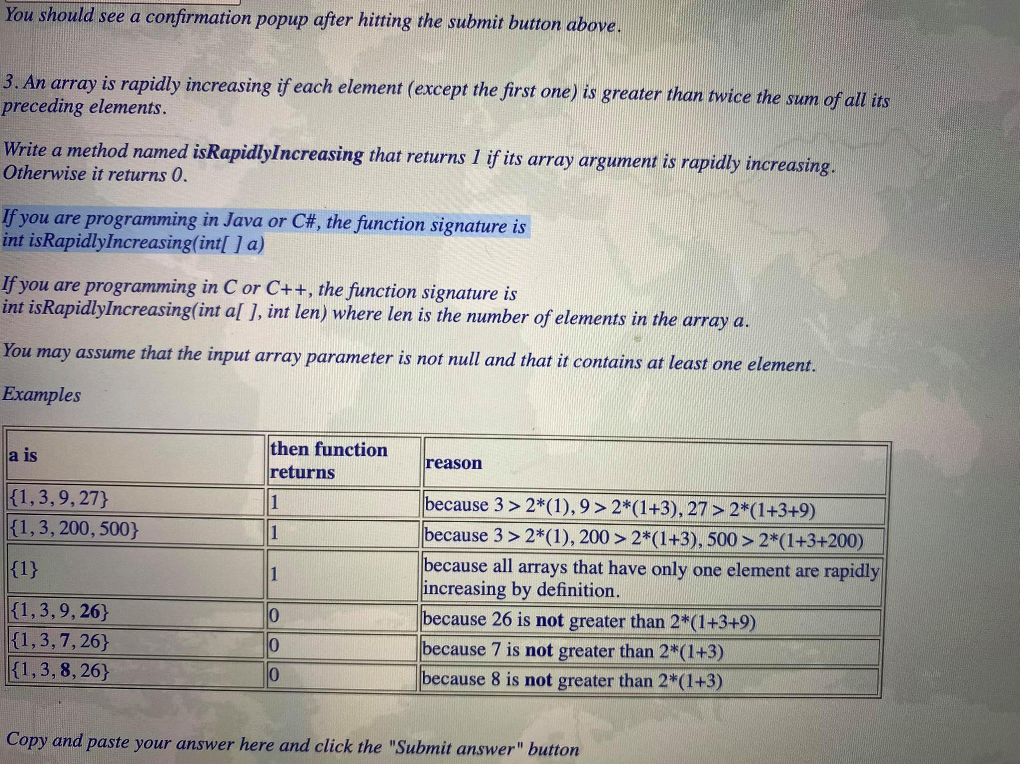

package com.test;  
  
public class isRapidlyIncreasing {  
  
 public static int isRapidlyIncreasing(int[] a){  
 int firstElement =a[0];  
 int sum=0;  
  
 for(int i=1; i<a.length; i++){  
 if(a[i]>2*(firstElement+sum)){  
 sum=sum+firstElement;  
 firstElement=a[i];  
 }  
 else {  
 return 0;  
 }  
 }  
 return 1;  
  
 }  
 public static void main(String[] args) {  
  
 System.*out*.println(*isRapidlyIncreasing*( new int[]{1,3,9,27}));  
 System.*out*.println(*isRapidlyIncreasing*( new int[]{1,3,200,500}));  
 System.*out*.println(*isRapidlyIncreasing*( new int[]{1}));  
 System.*out*.println(*isRapidlyIncreasing*( new int[]{1,3,9,26}));  
 System.*out*.println(*isRapidlyIncreasing*( new int[]{1,3,7,26}));  
 System.*out*.println(*isRapidlyIncreasing*( new int[]{1,3,8,26}));  
  
  
 }  
}

/Library/Java/JavaVirtualMachines/jdk-17.0.1.jdk/Contents/Home/bin/java -javaagent:/Users/zayedabdullah/Library/Application Support/JetBrains/Toolbox/apps/IDEA-C/ch-0/213.6461.79/IntelliJ IDEA CE.app/Contents/lib/idea_rt.jar=56559:/Users/zayedabdullah/Library/Application Support/JetBrains/Toolbox/apps/IDEA-C/ch-0/213.6461.79/IntelliJ IDEA CE.app/Contents/bin -Dfile.encoding=UTF-8 -classpath /Users/zayedabdullah/IdeaProjects/moharishiProblems/out/production/moharishiProblems com.test.isRapidlyIncreasing

1

1

1

0

0

0

Process finished with exit code 0

Sieve Of Eratosthenes Algorithm For Prime Numbers In A Range :

package com.test;  
  
import java.util.Arrays;  
  
public class sieveOfEratosthenes {  
  
 public static boolean[] sieveOfEratosthenes(int n){  
 boolean[] isPrime = new boolean[n+1];// to align numbers with index  
 Arrays.*fill*(isPrime, true);  
 isPrime[0]=false;  
 isPrime[1]=false;  
  
 for(int i=2; i*i<=n; i++){  
 for(int j= 2*i; j<=n; j+=i){  
 isPrime[j]=false;  
 }  
 }  
 return isPrime;  
  
 }  
  
 public static void printPrime (boolean[] a){  
  
 for(int i=0; i<a.length; i++){  
 if(a[i]==true){  
 System.*out*.print(i+" ,"+ " ");  
 }  
 }  
  
 }  
  
  
  
  
 public static void main(String[] args) {  
 boolean[] rangedNumber = *sieveOfEratosthenes*(12);  
 *printPrime*(rangedNumber);  
 }  
}

/Library/Java/JavaVirtualMachines/jdk-17.0.1.jdk/Contents/Home/bin/java -javaagent:/Users/zayedabdullah/Library/Application Support/JetBrains/Toolbox/apps/IDEA-C/ch-0/213.6461.79/IntelliJ IDEA CE.app/Contents/lib/idea_rt.jar=58208:/Users/zayedabdullah/Library/Application Support/JetBrains/Toolbox/apps/IDEA-C/ch-0/213.6461.79/IntelliJ IDEA CE.app/Contents/bin -Dfile.encoding=UTF-8 -classpath /Users/zayedabdullah/IdeaProjects/moharishiProblems/out/production/moharishiProblems com.test.sieveOfEratosthenes

2 , 3 , 5 , 7 , 11 ,

Process finished with exit code 0

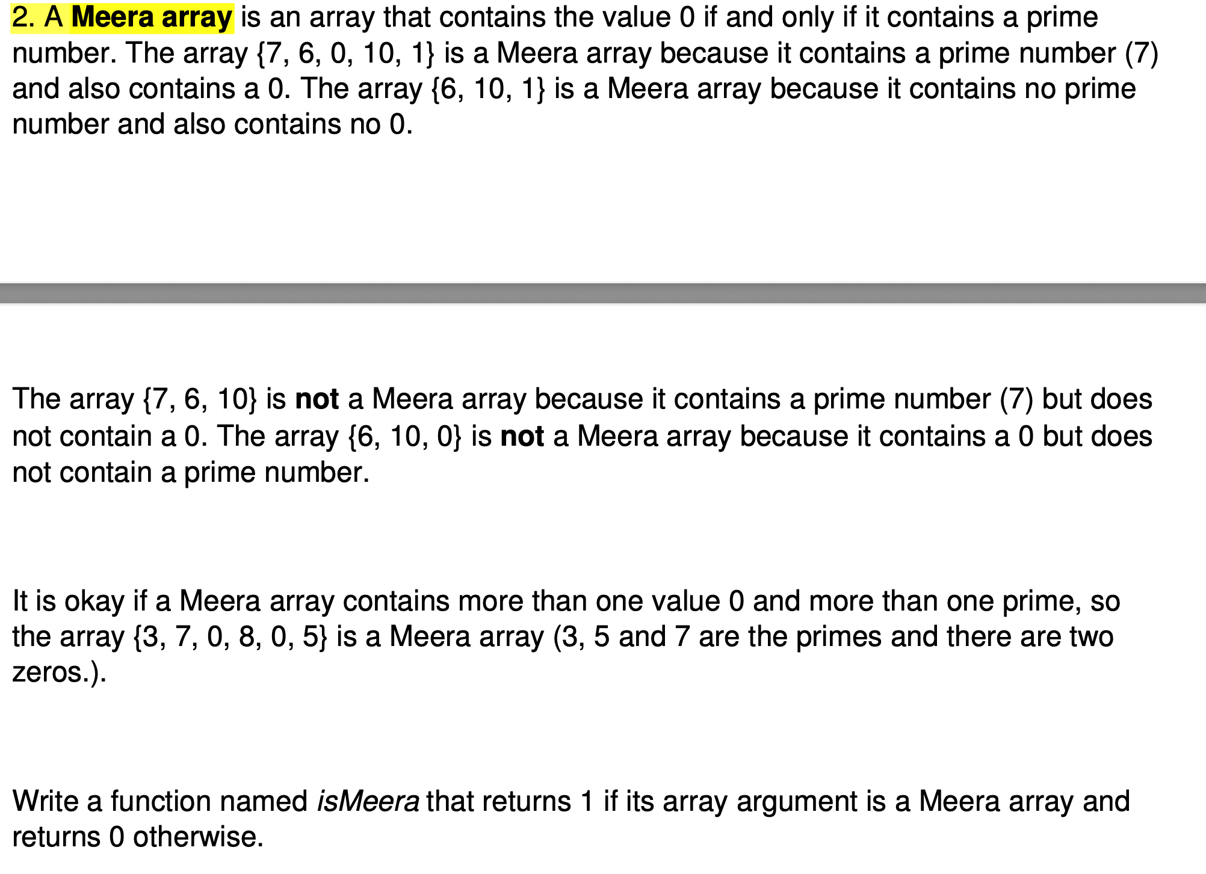

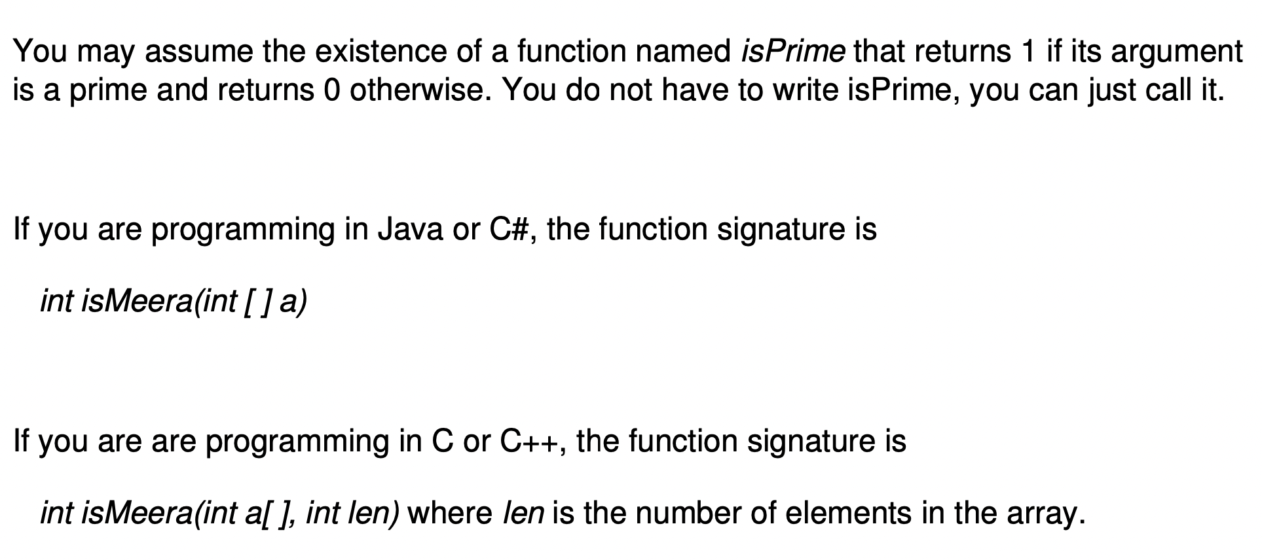

package com.test;  
  
public class meeraArrayWithPrimeNumberAndZero {  
  
 public static int isMeera(int[] a){  
 int isZeroThere =0;  
 int isPrimeThere =0;  
  
 for(int i=0; i<a.length; i++){  
 if(a[i]==0){  
 isZeroThere++;  
 }  
 else {  
 for(int j=2; j*j<a[i]; j++){ // i<root n  
 if(a[i]%j!=0){  
 isPrimeThere++;  
 break;  
 }  
 }  
 }  
 }  
 if((isPrimeThere>0 &&isZeroThere>0) ||( isPrimeThere==0 && isZeroThere==0)){  
 return 1;  
 }  
 return 0;  
  
 }  
  
  
 public static void main(String[] args) {  
  
 System.*out*.println(*isMeera*(new int[]{7,6,0,10,1}));  
 System.*out*.println(*isMeera*(new int[]{6,10,1}));  
 System.*out*.println(*isMeera*(new int[]{7,6,10}));  
 System.*out*.println(*isMeera*(new int[]{6,10,0}));  
 System.*out*.println(*isMeera*(new int[]{3,7,0,8,0,5}));  
  
 }  
}

/Library/Java/JavaVirtualMachines/jdk-17.0.1.jdk/Contents/Home/bin/java -javaagent:/Users/zayedabdullah/Library/Application Support/JetBrains/Toolbox/apps/IDEA-C/ch-0/213.6461.79/IntelliJ IDEA CE.app/Contents/lib/idea_rt.jar=64105:/Users/zayedabdullah/Library/Application Support/JetBrains/Toolbox/apps/IDEA-C/ch-0/213.6461.79/IntelliJ IDEA CE.app/Contents/bin -Dfile.encoding=UTF-8 -classpath /Users/zayedabdullah/IdeaProjects/moharishiProblems/out/production/moharishiProblems com.test.meeraArrayWithPrimeNumberAndZero

1

1

0

0

1

Process finished with exit code 0

1. A **Fibonacci number** is a number in the sequence 1, 1, 2, 3, 5, 8, 13, 21,.... Note that first two Fibonacci numbers are 1 and any Fibonacci number other than the first two is the sum ofthe previous two Fibonacci numbers. For example, 2 = 1 + 1, 3 = 2 + 1, 5 = 3 + 2 and so on.

Write a function named *isFibonacci* that returns 1 if its integer argument is a Fibonacci number, otherwise it returns 0.

The signature of the function is

*int isFibonacci (int n)*

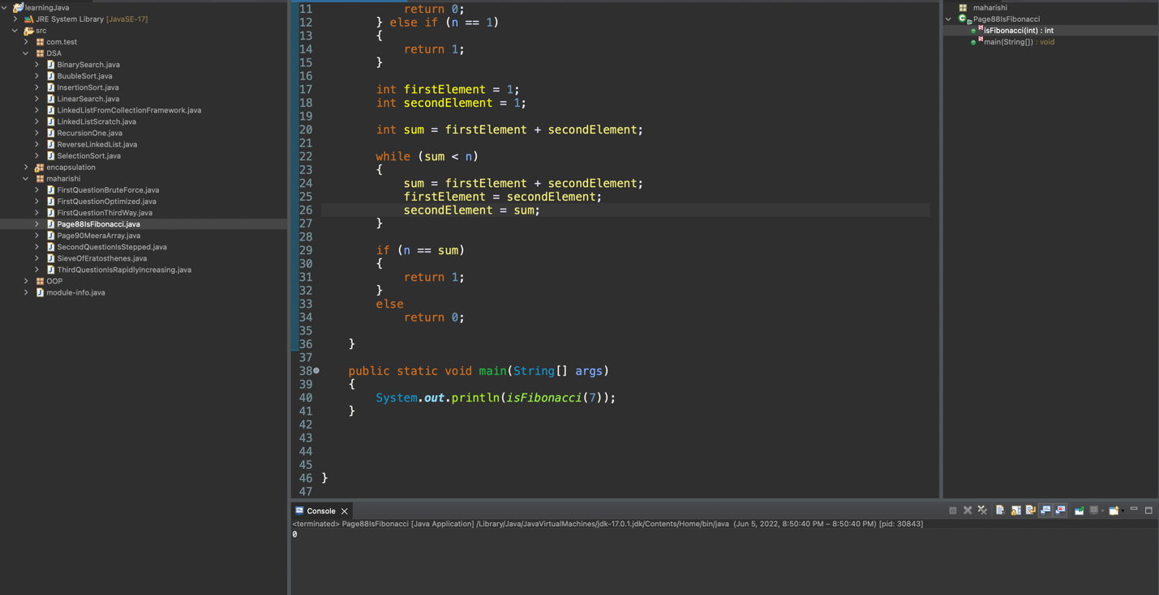

package maharishi;

public class Page88IsFibonacci

{

public static int isFibonacci(int n)

{

if (n == 0)

{

return 0;

} else if (n == 1)

{

return 1;

}

int firstElement = 1;

int secondElement = 1;

int sum = firstElement + secondElement;

while (sum < n)

{

sum = firstElement + secondElement;

firstElement = secondElement;

secondElement = sum;

}

if (n == sum)

{

return 1;

}

else

return 0;

}

public static void main(String[] args)

{

System.out.println(isFibonacci(7));

}

}

}

**Question 3.** An array is said to be hollow if it contains 3 or more zeros in the middle that are preceded and followed by the same number of non-zero elements. Write a function named isHollow that accepts an integer array and returns 1 if it is a hollow array, otherwise it returns 0. The function signature is

int isHollow(int[ ] a).

Examples: isHollow({1,2,4,0,0,0,3,4,5}) returns true. isHollow ({1,2,0,0,0,3,4,5}) returns false. : isHollow ({1,2,4,9, 0,0,0,3,4, 5}) returns false. isHollow ({1,2, 0,0, 3,4}) returns false.

package maharishi;

public class Page88isHollow

{

public static int isHollow(int[] a)

{

int zeroCount = 0;

int count = 0;

for (int i = 0; i < a.length; i++)

{

if (a[i] != 0)

{

count++;

} else

{

zeroCount++;

}

}

if (zeroCount >= 3 && count % 2 == 0)

{

if (zeroCount == count / 2)

{

return 1;

}

}

return 0;

}

public static void main(String[] args)

{

System.out.println(isHollow(new int[]

{ 1, 2, 3, 0, 0, 0, 3, 4, 5 }));

}

}