YOLO-ESCA: A High-Performance Safety Helmet Standard Wearing Behaviour Detection Model Based on Improved YOLOv5
In propose work author improving Yolov5 algorithm to predict helmet wearing behaviour of industrial workers. If they are wearing correctly then improved YOLO will detect as Helmet else detected as Uncertain. In proposed work to detect uncertainty with high speed author has modified YOLO with Soft-NMS non-maximal suppression, and the convolution block attention module (CBAM) and a small target detection layer (ADL) is added to improve model performance.
Propose model able to detect all classes like head, helmet and uncertainty with an accuracy of more than 94%. To train propose model author has used SHWD and self handmade dataset but handmade dataset not available on internet so we used SHWD dataset.
In below screen showing Yolov5 modified version code using YAML file
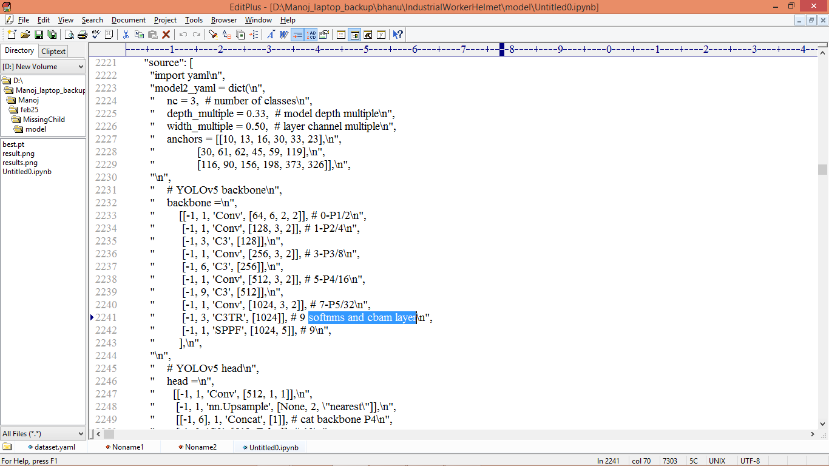
In above screen you can see Yolov5 is enhanced with additional layer called SOFT-NMS and CBAM.
To implement this project we have designed following modules
- Upload SHWD Helmet Dataset: using this module will upload dataset to application
- Pre-process Dataset: this module will read all images features and then normalize each image features and then identify different class labels available in dataset. This module will split processed images into train and test where application using 80% images for training and 20% for testing
- Train YOLO-ESCA Algorithm: 80% training data will be input to Yolov5-ESCA algorithm to train a model and this model will be applied on 20% test data to calculate prediction accuracy
- Training Graph: will plot training precision graph
- Detect Helmet from Image: user can upload test image and then Yolov5 will start detecting helmet from uploaded image.
- Detect Helmet from Video: user can upload test video and then Yolov5 will start detecting helmet from uploaded video.
SCREEN SHOTS
To run project double click on ‘run.bat’ file to get below page
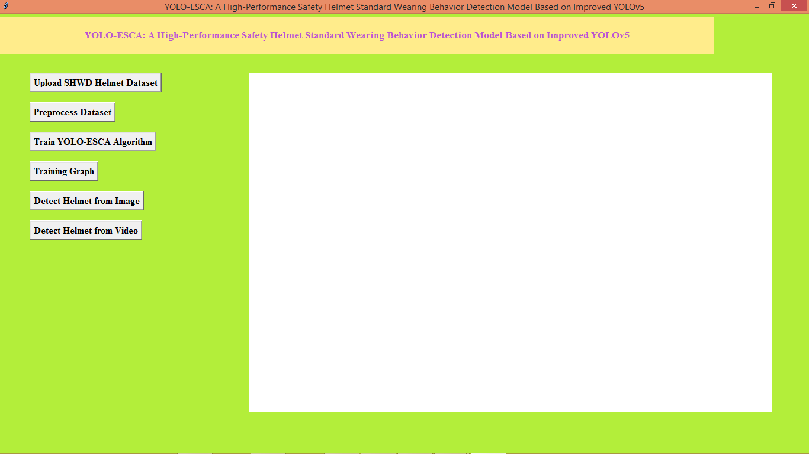
In above screen click on ‘Upload SHWD Helmet Dataset’ button to load dataset and then will get below page
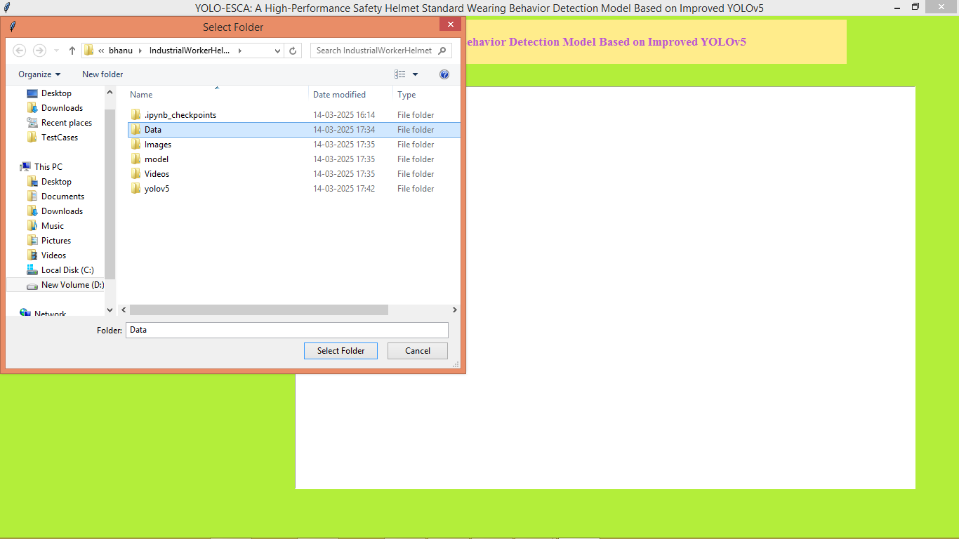
In above screen selecting and uploading ‘Data’ dataset folder and then click on ‘Select Folder’ button to load dataset and then will get below page
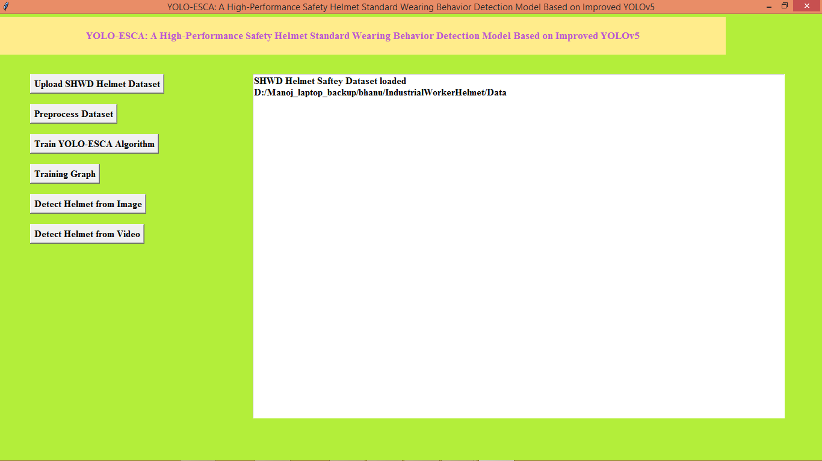
In above screen dataset loaded and now click on ‘Pre-process Dataset’ button to process dataset and then will get below page
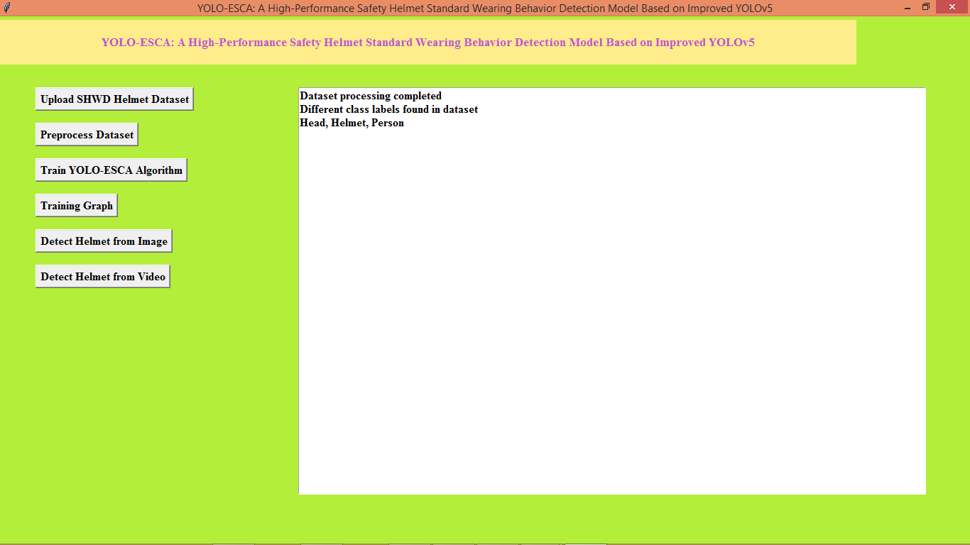
In above screen dataset processing completed and now click on ‘Train YOLO-ESCA Algorithm’ button to train model and then will get below page
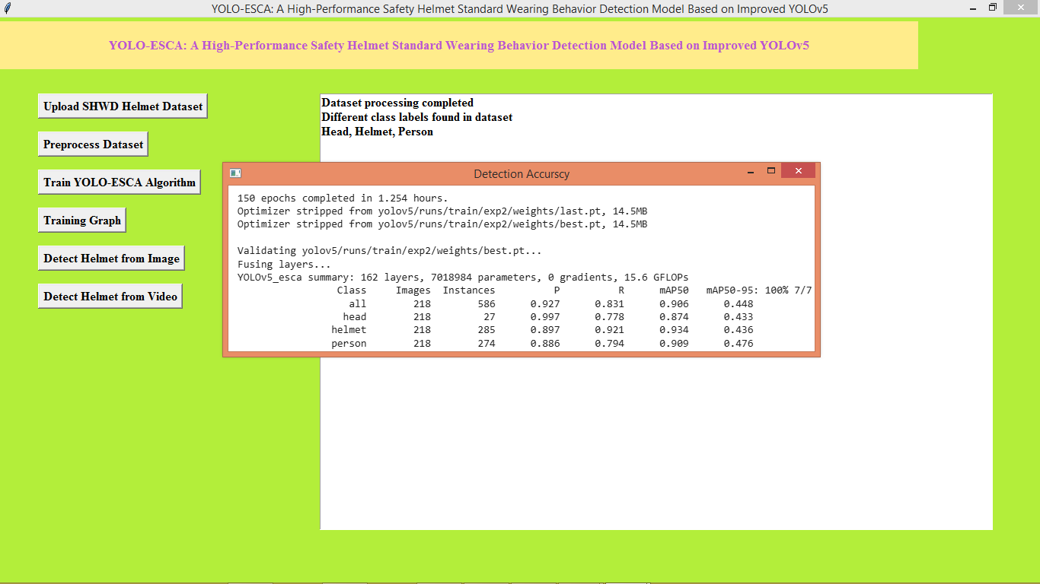
In above screen can see model prediction precision, recall values for each class label prediction and now click on ‘Training Graph’ link to get below page
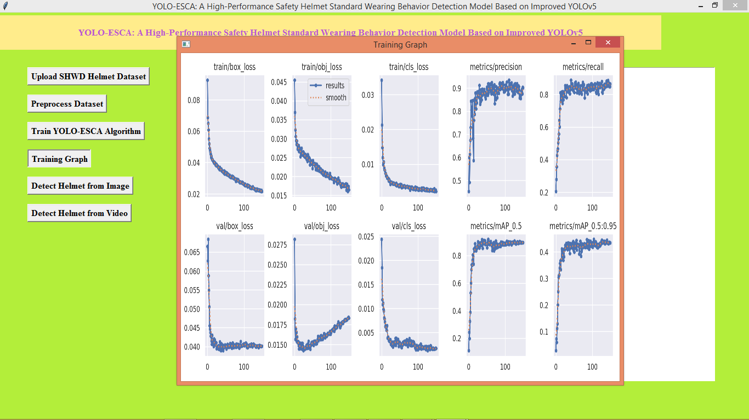
In above graph x-axis represents number of training epochs and y-axis represents precision and loss values and in each graph with increasing epoch precision and recall got increased and loss got decreased. Now click on ‘Detect Helmet from Image’ button to upload test image and then will get below page
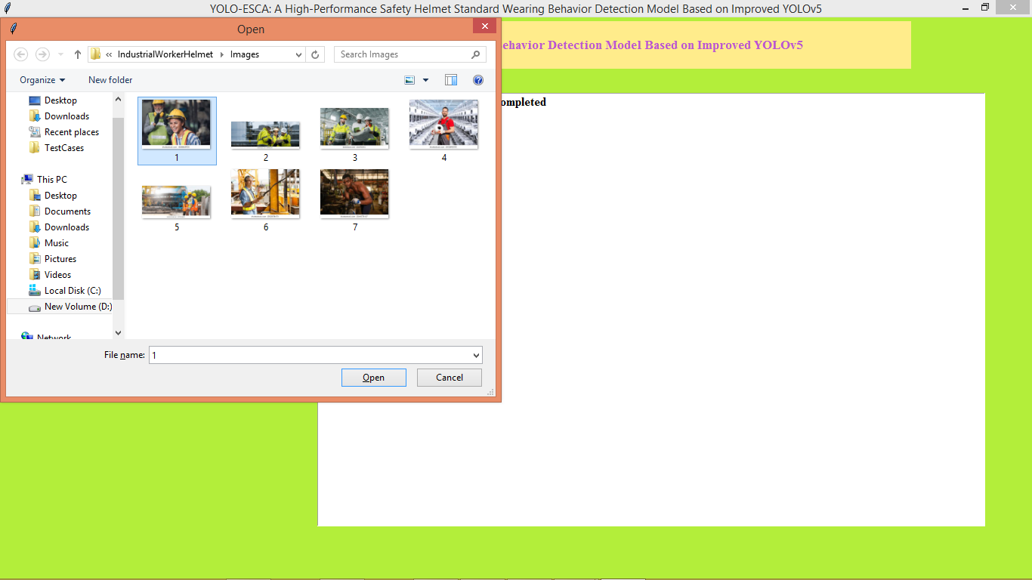
In above screen selecting and uploading image and then press ‘open’ button to get below page
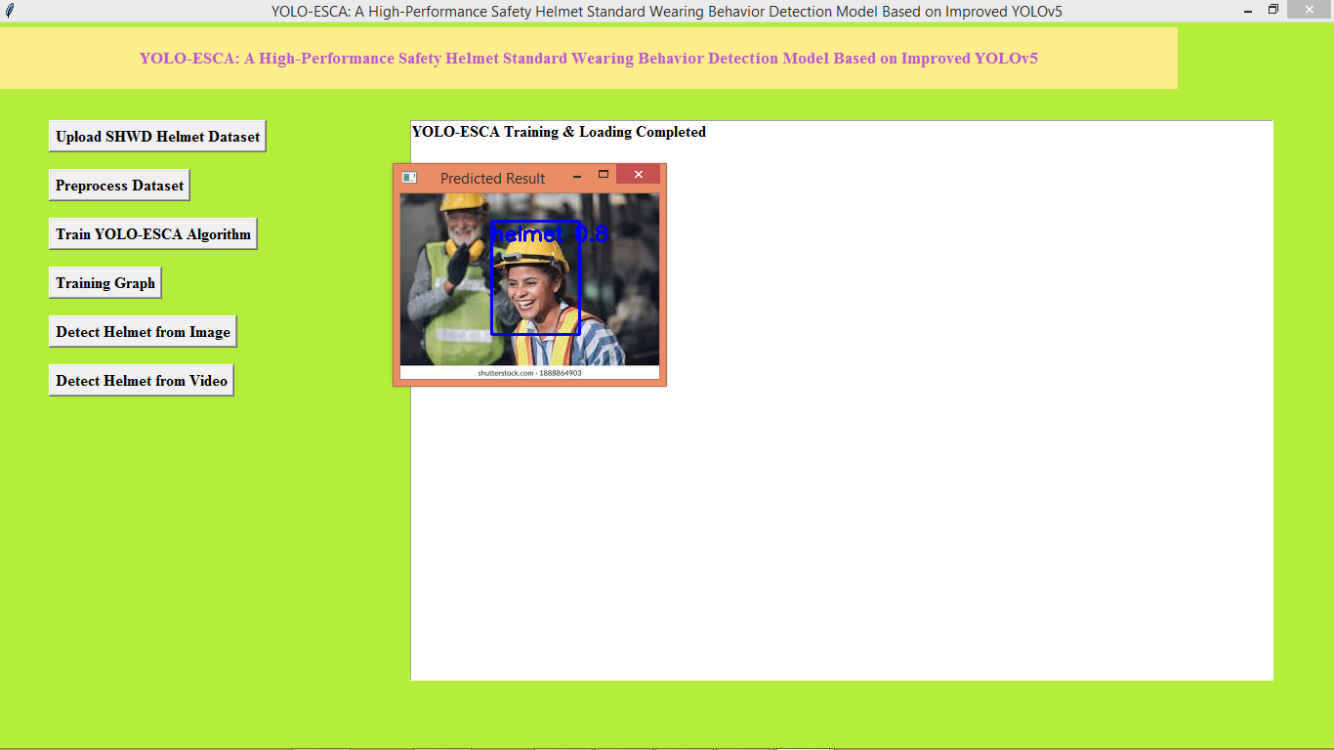
In above screen helmet detected and similarly you can upload and test other images
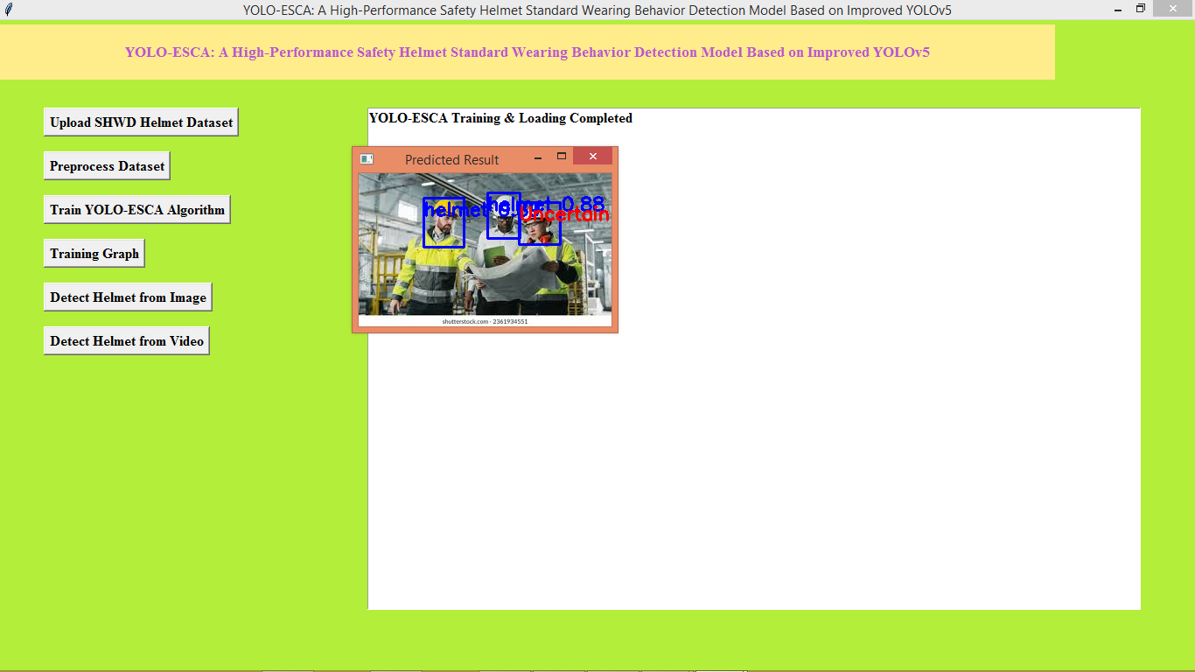
In above screen helmet detected and one helmet with uncertainty. Now click on ‘Detect Helmet from Videos’ button to get below page
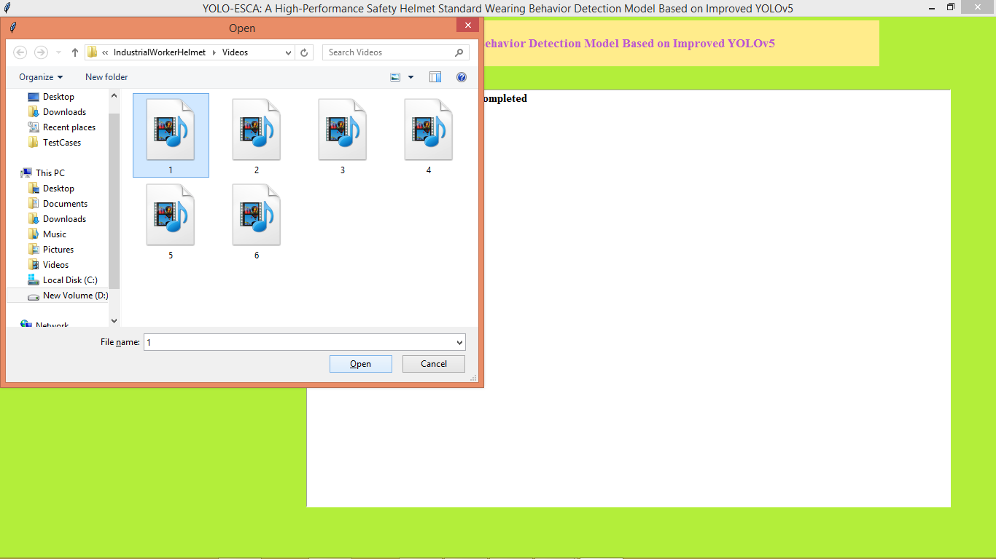
In above screen selecting and uploading video file and then press button to gtet below page
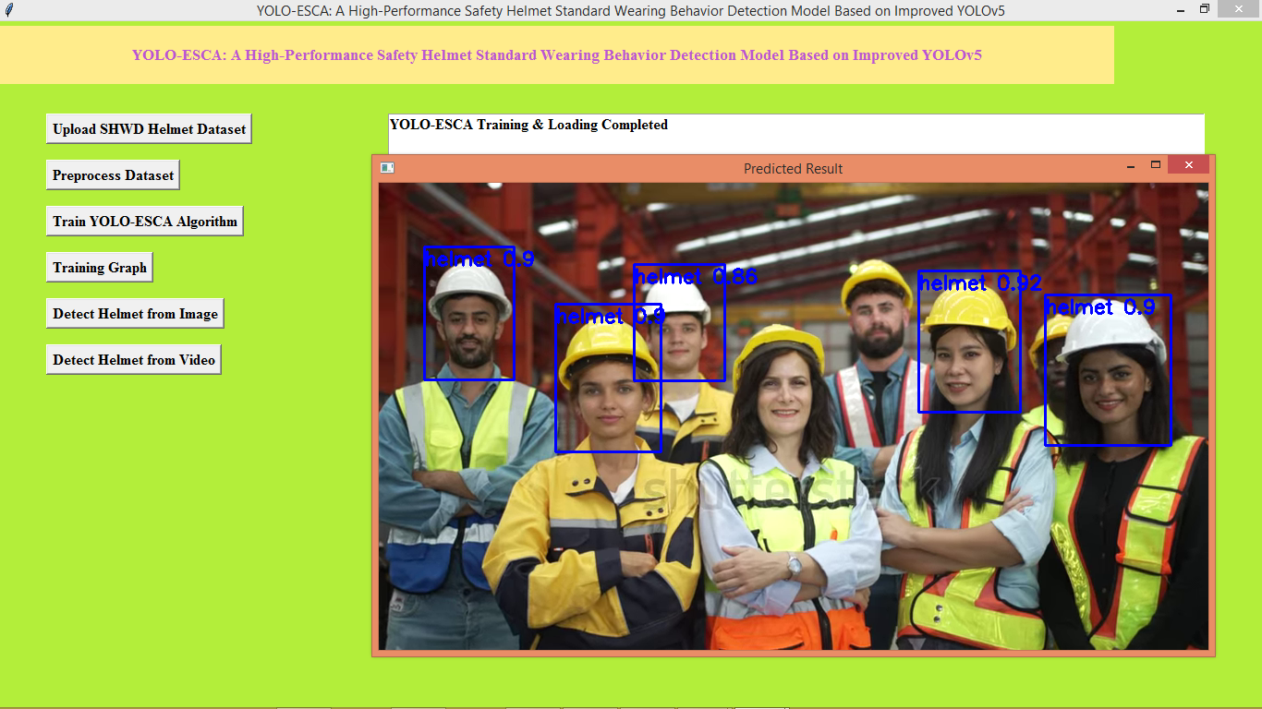
In above screen from video helmet start detection and similarly you can upload and test other videos
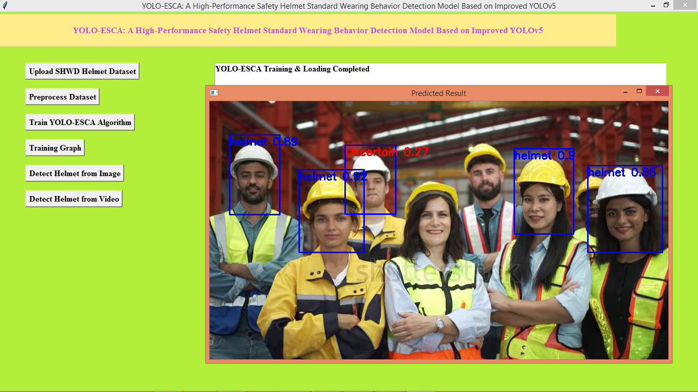
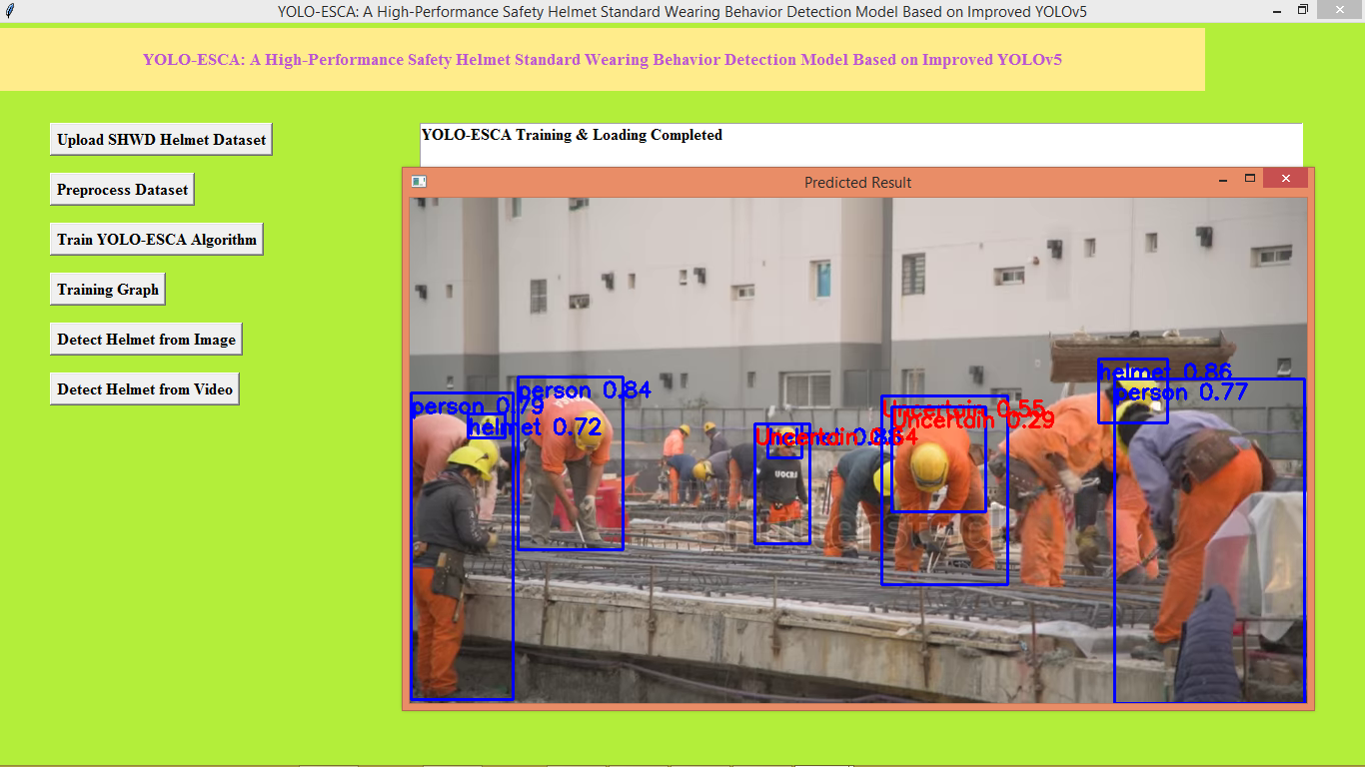
In above screen can see output from other videos
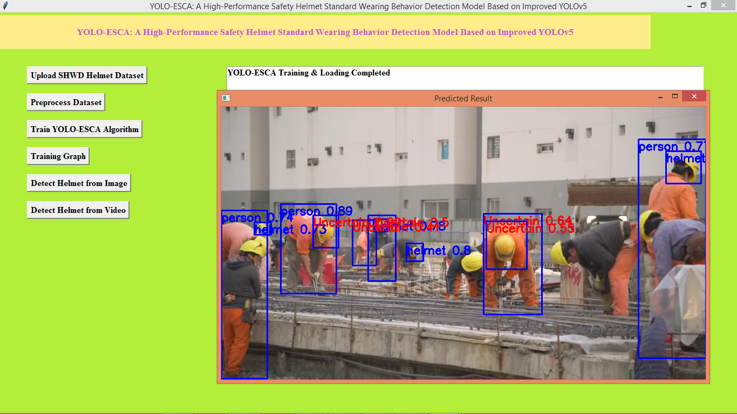
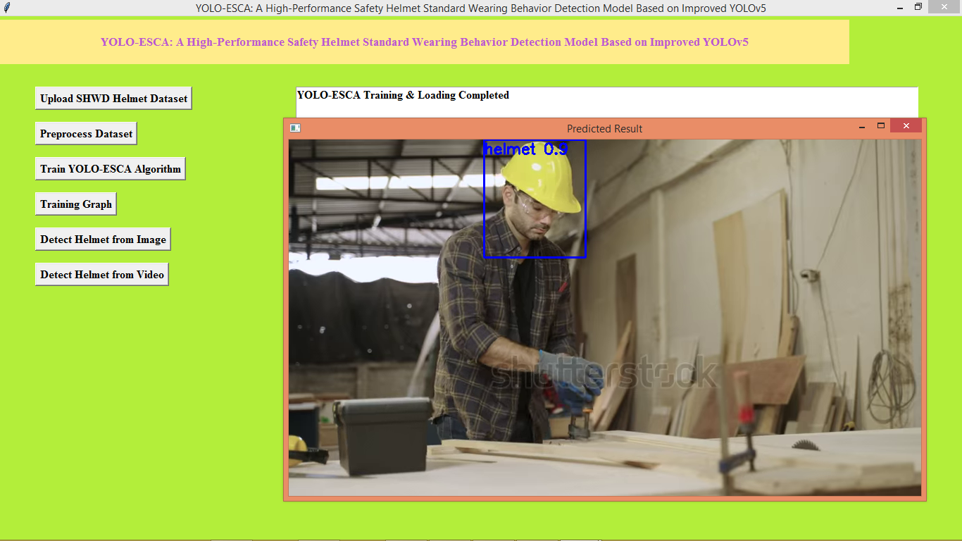
In above screen can see output from other video

