A
PROJECT REPORT
ON
LIBRARY MANAGEMENT
SYSTEM

SUBMITTED BY
RUDULA RAJU NAIK
&
KANISHQ NILESH KHOLE
UNDER THE GUIDANCE OF
Prof.Rupali Memane
In partial fulfillment of Bachelor of Business
Administration in Computer Application
(Semester –VI)
(2019-2020)
ARIHANT COLLEGE OF COMMERCE ARTS & SCIENCE

ACKNOWLEDGEMENT

We wish to record my heartfelt gratitude and sincere thanks to MRS. RUPALI MEMANE Professor, Department of Computer Applications, ACACS, for her kind support and inspiration given to us till the end of our project.
We thank MR.SANGRAM KAKDE, Head & Assoc. Professor, Department Of Computer Applications, Principal, Dr.MUKUND DONGARE, ACACS for their constant support and encouragement given throughout the development of the project.
Last but not the least our sincere thanks to our parents, family members and friends for their continuous support, inspiration and encouragement without which this project would not have been success.
Special thanks to our Senior Mr.MANPREET SINGH

RUDULA NAIK
&
KANISHQ KHOLE
CONTENTS

- INTRODUCTION

INTRODUCTION TO PROJECT
EXISTING SYSTEM & ITS DISADVANTAGES
PROPOSED SYSTEM & ITS ADVANDAGE

- SYSTEM ANALYSIS

  - STUDY OF THE SYSTEM
  - INPUT & OUTPUT REPRESENTATION
  - PROCESS MODELS USED WITH JUSTIFICATION
  - SYSTEM ARCHITECTURE

- FEASIBILITY STUDY

  - TECHNICAL FEASIBILITY
  - OPERATIONAL FEASIBILITY
  - ECONOMIC FEASIBILITY

- REQUIREMENT SPECIFICATIONS

  - FUNCIONAL REQUIREMENTS
  - PERFORMANCE REQUIREMENTS
  - SOFTWARE REQUIREMENTS
  - HARDWARE REQUIREMENTS

    - INTRODUCTION TO JAVA
    - JDBC
    - SQLite

- SYSTEM DESIGN

  - . INTRODUCTION
  - E-R DIAGRAM
  - DFDS
  - NORMALIZATION
  - DATA DICTIONARY

- OUTPUT SCREENS

- SYSTEM TESTING
  - INTRODUCTION TO TESTING
  - TESTING STRATEGIES

8. BIBLIOGRAPHY

  - INTRODUCTION & OBJECTIVE
The objective of the project is to develop a system that provide help for those students who want to take the services of Library. The purpose is to design a system that allows to check the book details which are available in library and perform various operations such as searching the books and reserving the books etc.

  - EXISTING SYSTEM

In the present system all the things were being done manually like going to library and searching the books. It’s time taking process. Manually searching the book is very difficult as there will be so many books.
And also more number of employees wanted to maintain the library.

  - PROPOSED SYSTEM

The proposed system is a standalone application and maintains a centralized repository of all information. In which we can maintain the all the information in our data base which will be given to search for their required books in our library. So in our system time taking for reserving and searching the books is very less.

2.1 STUDY OF THE SYSTEM
To provide flexibility to the users, the interfaces have been developed that are accessible through a browser. The GUI’S at the top level have been categorized as
- Administrative user interface
- The operational or generic user interface

The ‘administrative user interface’ concentrates on the consistent information that is practically, part of the organizational activities and which needs proper authentication for the data collection. These interfaces help the administrators with all the transactional states like Data insertion, Data deletion and Date updation along with the extensive data search capabilities.

The ‘operational or generic user interface’ helps the end users of the system in transactions through the existing data and required services. The operational user interface also helps the ordinary users in managing their own information in a customized manner as per the included flexibilities
2.2 INPUT & OUTPOUT REPRESENTETION

Input design is a part of overall system design. The main objective during the input design is as given below:
- To produce a cost-effective method of input.
- To achieve the highest possible level of accuracy.
- To ensure that the input is acceptable and understood by the user.

INPUT STAGES:
The main input stages can be listed as below:
- Data recording
- Data transcription
- Data conversion
- Data verification
- Data control
- Data transmission
- Data validation
- Data correction

INPUT TYPES:
It is necessary to determine the various types of inputs. Inputs can be categorized as follows:
- External inputs, which are prime inputs for the system.
- Internal inputs, which are user communications with the system.
- Operational, which are computer department’s communications to the system?
- Interactive, which are inputs entered during a dialogue.

Keeping in view the above description of the input types and input media, it can be said that most of the inputs are of the form of internal and interactive. As
Input data is to be the directly keyed in by the user, the keyboard can be considered to be the most suitable input device.
OUTPUT DESIGN:

In general are:
- External Outputs whose destination is outside the organization.
- Internal Outputs whose destination is with in organization and they are the User’s main interface with the computer. Outputs from computer systems are required primarily to communicate the results of processing to users. They are also used to provide a permanent copy of the results for later consultation. The various types of outputs
- Operational outputs whose use is purely with in the computer department.
- Interface outputs, which involve the user in communicating directly with the system.

OUTPUT DEFINITION

The outputs should be defined in terms of the following points:
    - Type of the output
    - Content of the output
    - Format of the output
    - Location of the output
    - Frequency of the output
    - Volume of the output
    - Sequence of the output

It is not always desirable to print or display data as it is held on a computer. It should be decided as which form of the output is the most suitable.
.

Keeping in view the above description the project is to have outputs mainly coming under the category of internal outputs. The main outputs desired according to the requirement specification are:

The outputs were needed to be generated as a hard copy and as well as queries to be viewed on the screen. Keeping in view these outputs, the format for the output is taken from the outputs, which are currently being obtained after manual processing. The standard printer is to be used as output media for hard copies.

2.3 PROCESS MODEL USED WITH JUSTIFICATION
SDLC (Spiral Model):
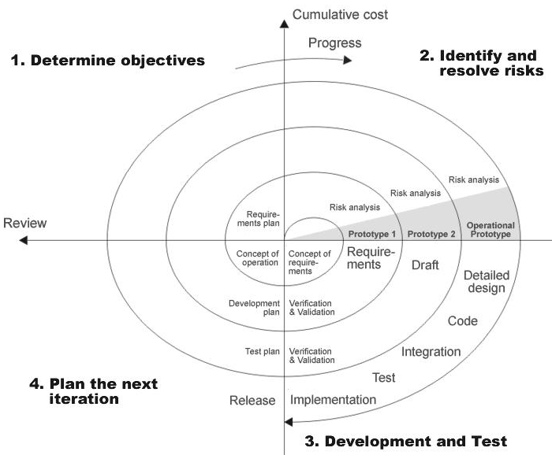
SDLC is nothing but Software Development Life Cycle. It is a standard which is used by software industry to develop good software.
Stages in SDLC:
- Requirement Gathering
- Analysis
- Designing
- Coding
- Testing
- Maintenance
2.4 SYSTEM ARCHITECTURE
Architecture flow:

Below architecture diagram represents mainly flow of requests from users to database through servers. In this scenario overall system is designed in three tires separately using three layers called presentation layer, business logic layer and data link layer. This project was developed using 3-tire architecture.
Business Logic Layer
Presentation Layer
Request
Response
Data Link
Layer
Data Base

3.Feasibility Study:

Preliminary investigation examines project feasibility; the likelihood the system will be useful to the organization. The main objective of the feasibility study is to test the Technical, Operational and Economical feasibility for adding new modules and debugging old running system. All systems are feasible if they are given unlimited resources and infinite time. There are aspects in the feasibility study portion of the preliminary investigation:
- Technical Feasibility
- Operation Feasibility
- Economic Feasibility

3.1 TECHNICAL FEASIBILITY

The technical issue usually raised during the feasibility stage of the investigation includes the following:
- Does the necessary technology exist to do what is suggested?
- Do the proposed equipments have the technical capacity to hold the data required to use the new system?
- Will the proposed system provide adequate response to inquiries, regardless of the number or location of users?
- Can the system be upgraded if developed?
Are there technical guarantees of accuracy, reliability, ease of access and data security?

3.2 OPERATIONAL FEASIBILITY

OPERATIONAL FEASIBILITY

User-friendly
Customer will use the forms for their various transactions i.e. for adding new routes, viewing the routes details. Also the Customer wants the reports to view the various transactions based on the constraints. Theses forms and reports are generated as user-friendly to the Client.

Reliability
The package wills pick-up current transactions on line. Regarding the old transactions, User will enter them in to the system.
Security
The web server and database server should be protected from hacking, virus etc
Portability
The application will be developed using standard open source software (Except Oracle) like Java, tomcat web server, Internet Explorer Browser etc these software will work both on Windows and Linux o/s. Hence portability problems will not arise.
Availability
This software will be available always.
Maintainability
The system called the ewheelz uses the 2-tier architecture. The 1st tier is the GUI, which is said to be front-end and the 2nd tier is the database, which uses My-Sql, which is the back-end.
The front-end can be run on different systems (clients). The database will be running at the server. Users access these forms by using the user-ids and the passwords.
3.3 ECONOMIC FEASILITY

The computerized system takes care of the present existing system’s data flow and procedures completely and should generate all the reports of the manual system besides a host of other management reports.
It should be built as a web based application with separate web server and database server. This is required as the activities are spread through out the organization customer wants a centralized database. Further some of the linked transactions take place in different locations.
Open source software like TOMCAT, JAVA, Mysql and Linux is used to minimize the cost for the Customer.

4.1 FUNCTIONAL REQUIREMENTS SPECIFICATION
MODULES:
The system is proposed to have the following modules:
1-Administrator module
2-Book module
3-Student Module

Administrator module:
Administrator manages the entire application. Administrator can add the books in database and can delete the book details and also he can update the orders.
Book module:
In this module we are providing the new book and after registration student can easily search the books details in our library database.
Student Module:

In this module student, those who are created by the admin will insert new books into the library

4.2 PERFORMANCE REQUIREMENTS

Performance is measured in terms of the output provided by the application. Requirement specification plays an important part in the analysis of a system. Only when the requirement specifications are properly given, it is possible to design a system, which will fit into required environment. It rests largely with the users of the existing system to give the requirement specifications because they are the people who finally use the system. This is because the requirements have to be known during the initial stages so that the system can be designed according to those requirements. It is very difficult to change the system once it has been designed and on the other hand designing a system, which does not cater to the requirements of the user, is of no use.
The requirement specification for any system can be broadly stated as given below:
- The system should be able to interface with the existing system
- The system should be accurate
- The system should be better than the existing system
The existing system is completely dependent on the user to perform all the duties.

4.3 SOFTWARE REQUIRMENTS:-
- Programming Language : Java,NetBeans
- Database Connectivity : JDBC
- Java Version : JDK1.8.0
- Backend Database : SQLite
- Operating System : Windows 7

4.4 HARDWARE REQUIRMENTS(MINIMUM):-
- Pentium processor : 233 MHZ
- RAM Capacity : 128MB
- Hard Disk : 20GB
- CD-ROM Drive : 32 HZ
- KeyBoard : 108 Standard
- Mouse : Optical
- Monitor : 15’’ Color Monitor

4.4.1. INTRODUCTION TO JAVA

About Java:

Initially the language was called as “oak” but it was renamed as “java” in 1995.The primary motivation of this language was the need for a platform-independent(i.e. architecture neutral)language that could be used to create software to be embedded in various consumer electronic devices.
- Java is a programmer’s language
- Java is cohesive and consistent
- Except for those constraint imposed by the Internet environment. Java gives the programmer, full control
Finally Java is to Internet Programming where c was to System Programming.
Importance of Java to the Internet

Java has had a profound effect on the Internet. This is because; java expands the Universe of objects that can move about freely in Cyberspace. In a network, two categories of objects are transmitted between the server and the personal computer. They are passive information and Dynamic active programs. in the areas of Security and probability. But Java addresses these concerns and by doing so, has opened the door to an exciting new form of program called the Applet.
Applications and applets. An application is a program that runs on our Computer under the operating system of that computer. It is more or less like one creating using C or C++ .Java’s ability to create Applets makes it important. An Applet I san application, designed to be transmitted over the Internet and executed by a Java-compatible web browser. An applet I actually a tiny Java program, dynamically downloaded across the network, just like an image. But the difference is, it is an intelligent program, not just a media file. It can be react to the user input and dynamically change.
Java Architecture
Java architecture provides a portable, robust, high performing environment for development. Java provides portability by compiling the byte codes for the Java Virtual Machine, which is then interpreted on each platform by the run-time environment. Java is a dynamic system, able to load code when needed from a machine in the same room or across the planet.

Systems design
Introduction: Systems design is the process or art of defining the architecture,
components, modules, interfaces, and data for a system to satisfy specified requirements. One
could see it as the application of systems theory to product development. There is some
overlap and synergy with the disciplines of systems analysis, systems architecture and
systems engineering.
    - JDBC

What is JDBC?
any relational database. One can write a single program using the JDBC API,and the JDBC is a Java Api for executing SQL,Statements(As a point of interest JDBC is trademarked name and is not an acronym; nevertheless,Jdbc is often thought of as standing for Java Database Connectivity. It consists of a set of classes and interfaces written in the Java Programming language.JDBC provides a standard API for tool/database developers and makes it possible to write database applications using a pure Java API
Using JDBC, it is easy to send SQL statements to virtually program will be able to send SQL .statements to the appropriate database. The Combination of Java and JDBC lets a programmer writes it once and run it anywhere.
4.4.3 SQLite
SQLite is an in-process library that implements a self-contained, serverless, zero-configuration, transactional SQL database engine. The code for SQLite is in the public domain and is thus free for use for any purpose, commercial or private. SQLite is the most widely deployed database in the world with more applications than we can count, including several high-profile projects.
SQLite is an embedded SQL database engine. Unlike most other SQL databases, SQLite does not have a separate server process. SQLite reads and writes directly to ordinary disk files. A complete SQL database with multiple tables, indices, triggers, and views, is contained in a single disk file. The database file format is cross-platform - you can freely copy a database between 32-bit and 64-bit systems or between big-endian and little-endian architectures. These features make SQLite a popular choice as an Application File Format. SQLite database files are a recommended storage format by the US Library of Congress. Think of SQLite not as a replacement for Oracle but as a replacement for fopen()
SQLite is a compact library. With all features enabled, the library size can be less than 600KiB, depending on the target platform and compiler optimization settings. (64-bit code is larger. And some compiler optimizations such as aggressive function inlining and loop unrolling can cause the object code to be much larger.) There is a tradeoff between memory usage and speed. SQLite generally runs faster the more memory you give it. Nevertheless, performance is usually quite good even in low-memory environments. Depending on how it is used, SQLite can be faster than direct filesystem I/O.

5.2 E-R DIAGRAM
Year
Cource
Name
Student_ID
FName
Branch
Student

Semester

M

Publisher
Edition
Price
Name
Pages
Book

Book_ID
M
Issues

5.3DFDs
CONTEXT LEVEL DIAGRAM

Book
Book details
Admin
0.0
Library Management System 1.0

Login
Fill Info Logins Verified

Given Information

Student

Student Book

Statistics Login

Admin
1.0
Authentication

User Details
UsrLog

2.0
Student
Registration

Admin
Admin maintain Student
Student details Add details
Student

3.0
New book
Registration

Admin
Admin maintain Book
Book details Add details
Book

4.0
Issue book
Admin
Maintain Issue Details
Student
stud.details Statistics
Book

book details
4.1

Return Book
Student
Statistics

Book

Admin
5.0
Report’s Authentication

Statistics
Report Generation

Student
Book

5.4. NORMALIZATION

A Database is a collection of interrelated data stored with a minimum of redundancy to serve many applications. The database design is used to group data into a number of tables and minimizes the artificiality embedded in using separate files. The tables are organized to:

- Reduced duplication of data.
- Simplify functions like adding, deleting, modifying data etc..,
- Retrieving data
- Clarity and ease of use
- More information at low cost

Normalization

Normalization is built around the concept of normal forms. A relation is said to be in a particular normal form if it satisfies a certain specified set of constraints on the kind of functional dependencies that could be associated with the relation. The normal forms are used to ensure that various types of anomalies and inconsistencies are not introduced into the database.
First Normal Form:
A relation R is in first normal form if and only if all underlying domains contained atomic values only.
Second Normal Form:
A relation R is said to be in second normal form if and only if it is in first normal form and every non-key attribute is fully dependent on the primary key.
Third Normal Form:
A relation R is said to be in third normal form if and only if it is in second normal form and every non key attribute is non transitively depend on the primary key

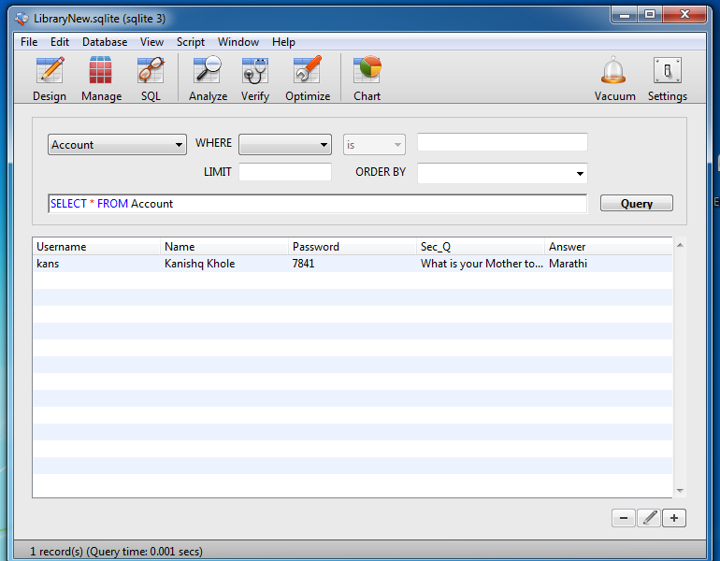
5.5 Data Dictionary:-
1. Account table:- 2. Book table:-
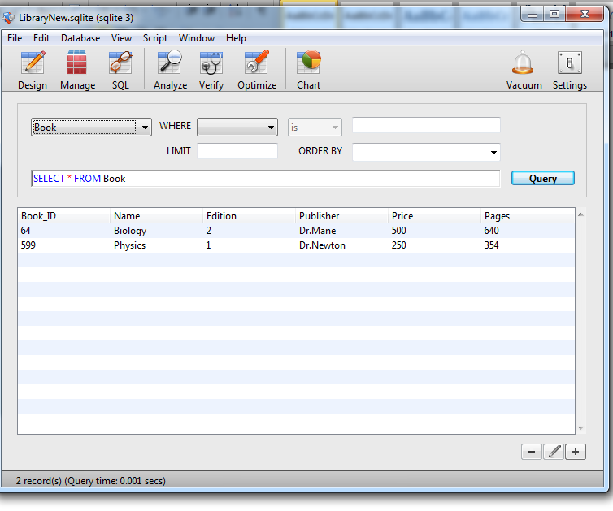
3. Issue table:-
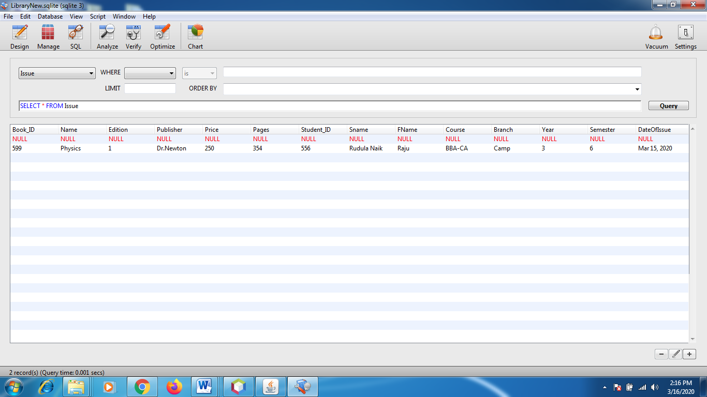

4.Return table:-
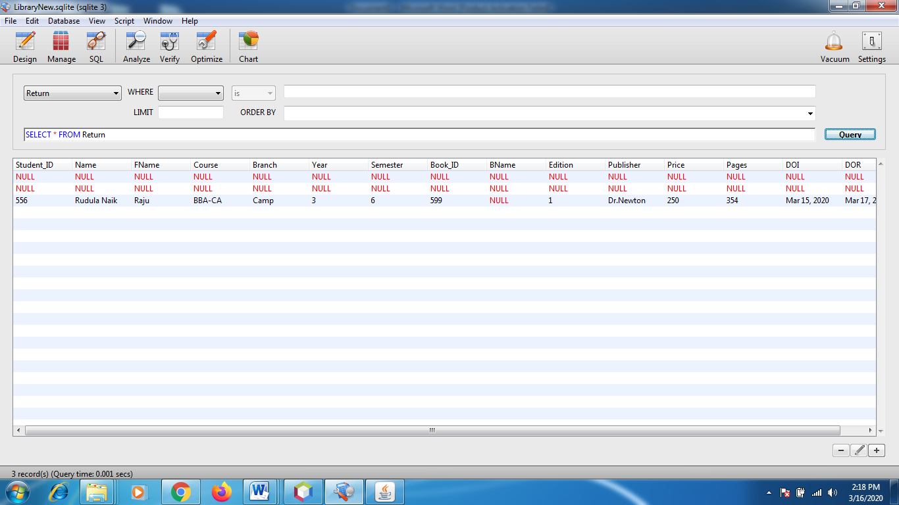

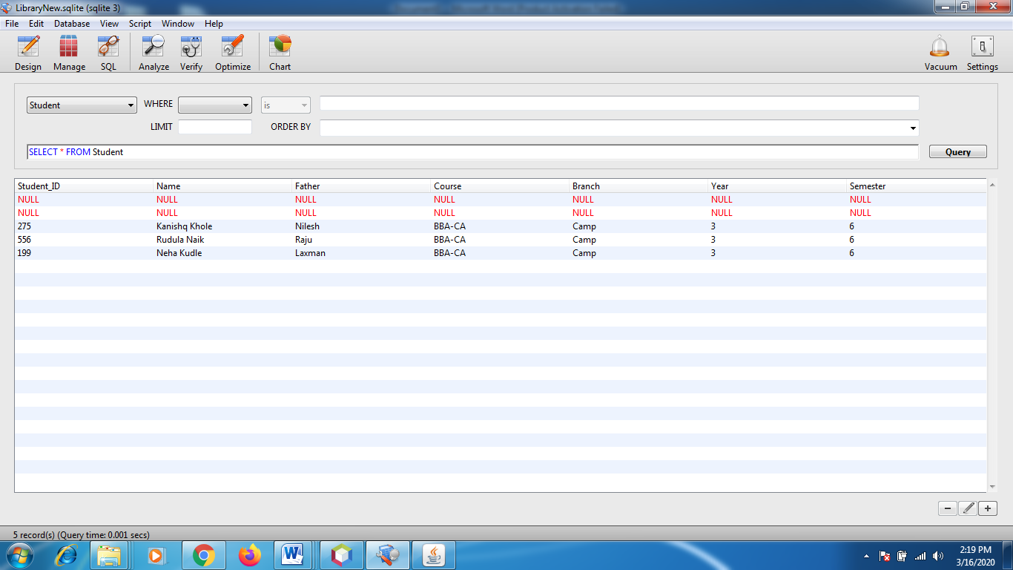
5. Student:-
7.1 INTRODUCTION TO TESTING

Introduction to Testing:
Testing is a process, which reveals errors in the program. It is the major quality measure employed during software development. During software development. During testing, the program is executed with a set of test cases and the output of the program for the test cases is evaluated to determine if the program is performing as it is expected to perform.

7.2 TESTING IN STRATEGIES

In order to make sure that the system does not have errors, the different levels of testing strategies that are applied at differing phases of software development are:
Unit Testing:

Unit Testing is done on individual modules as they are completed and become executable. It is confined only to the designer's requirements.

Each module can be tested using the following two Strategies:
Black Box Testing:
In this strategy some test cases are generated as input conditions that fully execute all functional requirements for the program. This testing has been uses to find errors in the following categories:
- Incorrect or missing functions
- Interface errors
- Errors in data structure or external database access
- Performance errors
- Initialization and termination errors.
In this testing only the output is checked for correctness.
The logical flow of the data is not checked.

White Box testing:
In this the test cases are generated on the logic of each module by drawing flow graphs of that module and logical decisions are tested on all the cases. It has been uses to generate the test cases in the following cases:

- Guarantee that all independent paths have been Executed.
- Execute all logical decisions on their true and false Sides.
- Execute all loops at their boundaries and within their operational bounds
- Execute internal data structures to ensure their validity.
Integrating Testing :
Integration testing ensures that software and subsystems work together a whole. It tests the interface of all the modules to make sure that the modules behave properly when integrated together.
System Testing :
Involves in-house testing of the entire system before delivery to the user. It's aim is to satisfy the user the system meets all requirements of the client's specifications.
Acceptance Testing :

It is a pre-delivery testing in which entire system is tested at client's site on real world data to find errors.

Test Approach :
Testing can be done in two ways:

- Bottom up approach
- Top down approach
Bottom up Approach:

Testing can be performed starting from smallest and lowest level modules and proceeding one at a time. For each module in bottom up testing a short program executes the module and provides the needed data so that the module is asked to perform the way it will when embedded with in the larger system. When bottom level modules are tested attention turns to those on the next level that use the lower level ones they are tested individually and then linked with the previously examined lower level modules.

Top down approach:
This type of testing starts from upper level modules. Since the detailed activities usually performed in the lower level routines are not provided stubs are written. A stub is a module shell called by upper level module and that when reached properly will return a message to the calling module indicating that proper interaction occurred. No attempt is made to verify the correctness of the lower level module.

Validation:

The system has been tested and implemented successfully and thus ensured that all the requirements as listed in the software requirements specification are completely fulfilled. In case of erroneous input corresponding error messages are displayed

8. BIBLIOGRAPHY
References for the Project Development Were Taken From the following Books and Web Sites.

JAVA Technologies
JAVA Complete Reference

JDBC
Java Database Programming with JDBC by Patel moss.
Software Engineering by Roger Pressman
Youtube:
Library Management System:-
Tech Enteraining:
https://www.youtube.com/playlist?list=PL_Ke9hjMFeR_TWfBOug40-2uSANxa8dtE
SQLite:-
https://www.sqlite.org/about.html

-X-X-X-X-X-X-X-X-X-X-X-X-X-X-X-X-X-X-X-X-X-X-X-X-X-X-X-X-X-X-X-X-X-X-X-X-X-X-X-X-X-X-

