Rudolph Carvajal

September 13, 2020

Foundations of Programming: Python

Assignment_09

CD Inventory: Modules

# Introduction

In this week’s module we finally combined objects. In prior weeks it was difficult to see the power of object oriented programming (OOP) because we were only using the CD object and thus the program itself wasn’t too different from earlier modules. However, this week not only revealed capability of OOP but I finally understood how multiple developers work together on a single project. In this document I’ll discuss the topics of multiple objects, inheritance and modules. I’ll also briefly cover the benefit of using a test harness and how much easier it is to debug with one. Finally, I’ll end by showing the CD_Inventory program running in Spyder and the terminal window

# Combining objects

Combining objects is a relatively simple concept to follow. In Chapter 9 of the class textbook, there is a great example where a *Hand* object has a collection of *Card* objects. Objects can be created using one class and then passed as arguments into another class’s method.

# Inheritance

Inheritance allows the programmer to inheritance attributes and methods from the parent class. This is useful because subclasses can be created with all of the functionality of parent classes but the parent classes themselves don’t change. This makes programming easier as you don’t have to write code that has already been written in another file. Additionally, this makes it easy to understand how developers work together or build off each other’s work. A [YouTube video](https://www.youtube.com/watch?v=RSl87lqOXDE) by creator, Corey Schafer, did a great job explaining this concept by creating Developer and Manager objects off the parent class Employee.

# Modules

We have been using built in modules throughout this course but this week we finally learned how to build on our modules. Creating modules makes it much easier to have a separation of concerns as well as share code with friends and colleagues. Modules should be a collection of related programming components such as functions and classes. By building modules we were introduced to the concept of “__main__”. This can be included in your module if it is meant to be imported vs ran directly.

# Test Harness

In this weeks’ module we also learned how to build and run a test harness. Testing code saves a lot of time and headache down the road, ensuring you catch fix problems because they enter into production or get to complex to fix. A good testing system will also ensure the entire program is still working as it should, not just the added functionality – this is common where an added function work properly but it can potentially unintentionally break other parts of the program.

The test harness made it really easy to debug my code in this week’s assignment by pointing to areas that weren’t working properly.

# The CD_Inventory with multiple modules

Based on this week’s learning, I used the starter code and made updates to it to get the program working properly. I noticed that I lacked a little confidence in knowing when to you methods from other classes so I did have the check my code with the example in this week’s module when it wasn’t working. Below are snapshots of the program running after adding a CD and track to inventory as well as the Test Harness running:

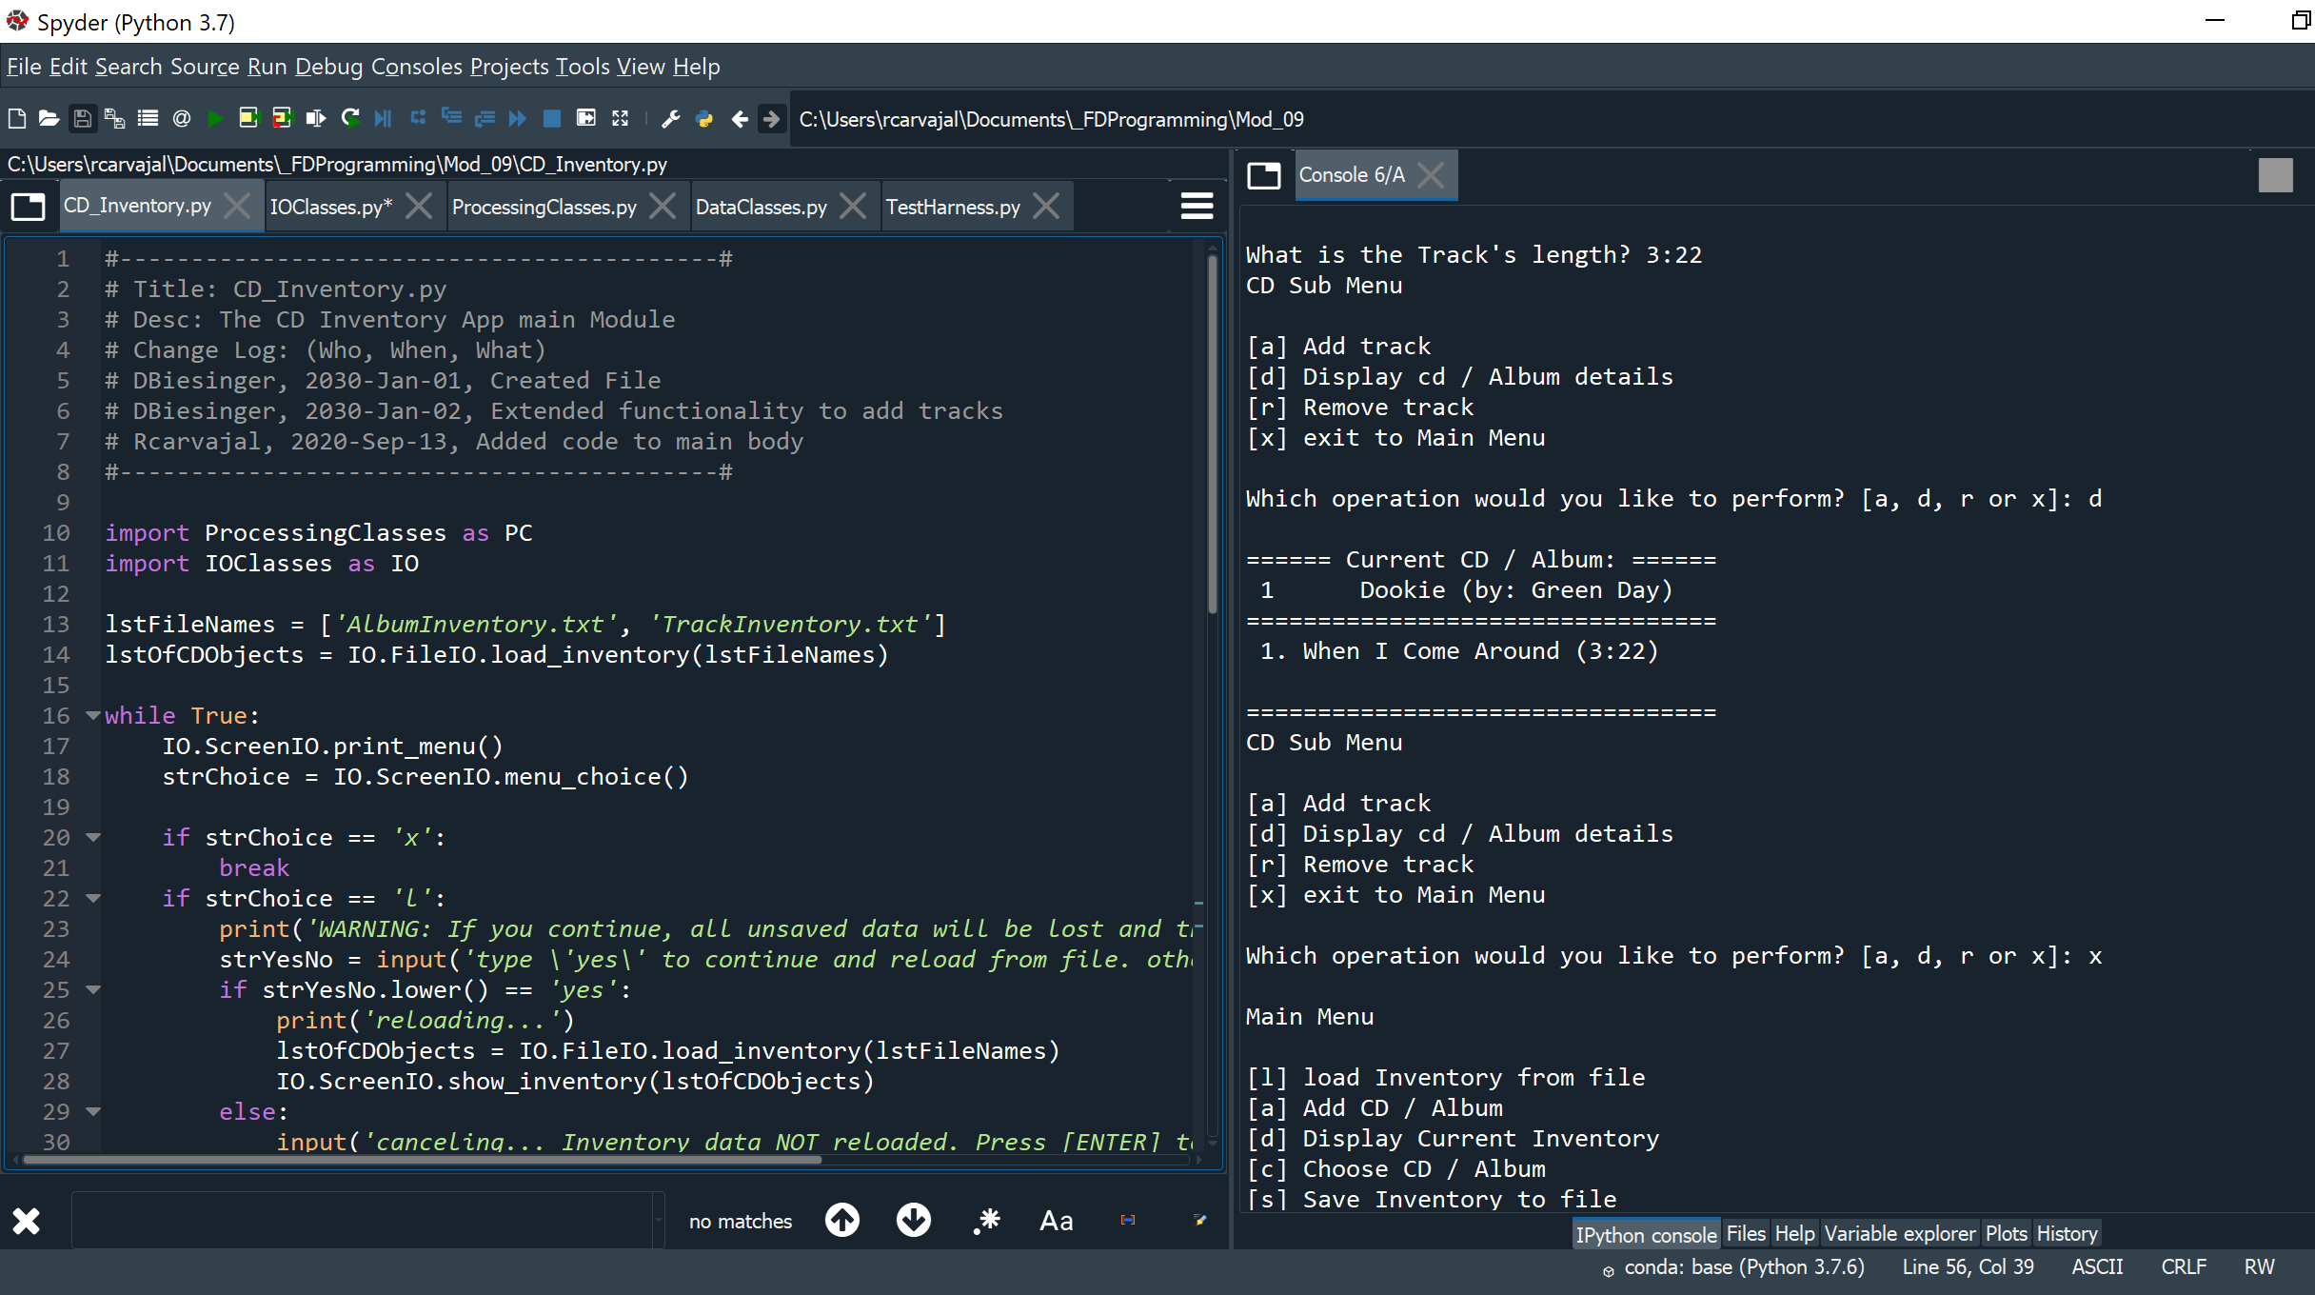

Figure - CD_Inventory program running in Spyder

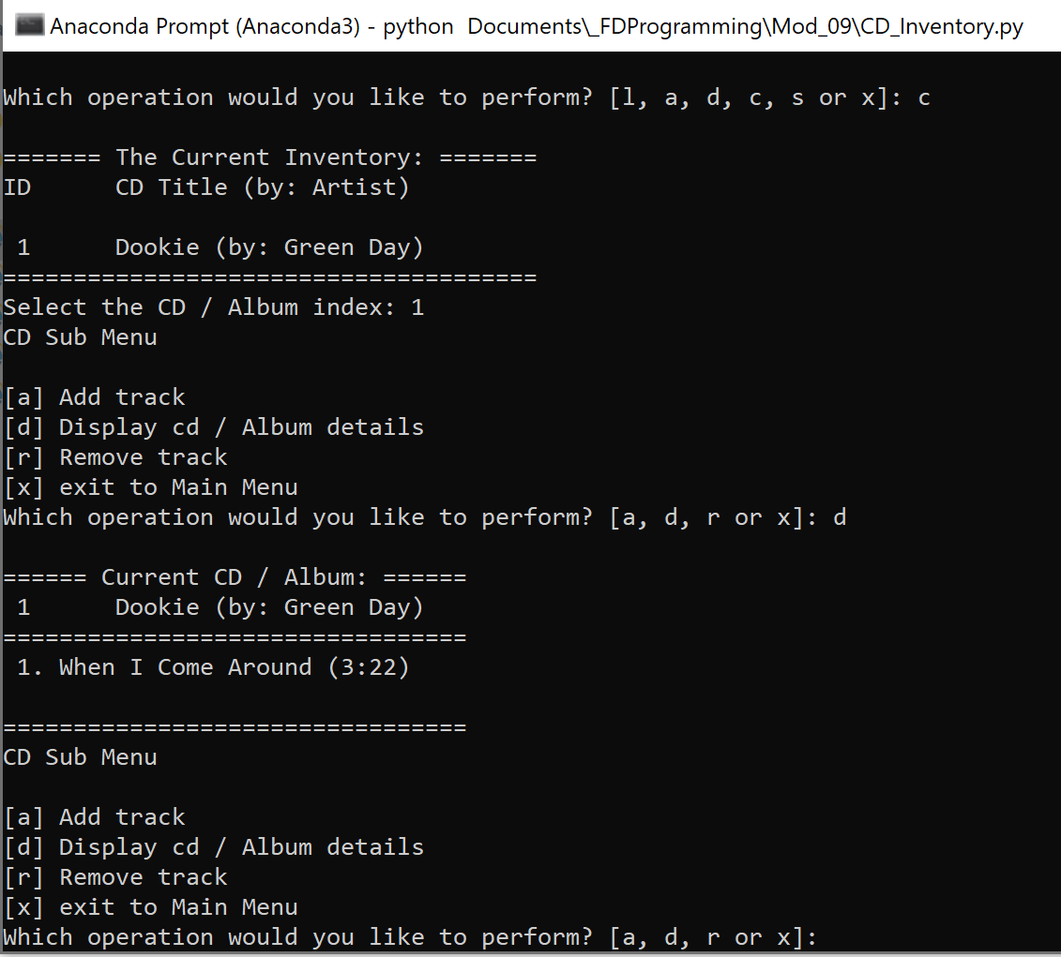

Figure - CD_Inventory program running in the terminal window

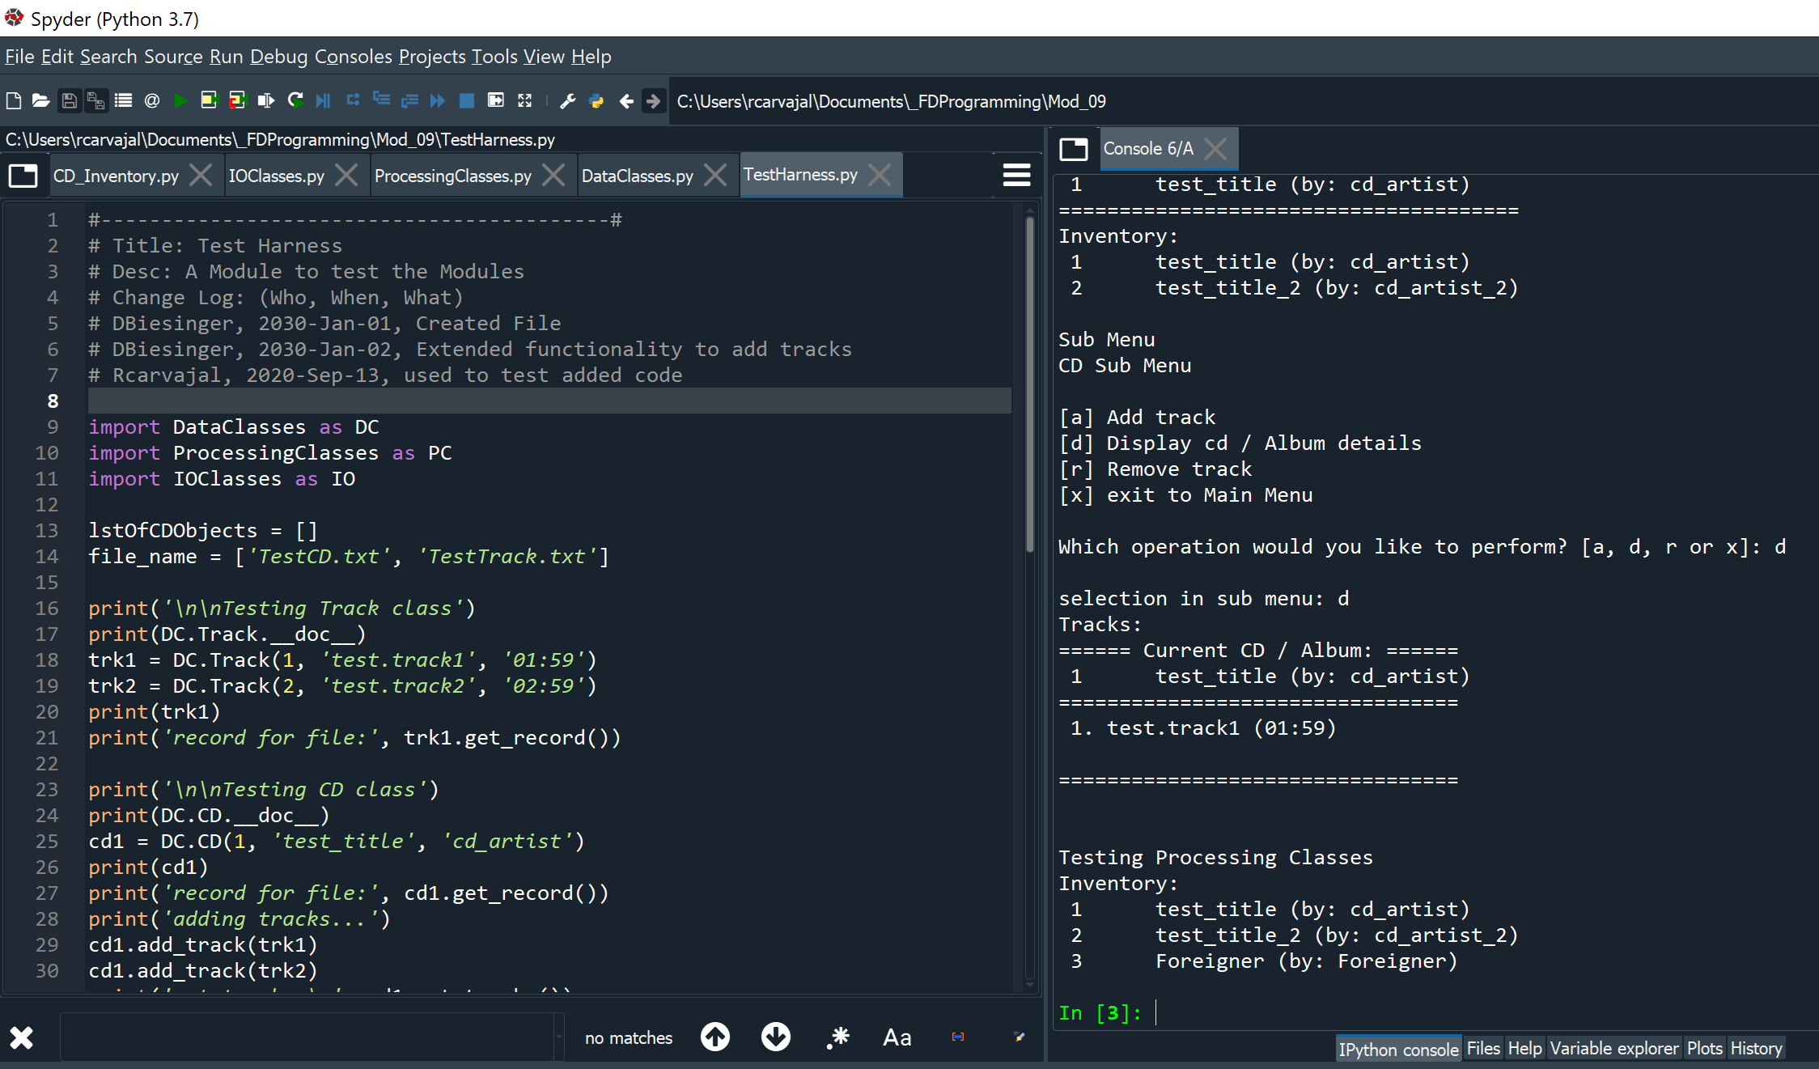

Figure - Running the Test Harness in Spyder

# Summary

We expanded on our learning of Classes and Objects this week by adding how to combine objects and use multiple modules when writing a program. The main benefit to me this week was understanding how my developer colleagues work together – prior to this week, it was hard for me to understand how they were all able to work on the same program. Additionally, we also learned how to test code – building a test harness made it easier to pinpoint where my bugs were when running my program.

My code can be seen at my Github: [https://github.com/rudycarvajal/Assignment_09](https://github.com/rudycarvajal/Assignment_09/upload/master)