LOAD CSV WITH HEADERS FROM 'file:///Positions.csv' AS row

WITH toInteger(row.Established) AS Established, toInteger(row.Removed) AS Removed, toInteger(row.DateRenamed) AS DateRenamed, row.Appointment AS Appointment, row.CabinetLevel AS CabinetLevel, row.Department AS Department, row.FormerDateRenamed AS FormerDateRenamed, row.FormerName as FormerName

CREATE (p:Position {Department: Department})

  SET p.Established=Established, p.Removed=Removed, p.DateRenamed=DateRenamed, p.Appointment=Appointment, p.CabinetLevel=CabinetLevel, p.Department=Department, p.FormerDateRenamed=FormerDateRenamed, p.FormerName=FormerName

RETURN count(p);

LOAD CSV WITH HEADERS FROM 'file:///Appts-Fixed.csv' AS row

WITH toInteger(row.Gender) AS Gender, toInteger(row.ForeignBorn) AS ForeignBorn, toInteger(row.Minority) AS Minority, toInteger(row.DiedOffice) AS DiedOffice, toInteger(row.Key) AS Key, (row.Administration) AS Administration, (row.Party) AS Party, row.Department AS Department, row.Name AS Name, row.LastName AS LastName, date(row.ServiceStart) AS ServiceStart, date(row.ServiceEnd) AS ServiceEnd, row.ScandalDesc AS ScandalDesc, row.EduDesc AS EduDesc, (row.MilitaryService) AS MilitaryService, (row.MilitaryDatesServed) AS MilitaryDatesServed, (row.MilitaryBranch) AS MilitaryBranch, (row.SenateVotesFor) AS SenateVotesFor, (row.SenateVotesAgainst) AS SenateVotesAgainst, (row.Law) AS Law

MERGE (a:Appointee {Key: Key})

    SET a.Gender=Gender, a.ForeignBorn=ForeignBorn, a.Minority=Minority, a.DiedOffice=DiedOffice, a.Key=Key, a.Administration=Administration, a.Party=Party, a.Department=Department, a.Name=Name, a.LastName=LastName, a.ServiceStart=ServiceStart, a.ServiceEnd=ServiceEnd, a.ScandalDesc=ScandalDesc, a.EduDesc=EduDesc, a.MilitaryService=MilitaryService, a.MilitaryDatesServed=MilitaryDatesServed, a.MilitaryBranch=MilitaryBranch, a.SenateVotesFor=SenateVotesFor, a.SenateVotesAgainst=SenateVotesAgainst, a.Law=Law

RETURN count(a)



CREATE CONSTRAINT UniqueKey ON (a:Appointee) ASSERT a.Key IS UNIQUE;

MATCH (a:Appointee), (p:Position)

WHERE a.Department=p.Appointment

CREATE (a)-[r:HAS_POSITION]->(p)

RETURN type(r)

1. MATCH(a:Appointee{Administration:'Clinton'})-[r:HAS_POSITION]->(p:Position)

RETURN DISTINCT p.Appointment

1. MATCH (a:Appointee{Gender:0})-[r:HAS_POSITION]->(p:Position)

RETURN a.Name, a.Department, a.ServiceStart, a.ServiceEnd, a.EduDesc

1. MATCH (a:Appointee)-[r:HAS_POSITION]->(p:Position {Appointment:'Postmaster General'})

WHERE a.ServiceStart > date("1850-01-01") AND a.ServiceStart < date("1950-01-01")

RETURN a.Name, a.ServiceStart, a.Administration

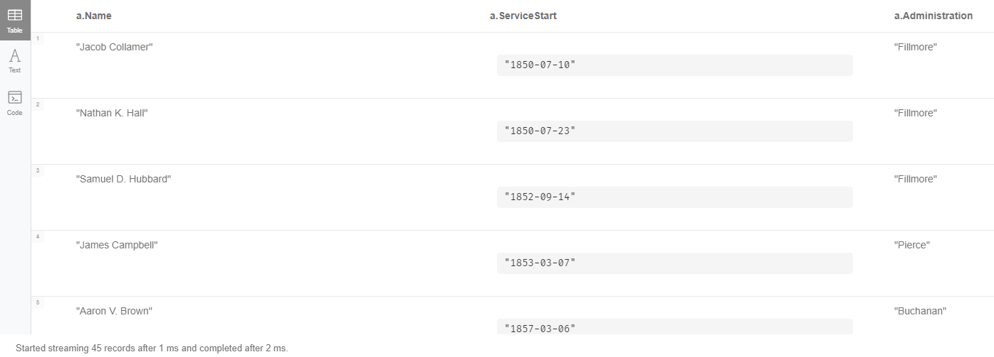ORDER BY a.ServiceStart

1. MATCH (a:Appointee)-[r:HAS_POSITION]->(p:Position)

WHERE p.Established > 1990

RETURN DISTINCT p.Appointment, p.Established

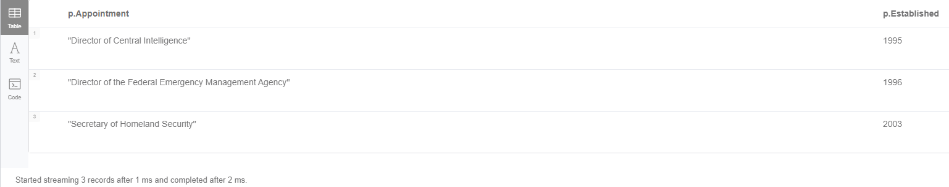ORDER BY p.Established

1. MATCH (a:Appointee)-[r:HAS_POSITION]->(p:Position)

WHERE EXISTS (p.DateRenamed)

RETURN DISTINCT p.Appointment

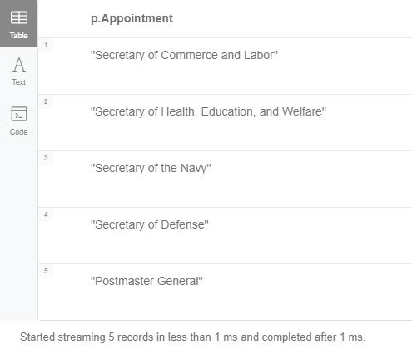

1. MATCH (a:Appointee)-[r:HAS_POSITION]->(p:Position)

WHERE a.Department CONTAINS 'Labor'

RETURN DISTINCT p.Appointment, p.Department

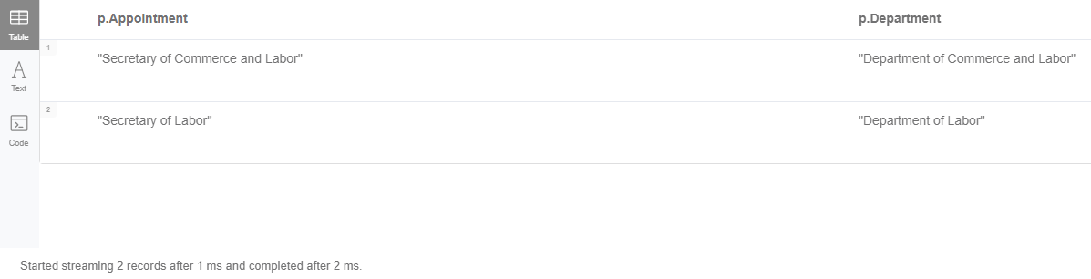

1. MATCH (a:Appointee)-[r:HAS_POSITION]->(p:Position)

RETURN DISTINCT p.Appointment, a.Department, a.Administration, p.Established

ORDER BY p.Established

1. MATCH (a:Appointee {MilitaryBranch:'Navy'})-[r:HAS_POSITION]->(p:Position)

RETURN count(DISTINCT p.Appointment)

1. MATCH (a:Appointee{Gender:0})-[r:HAS_POSITION]->(p:Position)

RETURN count(a.Department), a.Gender

1. MATCH (a:Appointee)-[r:HAS_POSITION]->(p:Position)

WHERE NOT a.MilitaryBranch = ""

RETURN count(DISTINCT a.Name), a.MilitaryBranch

