This is what I see in w205/ Nothing I was doing would work to upload files.

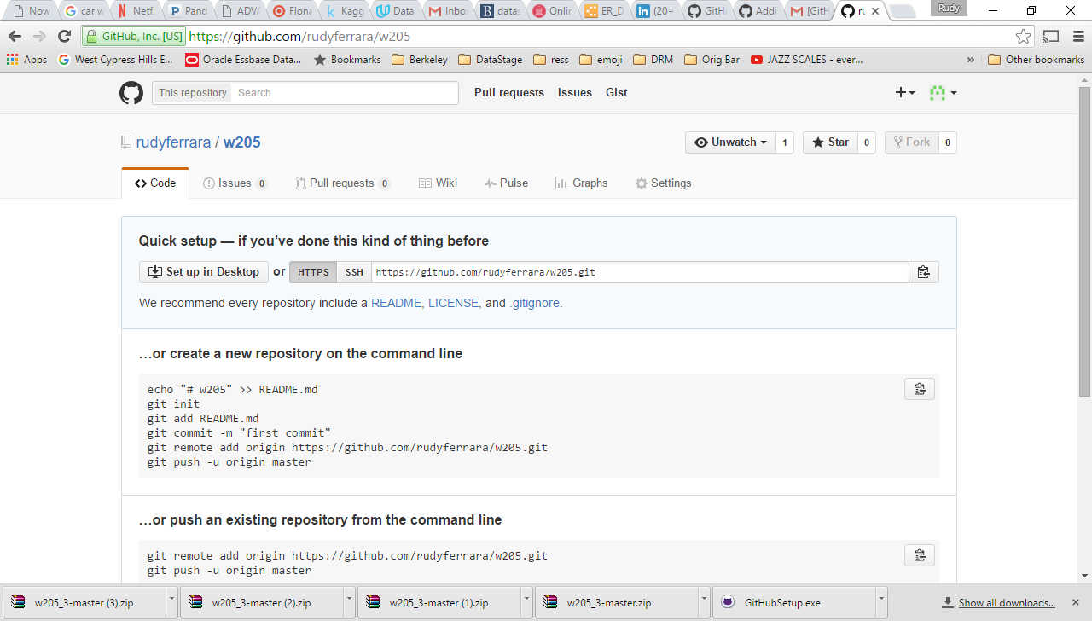

When I created w205_3 It let me upload files:

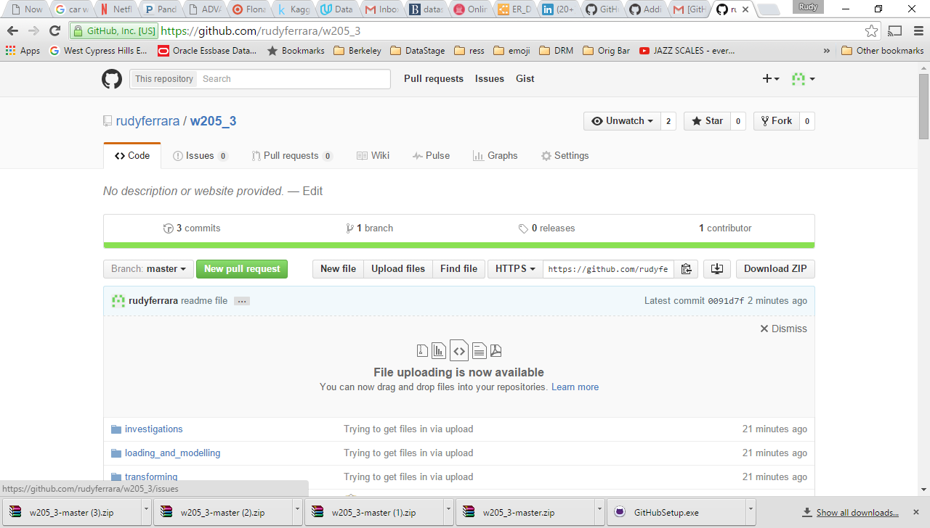

-----

From the command line I was getting errors like the following no matter what I tried. I am sure I was doing something wrong but I couldn’t figure it out. I tried creation a new repository from the command line but nothing would work.

[w205@ip-10-144-108-25 gittest2]$ git remote add origin https://github.com/rudyferrara/w205_2.git

[w205@ip-10-144-108-25 gittest2]$ git push -u origin master

error: The requested URL returned error: 403 Forbidden while accessing https://github.com/rudyferrara/w205_2.git/info/refs

fatal: HTTP request failed

[w205@ip-10-144-108-25 gittest2]$ git push -u origin master

error: The requested URL returned error: 403 Forbidden while accessing https://github.com/rudyferrara/w205_2.git/info/refs