This is the main screen. The user will be prompted to either join or create a game on this screen. They can then click on either of these buttons to begin either of these processes.

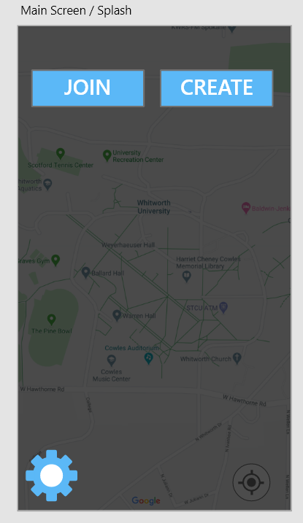

This is what happens when the user clicks the join game button. The user will be able to enter the unique game code and join the specified game.

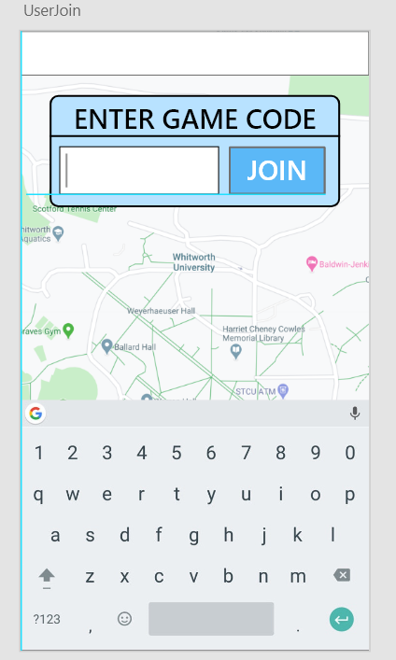

This is the main user screen during the game. There is a drop down task menu that allows you to see which tasks you have to complete. As you can see the tasks are location based on the map and you can submit them to be verified by the game host once they are completed.

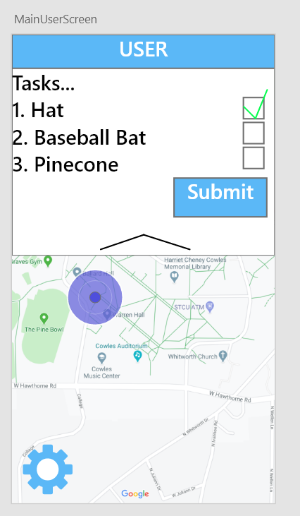

This is the submit screen that will show up when the user needs to upload or take a photo to complete the task. We will utilize camera functionality in order to take the photo from the Android or IOS device.

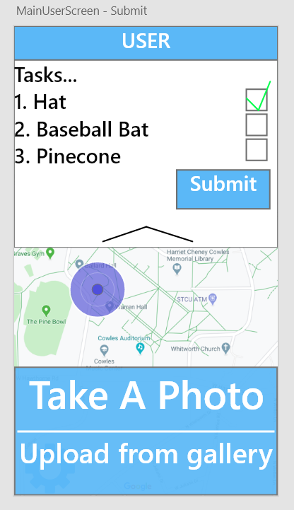

This is the screen that pops up when the user decides to create the game. Here the user can specify game rules and settings to fully customize and create the game.

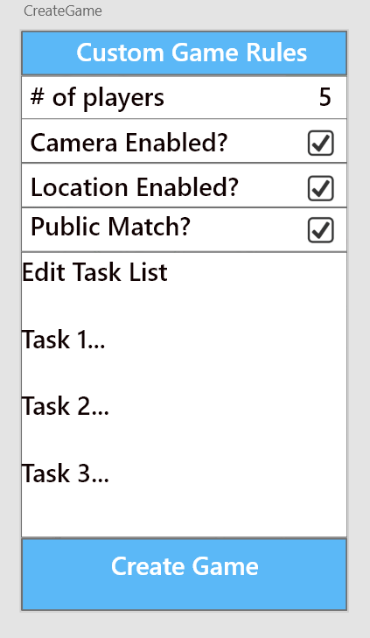

This is the central game management page where the host can access tasks that are essential to hosting the game. They can get into their inbox menu, kick/add players, or edit tasks all with their respective drop down menus.

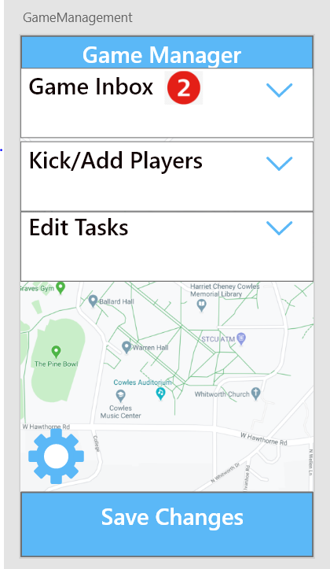

This is the inbox view where they can view the images/tasks completed by the users in their game and verify them.

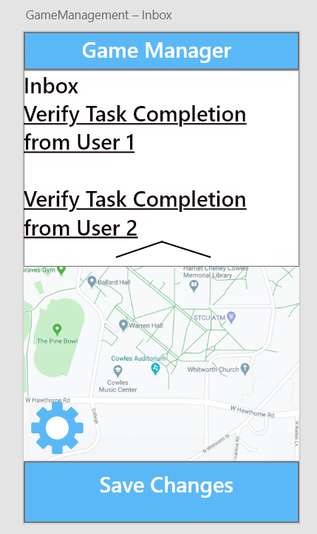

This is where the user can decide to remove players from the game that may be causing issues or no longer want to play.

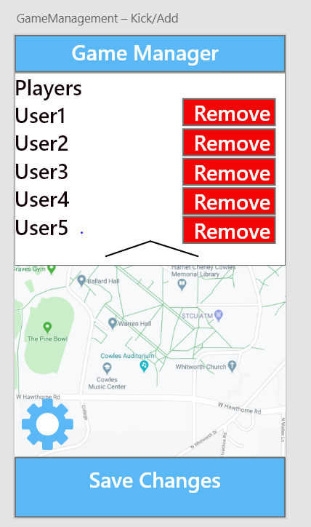

This is where the game host can edit tasks that are in the game in case they decide they want to change the tasks mid-game.

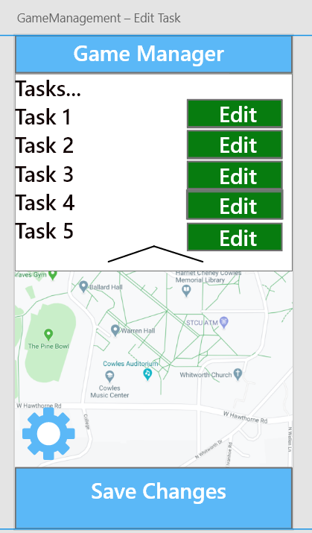

This is what happens when the host decided to edit a specific task. They can change the text of the description and choose whether the user needs to upload a photo or not.

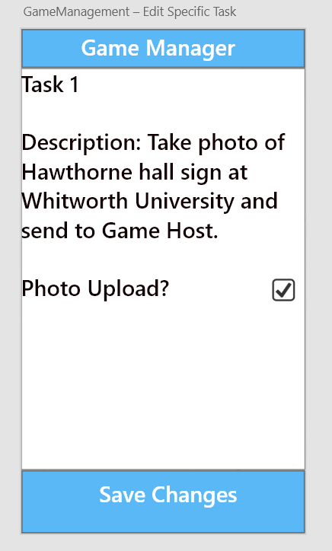

Here is the settings page. The users can click on the following settings and navigate to the area they are trying to change.

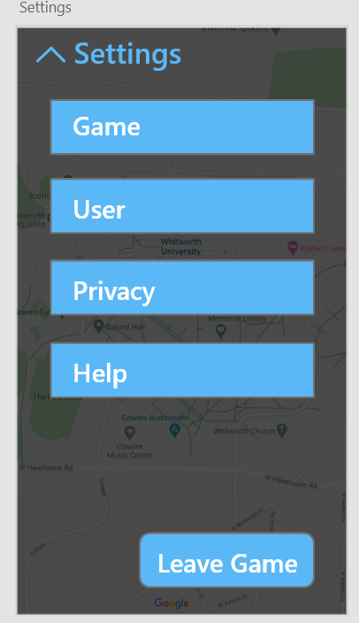

The user can type in the text box below and change their user name.

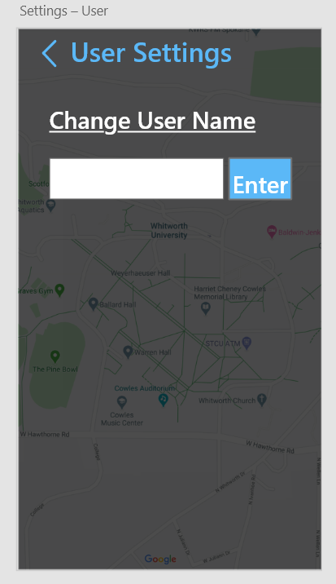

This is the privacy settings page. The user can use the checkboxes below to edit their privacy settigs.

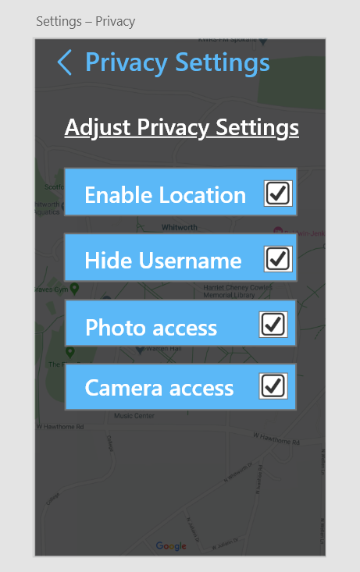

Here is an alternate mockup of adjusting the game settings. We may end up using this page for our host. Here you can add a new task, remove a task, and decide whether or not the match is public.

