The two Arduino mini's will sit in sockets on the right, above the one for the DALEK, the bottom one for the LEDS. That one will be connected with 4 wires to the PCB in the Dalek body that will take care of the 195 LEDS (65 RGB). The top one for moving the servo.

A newer version uses one ESP32 D1 Mini, instead of two Arduino mini’s.

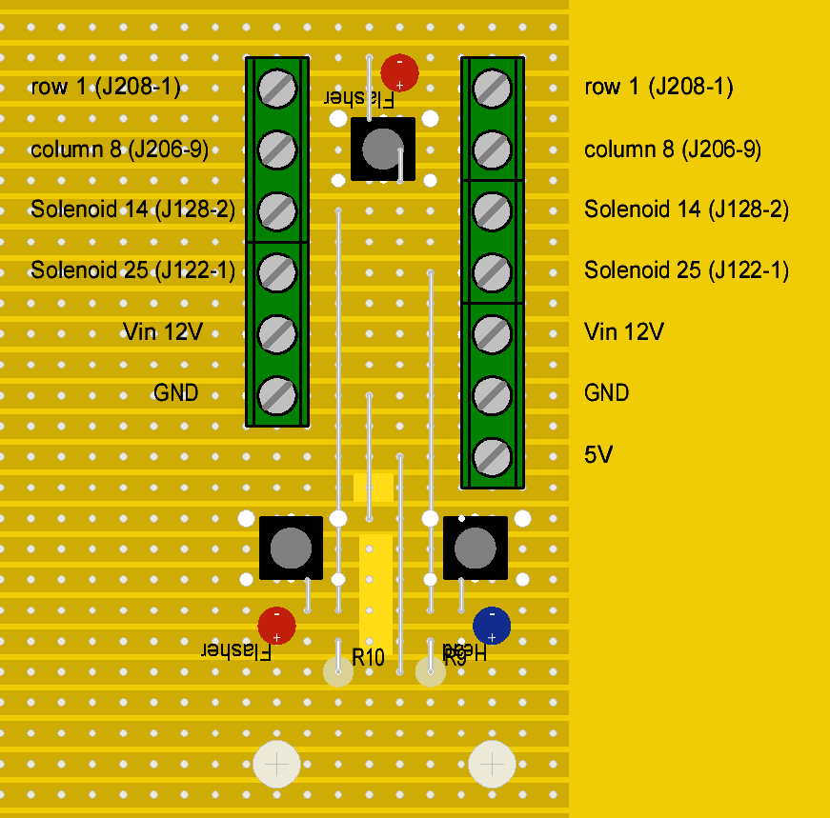
The interface between Pinball and Arduino / ESP32 uses a standard print with screw connectors.The four wires into your pinball are for the Solenoid 25 signal (J122-1), the Solenoid 14 signal (J128-2) and the switch matrix (J206-9 and J208-1) They sit in the middle on the left in the pinball PCB.

The buttons allow you to test: the top one manually activates the matrix switch 81 to be checked in the test menu of the pinball.

The lower ones forces a signal to the Arduino as if the pinball asks to wobble the head (right, blue LED), or to light up the flasher in the topper (left red LED). You can use those to make the Arduino force head movement, or switch on the topper light.

FOR THE ARDUINO

These two circuits are already connected, so do not need wiring into the arduino (pin5 and 6). You just need to hook up your servo to pin4.

Now.... you notice that there are TWO extra optoes there (left up end left down)... I'll test them, but they act as spare for e.g. the door opening stuff. You can put them on any pin of the arduino in the future (the two single pins on the right near the mini's) and have another input from and output to the pinball to play with.

FOR THE ESP32 D1 MINI

Pinball hookup (4 wires to the interface board) are on the right: Solenoid 14 and 25 (one wire each), as well as Switch 81 (two wires).

The power is hooked up to the upper left: 7V to 24V on the upper left. I used 12V in my pinball. Three step-down convertors convert to 5V (for the ESP32 D1 mini), 5.5V (for the LEDS) and 6V (for the servo).

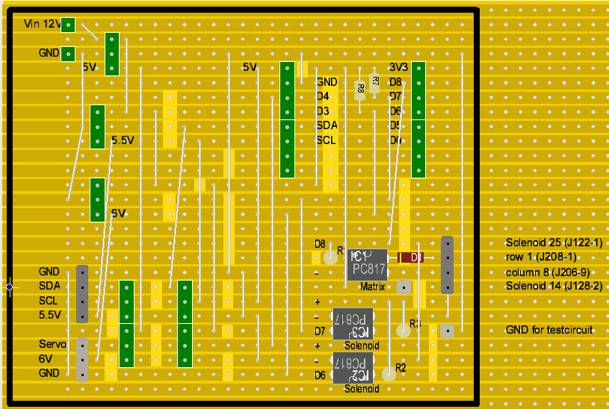
One 5V goes back to the interface board to light up the indicator LEDS for the solenoids. This 5V is not transferred back to the pinball, it stays on the interface card.

There are also pins for plugging in the servo (lower left) and the I2C interface for the LEDS, as well as 5.5V for the LEDS themselves. (lower left, just above the servo pins.)

This is how they are hooked up to the pinball (Solenoid 14 is missing in these pictures)

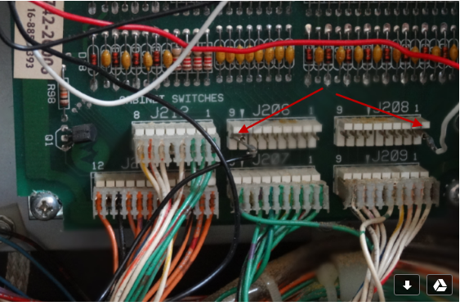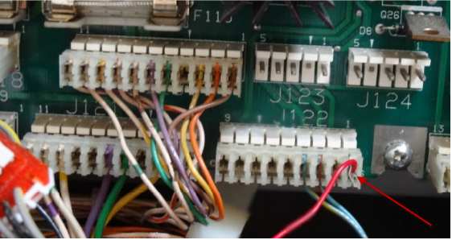

The powerplug needs to come from a different place than where I get it from currently: I originally got it from the regulated 12V (J114), but you can also get it to from the normal 12V (J116). Add a capacitor if you prefer

