 Time Management
Lesson Plan

[Standardized Training: Lesson Plan Sample]

December, 2014—Version 1.0

Time Management (2 hours)

Lesson Overview
Purpose of the Lesson: | This lesson is a part of the training curriculum for new supervisors/managers. Supervisors/managers requiring improvement in the area of time management may also use it as refresher training.
Prerequisite Training Requirements: | Prior to taking the Time Management lesson, employees must complete:  - New Supervisors Soft Skills Training (NSSST) (TMS Item VBA-505)
Target Audience: | This lesson is for new supervisors/managers. It is a one-time mandated requirement.
Lesson References: | - Covey, S. R. (1989). The Seven Habits of Highly Effective People. NY: Free Press.  - How to write an Action Plan. (2002). Retrieved from http://www.time-management-guide.com/plan.html  - I CARE Core Values. (2014). Retrieved from http://www.va.gov/icare/
Lesson Objectives: | At the end of this lesson, students will be able to:  - Differentiate among urgent, non-urgent, important, and unimportant tasks  - Prioritize tasks for effective time management, given a set of scenarios  - Develop an Action Plan for a typical work week

Instructor Notes
This lesson explores the importance of time management and provides practical tips for managing time. Students will learn about Stephen Covey’s Time Management Grid and how to classify tasks. The lesson also presents practice scenarios that allow students to practice making decisions in the interest of effective time management. Students will work in small groups to create an Action Plan that they can asdapt for use on the job. Students will complete an assessment and survey in TMS at the end of the lesson. Twenty-five scenario-based questions comprise the assessment.
[Note: The slides in the left column below match those in the Standardized PowerPoint Training Template. The Instructor Activities in the right column correspond with instructor notes, tips, and scripting for those slides.]
PowerPoint Slides | Instructor Activities
Time Management | DISPLAY slide  - “Time Management”  INTRODUCE yourself as the instructor and introduce fellow instructors.  INTRODUCE the lesson.
Overview of Today’s Training  Time Management Lesson  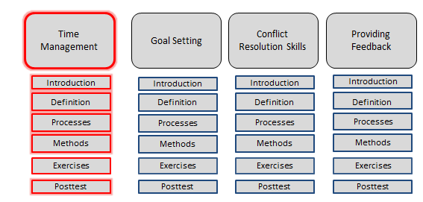 | DISPLAY slide  - “Overview of Today’s Training”  PROVIDE an overview of the day’s schedule.  EXPLAIN that students will be learning about time management today.  DISCUSS how time management fits into the lesson purpose, goals, and importance.
Introductions  - Student introductions  - Name  - Office location  - Time in position with VA | DISPLAY slide  - “Introductions”  ASK students to introduce themselves.
Icebreaker Activity  Answer this question:  - What is the most important thing you want to take away from this training? | DISPLAY slide  - “Icebreaker Activity”  ASK the question:  What is the most important thing you want to take away from this training?  ENCOURAGE students to think about their responses.  RECORD student responses for review at the end of the lesson.  TRANSITION to the next slide to tie the responses to the lesson objectives.
Lesson Objectives  At the end of this lesson, you will be able to:  - Differentiate among urgent, non-urgent, important, and non-important tasks  - Prioritize tasks for effective time management when given a set of scenarios  - Develop an Action Plan for a typical work week | DISPLAY slide  - “Lesson Objectives”  REVIEW the learning objectives and assure students they will have opportunities to practice what they learn.  EMPHASIZE that you will do your best to meet the expectations listed in the icebreaker during this training, as applicable.  EMPHASIZE that the post-lesson assessment will align with the content and these objectives.
Urgent versus Non-Urgent Tasks  - Urgent tasks demand immediate attention and are often associated with achieving someone else's goals.  - We make Urgent tasks a priority because they have consequences if not completed.  - Important tasks have an outcome that leads to the achievement of your goals. | DISPLAY slide  - “Urgent versus Non-Urgent Tasks”  TELL students that one can classify tasks as urgent, non-urgent, important, or non-important, based on a grid.  EXPLAIN that the difference between urgent tasks and important tasks is often whose goals they relate to (urgent tasks relate to achievement of others’ goals; important tasks relate to achievement of your own goals). Urgent tasks are a higher priority because of the possible consequences and risks.  TELL students that Covey’s approach to time management involves creating time to focus on important things before they become urgent.  REFERENCE Stephen Covey’s Time Management Grid from the Seven Habits of Highly Effective People.
Covey’s Time Management Grid  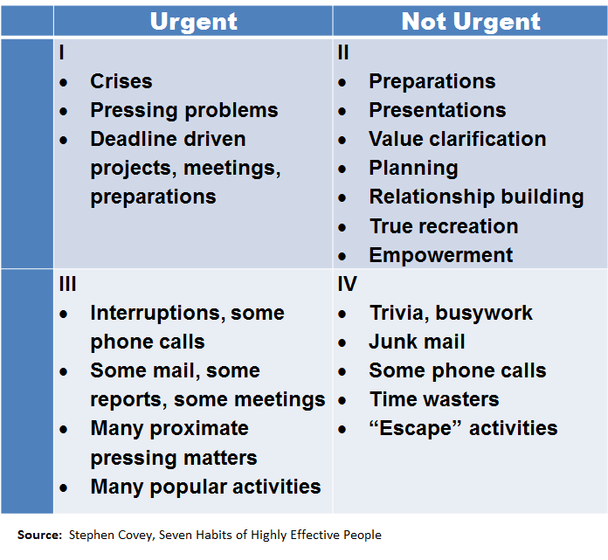 | DISPLAY slide  - “Covey’s Time Management Grid”  EXPLAIN the quadrants of Covey’s Time Management Grid:  Quadrant I is for the immediate and important deadlines.  Quadrant II is for long-term strategizing and development.  Quadrant III is for time-pressured distractions. They are not really important, but someone wants them now.  Quadrant IV is for those activities that yield little if any value. These are activities for taking a break from time-pressured and important activities.  TELL students that many people find that most of their activities fall into quadrants I and III. Many underuse Quadrant II, but it is exceptionally important because one must work both tactically and strategically at the same time. Finding ways to expand quadrant II activities is a common outcome from using this grid.  EMPHASIZE that students can use the grid to plan their to-do lists and prioritize their tasks.
Creating an Action Plan  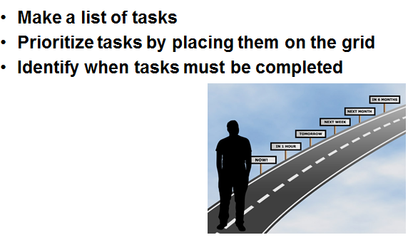 | DISPLAY slide  - “Creating an Action Plan”  REVIEW the steps on the slide.  EXPLAIN that students can use the Time Management Grid to create an Action Plan.  TELL students that creating an Action Plan by following these steps will help them accomplish all their tasks and manage their time effectively.
Question Screen  - What are some benefits of managing time effectively?  - What are consequences of poor time management? | DISPLAY slide  - “Question Screen”  ASK students to list benefits of managing time effectively.  ASK students to provide examples of consequences of not managing time effectively.  TELL students they can list real-life examples that they have experienced or they can consider hypothetical situations.  REVIEW the student responses and provide feedback.  REFER to the following possible answers/discussion points:  - Benefits:  - Meet deadlines  - Less stress  - Work product is better  - ICARE: Best performance of my duties  - Consequences:  - Missed deadlines  - Rushed work, more mistakes
Individual Activity—Prioritizing Tasks  SCENARIO:  You must complete a presentation by the end of the day. It is 8 a.m. You must complete the work by 4 p.m.  You know you need four hours for research and two hours to develop.  An employee enters your office with an emergency dealing with a client. It will require you to spend approximately 30 minutes communicating back and forth with the client and employee.  Suddenly, you receive an e-mail message from your supervisor asking for last quarter’s total training hours for all of your employees. Your supervisor needs this information first thing the next morning, and you know it will take you 15 minutes to run the report and send it to her.  Further, you are in charge of the upcoming canned-food drive and need to send an announcement to everyone in the office with information about the event. The deadline for collecting items is three days from today.  How would you prioritize these tasks? | DISPLAY slide  - “Individual Activity—Prioritizing Tasks”  EXPLAIN the tasking for the Individual Activity.  REVIEW the following directions:  - Read the scenario and prioritize the tasks using the Time Management Grid.  - Share your responses with the class.  TELL students they have 15 minutes to complete the tasking.  ENSURE that students understand the tasking.  REVIEW the student responses and provide feedback.  REFER to the following possible answers/discussion points. Note: Students may have slight variations in their responses, but generally, they should prioritize the tasks in the scenario as follows:  - Address the employee’s emergency with the client (Quadrant I)  - Run the report for your supervisor (Quadrant I)  - Research and develop your presentation (Quadrant I)  - Send out the e-mail announcement for the canned food drive (Quadrant II)
Group Activity—Develop an Action Plan  Directions:  - Meet in your small groups and select one person’s typical workweek. (This should be a list of tasks the person deals with in a five-day period.)  - Create an Action Plan based on what you learned in class today.  - Be sure that you consider the following when developing your group’s Action Plan:  - Prioritization of tasks based on importance  - Realistic due dates and times  Time allotted: 45 minutes | DISPLAY slide  - “Group Activity”  EXPLAIN the tasking for the Group Activity.  REVIEW the directions.  ENSURE that students understand the tasking.  TELL students they have the next 45 minutes to work on the Action Plan as a group and that they must bring the completed Action Plan to class the next day for review.  NOTE to Instructor: Answers will vary depending on the tasks in the manager’s typical workweek.
Lesson References  - Covey, S. R. (1989). The Seven Habits of Highly Effective People. NY: Free Press.  - How to write an Action Plan. (2002). Retrieved from http://www.time-management-guide.com/plan.html  - I CARE Core Values. (2014). Retrieved from http://www.va.gov/icare/ | DISPLAY slide  - “References”  IDENTIFY where students can find important VA and non-VA lesson references and job aids.
Summary  Today you:  - Differentiated among urgent, non-urgent, important, and non-important tasks  - Prioritized tasks for effective time management given a set of scenarios  - Developed an Action Plan for a typical work week | DISPLAY slide  - “Summary”  REVIEW the information in the day’s lesson.  REVIEW student responses to the icebreaker.
Questions? | DISPLAY slide  - “Questions?”  ASK students if they have any questions about the day’s lesson.  RESPOND to all questions before tasking students to complete the assessment.
TMS Assessment and Survey  - The assessment and survey are in TMS.  - Twenty-five scenario-based questions comprise the assessment.  - Today’s information forms the basis for the questions.  - You should be able to complete the assessment and survey within one hour.  - Be sure to complete both the assessment and the survey in TMS to receive credit for this training. | DISPLAY slide  - “TMS Assessment and Survey”  TELL students how to access the assessment and survey in TMS.  EXPLAIN that 25 scenario-based questions comprise the assessment, and they will cover what the students learned in class today.  REMIND them that they must complete both the assessment and the survey in order to receive credit in TMS for their training.  TELL students that the survey provides them an opportunity to improve the training and that their feedback is welcome.

