–

**PMTI COPY**

**ACKNOWLEDGEMENT RECEIPT**

**Date received: June 19, 2023**

**Name of Employee: Ruel Velasquez  
Position: Android Developer**

**DESCRIPTION:**

|  |  |  |
| --- | --- | --- |
| **QTY** | **OFFICE EQUIPMENT/ MACHINES** | **Model Name/**  **SERIAL NOS.** |
| 1 Unit | **BRAND NEW LAPTOP:**  **Lenovo IdeaPad Slim 3i 15IAU7 82RK0047PH** **with Charger, Laptop Bag & wired Mouse**  Product Description: **Lenovo IdeaPad Slim 3i 15IAU7 82RK0047PH Arctic Grey** - Intel Core i5-1235U, 10C (2P +8E) / 12T, P-core 1.3 / 4.4GHz, E-core 0.9 / 3.3GHz, 12MB | 8GB Soldered DDR4-3200 | 512GB SSD M.2 2280 PCIe 3.0x4 NVMe | 15.6inch FHD (1920x1080) IPS 300nits Anti-glare | Integrated Intel Iris Xe Graphics functions as UHD Graphics | Wi-Fi 6 11ax, 2x2 + BT5.1 | Windows 11 Home Max Memory Up to 16GB (8GB soldered + 8GB SO-DIMM) DDR4-3200 offering (**with** **Transcend 8GB DDR4-3200 SODIMM JM3200HS Memory Installed**) | PF484750 |
|  | *** nothing follows *** |  |

***NOTE: FRAGILE, PLEASE HANDLE WITH CARE****- Any damage/s upon return/turn-over of the laptop to PMTI will be charged to the employee undersigned.  
- In case of Broken or Lost Unit, the Employee will pay the total amount of the brand-new laptop (* **P37,487.00 /unit***).*

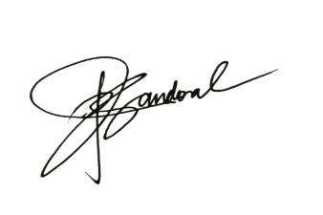**Thank you.**

**Pamela Jane B. Sandoval**

PMTI Tektite Office

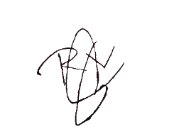

Received by:

**RUEL D.VELASQUEZ**

**Signature over printed name**

Date: ____________________