|  |
| --- |
| ***WORK EXPERIENCE SHEET*** |
| ***Instructions: 1.*** *Include only the work experiences relevant to the position being applied to.*  *2. The**duration should include start and finish dates, if known, month in abbreviated form, if known, and year in full. For the current position, use the word Present, e.g., 1998-Present. Work experience should be listed from most recent first.* |
| * Duration: July 20, 2020 – Present * Position: Android Programmer * Name of Office/Unit: * Immediate Supervisor: Maria Estrada * Name of Agency/Organization and Location: Pilipinas Micro Matrix Inc, Pasig, Ortigas * List of Accomplishments and Contributions (if any)   + Developed Mobile application * Summary of Actual Duties   + Develop and maintain mobile application |
| * Duration: June, 2019 – April 10, 2020 * Position: IT staff * Name of Office/Unit: Baloi Provincial Hospital * Summary of Actual Duties   + Maintain and Support of the existing software of the hospital   + Support for the hardware and software issue |

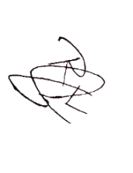

***Attachment to CS Form No. 212***

RUEL VELASQUEZ

(Signature over Printed Name

of Employee/Applicant)

Date:Febuary 7,2024