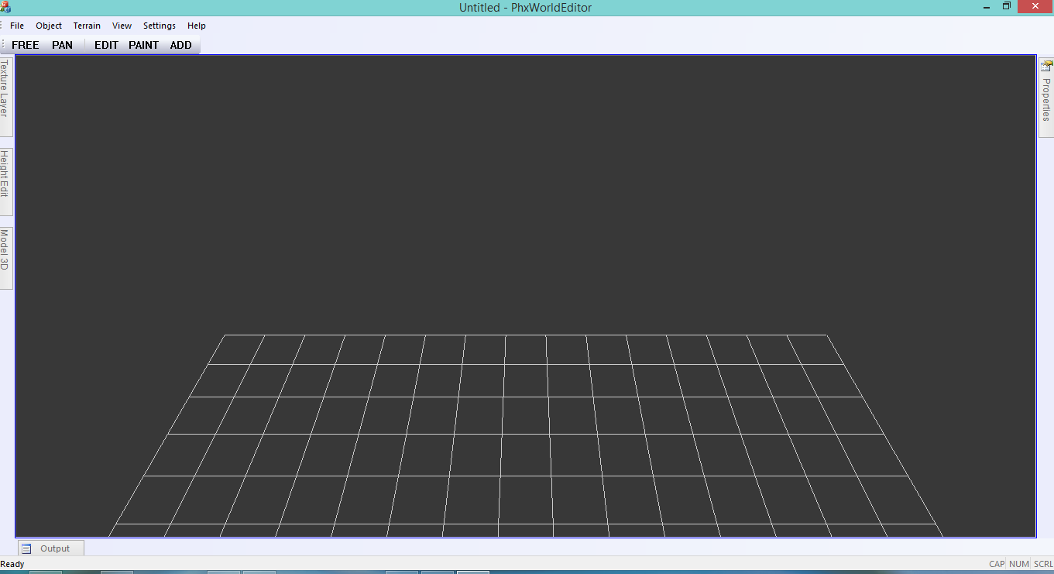

NO functionality yet

Tools panel

Mouse Mode Menus

NO functionality yet

**Mouse Mode**

* Free – means Free camera
  + First Person camera style
  + To Rotate the Camera view, Click and drag the mouse button
  + Use Arrow keys to move forward and side
* Pan – Camera Panning
  + When Active Drag the camera to the left/right to pan from side to side or drag up/down

To drag forward/backward.

* Edit – When active, the terrain can be edited by lowering/rising the ground.
* Paint – When active, user can paint the terrain using textures selected. Also known as Texture Splatting.
* Add – When Active, the user can add 3D objects in the terrain by clicking the left mouse button. Only active “Used” objects are added

Note: the buttons on the Mouse mode toolbar are all toggle buttons, which means only one mode is active at once, When No buttons are active, the mouse mode defaults to **SELECT**, which means, the user can select objects in the screen.

**Keyboard shortcuts**

* Standard
  + Ctrl + O – Open file, opens Phoenix world files only (*.phx)
  + Ctrl + S – Save file. Saves the current world.
  + Ctrl + X – Close current world.
  + **Ctrl + Mouse Wheel – Up/Down Camera.**
  + **Shift + Mouse Wheel – Pan Camera.**
* Free Mode
  + Arrow Keys – move camera.
* Select Mode (default)
  + OBJECTS MUST BE SELECTED
    - Ctrl + Arrow Keys
      * **Move Objects** forward/backward/sideways
    - Shift + Arrow Up/Arrow Down
      * **Move Objects** Up And down
  + Delete Key
    - **Delete** Selected Objects
  + Shift + A/ Shift + D
    - +/- **Rotation** Objects in Y Axis
  + Shift + W/ Shift + S
    - +/- **Rotation** Object in Z Axis
  + Shift + Q / Shift + E
    - +/- **Rotation** Object in X Axis
  + **Shift + J/ Shift + L**
    - **+/- Scale in X Axis**
  + **Shift + i/ Shift + K**
    - **+/- Scale in Y Axis**
  + **Shift + U / Shift + O**
    - **+/- Scale in Z Axis**
  + **Shift + N / Shift + M**
    - **+/- BALANCE Scale**
  + Ctrl + Mouse click
    - Multiple Object select
  + **Shift + Ctrl key + Mouse Drag** 
    - Rotate CAMERA (center at 0,0,0).

**Terrain Generation**

To generate terrain, go to Terrain->Generate

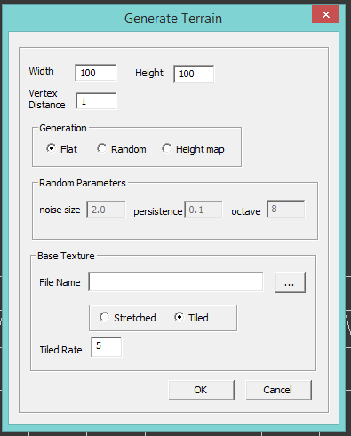

* Width, Height – the dimension of terrain, the number of vertex across the X and Z Axis.

Only accepts non decimal values.

**NOTE: Since this is built to work on mobile devices, please consider the size of the terrain.  
Bigger terrain means slower frame rate. I recommend 100x100 ideal terrain size or a maximum size of 500x500. Most mobile devices cant process so many triangles in one terrain.**

* Vertex Distance – the distance between each vertex of the terrain, the bigger the value the bigger the lower the terrain resolution, the smaller the value the finer the resolution the terrain gets.  
  Accepts decimal values.
* Generation
  + Flat – generate a flat Terrain
  + Random – generate a random terrain with Perlin noise technique.
  + Height map – loads a terrain from heightmap file **(not yet supported)**.
* Base Texture – the basic ground texture of the terrain. Without the texture, the terrain will generate a black terrain.
  + The base texture can either be one HUGE image file that is stretched across the terrain or tiled N times. Tiled Rate field sets the number of times the texture is tiled across the terrain. Textures must be tillable.

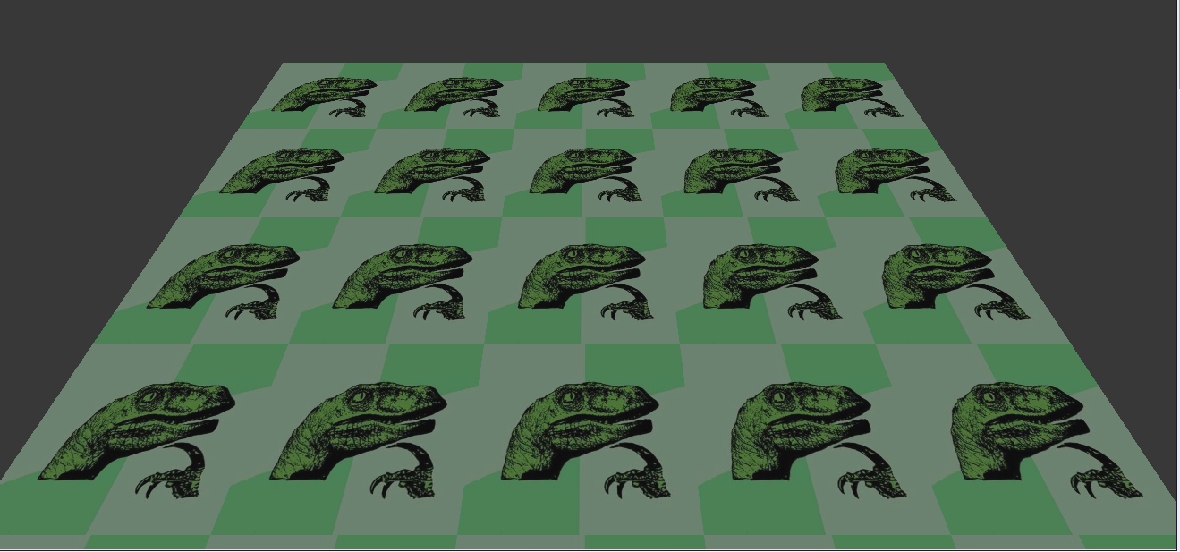

**Texture tiled 5 times.**

**Terrain Edit**

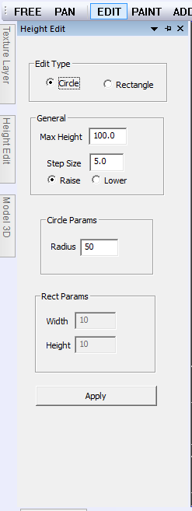

* Edit Type – choose between two brush type to edit the terrain height
  + Circle Brush
  + Rectangle Brush
* Max Height
  + The Maximum height a terrain can get, it can be used to create a plateau.
* Step Size
  + The amount of edit applied to a vertex, the bigger the value the quicker the raise/fall of the terrain.
* Radius/Width/Height – the range of the brush, the smaller the value, the smaller the vertex coverage.

After setting up values for Edit Terrain dialog, DO NOT forget to click APPLY button to reflect changes BEFORE editing the terrain.

**Terrain Paint**

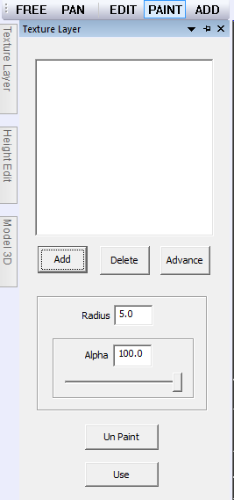

* Add/Delete

Add or delete a texture in the list. NOTE: the editor only accepts maximum of 3 textures.

* Advance

Opens up the height based texture dialog, user can set the height range of a certain texture to take effect. See Terrain Texture height example bellow.

* Radius

Terrain Paint brush range

* Alpha

The visibility of the selected brush paint in percentage.

* Unpaint Button

Undoes or remove the applied paint

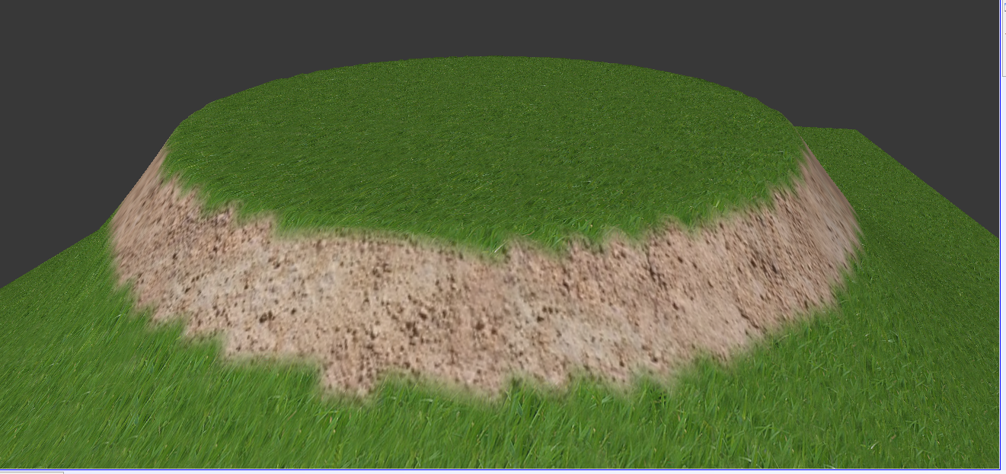

**Terrain Texture Height example**

The above example of a height based texture. The sand texture **height was set** to 10.0 to 15.0 and **maximum** **height** size is set to 15 thus making a plateau effect common in most games.

**Add Object**

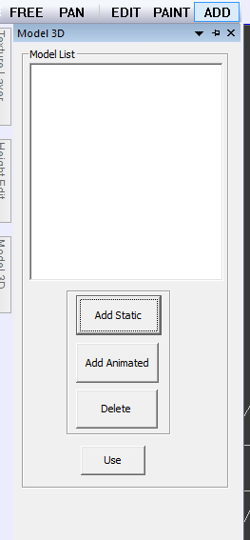

* Add Static – Loads static object to the list and NOT to the scene. Model format loaded is Wavefront OBJ.
* Add Animated – Loads an animated 3D model to the lists. (Not yet supported on world editor BUT already supported in Phoenix Model Viewer).
* Delete – Delete objects in the lists including all its instance
* Use – **toggle button** to add model to the scene.

**NOTE: when the toggle button is set to ON, and Mouse Mode is set to ADD. Whenever the user clicks on the terrain, an instance of the mode is added.**

**Movement**

Movements in the editor can be edited in Settings->Movement

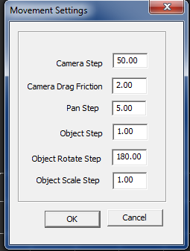

* Camera Step – camera forward, backward and sideward Step value.
* Camera Drag Friction – The reaction/friction value when you drag the mouse during FREE mouse mode.
* Pan Step – Pan Movement when mouse is dragged.
* Object Step – object movement step. Used for forward/backward and sideways values. This is use during selection mode.
* Object Rotate Step – Rotation step values per frame. Used during selection mode. This value is in radians.
* **Object Scale Step – Object Scale value.**

**Environment Settings**

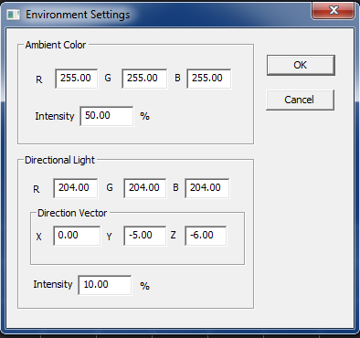

* Ambient Color – the overall ambience of the scene, this color is applied to all objects.
* Directional Light – the global Light, also known as the ‘Sun’ of the scene.
  + Note: Directional light does not have position but only light direction.