EmotionFusion EmpathyBot
Project Progress Report - 30% Complete
Rujeko Macheka

Project Description
EmotionFusion EmpathyBot is a multimodal deep learning system that detects emotions from both text and facial expressions to generate empathetic chatbot responses. The project aims to create a compassionate and contextually aware AI assistant suitable for mental health and support settings.

Core Components
- Text Emotion Analysis: DistilRoBERTa transformer analyzing emotional content in user messages
- Facial Expression Recognition: Custom CNN detecting emotions from facial images
- Multimodal Fusion: Attention-based mechanism combining both modalities for accurate predictions
- Empathy Response Generator: Context-aware supportive responses based on detected emotions

Datasets
- Text: Google's GoEmotions dataset with 27 emotion labels
- Images: FER2013 facial expression dataset with 7 emotion categories

Task Progress & Completion Status
Task/Feature | Progress | Status Details
User Interface & Deployment | 50% | Gradio interface deployed with text and image inputs
Text Emotion Model | 40% | Pre-trained model integrated; fine-tuning pending
Empathy Response System | 35% | Template responses created for 7 emotions
Multimodal Fusion | 30% | Rule-based fusion implemented; learned fusion pending
Facial Recognition Model | 25% | Using FER library; custom CNN training needed
Data Preparation & EDA | 20% | Datasets accessed; comprehensive EDA pending
Evaluation & Metrics | 15% | Basic probability outputs; comprehensive metrics needed
Ethical Considerations | 10% | Initial conceptualization; formal analysis pending

Code Implementation Screenshots

Text Emotion Prediction Function
This function processes user text input through the DistilRoBERTa transformer model and returns emotion probability distributions:
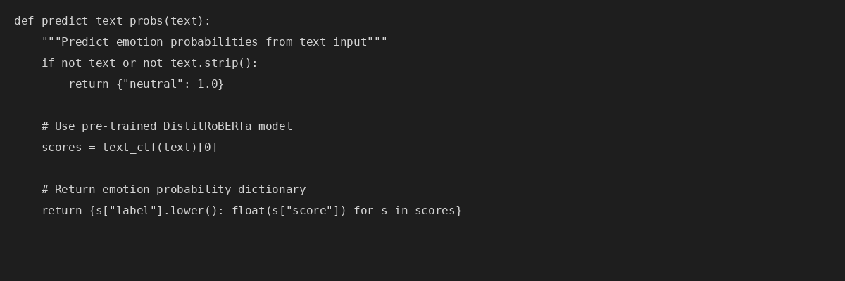

Multimodal Fusion Logic
The fusion function combines text and facial emotion predictions using a three-mode strategy: agreement, priority-based selection, and conflict detection:
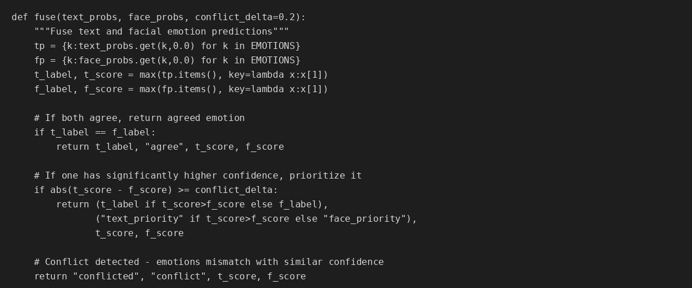

Gradio User Interface
The Gradio interface provides an intuitive way for users to interact with the multimodal emotion recognition system:
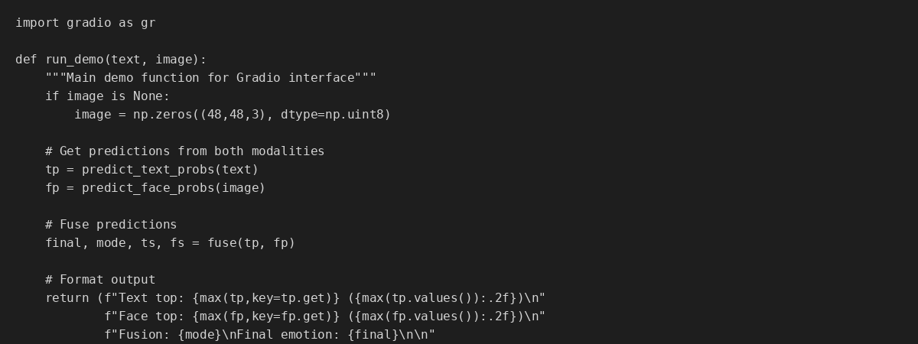

Challenges Encountered

1. Limited Deep Learning Implementation
Current implementation relies heavily on pre-trained models without custom training. For a deep learning course project, I need to demonstrate actual model development, training loops, and hyperparameter optimization. I'm addressing this by planning to fine-tune the text model and build a custom CNN for facial recognition from scratch.

2. Multimodal Data Alignment
Creating properly paired text-image samples for training the fusion mechanism is challenging since GoEmotions and FER2013 are separate datasets. I'm exploring options like the MELD dataset which contains both audio-visual and textual data, or creating synthetic pairings for training purposes.

3. Class Imbalance
Both emotion datasets suffer from significant class imbalance. Some emotions like 'neutral' and 'happy' are overrepresented while emotions like 'disgust' and 'fear' are underrepresented. I'll need to implement strategies like class weighting, oversampling minority classes, or focal loss to handle this issue effectively.

4. Fusion Strategy Complexity
Determining the optimal way to combine text and facial emotion signals is conceptually challenging. My current rule-based approach is too simplistic. I'm researching attention mechanisms and concatenation strategies to implement a learned fusion layer that can adapt based on modality reliability.

5. Computational Resources
Training deep learning models, especially transformers and CNNs, requires significant computational resources. Google Colab's free tier has limitations on GPU availability and session duration. I'm managing this by using smaller batch sizes and being strategic about when to train models, but I may need to explore Colab Pro or other cloud computing options.

6. Ethical Implications
Designing a system for mental health support carries significant ethical responsibility. I'm grappling with questions about how to handle situations where the model might miss signs of serious distress, ensuring the system doesn't reinforce biases against certain demographic groups, maintaining user privacy when dealing with sensitive emotional data, and clearly communicating that this is a support tool, not a replacement for professional help.

Next Steps (Priority Order)
- Implement Custom Model Training: Fine-tune DistilRoBERTa on GoEmotions dataset and design/train custom CNN on FER2013 with proper training loops and validation
- Create Comprehensive Evaluation Framework: Implement accuracy, precision, recall, F1-score metrics, generate confusion matrices and ROC curves, compare unimodal vs multimodal performance
- Develop Learned Fusion Mechanism: Replace rule-based fusion with neural network layer using attention-based approaches, train on paired multimodal data
- Address Data Quality Issues: Complete EDA for both datasets, implement class balancing strategies, create robust data augmentation pipelines
- Enhance Empathy Response System: Add conversation context awareness, implement response variation, integrate sentiment intensity
- Document Ethical Considerations: Conduct bias analysis, define clear limitations and use cases, implement uncertainty handling

Project Timeline
Weeks 1-2: Complete data preparation, implement custom training pipelines, begin fine-tuning text model
Weeks 3-4: Train custom CNN, implement evaluation metrics, develop learned fusion mechanism, conduct ablation studies
Weeks 5-7: Comprehensive evaluation, bias analysis and ethics review, enhance empathy responses, final documentation

Reflection
At approximately 30% completion, I've established a solid foundation with a working prototype that demonstrates the core concept of multimodal emotion recognition. The Gradio interface successfully integrates text and facial emotion analysis with a basic fusion mechanism and empathetic responses. However, the most challenging and educational aspects of the project lie ahead. Moving from pre-trained models to custom implementations will deepen my understanding of neural network architectures, training dynamics, and the intricacies of multimodal learning.
The ethical dimensions have become increasingly apparent to me. Working on a system intended for mental health support requires careful consideration of bias, privacy, and responsible AI practices. I'm committed to building a technically proficient model that is also transparent about its limitations and designed with user wellbeing in mind.

