1. SSH into EC2 using Git Bash to Run Hello World Python: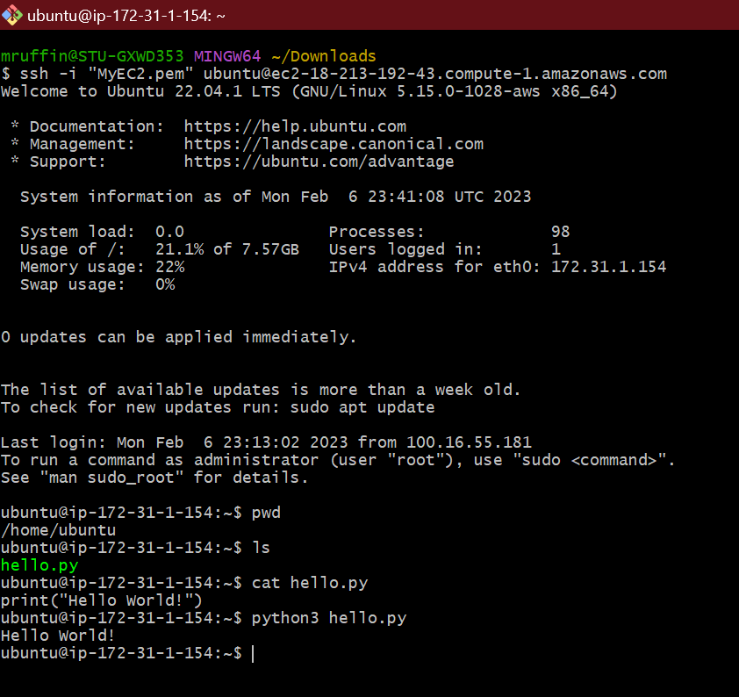
2. HTML Script: Hello World