AWS:

SSH into EC2

Run via URL:

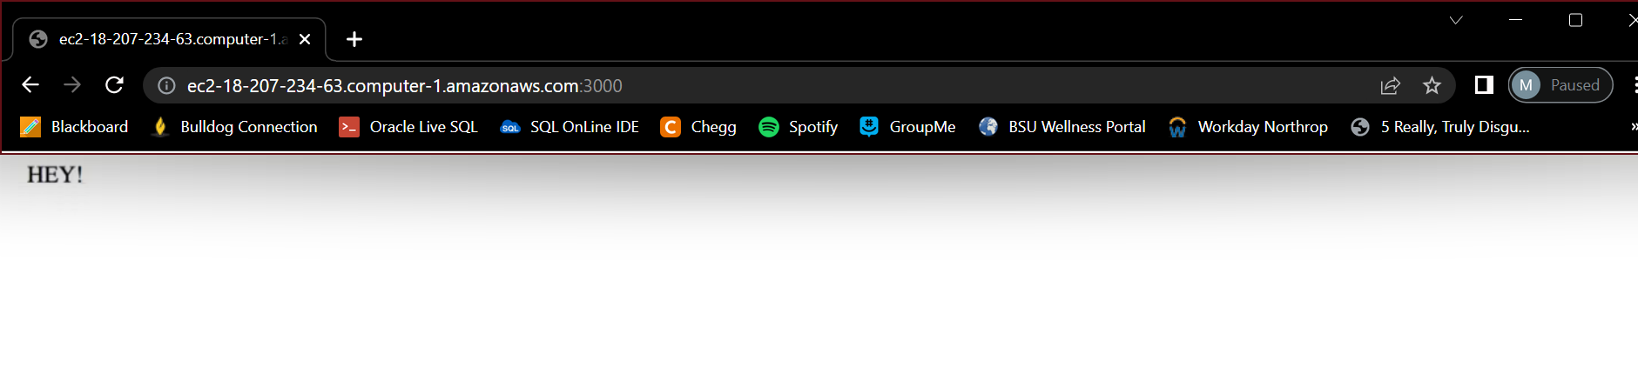

Heroku: Host App

