General Help of Network Traffic Generation and Analysis Platform

 

Author: Dr. Lei Guan ([lei.guan.tcd@gmail.com](mailto:lei.guan.tcd@gmail.com))

Modified by: Marco Ruffini ([marco.ruffini@tcd.ie](mailto:marco.ruffini@tcd.ie))

Optical Network Architectures Group

CONNECT / The Centre for Future Networks and Communication

The University of Dublin, Trinity College

Dublin 2, Ireland

Table of Contents

1. Main Structure of the NTGA Platform Software 3

2. Top Level Graphic User Interface 3

3. Service Profile Synthesizer 4

3.1 Introduction 4

3.2 Working Flow 5

4. User Profile Synthesizer 6

4.1 Introduction 6

4.2 Working Flow 8

5. Traffic Flow Generator 10

5.1 Introduction 10

5.2 Working Flow 11

# 1. Main Structure of the NTGA Platform Software

This network traffic generation and analysis (NTGA) platform has been constructed as shown in the following diagram and table.

Fig.1 Bone structure of the NTGA Platform Software at the system level.

Table I Main function of each module

|  |  |
| --- | --- |
| **Module name** | **Main functions** |
| Top Level GUI | Main UI;  Launch individual sub GUIs and some documents; |
| Service Profile Synthesizer | Load default service profile;  Modify a current service profile;  Save and update service profile;  Two approaches simple validation; |
| User Profile Synthesizer | Configure each types of service;  Generate statistical customisable user profiles with aggregated configuration of services;  View one trial of the statistical user profile;  Save and update user profile; |
| Traffic Flow Generator | Import user editable Metro core node configuration;  Statistically generate metro code node configuration;  Load service profile, user profile and percentage of each user profile;  Statistically generate traffic flow matrix;  Measure and evaluate the generated traffic flows;  Export traffic flows matrix; |

# 2. Top Level Graphic User Interface

Top GUI provides a high-level control of the software tool as shown below, which contains three buttons that link to three essential sub-GUI software tools, i.e., Service Profile Synthesizer, User Profile Synthesizer and Traffic Flow Generator.

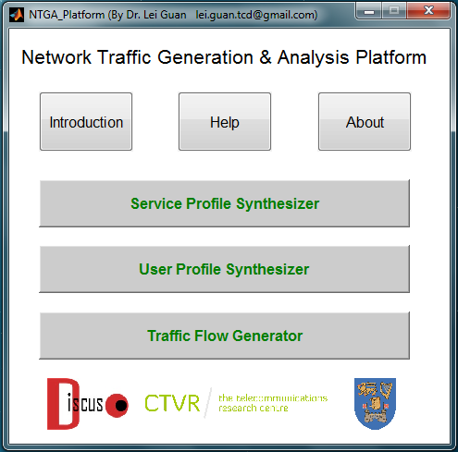

Fig. 2 The main UI of the NTGA platform.

# 3. Service Profile Synthesizer

## 3.1 Introduction

This sub-GUI is designed for characterizing different services that occurred in a given network. The main parameters of each service are: downstream bandwidth requirement, upstream bandwidth requirement, Peer-to-peer traffic percentage, Data centre traffic percentage and Internet Exchange traffic percentage.

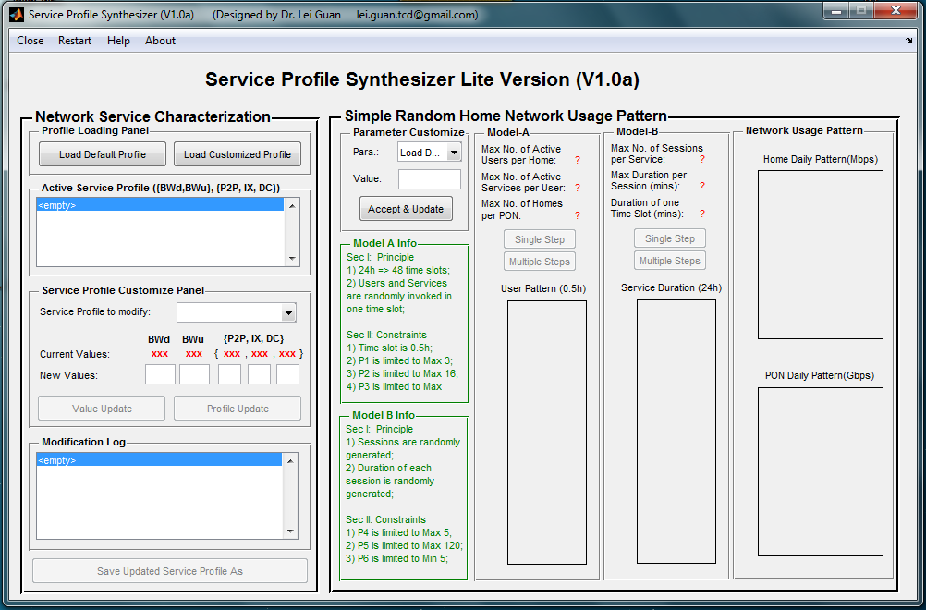

Fig.3 UI of Service Profile Synthesizer.

A default service profile has been pre-defined as below.

Table II. Default Service profile

|  |  |  |  |  |  |  |
| --- | --- | --- | --- | --- | --- | --- |
| **No.** | **Name** | **BWDS** | **BWUS** | **P2P** | **IX** | **DC** |
| S1-1 | E-Life | 1 | 0.5 | 0.3 | 0.4 | 0.3 |
| S1-2 | E-Entertainment | 1 | 0.5 | 0.3 | 0.4 | 0.3 |
| S1-3 | E-Commerce | 0.5 | 0.25 | 0.3 | 0.4 | 0.3 |
| S1-4 | E-Learning | 0.5 | 0.25 | 0.3 | 0.4 | 0.3 |
| S1-5 | E-Social | 5 | 2.5 | 0.3 | 0.4 | 0.3 |
| S2-1 | VoD-UHD(2160P) | 25 | 2.5 | 0.3 | 0.1 | 0.6 |
| S2-2 | VoD-FHD(1080P) | 18 | 1.8 | 0.2 | 0.1 | 0.7 |
| S2-3 | VoD-HD(720P) | 8 | 0.8 | 0.2 | 0.1 | 0.7 |
| S2-4 | VoD-SD(480P) | 2 | 0.2 | 0.2 | 0.1 | 0.7 |
| S2-5 | VC-HD(720P) | 16 | 16 | 0.2 | 0.3 | 0.5 |
| S2-6 | VC-SD(480P) | 3 | 3 | 0.2 | 0.3 | 0.5 |
| S2-7 | VC-LD(240P) | 0.7 | 0.7 | 0.2 | 0.3 | 0.5 |
| S2-8 | Online-Gaming | 6 | 3 | 0.3 | 0.4 | 0.3 |
| S2-9 | VoIP | 0.2 | 0.2 | 0.3 | 0.4 | 0.3 |
| S3-1 | File-Sharing | 10 | 10 | 0.8 | 0.05 | 0.15 |
| S3-2 | Data-Backup | 5 | 5 | 0.2 | 0.1 | 0.7 |

Except for the name of the service, other parameters of a given service can be customized according to the user’s measurement or prediction.

Besides the service profile modification capability, this sub-module also provides two simple validation models for evaluating the parameters.

## 3.2 Working Flow

*Load and modify service profile*

|  |  |  |
| --- | --- | --- |
| Load default profile | Modify a selected profile | Update the modified profile |

*Simple validation by model A*

|  |  |
| --- | --- |
|  | * Random invoke services from service list; * Minimum unit is 0.5h; * Single step generates pattern for 0.5 h (one time slot); * Multiple steps generate pattern for 24h (48 time slots); * Home Daily Pattern will statistically aggregated services usage; * A scaling parameter was used for showing PON pattern regarding various user behavior during different period of time; |

*Simple validation by model B*

|  |  |
| --- | --- |
|  | * Sessions are randomly generated for each service across 24 hours; * Duration of each session is randomly generated; * Service sessions durations are provided; * Home daily usage will aggregate all of the services in the list; * Normal distribution is used for PON level aggregation; |

# 4. User Profile Synthesizer

## 4.1 Introduction

This sub-GUI is designed for generating user profile that statistically characterizes the network usage behavior of a group of users.

In the current version (V1.0a), four parameters are used for reflecting the usage of a given service. Each of the parameter has been modelled by a beta function with typical inputs a, b, var or scaling factor. Several typical beta distributions have been pre-set as options in each of the popup menu. User customization function is also available in this version.

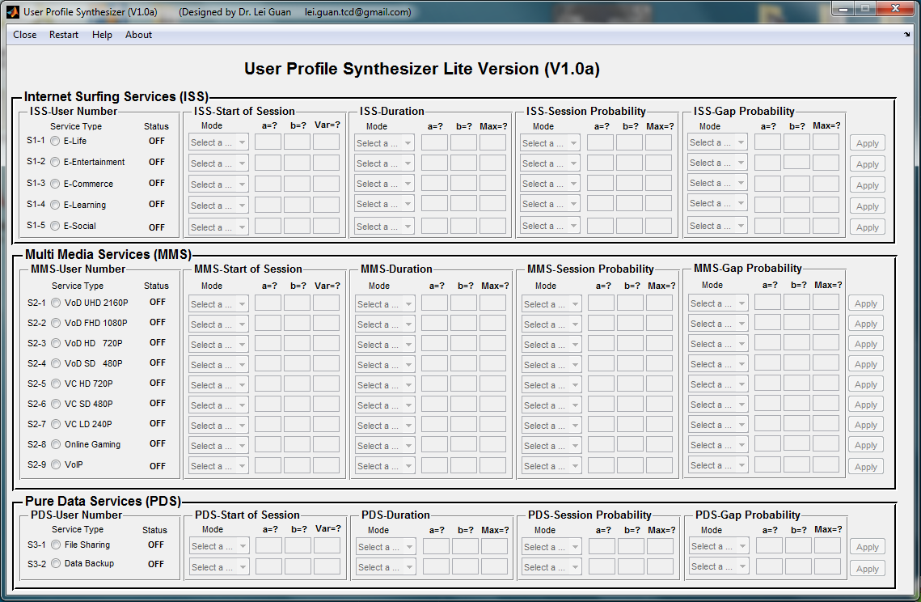

Fig. 4 UI of User Profile Synthesizer.

One meaningful user profile may contain one validated service or multiple services that characterized by beta functions respectively. One typical user profile actually aggregates all of the usage of selected services for one day statistically. For a particular day, it may look like as the figure shown below. The corresponding distribution, total duration, usage break down, duration break down will be also measured and shown in a new popup GUI.

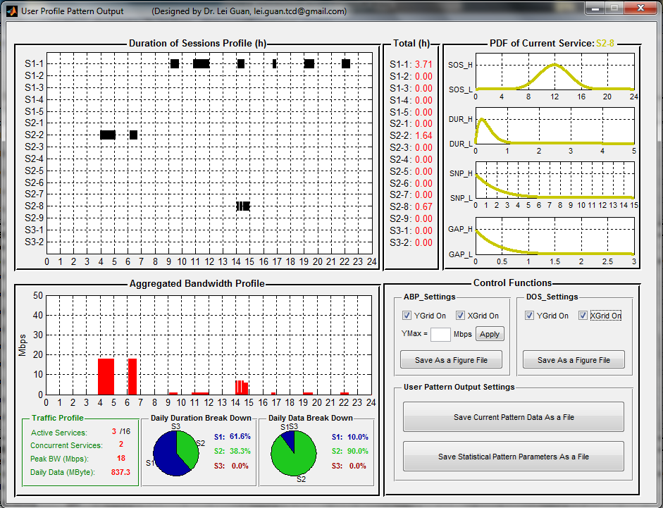

Fig. 5 Snap shot of an example of User Profile Output illustration.

## 4.2 Working Flow

*Enable Service*

|  |
| --- |
| After enabling a service, the corresponding status will be switched to “ON” automatically. |

*Beta Function Parameter input*

|  |
| --- |
| Two methods are provided, either pre-defined or user customized. Individual apply button can be used to latch in the statistical parameters providing an example trial result. |

*Pre-defined Parameter Value*

|  |  |  |  |  |  |  |  |  |  |  |
| --- | --- | --- | --- | --- | --- | --- | --- | --- | --- | --- |
| |  |  | | --- | --- | | **Function name** | **Predefined Beta function Paramters** | | Start of Session (SOS) | 3-14-0.05; 14-14-0.05; 14-3-0.05 | | Duration (Dur) | 2-15-5; 4-15-5;8-15-5 | | Session Probability (SNP) | 1-1-15; 1-1.2-15; 1-2-15; 1-8-15 | | Gap Probability (GAP) | 1-1-3; 1-1.2-3; 1-2-3; 1-8-3 | |

*Duration Aggregation and distribution*

|  |
| --- |
|  |

*Measurement of the current trial*

|  |
| --- |
|  |

*Control and Export*

|  |
| --- |
| Note: The user profile should be saved using “Save Statistical Pattern Parameters As a File”. |

# 5. Traffic Flow Generator

## 5.1 Introduction

Taking the service profile and user profiles as parts of input, the Traffic Flow Generator will generate traffic flow matrix for a number of given metro core nodes, which are specified in a given txt file or can be statistically generated within this tool. Corresponding measurement and processing status are also provided, and the traffic matrix can be replayed as well.

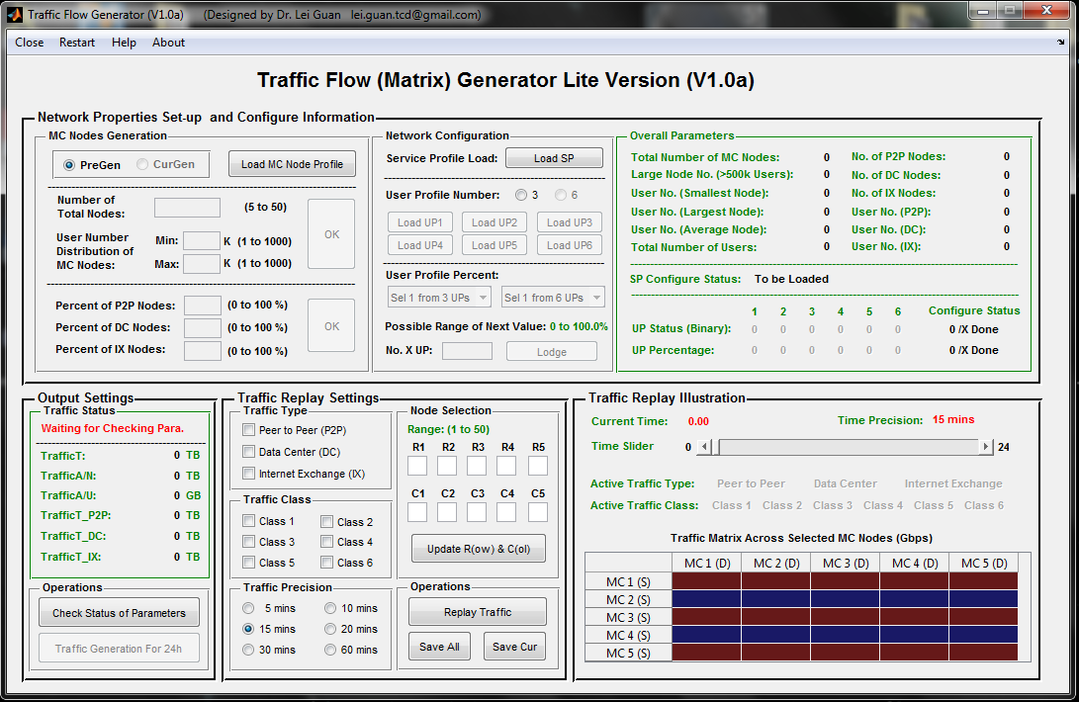

## 5.2 Working Flow

*Import MC Node Configuration*

|  |
| --- |
| Firstly, load MC node information from a proper file, and corresonding statistical information of this network will be analyzed and shown. |

*Import Pre-generated Service Profile*

|  |
| --- |
|  |

*Import Pre-generated User Profile*

|  |
| --- |
|  |

*Assign Percentage Pre-generated User Profile*

|  |
| --- |
|  |

*Colour of status turn to red when parameters have been successfully loaded*

|  |
| --- |
|  |

*Traffic Generation*

|  |  |  |
| --- | --- | --- |
| Standby | Status Check Done | Traffic Generating |
| Traffic Generation Done |  |  |

*Traffic Replay (Default)*

|  |
| --- |
| Replay the network traffic across default MC nodes at specific time precision.    Default active nodes are MC1, MC2, MC3, MC4, MC5. |

*Traffic Replay (Custormized)*

|  |
| --- |
| Replay the network traffic across selected MC nodes at specific time precision. |