General Introduction of Network Traffic Generation and Analysis Platform

 

Author: Dr. Lei Guan ([lei.guan.tcd@gmail.com](mailto:lei.guan.tcd@gmail.com))

Modified by: Marco Ruffini ([marco.ruffini@tcd.ie](mailto:marco.ruffini@tcd.ie))

Optical Network Architectures Group

CONNECT / The Centre for Future Networks and Communication

The University of Dublin, Trinity College

Dublin 2, Ireland

Dublin 2, Ireland

Table of Contents

1. Network Traffic Generation Platform 3

1.1. Top-Level GUI 3

1.2. Service Profile Synthesizer 3

1.3. User Profile Synthesizer 5

1.4. Traffic Flow Generator 6

# 1. Network Traffic Generation Platform

NTGA platform has been designed by Dr. Lei Guan and Dr. Marco Ruffini in Optical Network Group of CTVR, Trinity College Dublin. This chapter briefly describes the main purpose and major functions of this Graphic User Interface (GUI) based software tool sets.

## 1.1. Top-Level GUI

Top GUI provides a high-level control of the software tool as shown below, which contains three buttons related with sub-GUI software tools, i.e., Service Profile Synthesizer, User Profile Synthesizer and Traffic Flow Generator; and three buttons pointing to some documentaries of this software.

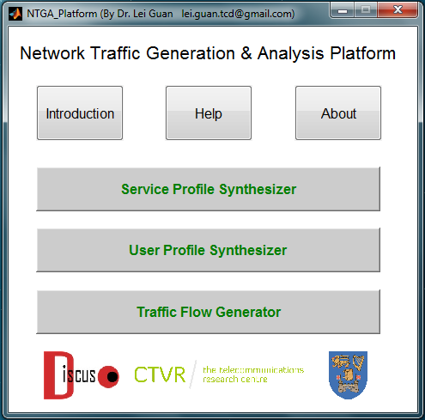

Fig. 1 Snap shot of NTGA platform at the top level.

## 1.2. Service Profile Synthesizer

This sub-GUI is designed for characterizing different services that occurred in a given network. The main parameters of each service are: downstream bandwidth requirement, upstream bandwidth requirement, Peer-to-peer traffic percentage, Data centre traffic percentage and Internet Exchange traffic percentage.

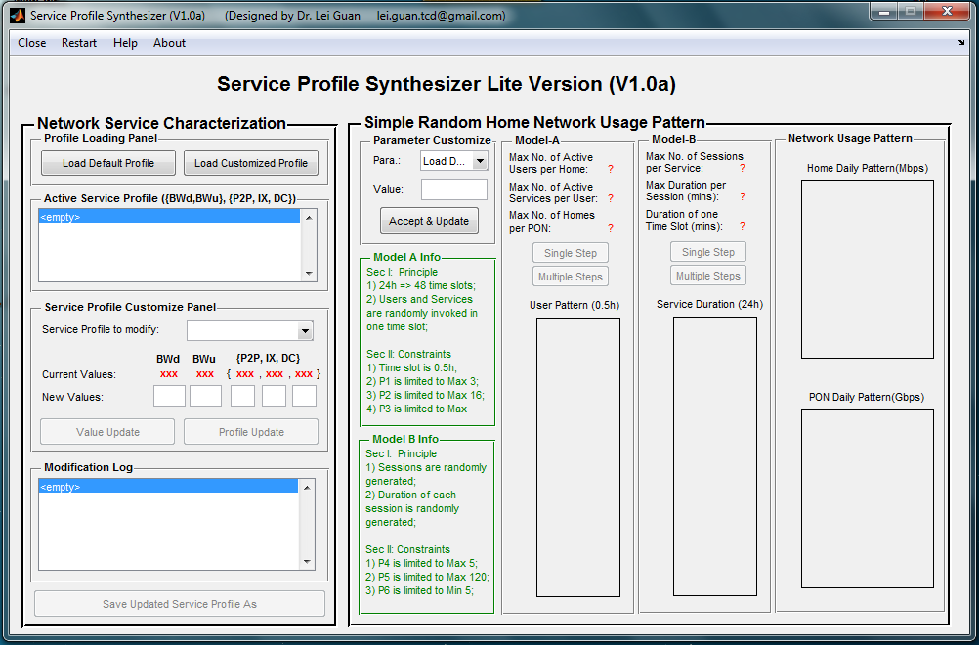

Fig.2 Snap shot of Service Profile Synthesizer.

A default service profile has been pre-defined as below.

Table I. Default Service profile

|  |  |  |  |  |  |  |
| --- | --- | --- | --- | --- | --- | --- |
| **No.** | **Name** | **BWDS** | **BWUS** | **P2P** | **IX** | **DC** |
| S1-1 | E-Life | 1 | 0.5 | 0.3 | 0.4 | 0.3 |
| S1-2 | E-Entertainment | 1 | 0.5 | 0.3 | 0.4 | 0.3 |
| S1-3 | E-Commerce | 0.5 | 0.25 | 0.3 | 0.4 | 0.3 |
| S1-4 | E-Learning | 0.5 | 0.25 | 0.3 | 0.4 | 0.3 |
| S1-5 | E-Social | 5 | 2.5 | 0.3 | 0.4 | 0.3 |
| S2-1 | VoD-UHD(2160P) | 25 | 2.5 | 0.3 | 0.1 | 0.6 |
| S2-2 | VoD-FHD(1080P) | 18 | 1.8 | 0.2 | 0.1 | 0.7 |
| S2-3 | VoD-HD(720P) | 8 | 0.8 | 0.2 | 0.1 | 0.7 |
| S2-4 | VoD-SD(480P) | 2 | 0.2 | 0.2 | 0.1 | 0.7 |
| S2-5 | VC-HD(720P) | 16 | 16 | 0.2 | 0.3 | 0.5 |
| S2-6 | VC-SD(480P) | 3 | 3 | 0.2 | 0.3 | 0.5 |
| S2-7 | VC-LD(240P) | 0.7 | 0.7 | 0.2 | 0.3 | 0.5 |
| S2-8 | Online-Gaming | 6 | 3 | 0.3 | 0.4 | 0.3 |
| S2-9 | VoIP | 0.2 | 0.2 | 0.3 | 0.4 | 0.3 |
| S3-1 | File-Sharing | 10 | 10 | 0.8 | 0.05 | 0.15 |
| S3-2 | Data-Backup | 5 | 5 | 0.2 | 0.1 | 0.7 |

Except for the name of the service, other parameters of a given service can be customized according to the user’s measurement or prediction.

Besides the service profile modification capability, this sub-module also provides two simple validation models for evaluating the parameters.

## 1.3. User Profile Synthesizer

This sub-GUI is designed for generating user profile that statistically characterizes the network usage behavior of a group of users.

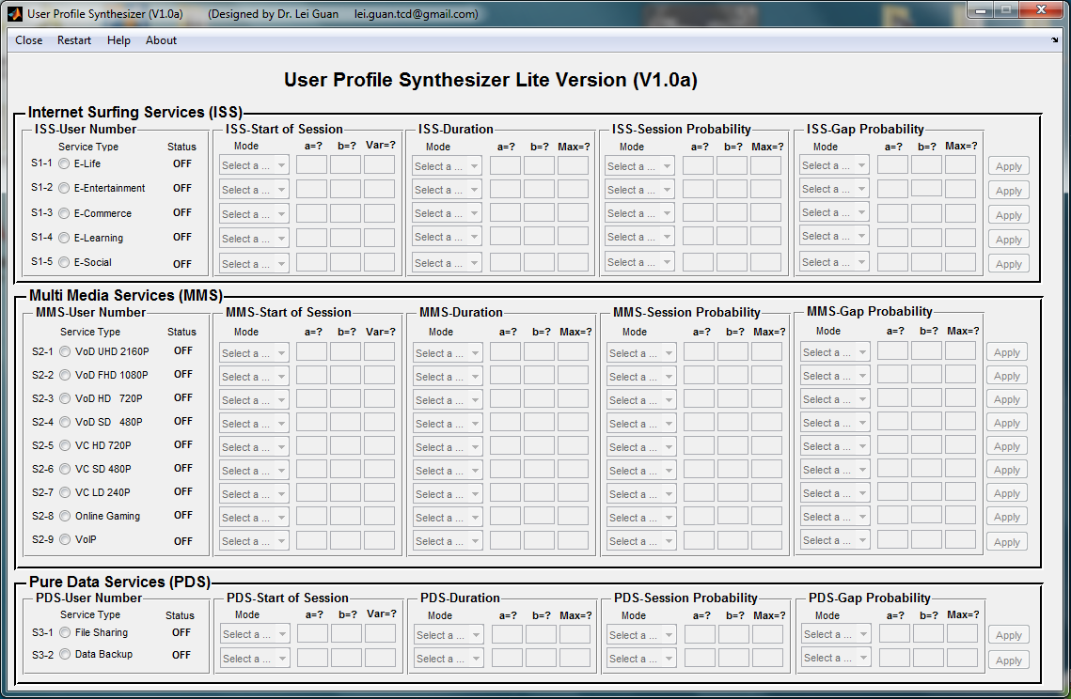

Fig. 3 Snap shot of User Profile Synthesizer.

In the current version (V1.0a), four parameters are used for reflecting the usage of a given service. Each of the parameter has been modelled by a beta function with typical inputs a, b, var or scaling factor. Several typical beta distributions have been pre-set as options in each of the popup menu. User customization function is also available in this version.

One meaningful user profile may contain one validated service or multiple services that characterized by beta functions respectively. One typical user profile actually aggregates all of the usage of selected services for one day statistically. For a particular day, it may look like as the figure shown below. The corresponding distribution, total duration, usage break down, duration break down will be also measured and shown in a new popup GUI.

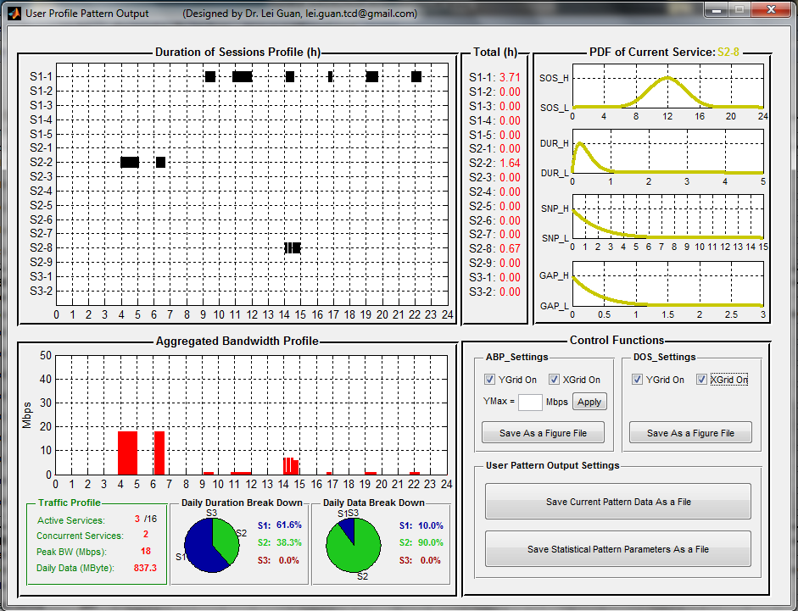

Fig. 4 Snap shot of an example of User Profile Output illustration.

## 1.4. Traffic Flow Generator

Taking the service profile and user profiles as parts of input, the Traffic Flow Generator will generate traffic flow matrix for a number of given metro core nodes, which are specified in a given txt file or can be statistically generated within this tool. Corresponding measurement and processing status are also provided, and the traffic matrix can be replayed as well.

