# ****Blockchain — World Chronicle|A Dialogue with RuffChain: How to build a new generation of IoT?****

How to build the next generation of IoT? What innovations does the blockchain-based RuffChain+Defi+NFT mode bring?

At 14:00 on April 20, [www.jinse.com](http://www.jinse.com/" \t "https://ruffchain.medium.com/_blank) held a new session of [Blockchain·World Chronicle](https://www.jinse.com/live/topic?id=113675" \t "https://ruffchain.medium.com/_blank), and invited Roy Li, Founder of RuffChain & Initiator of the NFT Catcher Program, as a special guest in the live studio to discuss how to build a new generation of blockchain-based IoT.

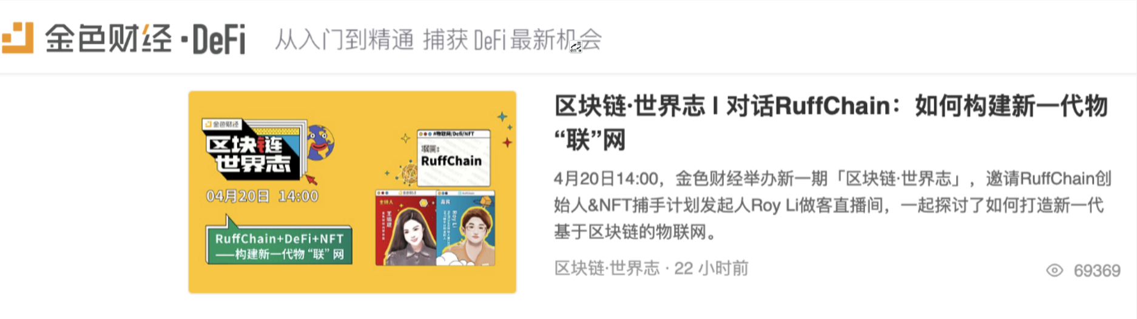

In the live broadcast, Roy introduced the economic model and development advantages of RuffChain. He said that RuffChain’ economic model is based on the fuel of transactions and contracts in the main network, which is charged very low. But in the future, it will be used on the links of value on chain, value storage and digitization. In other words, Ruff tokens must be used to make assets manageable and traded on the chain, especially in combination with NFT.

****Below is a detailed transcript of the live broadcast:****

****Wang Yukun: RuffChain is a project launched at the start of 2018. After a round of bull and bear markets, RuffChain remains in the industry and keeps developing forward. What has RuffChain done in recent years? After the round of bull and bear markets, what are the changes?****

****Roy Li:**** The past three years have been very bumpy for Ruff. The main reason is that after the whole bear market, its business model is not sustainable and its cost is relatively high. But, our whole team remains very confident, mainly because we believe in the future of blockchain. Last year, thing improved a lot, mainly thanks to a maturing industry ecosystem. For example, there is more demand for IoT (mines, asset management), and some blockchain projects have cooperated with our basic chain. Besides, Defi has become a killer-class application, and NFT also has a broad future.

Overall, it is Defi that gives a closed business loop to many old projects that are still persisting, while NFT has infinitely amplified the limitations of the scenarios. It can be said that the current bull market has brought more hope than token price.

****Wang Yukun: Our theme today is IoT+Defi+NFT. Could you please explain to our viewers how to combine these three concepts? How does Ruff put these concepts into practice?****

****Roy Li:**** Defi is decentralized finance. We believe that Defi represents the future, because the biggest challenge of finance itself is trust. This is an issue which can hardly be solved in a centralized way. Decentralization can be very efficient. We already see that projects like Compound can make very fast mortgage lending. I believe that Defi will bring enormous changes to finance and such changes will come soon.

NFT expands the Defi scenario infinitely. Imagine that currently Defi can only mortgage homogeneous assets. But, if it is the painting that has been auctioned at a skyrocketing price recently, can it be mortgaged? IoT is the catching hand of value on chain. Perhaps, in the near future, if you invest in a project, such as a charging pile or a rental apartment, IoT+NFT+Defi technology will be used in the settlement and pledge process. No complicated documents and operation processes will be required.

****Wang Yukun: As far as I know, you have recently launched the NFT Catcher Program with several public chain projects. As the sponsor, could you please tell us something about the Program? What will RuffChain provide for it?****

****Roy Li:**** The initiators of the Catcher Program all come from the previous batch of public chain projects. Because it is difficult to create an ecosystem, these projects are technically implemented but lack application. Therefore, for us, NFT must work together to capture opportunities. One example is Flow, which has become a successful public chain through a killer-class application like NBA Top Shot. We also think that opportunities for NFT are just beginning to emerge, and there may be many such opportunities. So we jointly launched this program after several rounds of discussion. We are most interested in the market outside art and games, such as NFT20, NFTFI. We also look at technology-based products like immutable.

****Wang Yukun: What’s the difference between NFT in IoT applications and the current public perception of NFT? What is the future explosive potential of NFT in IoT?****

****Roy Li:**** Currently, NFT is entirely online. If you want to put value on chain, you must use the IoT. It can be said that IoT is a key to the interaction between the blockchain and the real world. Let me give you a simple example: you want to invest in mines, including the current storage mines and such computer rooms generate a high return on investment. But if you are not familiar with computer rooms, do you know the electricity charges and maintenance cost? How about the computing load? Is any computing power theft? You need IoT equipment, cameras and other monitoring devices. But once there is a good way to do the monitoring, the computer room can be used as an asset for mortgage financing. In the future, we will deploy Ruff nodes on the IDC mining on Chia, which are expected to manage 500PB of computing power.

****Wang Yukun: is there any change in RuffChain’s economic model? How will you achieve business success in the future?****

****Roy Li:**** RuffChain’ current economic model is based on the fuel of transactions and contracts in the main network, which is charged very low. But in the future, it will be used on the links of value on chain, value storage and digitization. In other words, Ruff tokens must be used to make assets manageable and traded on the chain. This is very attractive, especially when used in combination with NFT.

I believe that if we can get an entrance on the track combining Defi and NFT. Ruff still has good opportunities. We won’t do node mining like some other IoT main networks, because we think that data mining has not have a big value. Storage mining is fine. But we will support the act of mining and use IoT to digitize mining revenues.

****Wang Yukun: How does the RuffChain Foundation fair at present?****

****Roy Li:**** The Ruff Foundation was in a relatively difficult financial situation in 2019, mainly due to the huge losses caused by the FCoin incident. I personally also used a lot of money to fill the gap. But fortunately, the price of BNB, a part of our reserve, has risen sharply this year. As the project itself can be profitable, the Ruff Foundation has been out of a financial predicament. In the future, the most important thing for the Ruff Foundation is how to find explosive opportunities.

****Wang Yukun: Could you please talk about your views on the future development of blockchain and recent moves by RuffChain?****

****Roy Li:**** Let me start with our recent moves. We have taken several major actions. First, we are progressing well with the 50PB Chia computing power and IDC’s asset management. We will use 2.5% of the future revenue to buy back Ruff. At present, we have started to collect intentions on position locking conversion power. The plan is to lock roughly 50000 Ruff to get 1T of computing power. Another thing is that the first phase of the locked positions has been released in succession, with a total of 58.8 million Ruff tokens, which will expire on April 18. Those who hold them are advised to contact our customer service to collect their tokens. Ruff has issued more than $1.3 million prize money for mobile mining on heco.

I believe that few project owners support their own token holders like we do. Because we have a constantly improving business model, we have the strength and determination to do so.

As for the future of blockchain, I mainly focus on the following aspects:

1. The next generation of Defi, such as over lending, or something to improve capital utilization, and what I think there as synthetic assets and derivatives. All these still have a huge market to be developed.

2. The comprehensive digitization of assets and the explanation of compliance in it. I hope that one day we can use digital currency to trade houses, cars, and even mortgage our houses and cars. But, none of these can be realized quickly without trust.

Finally, because I am a technician, I have my own understanding of flashbot solution for MEV, P disk-based mining and so on. I am looking forward to seeing more improvement in this aspect. Even though I do not quite identify with the technical route of layer 2, I am nevertheless proud of the phased success of such projects. In short, after enduring such a long time of questioning and doubt, blockchain is finally heading for full implementation. It is worthy of congratulations. While there is still a long way to go, the future is very promising.