
PROJECT REPORT
EventForce Management System
A Salesforce CRM solution for event planning teams

Item | Details
Project Title | EventForce Management System – Salesforce Implementation
Team ID | SWTID-2026-8343
Team Lead | Roobina J (roobina060805@gmail.com)
Team Member | Grace vilma Michael T (gracevilmagracevilma@gmail.com)
Team Member | Dennish P(dennishp50@gmail.com)
Team Member | Vinoth Kumar M(vinothkumar582006@gmail.com)
Team Member | Pradheepa P (pradheepa.p130905@gmail.com)

Alpha College of Engineering, Thirumazhisai, Chennai
Contents
INTRODUCTION
1.1 Project Overview
1.2 Purpose
2. IDEATION PHASE
2.1 Problem Statement (Customer Problem Statement Template)
2.2 Empathy Map Canvas
2.3 Brainstorming & Idea Prioritization
3. REQUIREMENT ANALYSIS PHASE
3.1 Customer Journey Map
3.2 Solution Requirements
3.3 Data Flow Diagram
3.4 Technology Stack
4. PROJECT DESIGN PHASE
4.1 Problem–Solution Fit
4.2 Proposed Solution
4.3 Solution Architecture
5. PROJECT PLANNING & SCHEDULING
5.1 Project Planning
6. PROJECT DEVELOPMENT PHASE
6.1 Phase 1: Requirement Analysis & Planning
6.2 Phase 2: Backend Development & Configurations
6.3 Phase 3: UI/UX Development & Customization
6.4 Phase 4: Data Migration, Testing & Security
6.5 Phase 5: Deployment, Documentation & Maintenance
7. FUNCTIONAL & PERFORMANCE TESTING
8. ADVANTAGES & DISADVANTAGES
9. CONCLUSION
10. FUTURE SCOPE
11. APPENDIX

Project Summary
EventForce is a Salesforce-based platform that gives event teams one place to run their work: client bookings, event scheduling, venue reservations, vendor coordination, cancellation approvals, reminders and feedback. Events, Clients, Vendors, Venues and Feedback are held in a structured data model with defined relationships.
Flows send event reminders and keep records current, while an Approval Process governs cancellation requests. Apex classes and triggers add the heavier logic, such as updating venue availability and blocking double bookings. A Lightning App with reports and dashboards shows event schedules, vendor activity and operational performance as they happen.
The result is more efficient event handling, tighter booking coordination, more accurate data, clearer communication, better operational visibility and a better experience for clients.

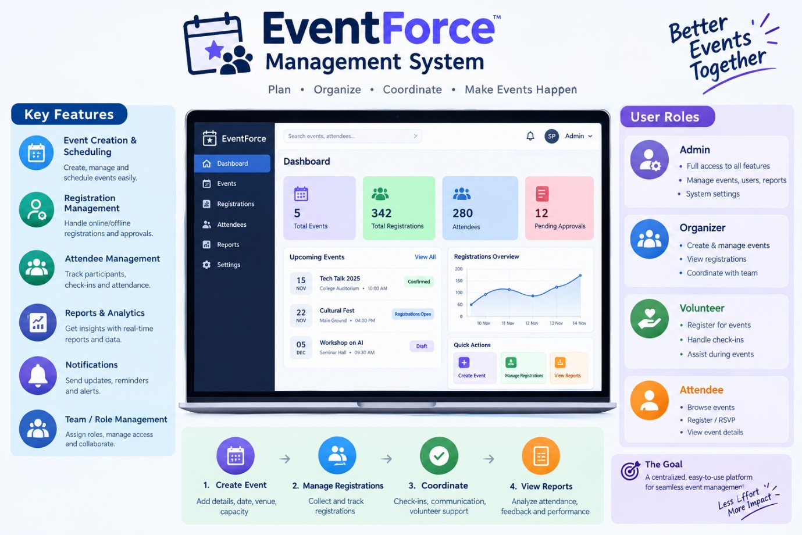

1. Introduction

1.1 Project Overview
EventForce Management System is a CRM built on Salesforce to bring event planning and day-to-day management onto one platform. It covers clients, events, venues, vendors, feedback and cancellations.
The build relies on custom objects and relationships, validation rules, Flows, an Approval Process, Apex triggers and classes, reports and dashboards. Together these automate the main business steps: managing venue availability, stopping double bookings, sending reminders, approving cancellations, collecting feedback and reporting on operations.
The goal is to cut manual work, make bookings easier to coordinate, keep data accurate, improve communication with clients and internal teams, and give everyone a clear view of event activity.

1.2 Purpose
EventForce exists to give event teams a single, automated Salesforce workspace. Specifically, it is meant to:
- Hold client, event, venue, vendor and feedback information in one place.
- Simplify event booking and venue reservation.
- Use Apex logic to stop venues from being booked twice.
- Automate event reminders and cancellation approvals.
- Improve coordination among clients, coordinators, vendors and venue managers.
- Supply reports and dashboards that support operational decisions.
- Lower manual effort, raise data accuracy and improve the client experience.

Expected Business Value
Business Outcome | Target
Reduction in manual processes | 60%
Improvement in booking efficiency | 40%
Client satisfaction | Improved through timely reminders and communication
Decision making | Data-driven insight from integrated reports and analytics

2. Ideation Phase

2.1 Problem Statements
Eight customer problem statements were captured, each from the point of view of a specific user role.
# | Role | Wants to | But | Because | Feels
PS1 | Event Operations Manager | Run event planning operations smoothly | Client, event, venue and vendor data cannot be handled from one place | Running events needs coordination across many areas | Frustrated, worried
PS2 | Event Coordinator | Create and handle event bookings quickly | Event, client and venue details each need separate manual work | No single platform covers the full event lifecycle | Overwhelmed, frustrated
PS3 | Venue Manager | Keep venue availability accurate | One venue can end up assigned to several events | Bookings need availability tracking and double-booking protection | Worried, unsure
PS4 | Vendor Manager | Coordinate vendors across events | Vendor details and event assignments are managed separately | One event often needs several vendors and services | Overwhelmed, worried
PS5 | Event Coordinator | Send event information and reminders on time | Reminders are sent by hand | Clients must be notified before their event | Stressed, worried
PS6 | Event Administrator | Handle cancellation requests in an orderly way | Requests need approval and status changes | Cancellations must pass through a controlled approval step | Frustrated, unsure
PS7 | Event Coordinator | Gather and manage client feedback | Feedback must be stored alongside event and client details | Each item relates to both an event and a client | Concerned about satisfaction
PS8 | Event Operations Manager | Track operations and performance | Operational data is not visible in one place | Event data must be organised into reports and dashboards | Worried, less confident in decisions

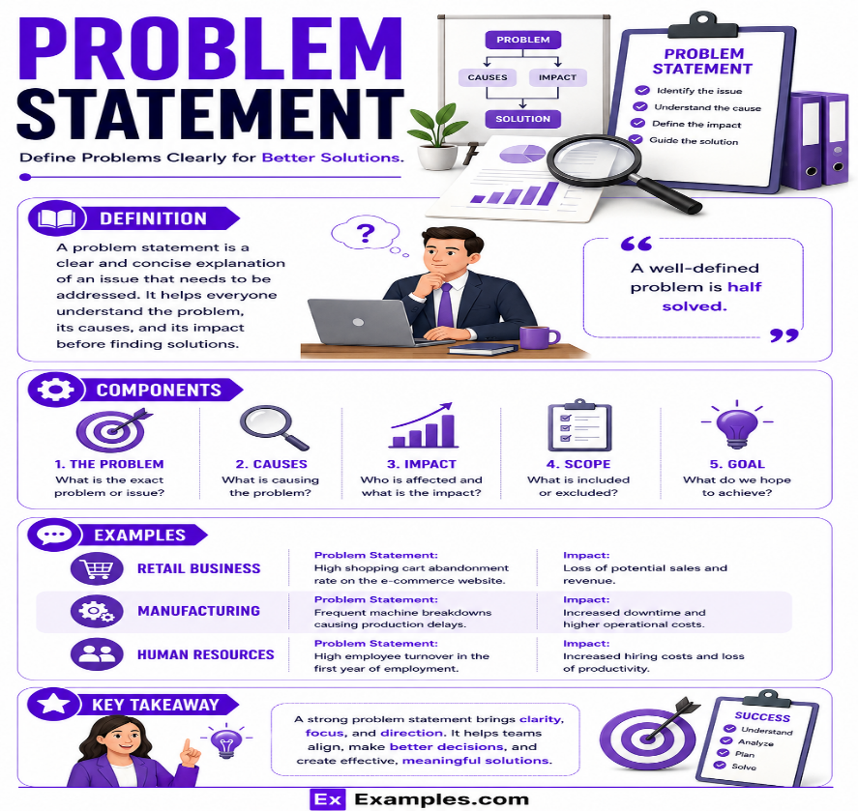
Figure 1 – Customer problem statements

2.2 Empathy Map
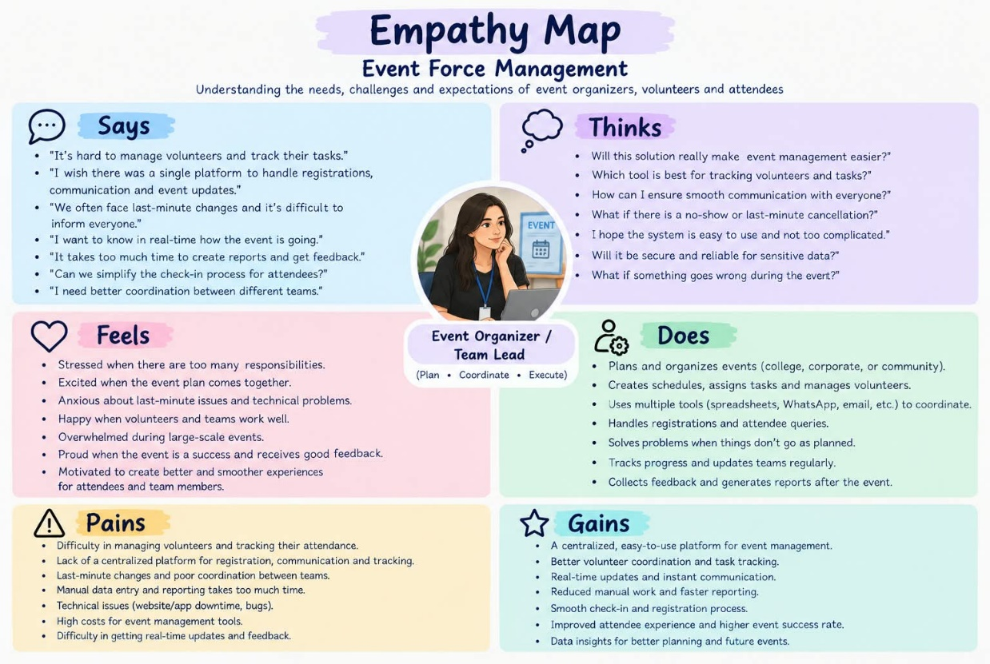
Figure 2 – Empathy map for the Event Coordinator persona

Persona: Event Coordinator
Main responsibility: handling event bookings, client requirements, venue reservations, vendor coordination, reminders and event status updates.
- Thinks & feels: wants events to run smoothly, wants to avoid booking clashes and to give clients a dependable experience.
- Hears: requirements and updates from clients, vendors, venue managers and administrators.
- Sees: event details, client records, venue availability, vendor assignments, cancellations and feedback.
- Says & does: liaises with stakeholders, updates event records, manages bookings, follows up on requirements and tracks progress.
- Pain: manual coordination, scattered information, the risk of double-booked venues and difficulty following many events at once.
- Gain: one source of event information, automated reminders and processes, reliable venue availability, easier coordination and better visibility.

2.3 Brainstorming & Idea Prioritization
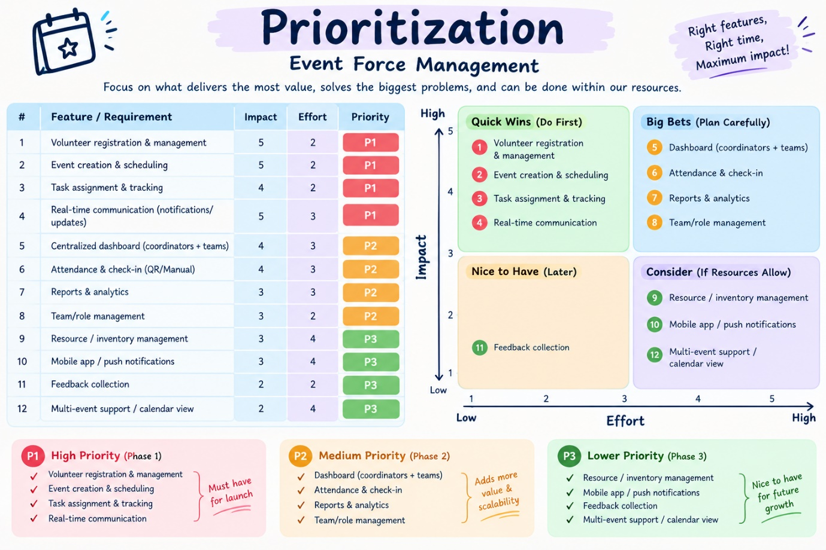
Figure 3 – Brainstorming and idea prioritisation

Options Considered
Option | How it would work | Main drawback
Manual registers | Record event, client, venue and vendor details by hand | Slow and hard to keep up to date
Spreadsheets | Track bookings and events in spreadsheet files | Little automation and no real-time coordination
Standalone portal | Build a dedicated web portal for event management | Heavy development and upkeep effort
Salesforce CRM | Run event operations on the Salesforce platform | Needs proper configuration and implementation

Why Salesforce
- Automation – reminders, approvals, status changes and other processes run on their own.
- Scalability – the platform grows with more events, users, records and requirements.
- Real-time visibility – centralised data, reports and dashboards support monitoring.
Decision: Salesforce CRM is the best fit for a centralised, automated and scalable EventForce system.

3. Requirement Analysis

3.1 Customer Journey
Stage | Journey step | What happens
1 | Enquiry & client registration | Client needs and contact details are recorded in Salesforce.
2 | Event planning & booking | Event type, date, budget and status are created and maintained.
3 | Venue selection & reservation | Suitable venues are shortlisted, availability is checked and reservations are handled without double booking.
4 | Vendor coordination | Vendors and services are assigned to the event and their status is tracked.
5 | Confirmation & communication | A confirmed event triggers automatic messages, including a reminder to the client ahead of the date.
6 | Execution & monitoring | Progress is followed through Salesforce records, reports and dashboards.
7 | Cancellation & approval | Cancellation requests go through the approval process, with status updates and notifications.
8 | Feedback & closure | Feedback is captured after the event and completed events are updated for tracking and analysis.

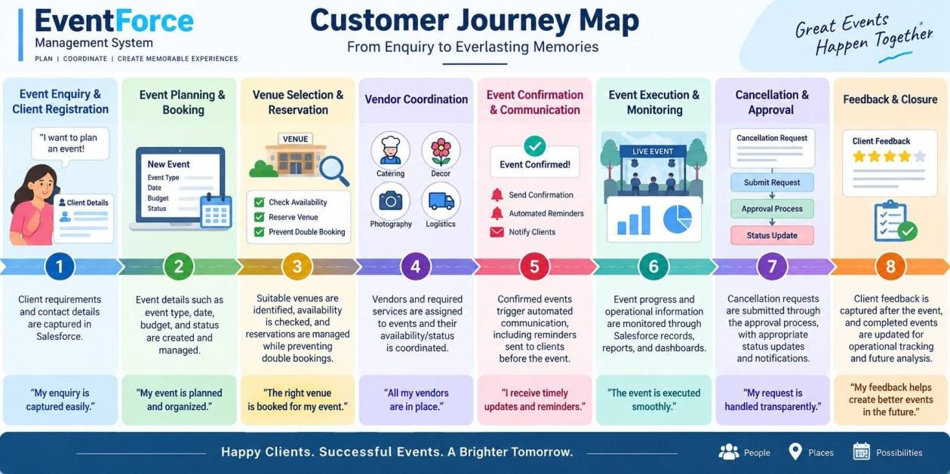
Figure 4 – Customer journey map

3.2 Solution Requirements

Functional Requirements
ID | Requirement
FR-1 | Event management
FR-2 | Client management
FR-3 | Venue management
FR-4 | Vendor management
FR-5 | Assigning vendors to events
FR-6 | Venue availability and double-booking prevention
FR-7 | Automated event reminders
FR-8 | Approval of event cancellations
FR-9 | Feedback management
FR-10 | Reports and dashboards
FR-11 | Automatic event status updates
FR-12 | Data migration with the Data Import Wizard

Non-Functional Requirements
Attribute | Description
Usability | A Lightning App that makes navigation and event handling easy
Security | Access controlled through profiles, roles and permission sets
Reliability | Dependable automation, approvals and venue-booking validation
Performance | Efficient handling of event and operational data
Availability | Cloud access to Salesforce for authorised users
Scalability | Handles growth in events, clients, vendors, venues and users
Maintainability | Flows, Apex, validation rules and security can be monitored and changed
Data integrity | Validation and controlled migration keep records accurate

3.3 Data Flow
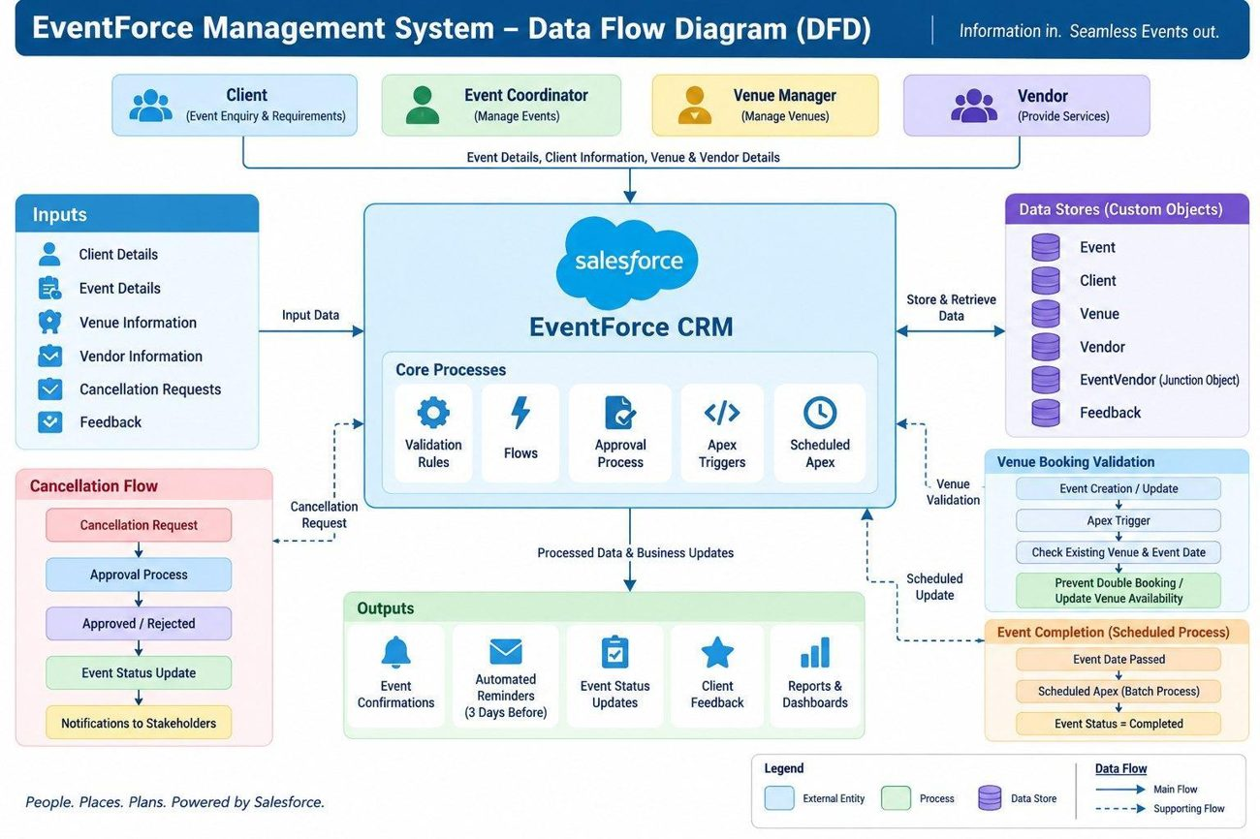
Figure 5 – Data flow diagram

Main Flow
Client or event team → enter client and event details → EventForce validates and stores the data → event, client, venue and vendor records → venue availability check → venue and vendor assignment → event confirmation → automatic reminder three days before → event execution and status updates → feedback collection → reports and dashboards.

Supporting Flows
- Cancellation: Event Coordinator submits a request → Approval Process → approved or rejected → event status updated → stakeholders notified.
- Venue booking check: Event saved → Apex trigger → VenueStatusHelper → compare against existing bookings for that venue and date → block the double booking or update venue availability.
- Event completion: Event date passes → Scheduled Apex starts a batch → event status becomes Completed.

Overview
Users (clients, coordinators, vendor and venue managers) → Salesforce EventForce → custom objects (Event, Client, Vendor, Venue, Feedback, EventVendor) → Flows, Approval Process and Apex → operational data and status updates → reports and dashboards → decisions.

3.4 Technology Stack
Layer | Technology
Platform | Salesforce CRM, Developer Edition
User interface | Salesforce Lightning App
Data storage | Salesforce custom objects
Business logic | Flows, formula fields, validation rules
Approvals | Salesforce Approval Process
Automation | Record-triggered Flows and Apex triggers
Background processing | Batch Apex and Scheduled Apex
Security | Profiles, roles, permission sets, sharing rules, OWD
Reporting | Reports and dashboards

4. Project Design

4.1 Problem–Solution Fit
Each operational problem identified earlier maps to a specific Salesforce capability. Custom data structures, automation, Apex logic, approvals, security and reporting work together to address the pain points of event planning.
Problem | EventForce solution | Benefit
Client, event, venue and vendor data is hard to manage centrally | Custom objects: Event, Client, Venue, Vendor, Feedback, EventVendor | Centralised, structured data
Booking involves many manual steps | Flows and automated processes | Less manual effort, faster processing
Venues may be double booked | Apex trigger and VenueStatusHelper | Availability is validated and clashes are blocked
Vendor coordination is hard to follow | EventVendor junction object and Vendor records | Clear event–vendor assignment
Clients may miss event reminders | 3-Day Reminder Flow | Reminders go out automatically before confirmed events
Cancellations need controlled handling | Event_Cancellation_Process approval | Structured approvals and status updates
Feedback must tie to events | Feedback object linked to Event and Client | Organised feedback records
Operations are hard to monitor | Reports and EventForce Operations Dashboard | Better visibility for decisions
Users need different access levels | Profiles, roles, permission sets, OWD, sharing rules | Controlled, secure access

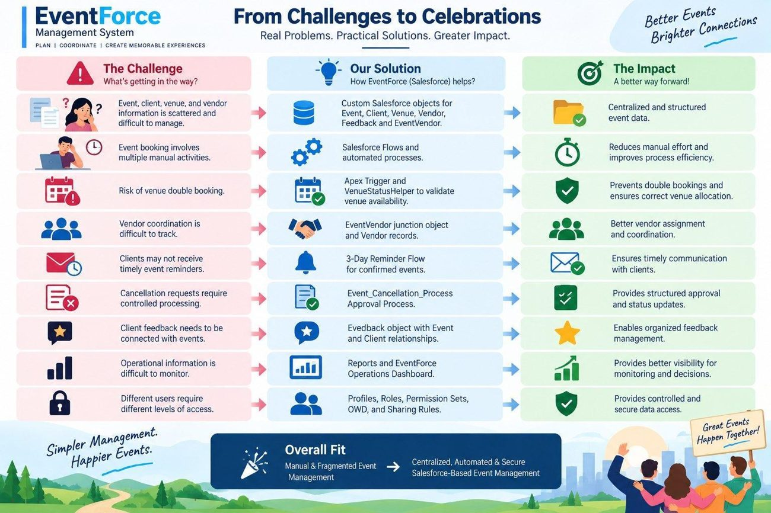
Figure 6 – Problem–solution fit

4.2 Proposed Solution
Aspect | Description
Problem | Event management that is manual and fragmented
Solution | Salesforce CRM
Innovation | Automated reminders, venue validation and cancellation approvals
Impact | Faster coordination and clearer operational visibility
Business model | Centralised event planning and management
Scalability | Supports more events, clients, vendors, venues and users

4.3 Solution Architecture
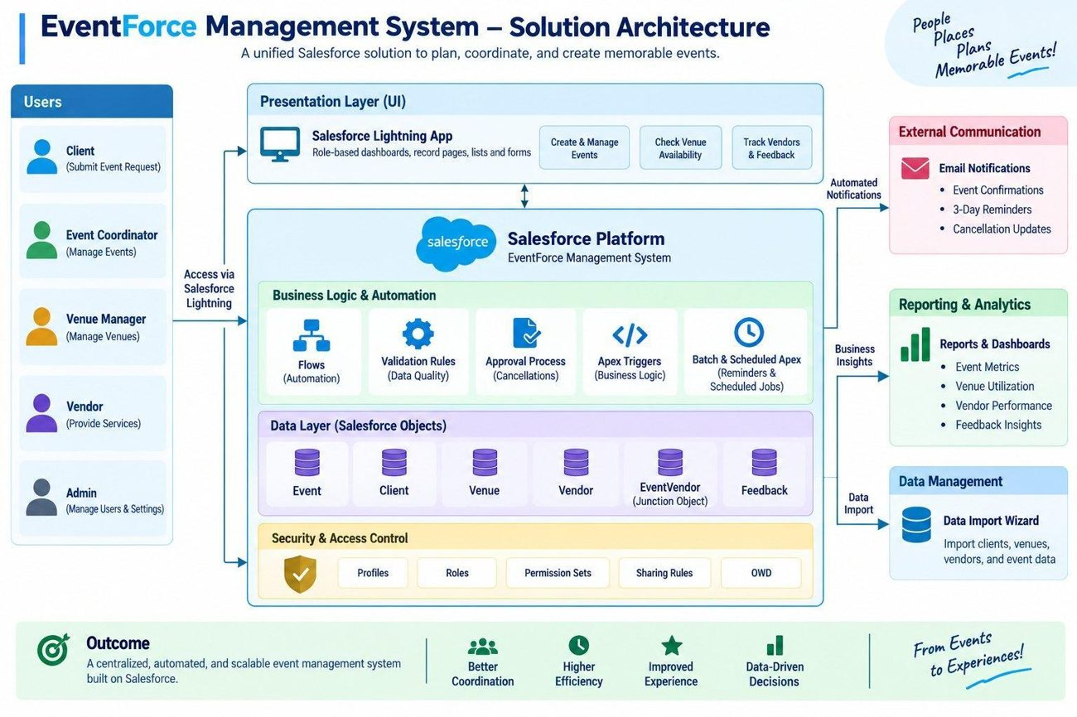
Figure 7 – Solution architecture
The solution is made up of the following components:
Data & logic | Automation & processing | Security, UI & analytics
Event, Client, Vendor, Venue objects | Flows | Profiles & roles
EventVendor junction object | Approval Process | Permission sets & sharing rules
Feedback object | Apex triggers & classes | Data Import Wizard
Validation rules | Batch Apex | Lightning App
Formula fields | Scheduled Apex | Reports & dashboards

5. Project Planning & Scheduling

5.1 Approach
- Agile methodology
- Work organised as epics → user stories → story points
- Sprint-based delivery
- Velocity used to estimate capacity

Product Backlog
Sprint | Epic | Story | Description | Pts | Priority | Owner
1 | Event management | US-01 | As an Event Coordinator, I want to create events with a type, date and status so event data is standardised. | 3 | High | Ashvitha V
1 | Client & venue management | US-02 | As an Event Coordinator, I want to link a client and venue to an event so coordination is centralised. | 5 | High | Sowmiya A
2 | Vendor management | US-03 | As a Vendor Manager, I want to assign several vendors to an event so services are coordinated. | 5 | High | Saranya S
2 | Notifications & automation | US-04 | As a Client, I want timely reminders so I know when my event is close. | 3 | High | Vaishnavi V
3 | Approval management | US-05 | As an Event Coordinator, I want cancellations to follow an approval process so they are controlled. | 5 | High | Nivetha T
3 | Venue management & Apex | US-06 | As a Venue Manager, I want double bookings prevented so schedules stay accurate. | 8 | High | Ashvitha V
4 | Security & access | US-07 | As an Event Administrator, I want role-based access so users see only what they should. | 5 | High | Sowmiya A
4 | Reports & dashboards | US-08 | As Management, I want reports and dashboards so operations can be monitored. | 5 | Medium | Saranya S

Sprint Tracker
Sprint | Points | Duration | Start | Planned end | Completed | Released
Sprint-1 | 20 | 6 days | 24 Oct 2022 | 29 Oct 2022 | 20 | 29 Oct 2022
Sprint-2 | 20 | 6 days | 31 Oct 2022 | 05 Nov 2022
Sprint-3 | 20 | 6 days | 07 Nov 2022 | 12 Nov 2022
Sprint-4 | 20 | 6 days | 14 Nov 2022 | 19 Nov 2022

Velocity: the team planned 20 story points per sprint, 80 points across four 6-day sprints. That averages 20 points per sprint, or roughly 3.33 points per day (20 ÷ 6).

6. Project Development

6.1 Phase 1: Requirement Analysis & Planning
The aim was a single Salesforce application through which event planners manage client bookings, vendor coordination, venue reservations and feedback. Event scheduling, cancellation approvals and client reminders are automated, and reports and dashboards give live visibility.
This phase established what the system must do, who would use it and the order in which it would be built.

6.1.1 Functional Scope
- Custom objects: Event, Client, Vendor, Venue, Feedback and Event Vendor (junction).
- Relationships: Lookup, Master-Detail and many-to-many (Event ↔ Vendor).
- Flows for reminders, feedback notifications and approval updates.
- Validation rules and formula fields for clean data and automatic event budgets.
- An approval process for cancellations, with email alerts to coordinators and clients.
- Profiles, roles and permission sets for user-level security.
- Reports and dashboards for event summaries, vendor performance and upcoming events.

6.1.2 Stakeholder Mapping
Stakeholder | Role | Profile | Main needs
Event Administrator | Event Admin | Event Admin | Full oversight, security and monitoring
Event Coordinator | Event Coordinator | Event Coordinator | Scheduling, client communication, approvals
Vendor Manager | Vendor Manager | Vendor Manager | Vendor records and assigned services
Client | Client | Client Profile | View own events, submit feedback

6.1.3 Execution Roadmap
Step | Activity | Outcome
1 | Object and field setup | Event, Client, Vendor, Venue, Feedback and Event Vendor objects created
2 | Automation Flows | Record-triggered flow for event reminders
3 | Validation rules and formula fields | Accurate data and automatic budget calculation
4 | Profiles, roles, permission sets | User access and record visibility configured
5 | Approval process | Cancellation workflow with notifications
6 | Apex classes and triggers | Venue availability updates and double-booking prevention
7 | Reports and dashboards | Analytics on upcoming events and performance

6.2 Phase 2: Backend Development & Configuration
This phase built the working core of the system. Declarative tools (record-triggered Flows, validation rules, formula fields and approval processes) handle booking confirmations, reminders and cancellations, while Apex classes and triggers cover venue availability updates and double-booking prevention. Work was split into the milestones below.

Milestone 1 – Salesforce Developer Account
Salesforce is a customer-success platform for selling, servicing, marketing, analysing and connecting with customers. A free Developer Edition org was set up to build and test the whole project.
Activity 1 – Create the account
- Go to https://developer.salesforce.com/signup.
- Enter first name, last name and email, choose Developer as the role, enter the college name as company, select India as country and add the postal code.
- Provide a unique username in email format (for example username@organization.com); it does not need to be a working mailbox.
- Click Sign me up.
Activity 2 – Activate the account
- Open the verification email (it can take 5–10 minutes) and click Verify Account.
- Set a password, answer the security question and click Change Password.
- You land on the Salesforce Setup home page.
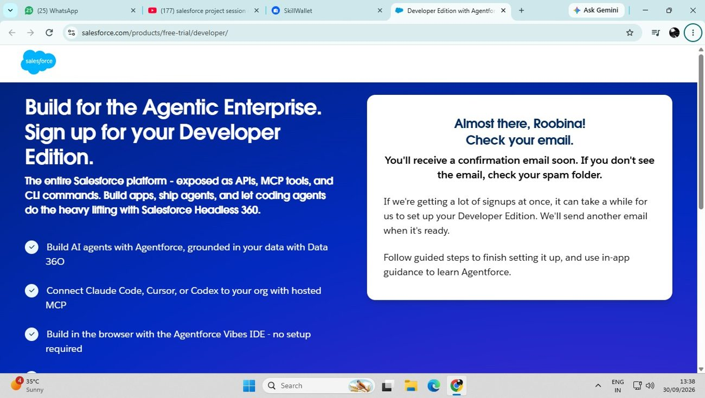
Figure 8 – Developer Edition sign-up confirmation
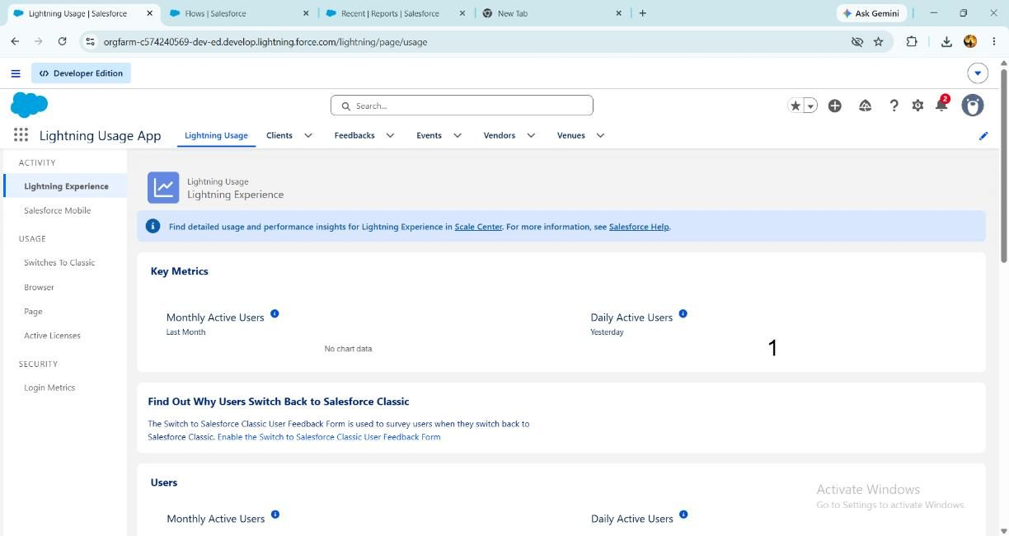
Figure 9 – Lightning Usage app after first login

6.2.1 Data Architecture
The data model has five main custom objects and one junction object. An object works like a database table: fields are its columns and records are its rows.
Object | API name | Record name | Purpose
Event | Event__c | Event Name (Text) | Event details, status and budget
Client | Client__c | Client Name (Text) | Client contact information
Vendor | Vendor__c | Vendor Name (Text) | Vendor details and services
Venue | Venue__c | Venue Name (Text) | Venue details and availability
Feedback | Feedback__c | Feedback ID (Auto Number, F-{0000}) | Client ratings and comments
Event Vendor | EventVendor__c | Auto-generated | Junction linking Event and Vendor

Milestone 2 – Creating Custom Objects
Each object was made through Setup → Object Manager → Create → Custom Object. The Event object used these options:
- Label Event, plural label Events, record name Event Name, data type Text.
- Optional features: Allow Reports, Allow Activities, Track Field History.
- Deployment status Deployed; search status Allow Search.
- Notes and Attachments related list added to the default page layout.
Client, Vendor and Venue were created the same way (text record name, with Allow Reports, Allow Search and the Notes and Attachments list). Feedback uses an Auto Number record name formatted F-{0000}, starting at 0. The Event Vendor junction object was created separately, as described under Relationships.
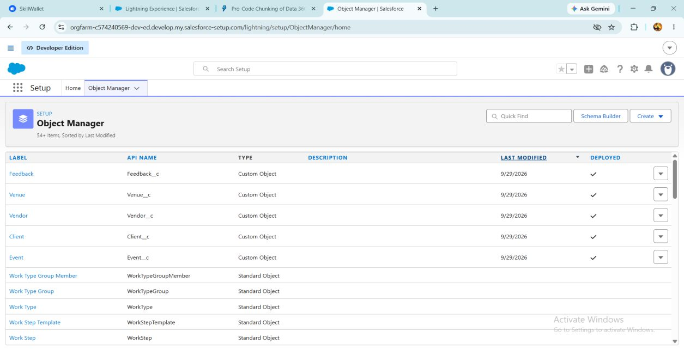
Figure 10 – Custom objects listed in Object Manager
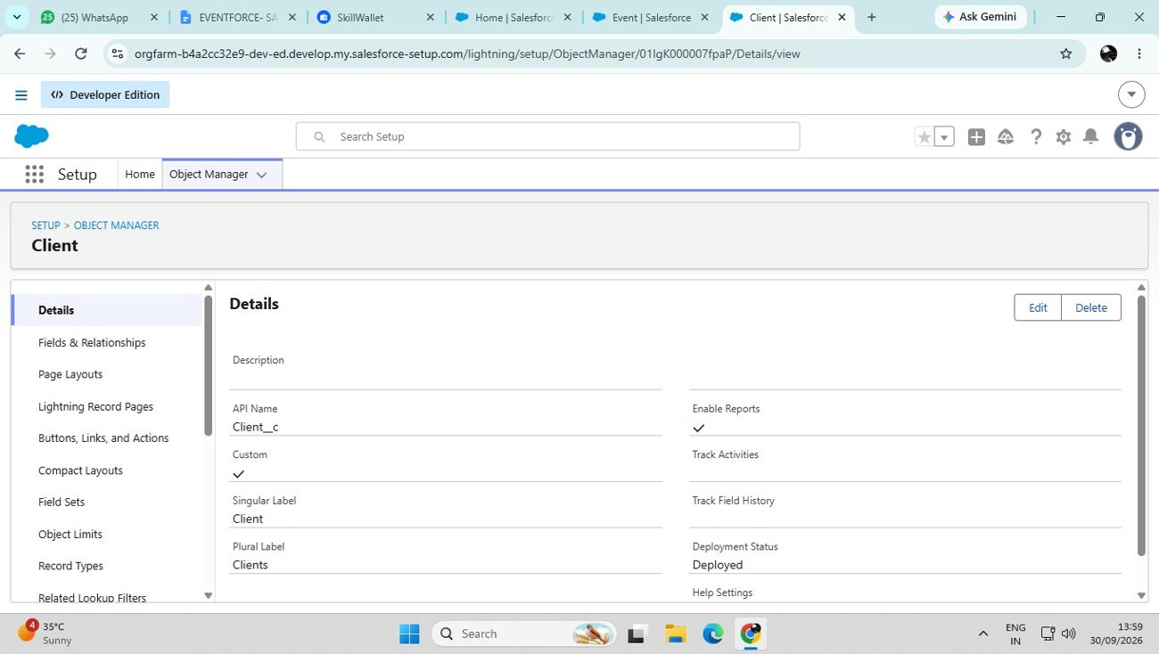
Figure 11 – Client object details (Client__c)
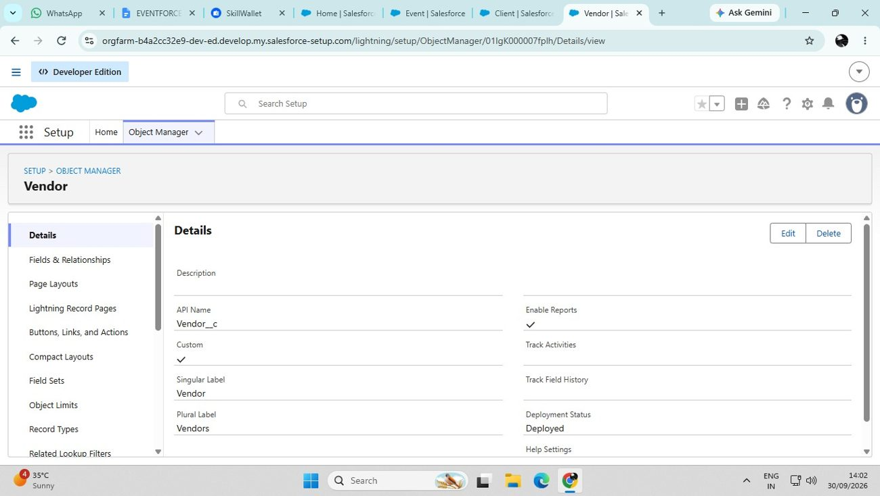
Figure 12 – Vendor object details (Vendor__c)

Milestone 3 – Custom Tabs
Tabs present each object’s data at a glance. For Event, Client, Vendor, Venue and Feedback, a tab was added via Setup → Tabs → Custom Object Tabs → New: choose the object, pick a tab style icon, accept the defaults (Next, Next) and Save.
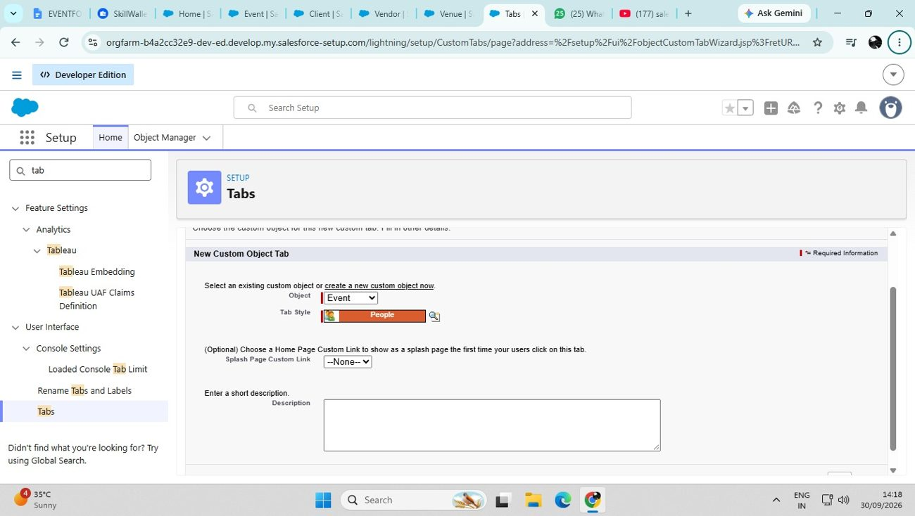
Figure 13 – Creating the Event custom tab
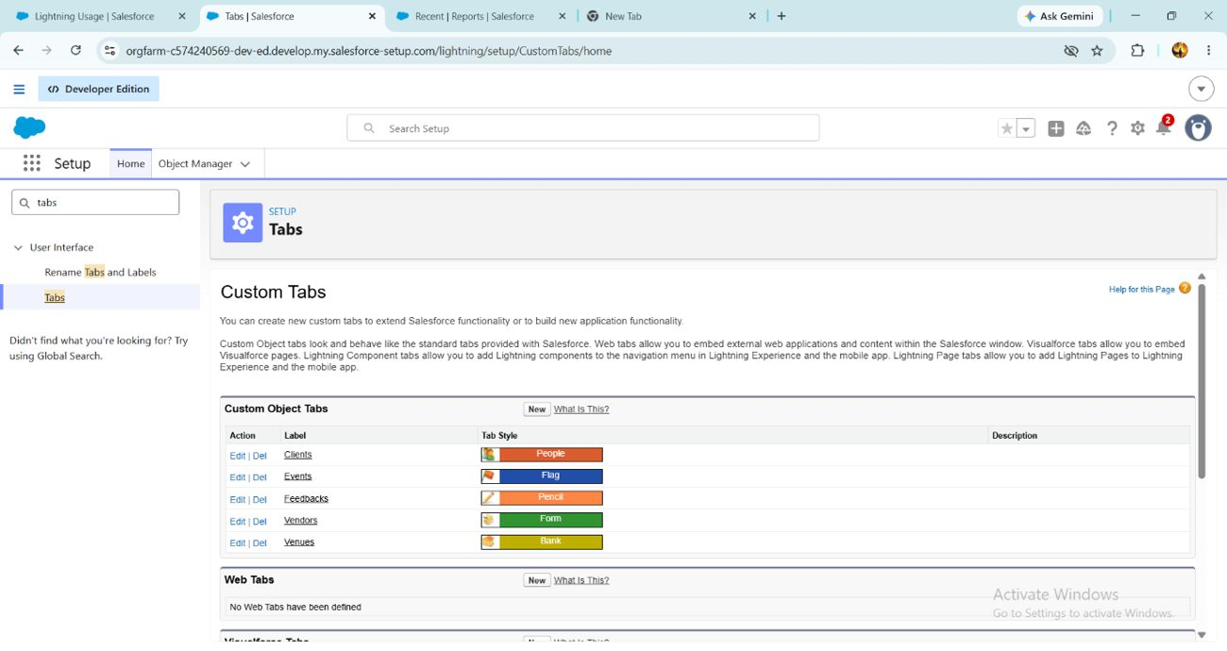
Figure 14 – Custom object tabs created

Milestone 4 – Fields
Fields were added to every object using Object Manager → Fields & Relationships → New with a suitable data type.
Object | Field | Type | Values / notes
Event | Event Type | Picklist | Wedding, Corporate, Birthday, Anniversary, Festival, Concert, Other
Event | Event Date | Date | Date the event takes place
Event | Event Status | Picklist | Planned, Confirmed, Completed, Pending Cancellation, Canceled, Rejected
Event | Event Budget | Formula (Currency) | Derived from Event Type (see section 6.2.3)
Client | Email | Email | Client email address
Client | Phone | Phone | Client contact number
Client | Address | Text Area | Client address
Client | Country | Picklist | India, Philippines, Saudi Arabia, USA, Switzerland, Thailand, Maldives, Dubai, Sri Lanka, Bangkok, Singapore, Myanmar, France, Nepal
Client | City | Picklist | Hyderabad, Mumbai, Delhi, Bangalore, Chennai, Alaminos, Angeles City, Palayan, Quezon City, San Juan, Riyadh, Jeddah, Tayma, Dammam, Medina, New York, Los Angeles, Chicago, Houston, Columbus, Geneva, Basel, Lausanne, Bern, Lucerne
Vendor | Service Type | Multi-select picklist | Catering, Decor, Photography, Videography, Lighting, Stage Setup, Makeup Artist, DJ/Music, Transportation, Hosting/Anchor
Vendor | Email | Email | Vendor email address
Vendor | Phone | Phone | Vendor contact number
Vendor | Status | Picklist | Available, Booked, Cancelled
Venue | Address | Text Area | Venue address
Venue | Location | URL | Map link to the venue
Venue | Capacity | Number | Maximum number of guests
Venue | Availability Status | Picklist | Available, Reserved, Not Available
Feedback | Rating | Picklist | 1, 2, 3, 4, 5
Feedback | Comments | Long Text Area | Client comments

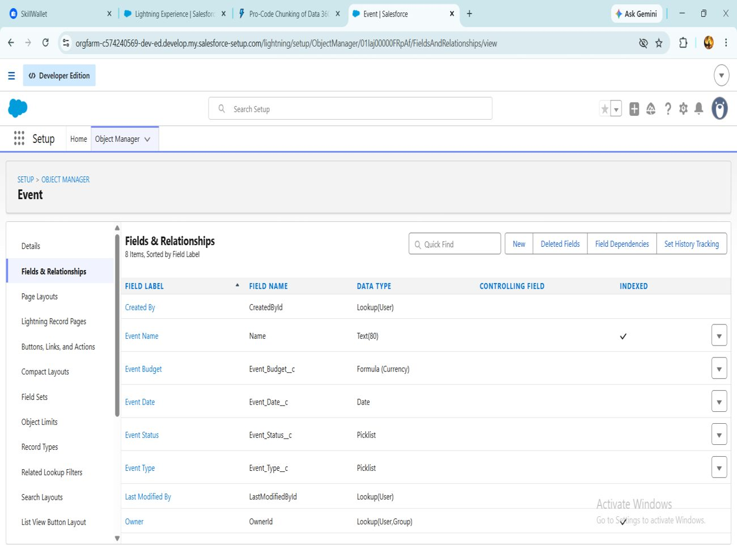
Figure 15 – Fields and relationships on the Event object

Relationships
Relationships tie the objects together. A Lookup links records loosely, whereas a Master-Detail creates a tight parent–child dependency. Salesforce has no direct many-to-many relationship, so the Event Vendor junction object, carrying two Master-Detail fields, links Event and Vendor.
Relationship | Type | Field label
Event → Client | Lookup | Client
Event → Venue | Lookup | Venue
Feedback → Event | Lookup | Event
Feedback → Client | Lookup | Client
EventVendor → Event | Master-Detail | Event
EventVendor → Vendor | Master-Detail | Vendor

Creating the lookups
- In Setup open Object Manager and choose the Event object.
- Select Fields & Relationships → New → Lookup Relationship → Next.
- Pick the related object (Venue), click Next, enter the field label, then continue through Next, Next, Next and Save.
- Repeat for the Client lookup on Event and for the Event and Client lookups on Feedback.
Creating the many-to-many link (Event ↔ Vendor)
- Go to Object Manager → Create → Custom Object, with label Event Vendor and object name EventVendor__c.
- On that object choose Fields & Relationships → New → Master-Detail Relationship, select Event, label it Event and click Save & New.
- Add a second Master-Detail relationship to Vendor, label it Vendor and Save.
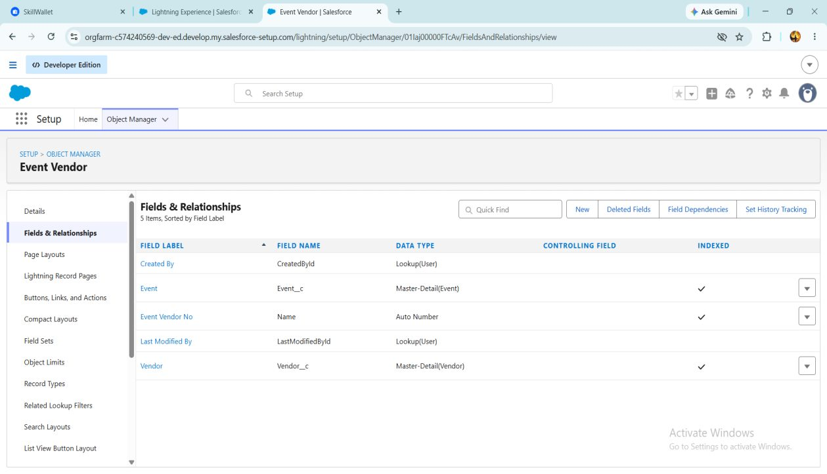
Figure 16 – Event Vendor junction object fields
Lookup filter (Feedback → Event)
Scenario: after a client is chosen on a Feedback record, the Event lookup should list only that client’s events. If Ramesh is selected, only Ramesh’s events appear.
- Open Object Manager → Feedback → Fields & Relationships → Event (Event__c) and click Edit.
- In the Lookup Filter section click Show Filter Settings.
- Set the criteria: Event: Client (Client__c) equals Field → Feedback: Client (Client__c).
- Tick Enable this filter and click Save.
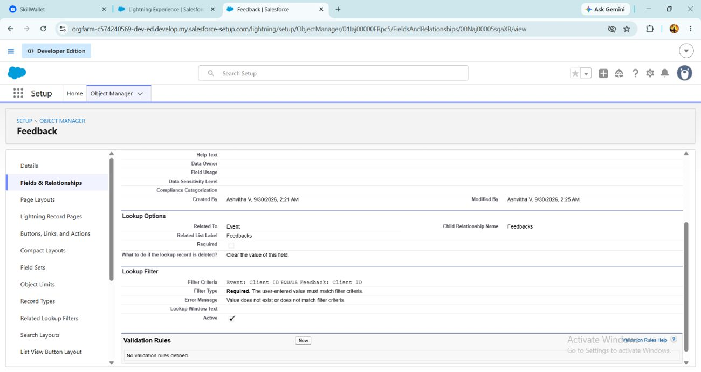
Figure 17 – Lookup filter on the Feedback → Event field

6.2.2 Formula Field – Event Budget
Event Budget is a Currency formula field on Event. It works out the budget from the Event Type automatically, which removes manual-entry errors. Go to Fields & Relationships → New → Formula, label it “Event Budget”, choose Currency, paste the formula below, click Check Syntax, then Next, Next, Save.
CASE(
TEXT(Event_Type__c),
"Wedding", 50000,
"Corporate", 30000,
"Birthday", 10000,
"Anniversary", 20000,
"Festival", 60000,
"Concert", 40000,
"Other", 15000,
0
)

Event type | Budget
Wedding | 50,000
Corporate | 30,000
Birthday | 10,000
Anniversary | 20,000
Festival | 60,000
Concert | 40,000
Other | 15,000

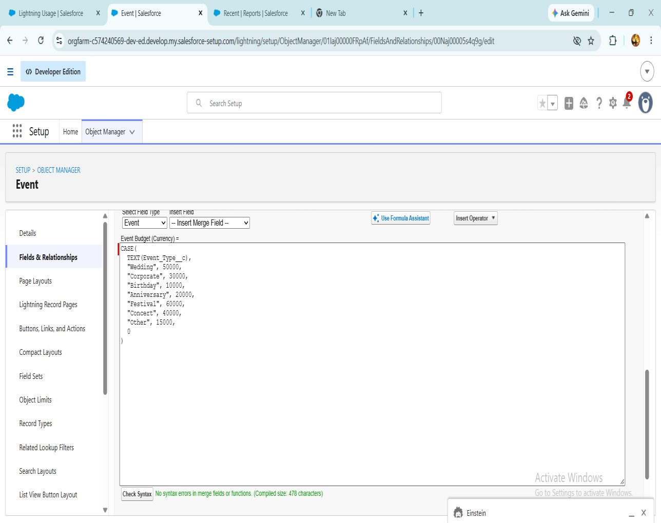
Figure 18 – Event Budget formula and syntax check

6.2.3 Milestone 5 – Validation Rule
A validation rule runs when a record is saved and blocks the save if the data fails the criteria. One was created on Client so that only properly formatted email addresses are stored.
- Setup → Object Manager → Client → Validation Rules → New.
- Rule name Email_Valid_Address, with Active ticked.
- Enter the error condition formula shown below.
- Set the error message to “Please Enter Valid Email Address”, error location Field → Email, and Save.
NOT(REGEX(Email__c, "^[a-zA-Z0-9._]+@[a-zA-Z0-9.]+\\.[a-zA-Z]{2,}$"))

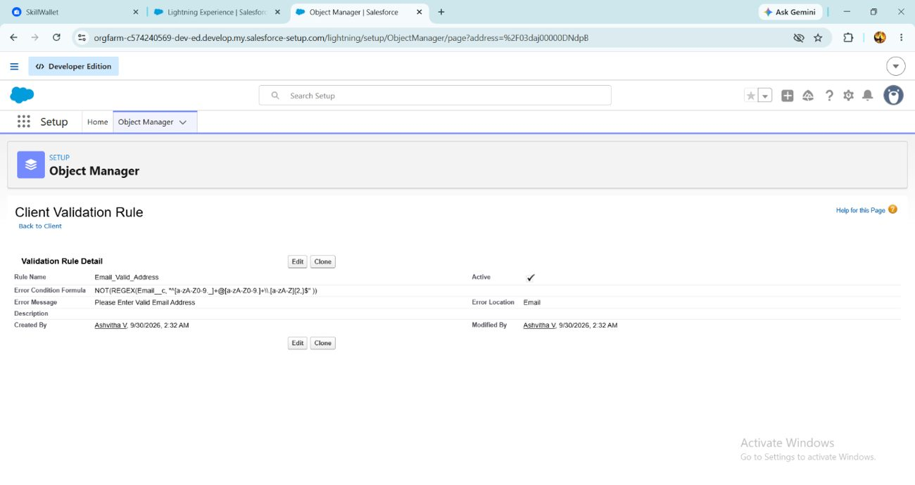
Figure 19 – Client validation rule detail

6.2.4 Milestone 6 – Approval Process (Event Cancellation)
This process makes sure an event is canceled only after a manager approves it, and that all parties are notified automatically. The Profiles, Roles and Users milestones (6.4.1–6.4.3) must be completed before the approval process is built.
Step A – Classic email templates. Four Text-type classic templates were created in Setup → Email Templates → Classic Email Templates → New Template (folder Unfiled Public Email Templates, UTF-8).
Template | Subject | Used for
Event Cancellation Request Notification | Approval Request: Cancel Event {!Event__c.Name} | Alert when an approval request is submitted
Email to Client After Cancellation | Event Cancellation Notice – {!Event__c.Name} | Tells the client the cancellation is approved
Approval Notification to Event Owner | Event Cancellation Approved: {!Event__c.Name} | Tells the owner of approval
Rejection Notification to Event Owner | Event Cancellation Rejected: {!Event__c.Name} | Tells the owner of rejection

Sample body – Event Cancellation Request Notification
Hello!

An approval request has been submitted to cancel the event:
- Event Name: {!Event__c.Name}
- Event Date: {!Event__c.Event_Date__c}

Thank you,
EventForce Management System

Sample body – Approval Notification to Event Owner
Hello {!Event__c.OwnerFullName},

Your cancellation request for the event {!Event__c.Name} has been approved.

Event Date: {!Event__c.Event_Date__c}

The event status has been updated to Canceled.

Thank you,
EventForce Management System

The rejection template follows the same layout, saying the request was rejected and that the event status reverted to Confirmed. The client template states that the event (name and date) has been canceled and invites the client to contact the team with questions.
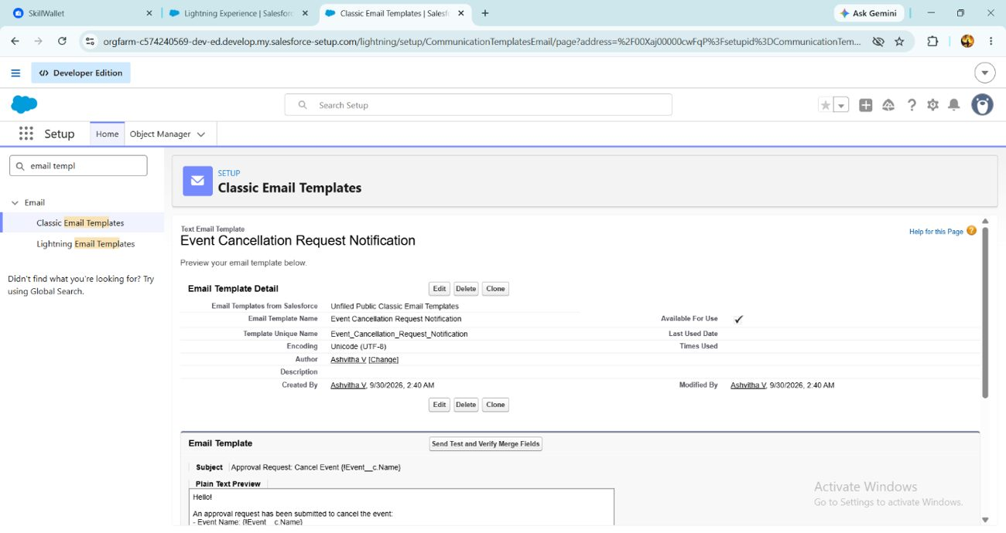
Figure 20 – Classic email template: Event Cancellation Request Notification
Step B – Create the approval process
- Setup → Approval Processes → choose the Event object → Create New Approval Process → Use Standard Setup Wizard.
- Basic settings: name Event_Cancellation_Process (the unique name fills in automatically).
- Entry criteria: Event: Event Status equals Pending Cancellation.
- Approver: assign automatically to a user or queue, such as the submitter’s manager (make sure a manager is set on the User record).
- Email template: Event Cancellation Request Notification.
- Approval page fields: Event Name, Owner, Client, Last Modified By, Created By, Event Budget, Event Date, Event Status, Event Type, Venue.
- Initial submitters: Event Owner. Click Save.
Step C – Actions
Stage | Action | Configuration
Initial submission | Email alert | Event Cancellation Request alert; template Event Cancellation Request Notification; recipient role Event Coordinator; sender is the current user
Final approval | Field update | Event Status Update: set Event Status to Canceled
Final approval | Email alert | Cancellation Approved alert; template Approval Notification to Event Owner; recipient Event Owner
Final rejection | Email alert | Cancellation Rejected alert; template Rejection Notification to Event Owner; recipient Event Owner
Final rejection | Field update | Event Status To Rejected: set Event Status to Rejected

Step D – Approval step and activation
- Click Add New Step, name it Manager Review and let all records enter the step; click Next.
- Assign the approver automatically (a specific or related user) and click Save.
- Open View Approval Process Detail Page and click Activate.
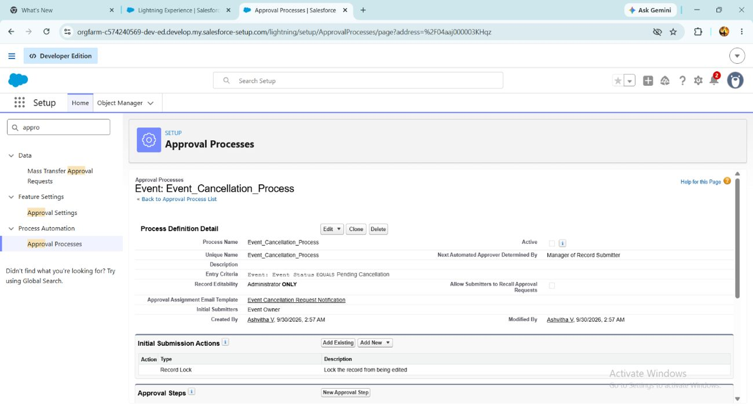
Figure 21 – Event_Cancellation_Process approval process

6.2.5 Milestone 7 – Flow: 3-Day Reminder Email
Scenario: when an Event is created or updated with Event Status = Confirmed and the client has a valid email address, the system emails the client a reminder three days before the Event Date.
- Setup → Flows → New Flow → Record-Triggered Flow → Create.
- Object Event; trigger when a record is created or updated.
- Condition: Event Status equals Confirmed. Optimise for Actions and Related Records, then click Done.
- Click Start → Add Schedule Path. Path name 3_Days_Before; time source Event__c: Event Date; offset 3 days before.
- From the toolbox choose New Resource → Text Template. API name Subject, plain text: “Reminder: Your Event {!$Record.Name} is in 3 days”.
- Create a second text template with API name Body (content below).
- Under the 3_Days_Before path click + → Action → Send Email, labelled Alert_Client_3Day_Reminder.
- Recipient address list: Client Email; CC address list: Event Owner.
- Compose the email content with the Subject resource as subject and the Body resource as body.
- Save with the flow label “Client Reminder - 3 Days Before”, then Save & Activate.
Body text template
Hello {!$Record.Client__r.Name},

This is a reminder that your event "{!$Record.Name}" will take place on {!$Record.Event_Date__c}.

Venue: {!$Record.Venue__r.Name}
Type: {!$Record.Event_Type__c}

We look forward to seeing you!
- EventForce Team

6.2.6 Milestone 8 – Apex Class & Trigger: Venue Status
Scenario: when an Event with a Venue is created or updated, the venue’s Availability Status becomes Reserved if the event is Confirmed, and returns to Available if the event is Canceled. The logic sits in a helper class called from a thin trigger, which is the recommended practice.
Apex class VenueStatusHelper – gear icon → Developer Console → File → New → Apex Class, then save with Ctrl+S.
public with sharing class VenueStatusHelper {
public static void updateVenueStatus(List<Event__c> events){
List<Venue__c> venues = new List<Venue__c>();
for(Event__c ev : events){
if(ev.Venue__c != null){
if(ev.Event_Status__c == 'Confirmed'){
venues.add(new Venue__c(Id=ev.Venue__c, Availability_Status__c='Reserved'));
} else if(ev.Event_Status__c == 'Canceled'){
venues.add(new Venue__c(Id=ev.Venue__c, Availability_Status__c='Available'));
}
}
}
if(!venues.isEmpty()) update venues;
}
}

Apex trigger EventTrigger13 – File → New → Apex Trigger, sObject Event__c.
trigger EventTrigger13 on Event__c (after insert, after update) {
VenueStatusHelper.updateVenueStatus(Trigger.new);
}

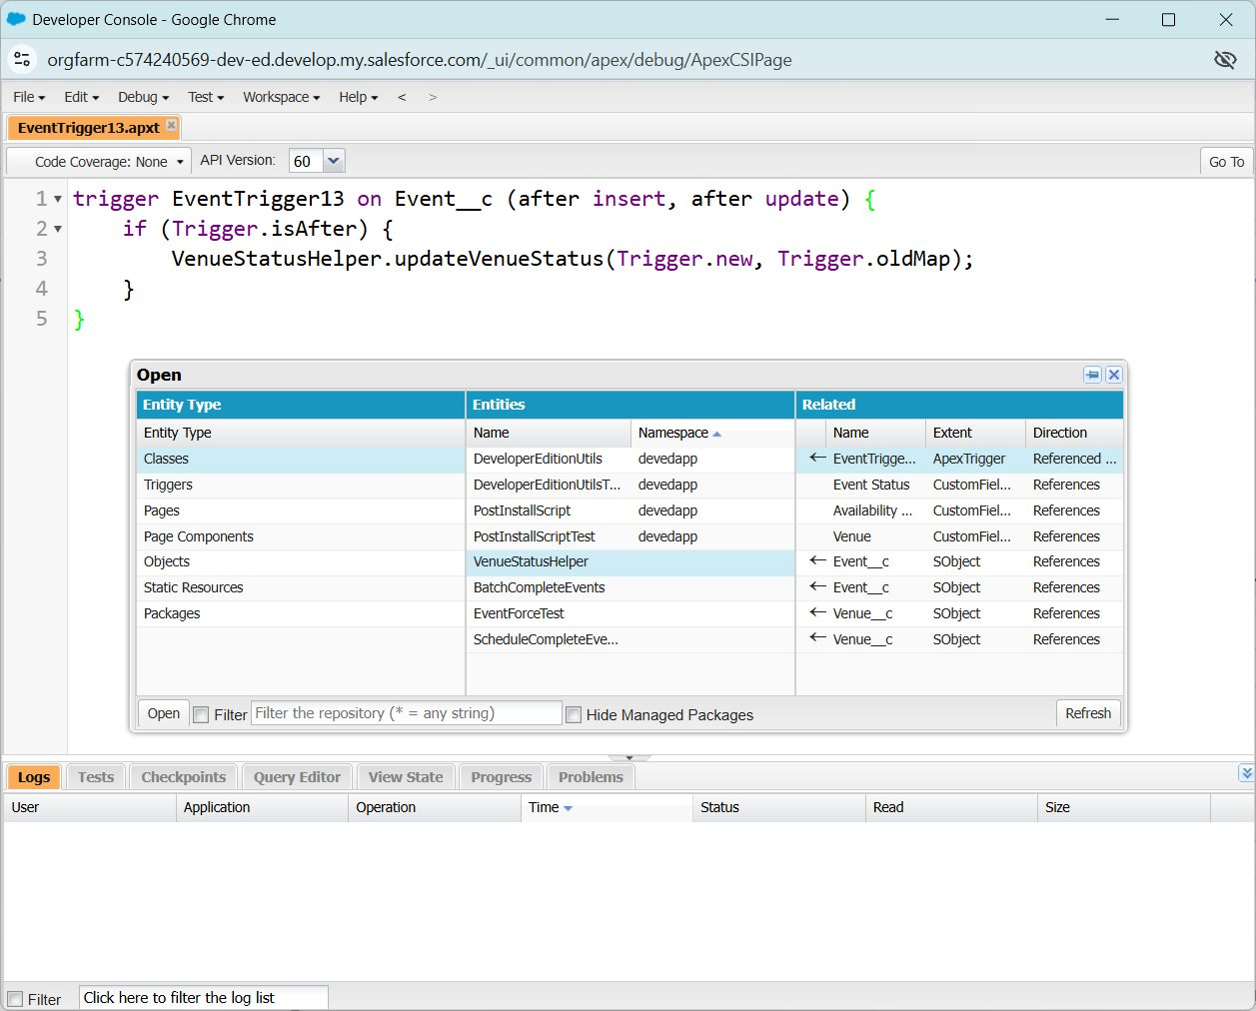
Figure 22 – EventTrigger13 in the Developer Console

6.2.7 Milestone 9 – Apex Trigger: Prevent Double Booking
Scenario: two events must not share a venue on the same date. This before-insert / before-update trigger gathers the venues involved, fetches the existing events at those venues in a single (bulk-safe) query, and raises an error when another event already holds that date.
trigger PreventDoubleBooking on Event__c (before insert, before update) {
Set<Id> venueIds = new Set<Id>();
for(Event__c ev : Trigger.new){
if(ev.Venue__c != null) venueIds.add(ev.Venue__c);
}

Map<Id, List<Event__c>> venueEventMap = new Map<Id, List<Event__c>>();
for(Event__c e : [SELECT Id, Venue__c, Event_Date__c
FROM Event__c WHERE Venue__c IN :venueIds]){
if(!venueEventMap.containsKey(e.Venue__c)){
venueEventMap.put(e.Venue__c, new List<Event__c>());
}
venueEventMap.get(e.Venue__c).add(e);
}

for(Event__c ev : Trigger.new){
if(ev.Venue__c != null && venueEventMap.containsKey(ev.Venue__c)){
for(Event__c existing : venueEventMap.get(ev.Venue__c)){
if(existing.Event_Date__c == ev.Event_Date__c && existing.Id != ev.Id){
ev.addError('This Venue is already booked on this date.');
}
}
}
}
}

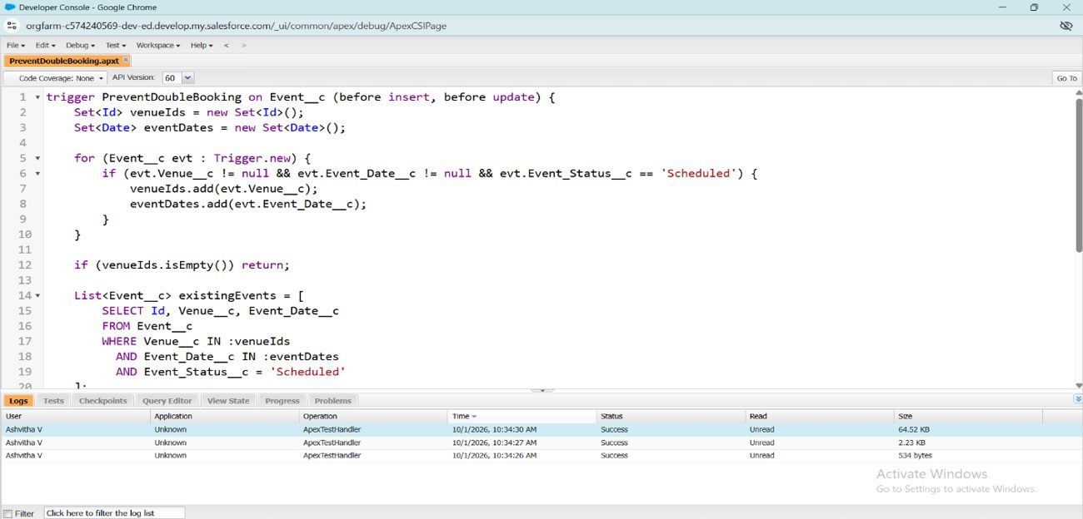
Figure 23 – PreventDoubleBooking trigger in the Developer Console

6.2.8 Milestone 10 – Batch & Schedulable Apex
Scenario: every night, mark all past events as Completed. A Batch Apex class handles the records in chunks and a Schedulable class launches it automatically.
Batch class BatchCompleteEvents
global class BatchCompleteEvents implements Database.Batchable<sObject> {
global Database.QueryLocator start(Database.BatchableContext bc){
return Database.getQueryLocator(
'SELECT Id, Event_Date__c, Event_Status__c FROM Event__c ' +
'WHERE Event_Date__c < TODAY AND Event_Status__c != \'Completed\''
);
}
global void execute(Database.BatchableContext bc, List<Event__c> scope){
for(Event__c ev : scope){
ev.Event_Status__c = 'Completed';
}
update scope;
}
global void finish(Database.BatchableContext bc){
System.debug('Past events marked as Completed');
}
}

Schedulable class ScheduleCompleteEvents
global class ScheduleCompleteEvents implements Schedulable {
global void execute(SchedulableContext sc){
Database.executeBatch(new BatchCompleteEvents(), 200);
}
}

Scheduling the job
- Setup → Apex Classes → click Schedule Apex.
- Job name Daily Event Completion; Apex class ScheduleCompleteEvents.
- Frequency Weekly with every day selected; preferred start time 8:00 PM.
- Click Save. The batch now runs each night at 8 PM and marks past events Completed.
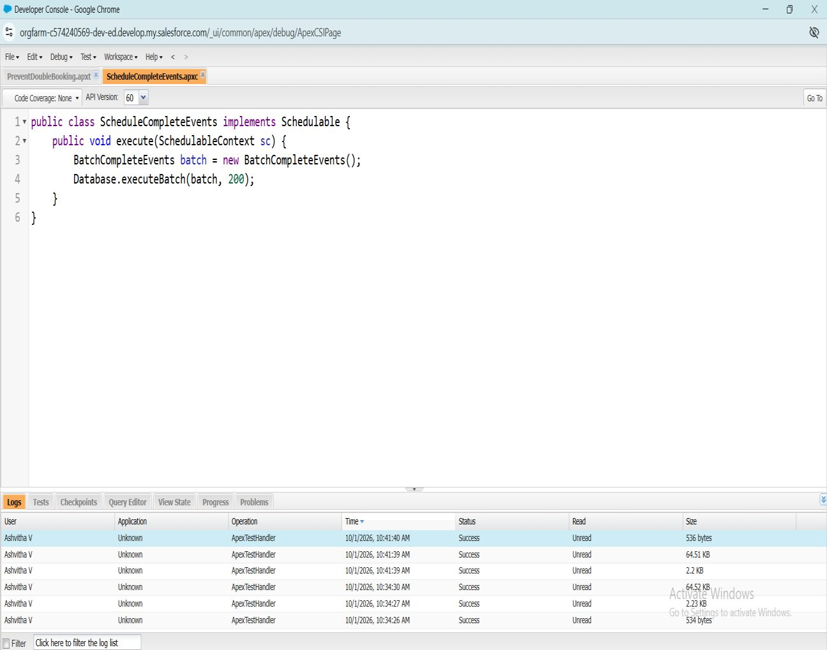
Figure 24 – ScheduleCompleteEvents class

6.3 Phase 3: UI/UX Development & Customization
This phase delivered an easy-to-use interface: a custom Lightning App that gathers every module into one workspace, plus reports and dashboards showing event schedules, vendor performance and client feedback.

Milestone 11 – The Lightning App
An app is a set of tabs working together under one name and logo. The Event Planner app was built as follows:
- Setup → App Manager → New Lightning App. Name it Event Planner, upload an image and click Next.
- Keep the default app options and utility items; click Next.
- Move Event, Client, Vendor, Venue, Feedback, Reports and Dashboards from Available Items to Selected Items; click Next.
- Move System Administrator (and any other needed profiles) to Selected Profiles.
- Click Save & Finish, then confirm by searching Event Planner in the App Launcher.
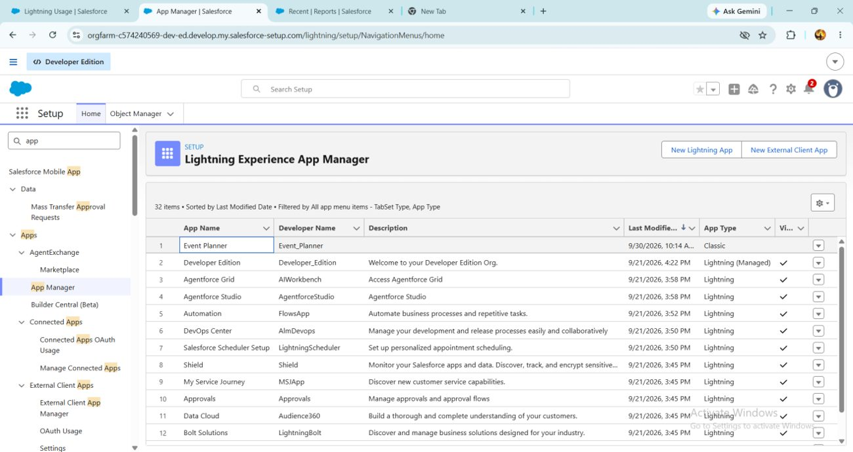
Figure 25 – Event Planner in the Lightning Experience App Manager

Milestone 12 – Reports
Report folder. In the App Launcher open Reports → New Folder, label it EventForce Report and Save. From All Folders open the folder’s drop-down → Share, share with the Event Coordinator and Vendor Manager roles at View access, then Share and Done.
Report: Upcoming Events by Month. It shows upcoming events with their counts and budgets per month. At least 10 records were created in every object before building it.
- Reports → New Report; category All; choose Events (or Events with Client & Venue); Start Report.
- Columns: Event Name, Event Date, Event Type, Client Name, Venue Name, Event Budget.
- Filters: Show Me = All Events; Event Date ≥ TODAY (or Next 30 Days); Event Status ≠ Canceled.
- Group rows by Event Date, by Calendar Month.
- Summaries: Row Count and SUM of Event Budget.
- Chart: column or line, X-axis Event Date (Calendar Month), Y-axis Row Count or SUM(Event Budget).
- Save as Upcoming Events by Month in the EventForce Report folder and click Run.
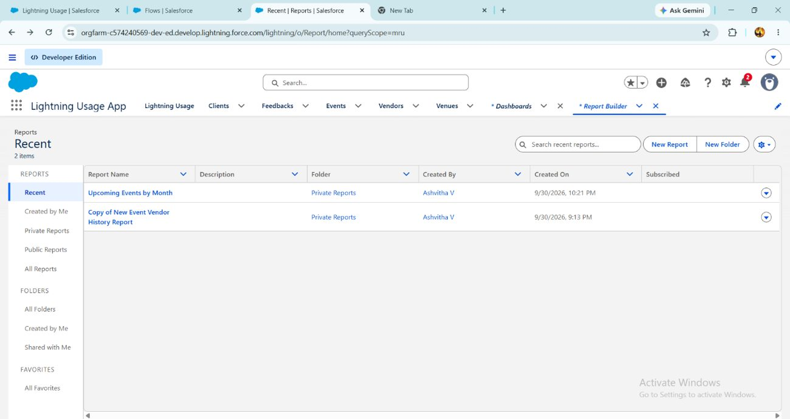
Figure 26 – Upcoming Events by Month in the report list

Milestone 13 – Dashboards
- In the Event Planner app open Dashboards → New Dashboard.
- Name it EventForce Operations Dashboard and click Create.
- Click + Widget and pick the Upcoming Events by Month report.
- Chart type Donut, max values displayed 6, subtitle Upcoming Events Overview, widget theme Light.
- Click Save.
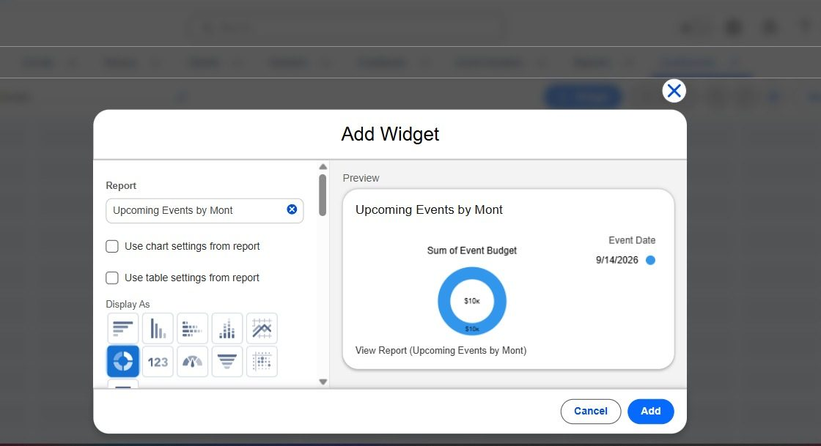
Figure 27 – Adding the Upcoming Events by Month donut widget
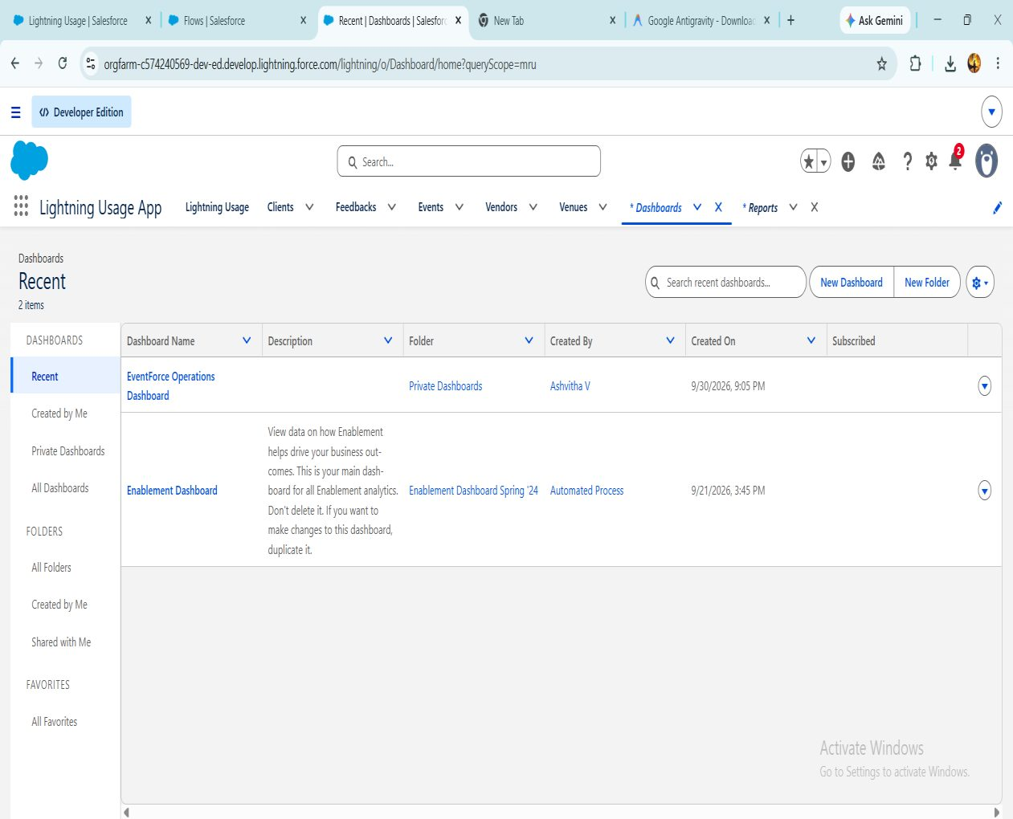
Figure 28 – Dashboards list including EventForce Operations Dashboard

6.4 Phase 4: Data Migration, Testing & Security
This phase made the system ready for use: loading validated data, creating users and applying role-based access. Records for Events, Clients, Vendors, Venues and Feedback were imported with the Data Import Wizard after checks to avoid duplicates. Four account types (Event Admin, Event Coordinator, Vendor Manager and Client) were created with matching profiles and roles. Organization-Wide Defaults were set to Private and then opened up through sharing rules.

Milestone 14 – Profiles
A profile bundles the settings and permissions that decide what a user can do: object and field access, tab and app settings, login hours and so on. Each user has exactly one profile, but one profile can serve many users.
Event Admin. Created by cloning System Administrator (Setup → Profiles → New Profile → existing profile System Administrator → name Event Admin). The clone carries Modify All Data, Customize Application and full CRUD on all objects, which suits an administrator.
Other profiles. Event Coordinator, Vendor Manager and Client Profile were cloned from Standard Platform User and edited: the default custom app is Event Planner, object permissions are as below, the session times out after 2 hours of inactivity, passwords never expire and the minimum length is 8.
Object | Event Coordinator | Vendor Manager | Client Profile
Event | Create, Read, Edit, Delete | Read only | Read only (own events)
Client | Read, Edit | Read only | —
Vendor | Read | Create, Read, Edit, Delete | No access
Venue | Read | Read only | No access
Feedback | Create, Read | Read only | Create, Read

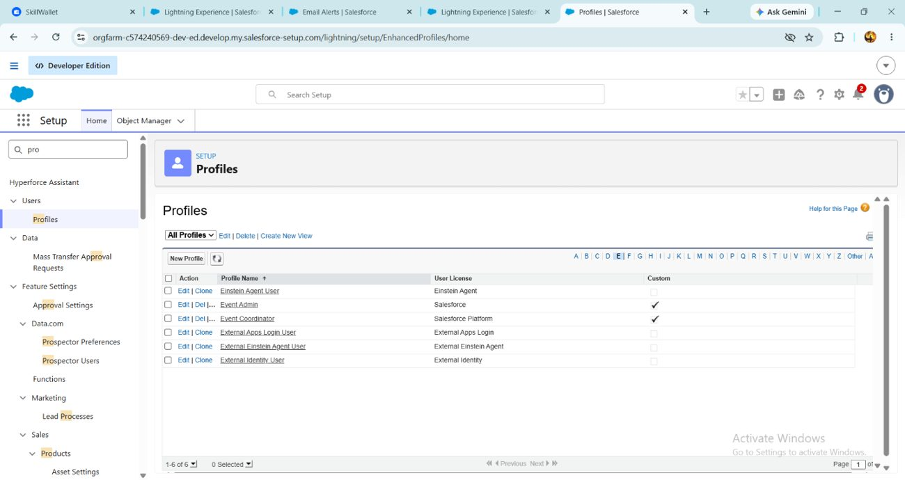
Figure 29 – Profiles page in Setup

Milestone 15 – Roles
Roles define the reporting hierarchy and let record visibility flow upward. The Event Admin role was placed under CEO (Setup → Roles → Set Up Roles → Expand All → Add Role) and three roles were added beneath it.
Role | Reports to
Event Admin | CEO
Event Coordinator | Event Admin
Vendor Manager | Event Admin
Client | Event Admin

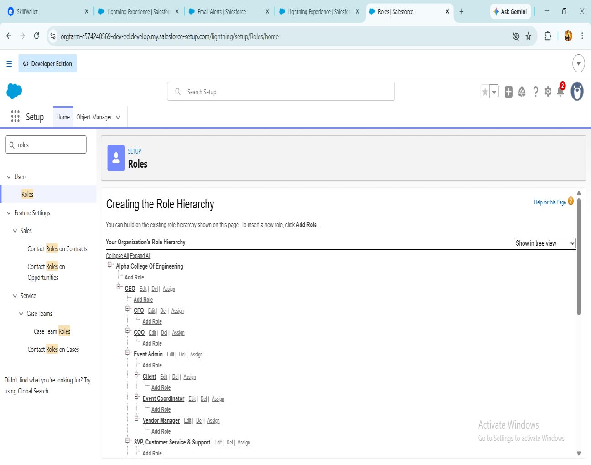
Figure 30 – Role hierarchy
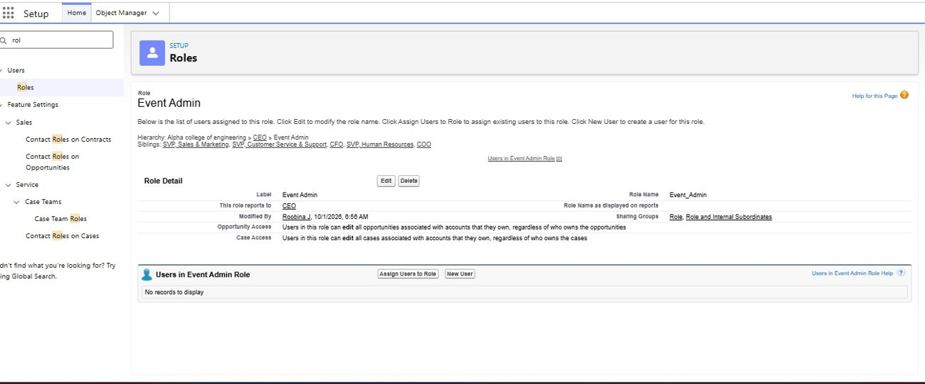
Figure 31 – Event Admin role detail

Milestone 16 – Users
A user is anyone who logs in to Salesforce. Users were created from Setup → Users → New User. The first user received the Event Admin role, Salesforce license and Event Admin profile; the others used the Salesforce Platform license with the matching role and profile.
User type | Role | License | Profile
Event Admin | Event Admin | Salesforce | Event Admin
Event Coordinator | Event Coordinator | Salesforce Platform | Event Coordinator
Vendor Manager | Vendor Manager | Salesforce Platform | Vendor Manager
Client | Client | Salesforce Platform | Client Profile

A Developer Edition org has only a few Salesforce licenses. If none are free, deactivate an existing user holding one or change the license type.
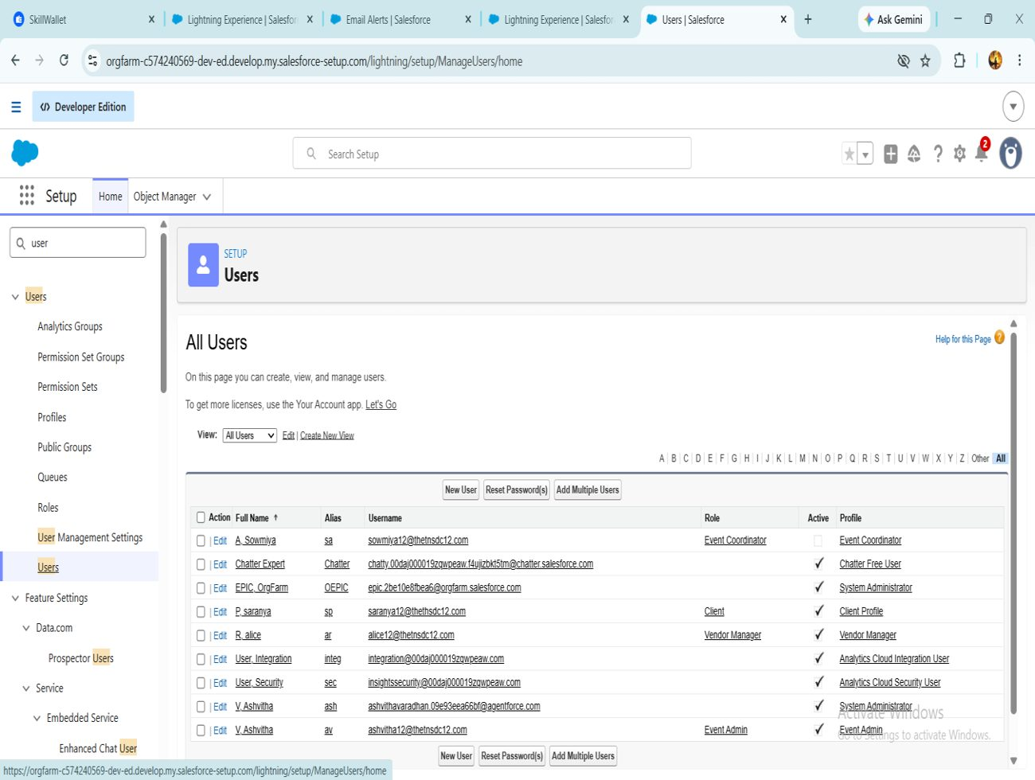
Figure 32 – All Users list

Milestone 17 – Permission Set
A permission set adds permissions without touching a user’s profile. A Feedback Manager permission set was created to give selected users full access to Feedback.
- Setup → Permission Sets → New; label it Feedback Manager and Save.
- Open Object Settings → Feedback → Edit, enable Read, Create, Edit and Delete, and Save.
- Click Manage Assignments → Add Assignment, select the Event Coordinator user, then Next → Assign.
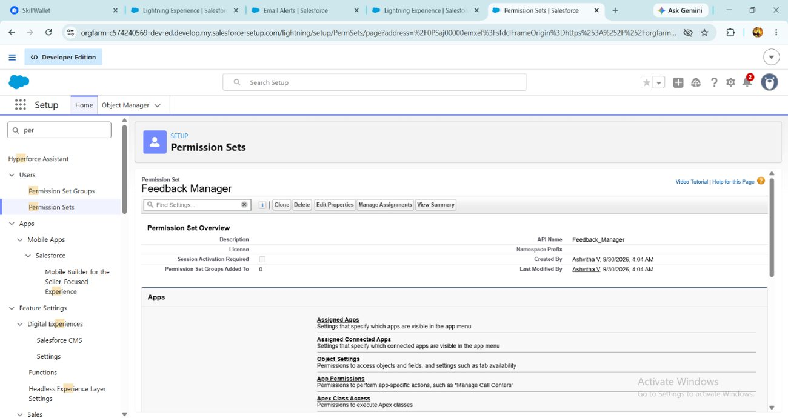
Figure 33 – Feedback Manager permission set

Milestone 18 – Sharing Settings
Organization-Wide Defaults (OWD) set the baseline record access, which can then be widened through the role hierarchy, sharing rules, manual sharing or Apex sharing. Sharing rules can only extend access, never restrict it.
Configuring OWD
- Setup → Sharing Settings → Edit (Organization-Wide Defaults).
- For Event set Default Internal Access and Default External Access to Private.
- Click Save.
Sharing rule: Event_Sharing_For_Vendors
- In Sharing Settings find the Event sharing rules and click New.
- Label it Event_Sharing_For_Vendors (the rule name fills in automatically).
- Records to share: owned by members of Roles → Event Coordinator.
- Share with: Roles → Vendor Manager.
- Access level Read Only; click Save.
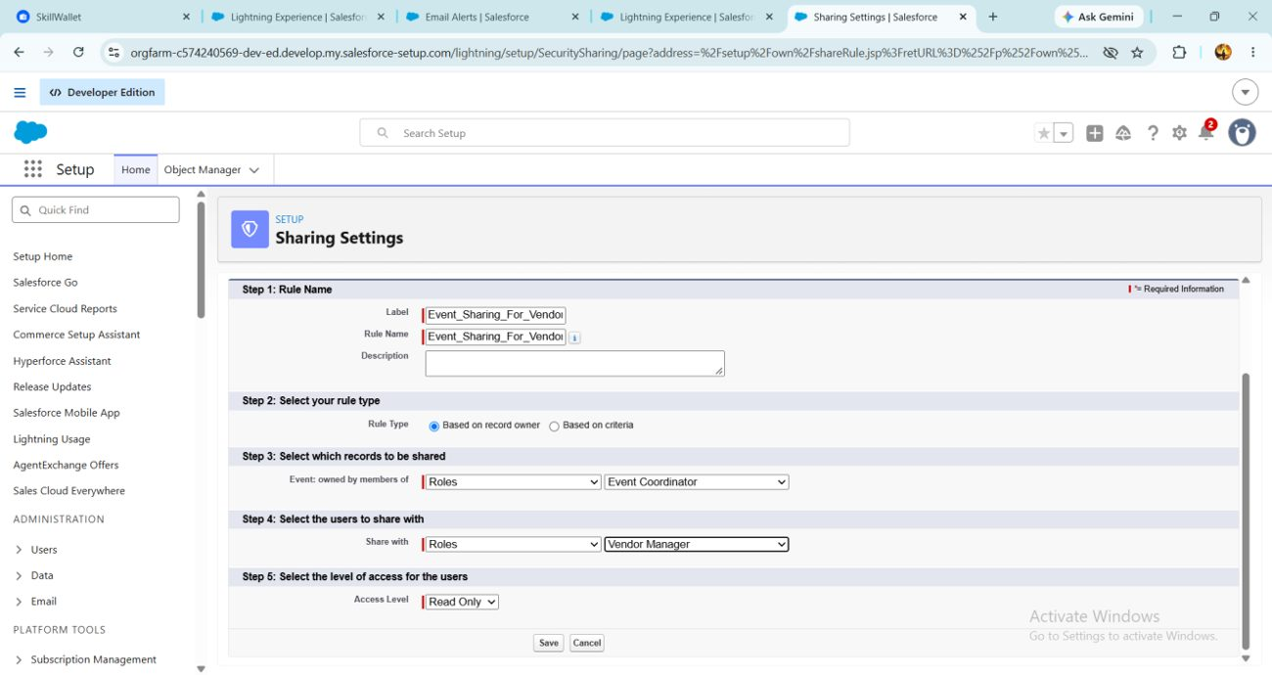
Figure 34 – Event_Sharing_For_Vendors sharing rule

6.5 Phase 5: Deployment, Documentation & Maintenance

6.5.1 Deployment Strategy
Everything was configured and tested inside a Salesforce Developer Edition org. The purpose of this phase is to show how a real Salesforce solution is readied for release after configuration, testing and security setup. No production deployment was carried out, because Developer Edition orgs are standalone and not linked to production instances; real deployments use sandboxes, change sets or DevOps tooling.
In an enterprise, the recommended path would be:
- Build and unit-test in a Developer or Developer Pro sandbox.
- Promote the metadata (objects, fields, flows, Apex, approval process, reports, dashboards) to a Partial or Full sandbox for UAT using change sets or Salesforce DX / Git-based CI/CD.
- Run Apex tests (at least 75% code coverage is required to deploy to production) and validate the deployment.
- Deploy during a low-usage window, then activate flows, approval processes and scheduled jobs and assign permission sets.
- Load production data, train users and provide post-go-live support.
Note: Apex test classes were outside the scope of this academic build. Before any production deployment, tests for VenueStatusHelper, PreventDoubleBooking, BatchCompleteEvents and ScheduleCompleteEvents must be written to reach 75% coverage.

6.5.2 Maintenance, Monitoring & Troubleshooting
Regular upkeep keeps event, client, vendor and feedback data accurate and the automations healthy.
Activity | Approach
Monitoring | Review Flow error emails, Apex Jobs, Scheduled Jobs and pending approvals
Access issues | Check profiles, permission sets, roles and sharing rules to fix permission conflicts
Debugging | Use debug logs and the Developer Console for Apex triggers and Flow logic
Rule tuning | Adjust validation rules and sharing settings as needs change
Data quality | Run duplicate checks and periodic cleansing; look for anomalies in reports
Releases | Read the seasonal release notes and retest critical automations after each release

Common Issues
Issue | Likely cause | Resolution
User cannot see the Event Planner app or a tab | Profile or permission set lacks app/tab access | Enable app/tab visibility in the profile or permission set
Approval cannot be submitted | No manager/approver set, or entry criteria not met | Set a manager on the User record and confirm status is Pending Cancellation
Reminder email not sent | Flow inactive, status not Confirmed, or client email blank | Activate the flow; check status and client email
Event cannot be saved | Double-booking trigger fired | Choose another date or venue
Cannot create a user | No free Salesforce license in the org | Deactivate an unused user or change the license type

6.5.3 Documentation Summary
This report records the purpose, data model, configuration, automation, security and testing of EventForce. It covers:
- Business overview and objectives.
- Phase-by-phase implementation: requirements, development, UI, testing, security.
- Data model and relationships (Event, Client, Vendor, Venue, Feedback, Event Vendor).
- Automation: Flow, Approval Process, validation rule and Apex logic.
- Security model: profiles, roles, permission sets, OWD and sharing rules.
- Test results and screenshots of the Salesforce features.
It serves as a blueprint for future developers and administrators, supporting consistent development, training and knowledge transfer.

7. Functional & Performance Testing
Screenshots were captured from Salesforce while testing event creation, venue assignment, the double-booking trigger, approval status changes, batch processing, scheduled reminders and dashboard analytics. All features behaved correctly.
Testing covered data accuracy, automation performance and user permissions. The main scenarios are listed below.
# | Area | Test scenario | Expected result
1 | Validation rule | Save a Client with an invalid email such as “abc@” | Save is blocked with “Please Enter Valid Email Address”
2 | Formula field | Create an event of each Event Type | Event Budget fills in according to the formula
3 | Double booking | Create two events at the same venue on the same date | Error: “This Venue is already booked on this date.”
4 | Venue status | Set an event to Confirmed, then Canceled | Venue becomes Reserved, then Available
5 | Approval process | Set status to Pending Cancellation and submit | Approval request and alert emails are sent
6 | Approval – approve | Approver approves the request | Status = Canceled; owner notified
7 | Approval – reject | Approver rejects the request | Status = Rejected; owner notified
8 | Flow | Confirm an event 3+ days ahead with a client email | Reminder is sent three days before the event date
9 | Batch Apex | Run the batch with past-dated events | Past events are marked Completed
10 | Lookup filter | Pick a client on Feedback, then open the Event lookup | Only that client’s events are listed
11 | Security | Log in as each user type | Each user sees only permitted tabs, objects and records
12 | Sharing rule | Vendor Manager views coordinator-owned events | Events are visible as Read Only

8. Advantages & Disadvantages

Advantages
- Centralised data – Event, Client, Vendor, Venue, Feedback and EventVendor records live in Salesforce.
- Process automation – Flows send reminders and run other steps, cutting manual work.
- No double bookings – the Apex trigger and VenueStatusHelper validate availability and prevent conflicts.
- Controlled cancellations – the Approval Process handles requests in a structured way.
- Operational visibility – reports and dashboards show schedules, vendor activity and feedback.
- Secure access – profiles, roles, permission sets, OWD and sharing rules control who sees what.
- Scalable – the platform can support growth and new requirements.
- Better data quality – validation rules and pre-checks during migration keep data consistent.

Disadvantages
- Developer Edition only – built for academic purposes and not connected to a production environment.
- No production rollout – migration to production was out of scope.
- Extra tooling for real deployment – sandboxes, change sets, Salesforce DX or CI/CD pipelines may be needed.
- Configuration complexity – Flows, Apex, approvals and security need Salesforce expertise.
- Ongoing maintenance – flows, Apex jobs, approvals, validation rules and sharing settings need regular monitoring.

9. Conclusion
EventForce shows how Salesforce can streamline and automate event planning and management. Events, Clients, Vendors, Venues, Feedback and EventVendor data now sit on one platform.
The implementation combines Lightning, Flows, validation rules, formula fields, approval processes, Apex triggers and classes, Batch and Scheduled Apex, security controls, reports and dashboards. Automation covers event reminders, cancellation approvals, venue availability, double-booking prevention and event completion.
The project also highlights how important data migration, testing, security, documentation and maintenance are in a Salesforce rollout. Although it was built and tested in a Developer Edition org without a production deployment, it follows real-world Salesforce practice and gives a solid base for future growth.

Key Learnings
- Designing a scalable data model, including junction objects for many-to-many links.
- Combining declarative tools (Flows, approvals, validation rules) with Apex for advanced logic.
- Writing bulk-safe Apex triggers and using Batch and Schedulable Apex for asynchronous work.
- Layering security with profiles, roles, permission sets, OWD and sharing rules.
- Turning operational data into decisions through reports and dashboards.
- Seeing how a Developer Org build maps to real deployment, maintenance and documentation practice.

10. Future Scope
EventForce can be extended to handle larger event operations and to improve automation, integration and usability.
- Production deployment – move the solution to a production org using proper deployment tools.
- Wider event automation – automate more planning and operational activities.
- Richer vendor management – add more advanced vendor tracking and performance measures.
- Advanced analytics – build more reports and dashboards on events, venues, vendors and feedback.
- External integrations – connect Salesforce with the outside systems that event operations rely on.
- Mobile access – make event management convenient on mobile devices.
- Greater scale – support larger numbers of events, clients, vendors, venues and users.
- Continuous optimisation – keep improving flows, Apex, validation rules and sharing settings as requirements change.
With these enhancements, EventForce can grow into a fuller, enterprise-ready event management CRM.

11. Appendix
Ref | Topic | Contents
A | Custom objects | Event, Client, Vendor, Venue, EventVendor, Feedback
B | Automation | Flows, validation rules, approval process, Apex triggers and classes
C | Processing | Batch Apex and Scheduled Apex
D | Security | Profiles, roles, permission sets, OWD, sharing rules
E | Data migration | Salesforce Data Import Wizard
F | UI & analytics | Lightning App, reports and dashboards
G | Testing & documentation | Configuration, security and automation testing; project documentation

Thank You

