
Department of Information technology

Title of the Project : Credit Card Fraud Detection Using Face Recognition

Name and Designation of the Supervisor : Ms.M.Subitha , Assistant Professor
S.NO | STUDENT’S NAME | REGISTER NUMBER | YEAR/SEM/SEC
1 | RUFINA MARY JOYCE S | 25UIT177 | I/II/C
2 | GOMATHY G | 25UIT053 | I/II/C
3 | SWETHA M | 25UIT211 | I/II/C
4 | SANGEETHA J | 25UIT185 | I/II/C
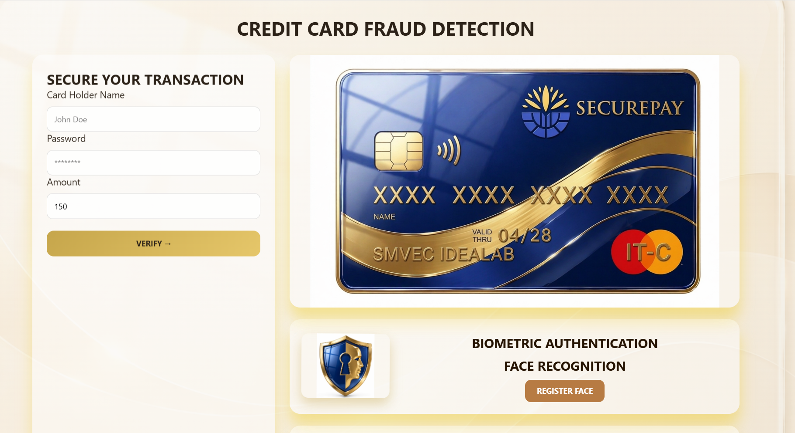
ABSTRACT
Credit card fraud is a major challenge in digital payment systems because traditional security methods such as PINs and OTPs can be stolen, shared, or hacked. This project proposes a face recognition-based authentication system to make credit card transactions more secure. The credit card is linked with the facial data of one or more authorized users. During every transaction, the user’s face is captured in real time and compared with the stored facial database using image processing techniques. If the face matches, the transaction is approved successfully. If the face does not match, the transaction is blocked immediately and a fraud alert is sent to the card owner or bank.This biometric solution improves security, reduces unauthorized access, and increases trust in digital payment systems.
APPLICATIONS
• Banking & Finance – ATM security, card transactions, fraud monitoring
• E-commerce – Secure online payments and identity verification
• Retail (POS systems) – In-store payment authentication

• Mobile Banking Apps – Secure login and transaction approval

