LABORATORY 4

-

OPERATING SYSTEMS

RUFINO GARCIA SANCHEZ

**Exercise 1**

Write a child process which execute a process ./calc with  argv[1], argv[2] and argv[3] parameters.

Where:

**argv[1] - first number,**

**argv[2] - operation  (+-x/),**

**argv[3]  - second number.**

Use one of the **execv* functions to pass arguments to the program.**

**For this exercise this is the code I have made in the main.c to run with the execv* function:**

**The code of calc.c is this:**

**And when we execute and run the code we can see in the next image that works correctly:**

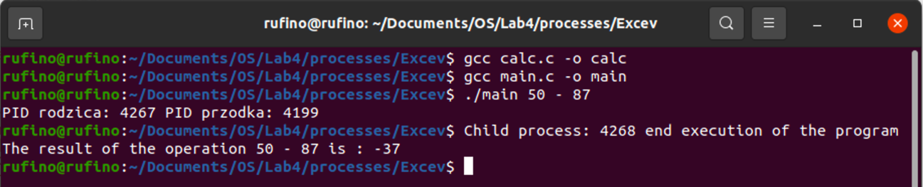

**EXERCISE 2**

**Prepare 3 versions of this program using both execl* and execv* commands.**

For the first one, **execlp*:**

The code of the program **calc.c** still the same as the **EXERCISE 1.**

**And when we execute and run the code we can see in the next image that works correctly:**

For the second one, **execvp*:**

The code of the program **calc.c** still the same as the **EXERCISE 1.**

**And when we execute and run the code we can see in the next image that works correctly:**

For the third and last one**, execl*:**

The code of the program **calc.c** still the same as the **EXERCISE 1.**

**And when we execute and run the code we can see in the next image that works correctly**