ASSIGNMENT-2

-CB.EN.U4CSE17147

1)

<!DOCTYPE html>

<html>

<head>

<style>

table, th, td {

  border: 1px solid black;

  border-collapse: collapse;

}

th, td {

  padding: 5px;

  text-align: left;

}

</style>

</head>

<body>

<table >

    <caption>Company Name:XXX</caption>

  <tr>

</tr>

</tr>

    <th >Name</th>

<th>ID</th>

<th >Designation</th>

<th >Contact Details</th>

<th >Academic Details </th>

  </tr>

    <tr>

        <td>Raju</td>

        <td>101</td>

        <td>Programmer</td>

        <td>

        <table>

            <thread>

               <tr>

                  <td>Phone</td>

                  <td>8275689053</td>

                  </tr></thread>

                   <tr>

                       <td>Email</td>

                       <td>aa@aaa.com</td>

                   </tr>

                   <tr>

                    <td>Adress</td>

                    <td>12/xxx</td>

                   </tr>

        </table>

        </td>

        <td>

            <table>

                <thread>

                   <tr>

                      <td>UG</td>

                      <td>B.Tech</td>

                      </tr></thread>

                       <tr>

                           <td>PG</td>

                           <td>M.tech</td>

                       </tr>

            </table>

            </td>

      </tr>

      <tr>

        <td>Raju</td>

        <td>101</td>

        <td>Programmer</td>

        <td>

        <table>

            <thread>

               <tr>

                  <td>Phone</td>

                  <td></td>

                  </tr></thread>

                   <tr>

                       <td>Email</td>

                       <td></td>

                   </tr>

                   <tr>

                    <td>Adress</td>

                    <td></td>

                   </tr>

        </table>

        </td>

        <td>

            <table>

                <thread>

                   <tr>

                      <td>UG</td>

                      <td></td>

                      </tr></thread>

                       <tr>

                           <td>PG</td>

                           <td></td>

                       </tr>

            </table>

            </td>

      </tr>

      <tr>

        <td>Raju</td>

        <td>101</td>

        <td>Programmer</td>

        <td>

        <table>

            <thread>

               <tr>

                  <td>Phone</td>

                  <td></td>

                  </tr></thread>

                   <tr>

                       <td>Email</td>

                       <td></td>

                   </tr>

                   <tr>

                    <td>Adress</td>

                    <td></td>

                   </tr>

        </table>

        </td>

        <td>

            <table>

                <thread>

                   <tr>

                      <td>UG</td>

                      <td></td>

                      </tr></thread>

                       <tr>

                           <td>PG</td>

                           <td></td>

                       </tr>

            </table>

            </td>

      </tr>

</table>

</body>

</html>

Ouput:

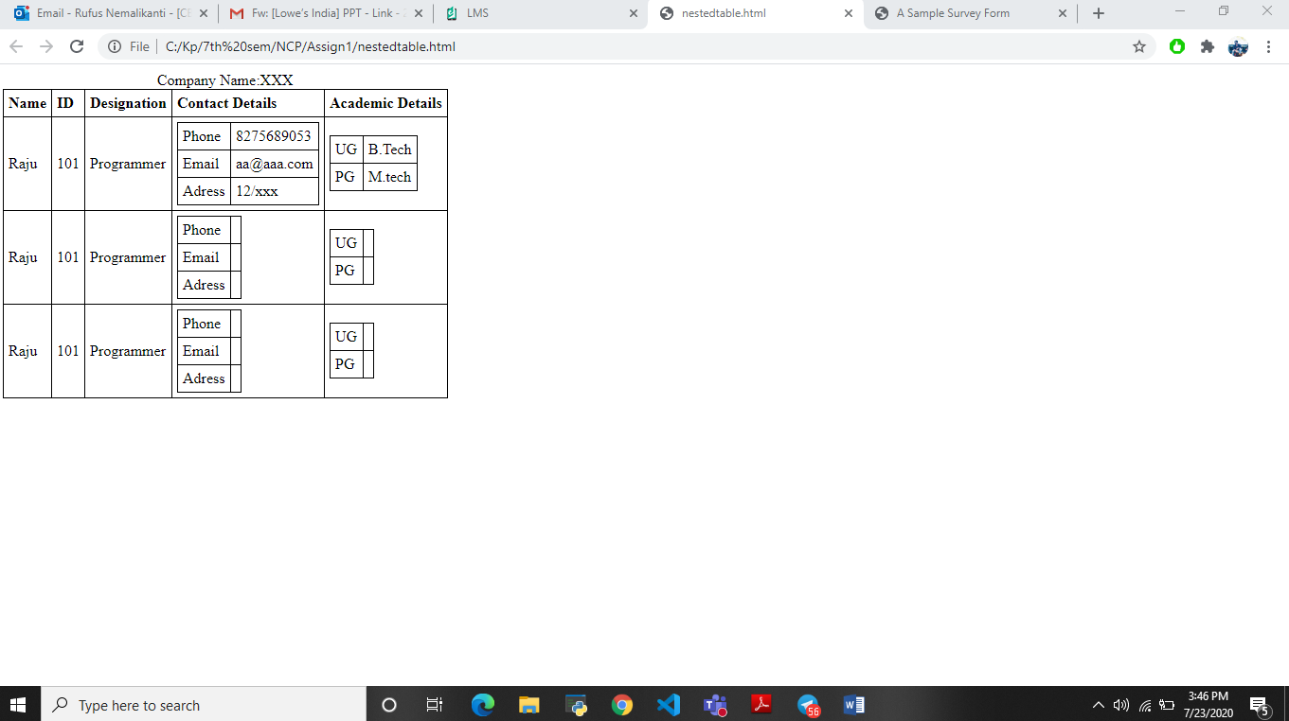

2)

<!DOCTYPE html>

<html>

<head>

<meta http-equiv="Content-Type" content="text/html; charset=UTF-8">

<title>A Sample Survey Form</title>

<link rel="stylesheet" type="text/css" href="view.css" media="all">

</head>

<body id="main_body" >

    <img id="top" src="top.png" alt="">

    <div id="form_container">

        <h1><a>A Sample Survey Form</a></h1>

        <form id="form_118777" class="appnitro"  method="post" action="">

                    <div class="form_description">

            <h2>A Sample Survey Form</h2>

            <p>Help us in filling the form to improve ourself.</p>

        </div>

            <ul >

                <center>

                    <li id="li_1" >

        <label class="description" for="element_1">Name </label>

        <div>

            <input id="element_1" name="element_1" class="element text medium" type="text" maxlength="255" value=""/>

        </div>

        </li>       <li id="li_2" >

        <label class="description" for="element_2">Email </label>

        <div>

            <input id="element_2" name="element_2" class="element text medium" type="text" maxlength="255" value=""/>

        </div>

        </li>       <li id="li_3" >

        <label class="description" for="element_3">Age </label>

        <div>

            <input id="element_3" name="element_3" class="element text large" type="text" maxlength="255" value=""/>

        </div>

    </center>

        </li>       <li id="li_4" >

        <label class="description" for="element_4">Which option best describes your current role? </label>

        <div>

        <select class="element select medium" id="element_4" name="element_4">

            <option value="" selected="selected"></option>

<option value="1" >Student</option>

<option value="2" >Graduate</option>

        </select>

        </div>

        </li>       <li id="li_5" >

        <label class="description" for="element_5">How likely is that you would recommend freecodecamp to your friend? </label>

        <span>

            <input id="element_5_1" name="element_5" class="element radio" type="radio" value="1" />

<label class="choice" for="element_5_1">Definitely</label>

<input id="element_5_2" name="element_5" class="element radio" type="radio" value="2" />

<label class="choice" for="element_5_2">May Be</label>

<input id="element_5_3" name="element_5" class="element radio" type="radio" value="3" />

<label class="choice" for="element_5_3">Not Sure</label>

        </span>

        </li>       <li id="li_6" >

        <label class="description" for="element_6">What do you like the most in FCC? </label>

        <div>

        <select class="element select medium" id="element_6" name="element_6">

            <option value="" selected="selected"></option>

<option value="1" >First option</option>

<option value="2" >Second option</option>

        </select>

        </div>

        </li>       <li id="li_7" >

        <label class="description" for="element_7">Things that should be improved in the future

(check all that apply) </label>

        <span>

            <input id="element_7_1" name="element_7_1" class="element checkbox" type="checkbox" value="1" />

<label class="choice" for="element_7_1">Front-end Projects</label>

<input id="element_7_2" name="element_7_2" class="element checkbox" type="checkbox" value="1" />

<label class="choice" for="element_7_2">Back-end Projects</label>

<input id="element_7_3" name="element_7_3" class="element checkbox" type="checkbox" value="1" />

<label class="choice" for="element_7_3">Data Visualization</label>

        </span>

        </li>

                    <li class="buttons">

                <input type="hidden" name="form_id" value="118777" />

                <input id="saveForm" class="button_text" type="submit" name="submit" value="Submit" />

        </li>

            </ul>

        </form>

    </div>

    </body>

</html>

output:

