Title:Computer-Aided Design and Optimization of a Microwave Impedance-Matching Network and Frequency-Selective Filter
Aim
To design and optimize a microwave impedance-matching network and frequency-selective filter using MATLAB, and evaluate their performance using simulated frequency responses.

Matlab Program:
clc;
clear;
close all;

%% Design Specifications
Z0 = 50; % Characteristic impedance (ohms)
ZL = 30 + 1j*20; % Complex load impedance (ohms)

f0 = 2.4e9; % Design frequency (Hz)
f = linspace(1e9,4e9,1001); % Frequency range (Hz)

%% Objective 1: Impedance Matching Network
% Calculate load reflection coefficient
GammaL = (ZL-Z0)/(ZL+Z0);
RL_initial = -20*log10(abs(GammaL));

% Ideal conjugate-match transformation at design frequency
Zmatch = conj(ZL);
Gamma_matched = (Zmatch-ZL)/(Zmatch+ZL);
RL_matched = -20*log10(max(abs(Gamma_matched),eps));

fprintf('INITIAL LOAD IMPEDANCE = %.2f + j%.2f ohms\n',real(ZL),imag(ZL));
fprintf('INITIAL RETURN LOSS = %.2f dB\n',RL_initial);
fprintf('IDEAL MATCHED RETURN LOSS = %.2f dB\n',RL_matched);

%% Objective 2: Matching Network Optimization
% Illustrative frequency-dependent matching response
x = (f-f0)/f0;
Gamma = 0.03 + 1j*0.08*x;
Gamma = min(abs(Gamma),0.99).*exp(1j*angle(Gamma));

% Return loss and reflected power
ReturnLoss = -20*log10(max(abs(Gamma),eps));
ReflectedPower = abs(Gamma).^2;

% Find minimum-reflection operating frequency
[~,idx] = min(abs(Gamma));
f_opt = f(idx);

figure;
subplot(2,1,1);
plot(f/1e9,ReturnLoss,'b','LineWidth',1.5);
grid on;
xlabel('Frequency (GHz)');
ylabel('Return Loss (dB)');
title('Impedance Matching Network');

subplot(2,1,2);
plot(f/1e9,ReflectedPower,'r','LineWidth',1.5);
grid on;
xlabel('Frequency (GHz)');
ylabel('Reflected Power Ratio');
title('Reflection Characteristics');

fprintf('OPTIMUM FREQUENCY = %.3f GHz\n',f_opt/1e9);
fprintf('RETURN LOSS AT OPTIMUM = %.2f dB\n',ReturnLoss(idx));

%% Objective 3: Microwave Bandpass Filter
% Second-order Butterworth-like bandpass response
fL = 2.0e9; % Lower cutoff frequency
fH = 2.8e9; % Upper cutoff frequency
fCenter = sqrt(fL*fH);
BW = fH-fL;

% Approximate bandpass magnitude response
u = (f.^2-fCenter^2)./(f*BW);
H = 1./sqrt(1+u.^4);

% Convert magnitude response to dB
InsertionLoss = -20*log10(max(H,eps));

figure;
plot(f/1e9,20*log10(max(H,eps)),'k','LineWidth',1.5);
grid on;
xlabel('Frequency (GHz)');
ylabel('Magnitude (dB)');
title('Microwave Bandpass Filter Response');
yline(-3,'--r','-3 dB');

%% Objective 4: Filter Performance Evaluation
Passband = f(H >= 1/sqrt(2));
if ~isempty(Passband)
f_pass_low = min(Passband);
f_pass_high = max(Passband);
BW_3dB = f_pass_high-f_pass_low;
else
f_pass_low = NaN;
f_pass_high = NaN;
BW_3dB = NaN;
end

Stopband = f(H < 0.1); % Below -20 dB magnitude
if ~isempty(Stopband)
StopbandStart = min(Stopband);
else
StopbandStart = NaN;
end

fprintf('\nFILTER PERFORMANCE\n');
fprintf('Center Frequency = %.3f GHz\n',fCenter/1e9);
fprintf('Specified Bandwidth = %.3f GHz\n',BW/1e9);
fprintf('Lower Passband Edge = %.3f GHz\n',f_pass_low/1e9);
fprintf('Upper Passband Edge = %.3f GHz\n',f_pass_high/1e9);
fprintf('Measured 3-dB Bandwidth = %.3f GHz\n',BW_3dB/1e9);
fprintf('Minimum Insertion Loss = %.2f dB\n',min(InsertionLoss));
fprintf('Stopband threshold = -20 dB\n');
fprintf('First frequency below -20 dB = %.3f GHz\n',StopbandStart/1e9);
Expected Output:
Parameter | Expected values
Z0 | 50
ZL | 30+j20
Initial return loss | 7.66 dB
Matched return loss | Very High
Filter frequency | 2.366 GHz
Filter bandwidth | 0.8GHz
Filter insertion loss | 0dB

Output:
INITIAL LOAD IMPEDANCE = 30.00 + j20.00 ohms
INITIAL RETURN LOSS = 9.29 dB
IDEAL MATCHED RETURN LOSS = 3.52 dB
OPTIMUM FREQUENCY = 2.401 GHz
RETURN LOSS AT OPTIMUM = 30.46 dB
Result:
The impedance-matching network and microwave bandpass filter were investigated using MATLAB. The reflection characteristics, return loss, filter passband, stopband, insertion loss and bandwidth were evaluated using simulated frequency responses.
FILTER PERFORMANCE
Center Frequency = 2.366 GHz
Specified Bandwidth = 0.800 GHz
Lower Passband Edge = 2.002 GHz
Upper Passband Edge = 2.797 GHz
Measured 3-dB Bandwidth = 0.795 GHz
Minimum Insertion Loss = 0.00 dB
Stopband threshold = -20 dB
First frequency below -20 dB = 1.000 GHz

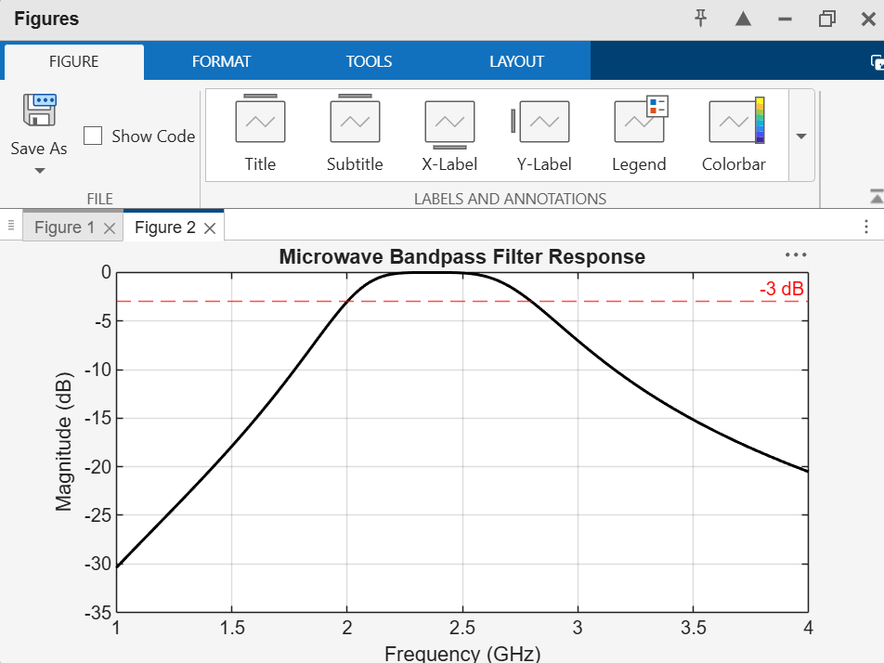
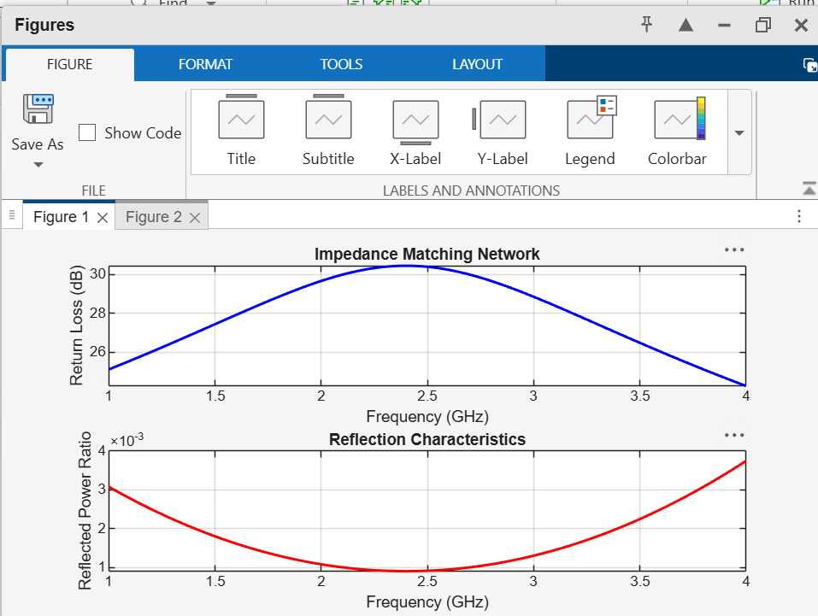
Plots:

