CHAPTER 1

INTRODUCTION

The rapid advancement of technology in recent decades has opened new possibilities for transforming traditional agricultural practices into intelligent, automated systems. Agriculture remains the backbone of human civilization, yet it continues to face significant challenges such as unpredictable weather patterns, water scarcity, labour shortages, and inefficient resource management. In this context, the Internet of Things (IoT) has emerged as a powerful enabler that bridges the gap between the physical environment and digital intelligence.

The Smart Environment Monitoring and Automatic Irrigation System is an IoT-based solution developed to monitor temperature, humidity, and soil moisture in real time, while also automating the watering process based on actual soil conditions. The system uses an ESP32 microcontroller, a DHT11 sensor, a soil moisture sensor, a relay-driven water pump, an LCD display, and the Blynk IoT platform to provide continuous environmental tracking and remote monitoring through a mobile dashboard. By collecting live data from the field and making automated decisions, the system eliminates the need for constant manual supervision. This project aims to reduce manual intervention, conserve water, and improve overall agricultural efficiency through a low-cost and scalable embedded solution.

1.1 IMPORTANCE OF THE PROJECT

Modern agriculture demands precision monitoring of climatic factors and soil conditions to ensure optimal crop health and resource efficiency. Manual irrigation results in water wastage, inconsistent watering patterns, and significant crop stress, all of which directly impact agricultural yield and profitability. Farmers often lack access to real-time data, making it difficult to respond effectively to rapidly changing environmental conditions.

Automated IoT-based irrigation systems address these challenges by continuously sensing soil and environmental conditions and triggering irrigation only when truly necessary. Such systems ensure water conservation by eliminating unnecessary pump operation, promote healthier plant growth by delivering the right amount of water at the right time, reduce human effort by removing the need for manual monitoring and intervention, and enable 24/7 remote monitoring through a smartphone or web dashboard from any location.

Beyond individual farms, the widespread adoption of smart irrigation technology contributes to broader goals of sustainable agriculture and environmental conservation. Reducing water consumption in agriculture directly alleviates pressure on freshwater reserves, which is critical in water-stressed regions. This project integrates sensing, automation, and cloud communication to form an efficient, scalable, and low-cost smart agriculture solution that is accessible even to resource-limited farmers and can be deployed across a wide range of agricultural settings.

- BACKGROUND OF THE STUDY
- Agriculture has undergone significant transformation with the integration of modern technologies, particularly the Internet of Things (IoT).
- Traditional irrigation methods rely heavily on manual intervention, resulting in inefficient water usage, inconsistent irrigation, and poor crop health.
- Farmers typically irrigate fields based on assumptions rather than real-time data, leading to either overwatering or underwatering.
- With the rapid growth of IoT in agriculture, smart farming solutions have emerged that enable continuous monitoring of environmental conditions and automated decision-making.
- These systems use sensors, microcontrollers, and cloud platforms to improve precision, efficiency, and productivity.
- This project is developed in response to the need for a smarter, data-driven irrigation system that minimizes human effort while maximizing agricultural output

- PROBLEM STATEMENT
- Traditional irrigation systems face several critical challenges that reduce agricultural efficiency and resource utilization.
- Lack of real-time monitoring of soil and environmental conditions leads to improper irrigation practices such as overwatering and underwatering.
- Improper irrigation not only wastes water but also negatively affects plant growth and soil health.
- These systems depend heavily on human labour, making them time-consuming and prone to errors.
- The absence of automation and intelligent control limits the ability to respond to changing environmental conditions.
- There is a clear need for an automated system that can monitor parameters in real time and make accurate irrigation decisions without constant human intervention.
- OBJECTIVES OF THE PROJECT
- Design and develop an intelligent irrigation system that can monitor environmental conditions and automate the watering process efficiently.
- Continuously measure soil moisture, temperature, and humidity in real time using sensors.
- Automatically control the irrigation process based on soil moisture levels to ensure optimal water supply for plants.
- Reduce water wastage by providing precise irrigation only when required.
- Enable remote monitoring and control through the Blynk IoT platform, allowing users to access real-time data via a mobile application.
- Design the system to be low-cost, scalable, and easy to implement, making it suitable for practical agricultural use.

- SCOPE OF THE PROJECT
- The project is primarily focused on small-scale agricultural applications such as home gardens, greenhouses, and small farms.
- The system is designed to operate within areas that have stable WiFi connectivity, as it relies on cloud communication through the Blynk platform.
- The current implementation uses basic sensors to monitor soil moisture, temperature, and humidity.
- The system can be extended in the future for larger-scale agricultural operations with additional enhancements.
- The system is limited to real-time monitoring and threshold-based automation and does not include advanced features such as predictive analytics or artificial intelligence.
- Despite these limitations, it provides a strong foundation for developing more advanced smart irrigation systems.

- SIGNIFICANCE OF THE PROJECT
- The project addresses key challenges related to water management and crop health in modern agriculture.
- Automating the irrigation process ensures efficient use of water resources, thereby reducing wastage.
- Maintains optimal soil conditions, leading to improved plant growth and higher crop yield.
- Reduction in manual intervention saves time and labour, making farming more efficient and less dependent on constant supervision.
- Use of IoT technology promotes sustainable agricultural practices by enabling data-driven decision-making and resource optimization.

- LIMITATIONS OF THE PROJECT
- The project addresses key challenges related to water management and crop health in modern agriculture.
- Automating the irrigation process ensures efficient use of water resources, thereby reducing wastage.
- Maintains optimal soil conditions, leading to improved plant growth and higher crop yield.
- Reduction in manual intervention saves time and labour, making farming more efficient and less dependent on constant supervision.
- Use of IoT technology promotes sustainable agricultural practices by enabling data-driven decision-making and resource optimization.
- Overall, the system contributes to the development of smart and sustainable farming solutions.

1.2 GENERAL ORGANIZATION OF THE REPORT
This report is structured into eleven chapters, each addressing a distinct phase of the project from conceptualization to conclusion.
- Chapter 1 – Introduction: Provides overview, importance, and structure of the project.
- Chapter 2 – System Analysis: Describes the problem, existing solutions, and proposed system improvements.
- Chapter 3 – System Design: Covers architectural design, database structure (if applicable), and GUI/Blynk dashboard layout.
(Further chapters like implementation, testing, conclusion can be added later.)
- Chapter 4 – Project Description: Provides a detailed explanation of the overall system, including its working principle, components used, and how different modules such as sensors, ESP32, relay, and Blynk IoT interact to perform automatic irrigation and monitoring.
- Chapter 5 – System Development: Describes the step-by-step development of the system, including hardware assembly, sensor interfacing, programming using Arduino IDE, and integration with the Blynk IoT platform for real-time communication.
- Chapter 6 – System Testing and Validation: Explains the testing process used to verify system functionality, including checking sensor accuracy, pump operation, WiFi connectivity, and ensuring the system performs correctly under different soil and environmental conditions.
- Chapter 7 – User Manual: Provides instructions for setting up, operating, and maintaining the system, along with troubleshooting guidelines.
- Chapter 8 – System Deployment: Describes the process of deploying the system in a real-time environment, including hardware installation and network setup.
- Chapter 9 – Conclusion: Summarizes the outcomes of the project, highlighting its effectiveness, advantages, and practical applications.
- Chapter 10 – Future Enhancement: Discusses possible improvements and extensions to enhance system functionality and scalability.
- Chapter 11 – Bibliography: Lists all the references and resources used during the development of the project.

CHAPTER 2

SYSTEM ANALYSIS

2.1 PROBLEM DEFINITION

Traditional irrigation systems require manual monitoring of environmental conditions and soil moisture levels. This leads to major issues:

Over-watering or under-watering crops. Wastage of water resources. No real-time information about field conditions. No alerts during abnormal temperature/humidity variations. High labor involvement.

There is a need for a smart, automated system that can continuously monitor environmental factors and operate water pumps automatically when soil becomes dry.

2.2 EXISTING SYSTEM

Current irrigation practices mostly include:

Manual checking of soil moisture. Timed irrigation systems that run pumps at fixed intervals. Basic sensor systems without automation. No cloud connectivity or remote monitoring. No alert mechanism for abnormal environmental conditions.
Disadvantages:
- Manual checking of soil moisture with no automation
- Timed irrigation systems run pumps at fixed intervals regardless of actual soil needs
- Basic sensor systems with no intelligent decision-making
- No cloud connectivity or remote monitoring capability
- No alert mechanism for abnormal environmental conditions

2.3 PROPOSED SYSTEM

The proposed system integrates sensors, microcontroller, IoT cloud, and automation:

ESP32 collects data from Soil Moisture Sensor and DHT22. Real-time values displayed on LCD and sent to Blynk IoT Cloud. Automatic watering using relay-controlled pump when soil is dry. Blynk mobile app displays: Temperature, Humidity, Soil moisture, and Pump status.

Advantages:
- ESP32 automatically collects real-time data from Soil Moisture and DHT22 sensors
- Real-time values displayed on LCD and sent to Blynk IoT Cloud for remote access
- Automatic watering via relay-controlled pump triggered only when soil is dry
- Blynk mobile app provides live monitoring of temperature, humidity, soil moisture, and pump status
- Eliminates manual effort and reduces water wastage through intelligent, condition-based irrigation

2.4 SYSTEM REQUIREMENT

2.4.1 HARDWARE REQUIREMENT
- ESP32 Development Board
- DHT22 Temperature & Humidity Sensor
- Soil Moisture Sensor (Analog)
- 16×2 LCD (I2C)
- Relay Module (1-channel)
- Water Pump (5V/12V)
- External Power Supply for pump
- Jumper Wires
- Breadboard

2.4.2 SOFTWARE REQUIREMENT
- Arduino IDE
- Blynk IoT Platform (Mobile App + Cloud Dashboard)
- ESP32 Board Support Package
- Libraries:
  - SimpleDHT
  - BlynkSimpleEsp32
  - LiquidCrystal_I2C
  - Wire
- Circuit Designer / Fritzing (for schematics)
- Serial Monitor (debugging)

CHAPTER 3

SYSTEM DESIGN

3.1 CIRCUIT DIAGRAM

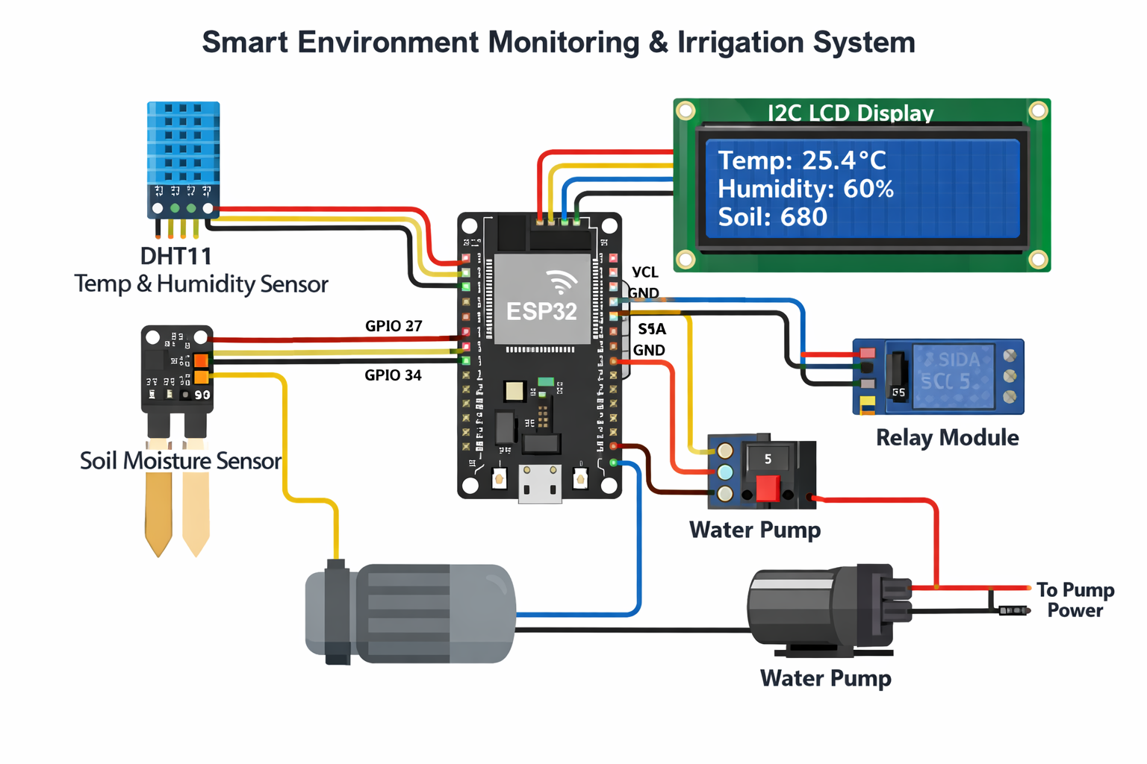

3.2 SEQUENCE DIAGRAM

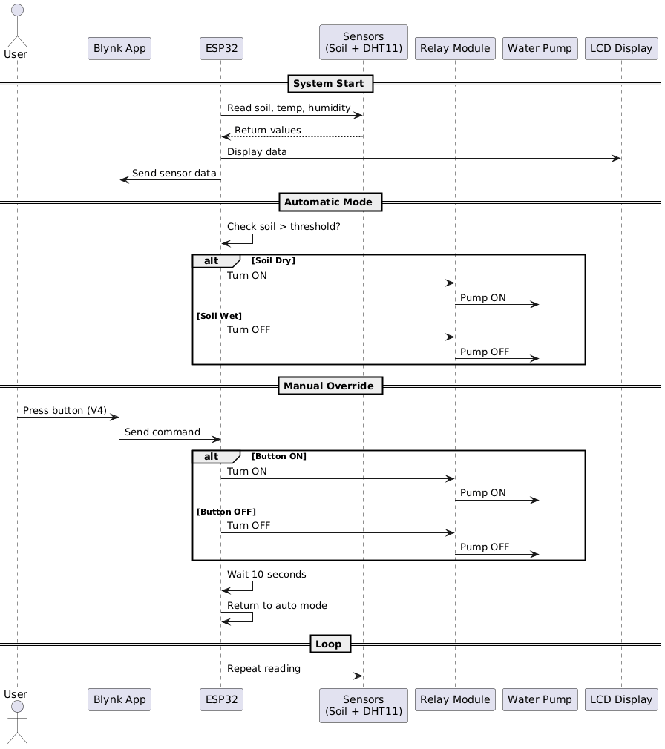

CHAPTER 4

PROJECT DESCRIPTION

The Smart Environment Monitoring and Automatic Irrigation System Using ESP32 and IoT is an intelligent, IoT-enabled solution developed to address the growing need for automated and efficient agricultural irrigation. The system continuously monitors critical environmental parameters including temperature, humidity, and soil moisture using a combination of sensors interfaced with the ESP32 microcontroller. Based on the real-time data collected, the system makes automated decisions to activate or deactivate a water pump through a relay module, ensuring that irrigation occurs only when the soil moisture falls below the defined threshold. This data-driven approach eliminates guesswork and prevents both over-irrigation and under-irrigation, which are common problems in traditional farming practices.

The ESP32 microcontroller serves as the central processing unit of the entire system. It interfaces with the DHT11 sensor to acquire temperature and humidity readings and with the analog soil moisture sensor to evaluate soil conditions. The processed data is simultaneously transmitted to the Blynk IoT cloud platform over Wi-Fi, enabling users to remotely monitor all environmental parameters through a mobile or web-based dashboard. In addition to automatic operation, the system also supports a manual override feature, allowing the user to directly control the water pump via the Blynk application when required. After a predefined time, the system automatically reverts to autonomous operation, ensuring uninterrupted functionality.

The system is designed to be low-cost, energy-efficient, and easily deployable in-home gardens, small farms, and smart agriculture environments. By combining embedded systems technology with IoT communication, this project delivers a scalable and practical solution that conserves water, reduces manual labor, and supports sustainable agricultural practices.

MODULES

1. Sensor Module

The Sensor Module forms the data acquisition layer of the system and is responsible for continuously measuring environmental conditions. The DHT11 sensor measures the ambient temperature and relative humidity of the surrounding environment. It provides reliable digital output that the ESP32 processes to determine whether atmospheric conditions fall within acceptable ranges. The Soil Moisture Sensor is an analog sensor inserted directly into the soil. It measures the volumetric water content of the soil and outputs an analog voltage value proportional to the moisture level. When the soil moisture falls below a predefined threshold value, it signals the system to activate irrigation. Together, these two sensors provide the essential inputs required for intelligent and condition-based irrigation control.

2. Processing Module (ESP32)

The ESP32 microcontroller is the central processing unit and intelligence hub of the entire system. It reads input data from the DHT11 and soil moisture sensors, executes the decision logic, controls output devices such as the relay and LCD, and manages wireless communication with the Blynk IoT cloud. The ESP32 is chosen for this project due to its built-in Wi-Fi and Bluetooth capabilities, dual-core processing power, multiple GPIO pins, and analog-to-digital conversion (ADC) support. It continuously evaluates sensor data and determines whether the pump should be activated or deactivated based on the configured soil moisture threshold. The ESP32 also handles the manual override logic, ensuring a smooth transition between automatic and manual operating modes without interrupting system stability.

3. Actuation Module

The Actuation Module is responsible for physically executing the irrigation command issued by the ESP32. The Relay Module acts as an electrically controlled switch that safely connects and disconnects the water pump from its power supply. Since the water pump operates at a higher voltage and current than the ESP32 can directly handle, the relay provides the necessary electrical isolation to protect the microcontroller. The Water Pump draws water from a reservoir and delivers it to the plants when the relay is activated. The pump is turned on only when the soil is dry, preventing unnecessary water consumption and ensuring plants receive water precisely when needed.

4. Display Module

The Display Module provides local, real-time visual feedback of the system's operational status. A 16×2 I2C LCD Display is used to show the current readings of temperature, humidity, soil moisture value, and the pump status directly at the hardware level. This allows users or technicians to monitor the system without requiring a smartphone or internet connection. The I2C interface reduces the number of GPIO pins required to operate the display, making the circuit design more compact and efficient. The display refreshes periodically as new sensor data is acquired, ensuring the information shown is always current and accurate.

5. Alert Module

The Alert Module enhances the system's reliability by notifying users of abnormal or critical conditions. A Buzzer is integrated into the hardware to provide an audible alarm when environmental readings such as temperature or humidity exceed safe operating limits. In addition, the Blynk IoT platform supports push notifications that are sent directly to the user's mobile device, even when they are not actively monitoring the dashboard. This dual-alert mechanism ensures that the user is promptly informed of any conditions that may require immediate attention, thereby enable swift corrective action and reduce the risk of crop damage.

6. IoT Communication Module

The IoT Communication Module establishes the wireless link between the embedded system and the internet, enabling remote access and control. The Blynk IoT Platform provides a cloud-based infrastructure that receives sensor data from the ESP32 over Wi-Fi and presents it through a customizable mobile and web dashboard. Users can view live readings of temperature, humidity, and soil moisture at anytime from anywhere. The platform also supports virtual pin-based control, allowing the user to manually toggle the pump through the app interface. The Blynk platform's reliability, ease of integration, and real-time data visualization capabilities make it an ideal choice for this IoT-based agriculture project.

7. Power Supply Module

The Power Supply Module provides stable and regulated electrical power to all components of the system. The ESP32 microcontroller and the sensors are powered through a 3.3V or 5V regulated supply, typically sourced from a USB power adapter or a battery pack. Since the water pump requires a higher current draw than the ESP32 can safely supply, it is powered through a separate external power source. This separation of power sources protects the microcontroller from electrical damage caused by inductive loads and ensures stable, uninterrupted operation of both the control circuitry and the pump. Proper grounding across all components is maintained to prevent signal noise and ensure consistent sensor readings.

CHAPTER 5

SYSTEM DEVELOPMENT

5.1 LANGUAGE / TOOL

PROGRAMMING LANGUAGE
- Embedded C / C++ (Arduino Framework)

DEVELOPMENT TOOLS
- Arduino IDE – Used for writing, compiling, and uploading the ESP32 program
- Blynk IoT Platform – Used for cloud connectivity, dashboard visualization, and notifications

LIBRARIES USED
- SimpleDHT – To read temperature and humidity data from the DHT22 sensor
- BlynkSimpleEsp32 – To connect ESP32 with Blynk IoT cloud
- LiquidCrystal_I2C – To control the 16×2 LCD display using I2C protocol
- Wire – To enable I2C communication.

5.2 PSEUDO CODE

START

INITIALIZE system
SET soil_moisture_threshold = predefined value
SET temperature_threshold (optional)
SET humidity_threshold (optional)

CONNECT to WiFi
IF WiFi not connected THEN
RETRY until connected
END IF

INITIALIZE Blynk platform
INITIALIZE sensors (Soil Moisture, DHT11)
INITIALIZE relay module (Pump OFF)

LOOP FOREVER

READ soil_moisture_value from soil sensor
READ temperature_value from DHT sensor
READ humidity_value from DHT sensor

SEND soil_moisture_value to Blynk
SEND temperature_value to Blynk
SEND humidity_value to Blynk

DISPLAY values on Serial Monitor (optional)

IF soil_moisture_value < soil_moisture_threshold THEN
TURN pump ON using relay
SEND status "Pump ON" to Blynk
ELSE
TURN pump OFF using relay
SEND status "Pump OFF" to Blynk
END IF

CHECK for manual control input from Blynk
IF users manually turn pump ON THEN
TURN pump ON
ELSE IF user manually turns pump OFF THEN
TURN pump OFF
END IF

WAIT for few seconds (delay)

END LOOP

END

CHAPTER 6

SYSTEM TESTING AND VALIDATION

System testing and validation ensure that the developed system works correctly, reliably, and meets the specified requirements. In this project, testing was carried out at different levels to verify individual components as well as the complete integrated system.

6.1 Unit Testing
Each hardware and software module was tested individually to verify correct operation.
Module | Test Performed | Result
DHT22 Sensor | Temperature & humidity reading | Pass
Soil Moisture Sensor | Dry and wet soil detection | Pass
Relay Module | Pump ON/OFF switching | Pass
Water Pump | Water flow operation | Pass
LCD Display | Data visualization | Pass
Blynk IoT | Cloud data update | Pass

6.2 Integration Testing
After unit testing, all modules were integrated and tested together.
Sensors successfully communicated with ESP32. Pump responded correctly to soil moisture levels. LCD displayed real-time sensor values. Blynk dashboard updated values instantly. Alerts triggered during abnormal conditions.
Result:
The integrated system worked reliably without conflicts between modules.

6.3 Acceptance Testing
Acceptance testing was conducted from the user’s perspective.
Pump activates automatically when soil becomes dry. Pump turns OFF when soil moisture is sufficient. Water level prevents dry run of pumps. Users can monitor values using mobile apps. Alerts are received during abnormal conditions.
Conclusion:
The system meets all functional and operational requirements.

6.4 Validations
The system was validated to ensure correctness and reliability.
Sensor readings were verified using real environmental conditions. Pump operation validated using different soil moisture levels. Alert notifications validated using extreme values. LCD and Blynk readings were cross verified.
The validation process confirmed that the system performs as intended under real world conditions.

CHAPTER 7

USER MANUAL

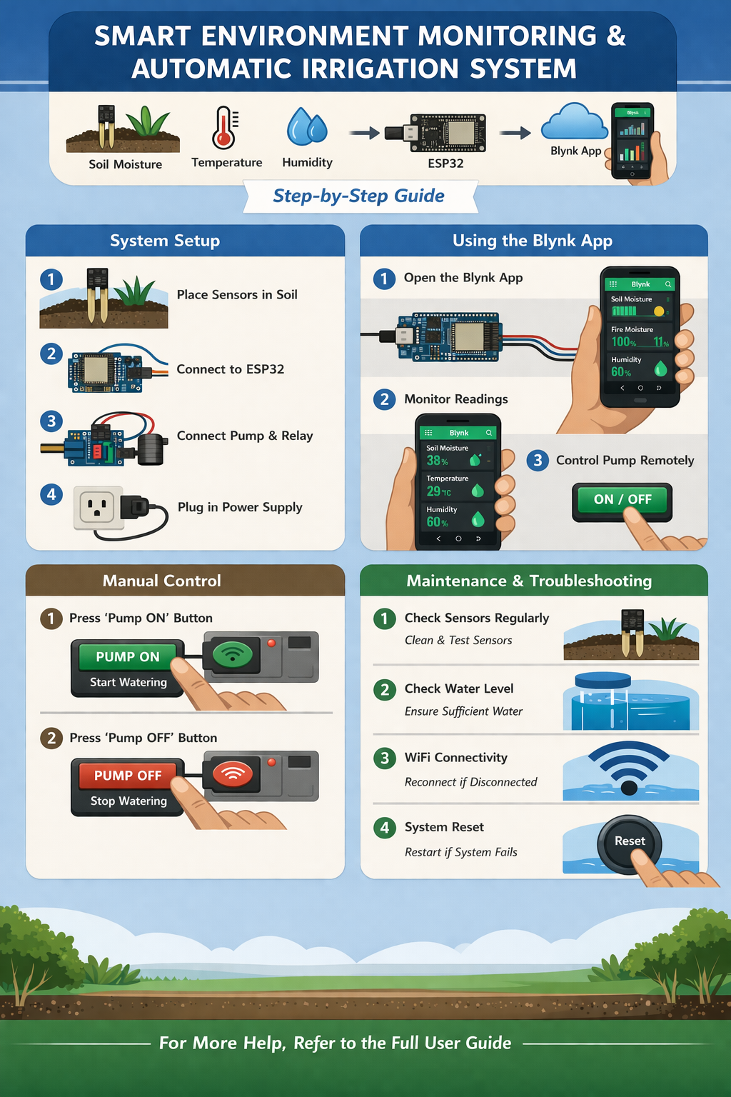

The User Manual in the Smart Environment Monitoring and Irrigation System allows users to interact with the system through the Blynk IoT application. It provides real-time monitoring and limited control over the irrigation process.

Through the Blynk dashboard, the user can view important parameters such as:
- Temperature (V0)
- Humidity (V1)
- Soil moisture (V2)

The user can also manually control the water pump using a button connected to Virtual Pin V4, enabling manual override mode. In this mode, the user can turn the pump ON or OFF regardless of automatic conditions. After a fixed duration, the system returns to automatic operation.

This module improves usability by providing remote access, real-time monitoring, and manual control, making the system more flexible and user-friendly.

The Smart Environment Monitoring and Automatic Irrigation System is an IoT-based solution using an ESP32 microcontroller to monitor environmental conditions and automate irrigation.

The system operates in both automatic mode and manual override mode.

7.1 STEPS TO RUN THE SYSTEM
- Connect all components as per circuit diagram
- Connect ESP32 to PC using USB
- Open Arduino IDE
- Select:
  - Board → ESP32 Dev Module
  - Correct COM port
- Upload the code
- Open Serial Monitor (115200 baud)
- Power ON the system
- Ensure ESP32 connects to WiFi
- Open Blynk app and confirm device is online

7.2 BLYNK DASHBOARD CONFIGURATION
Parameter | Virtual Pin | Function
Temperature | V0 | Displays temperature
Humidity | V1 | Displays humidity
Soil Moisture | V2 | Displays soil value
Pump Control | V4 | Button (Manual ON/OFF)

7.3 SYSTEM OPERATION

Automatic Mode
- Soil value is continuously monitored
- If: Soil Value > 700 → Pump ON
- Else → Pump OFF

Manual Override Mode
- User presses button (V4) in Blynk
- Pump turns ON/OFF manually
- System enters manual mode
- After 10 seconds, system automatically returns to auto mode:

Display Output

LCD shows:
- Temperature & Humidity
- Soil value
- Serial Monitor shows
- Sensor readings
- System status

7.4 PRECAUTIONS AND MAINTENANCE
- Use separate power for pump
- Keep ESP32 away from water
- Ensure common ground
- Clean soil sensor regularly
- Avoid loose wiring

7.5 TROUBLESHOOTING
Problem | Cause | Solution
No Blynk data | Wrong token/WiFi | Check credentials
Pump not working | Relay wiring | Check connections
Wrong soil values | Sensor issue | Recalibrate
LCD blank | I2C issue | Check address
ESP32 not detected | Driver issue | Install CP210x

CHAPTER 8

SYSTEM DEPLOYMENT

System deployment refers to the process of implementing the Smart Environment Monitoring and Automatic Irrigation System in a real-time environment. It involves setting up the hardware components, uploading the software, and ensuring proper network connectivity. In this project, the ESP32 is connected with sensors and a relay module, and the system is powered using a suitable power supply.The program is uploaded using Arduino IDE, and the ESP32 is connected to WiFi for communication with the Blynk IoT platform.Once deployed, the system continuously monitors soil moisture, temperature, and humidity, and automatically controls the water pump. The user can also monitor and control the system remotely using the Blynk application.

System deployment involves installing the system in real environment and ensuring proper operation.

8.1. Hardware Deployment

During hardware deployment, the ESP32 should be placed inside a protective enclosure to prevent damage. The soil moisture sensor must be inserted near the plant roots to accurately measure soil conditions, while the DHT sensor should be positioned in open air for correct temperature and humidity readings. The water pump is connected through a relay module to enable controlled operation, and proper common grounding must be ensured across all components for stable performance.

8.2. Software Deployment

In software deployment, the program is uploaded to the ESP32 using the Arduino IDE. After uploading, the serial output is verified to ensure that the system is functioning correctly. The connectivity with the Blynk platform is then checked, and sensor readings are confirmed to ensure accurate data transmission and system operation.

8.3. Network Deployment

Network deployment requires a stable WiFi connection to ensure uninterrupted communication between the ESP32 and the Blynk IoT platform. The ESP32 should be kept within the effective WiFi range to maintain connectivity, and the device status must be monitored regularly to ensure continuous operation.

8.4. Field Considerations

While deploying the system in real-world conditions, care should be taken to avoid placing sensors near direct water flow, as it may affect accuracy. For larger areas, multiple sensors can be used to improve coverage and precision. Additionally, all wires should be properly secured and protected to prevent damage and ensure long-term reliability.

CHAPTER 9

CONCLUSION

The Smart Environment Monitoring and Automatic Irrigation System demonstrates an effective application of IoT and embedded systems in modern agriculture. By continuously monitoring soil moisture, temperature, and humidity using sensors, the system ensures that irrigation is performed only when necessary. This data-driven approach eliminates guesswork and improves the overall efficiency of water usage.

The integration of the ESP32 microcontroller with the Blynk IoT platform enables real-time monitoring and remote accessibility. Users can view environmental conditions and control the irrigation system from anywhere using a mobile device. The inclusion of a manual override feature further enhances system flexibility, allowing users to temporarily control the pump based on specific requirements, after which the system automatically returns to its normal operation.

The system significantly reduces water wastage by preventing over-irrigation and ensures that plants receive adequate water based on actual soil conditions. It also minimizes human effort, making it suitable for continuous operation without manual supervision. The use of low-cost components makes the system economically feasible for small-scale agricultural and domestic applications.

Although the current system is designed for small areas, it can be expanded for larger agricultural fields by incorporating multiple sensors and zone-based irrigation techniques. Overall, the project proves to be a reliable, cost-effective, and scalable solution for smart irrigation, contributing to sustainable agricultural practices.

CHAPTER 10

FUTURE ENHANCEMENT

One important future enhancement of this system is the development of a plant-based database system. In this approach, a database containing different plant types and their water requirements can be created. Based on the selected plant, the system can automatically adjust irrigation levels and watering frequency. This allows the system to move beyond simple threshold-based irrigation and provide customized watering for different crops, improving accuracy and crop health.

In addition to this, the system can be further improved by implementing multi-zone irrigation, where different areas of land are controlled independently using multiple sensors and valves. The use of capacitive soil moisture sensors can improve durability and accuracy compared to resistive sensors. Integration of solar power can make the system energy-efficient and suitable for remote areas. Adding a water level monitoring system will prevent pump operation when the tank is empty, protecting the hardware. The system can also be enhanced by integrating weather data, allowing it to avoid irrigation during rainfall conditions. Furthermore, advanced features like data logging and analytics can be added to study irrigation patterns and optimize water usage over time.

BIBLIOGRAPHY

The following references were used in the development and understanding of the IoT-based Smart Environment Monitoring and Automatic Irrigation System:
- Arduino Official Documentation, ESP32 Programming Guide, available at:
https://docs.arduino.cc
- Espressif Systems, ESP32 Technical Reference Manual, available at:
https://www.espressif.com
- Blynk IoT Platform Documentation, Blynk Cloud and Mobile App Guide, available at: https://docs.blynk.io
- WiFi Library Documentation for ESP32, available at:
https://www.arduino.cc/en/Reference/WiFi
- DHT11 Sensor Datasheet, Temperature and Humidity Sensor Specifications
- Soil Moisture Sensor Documentation, Working and Calibration Guide
- LiquidCrystal_I2C Library Documentation, LCD Interface Guide
- Relay Module Documentation, Working and Interfacing Guide

APPENDIX A

#define BLYNK_TEMPLATE_ID "TMPL3rQG1lkdB"

#define BLYNK_TEMPLATE_NAME "Smart Plant"

#define BLYNK_AUTH_TOKEN "vZykZe-qH-g268WU8oe_a6kmDa8eT8ot"

#include <WiFi.h>

#include <BlynkSimpleEsp32.h>

#include <Wire.h>

#include <LiquidCrystal_I2C.h>

#include <DHT.h>

// WiFi

char ssid[] = "Rufus";

char pass[] = "rufu@102s";

// Pins

#define SOIL_PIN 34

#define DHTPIN 27

#define RELAY_PIN 25

#define DHTTYPE DHT11

// Components

LiquidCrystal_I2C lcd(0x27, 16, 2);

DHT dht(DHTPIN, DHTTYPE);

BlynkTimer timer;

// Threshold

int soilThreshold = 2000;

// Manual override variables

bool manualOverride = false;

unsigned long manualTimer = 0;

// ===== BLYNK BUTTON (V4) =====

BLYNK_WRITE(V4) {

int value = param.asInt();

manualOverride = true;

manualTimer = millis();

if (value == 1) {

digitalWrite(RELAY_PIN, LOW); // Pump ON

} else {

digitalWrite(RELAY_PIN, HIGH); // Pump OFF

}

}

// ===== MAIN FUNCTION =====

void sendData() {

int soilValue = analogRead(SOIL_PIN);

float humidity = dht.readHumidity();

float temperature = dht.readTemperature();

if (isnan(humidity) || isnan(temperature)) {

Serial.println("DHT ERROR");

return;

}

// ===== SERIAL =====

Serial.println("----- Sensor Data -----");

Serial.print("Soil: "); Serial.println(soilValue);

Serial.print("Temp: "); Serial.println(temperature);

Serial.print("Humidity: "); Serial.println(humidity);

// ===== LCD =====

lcd.setCursor(0, 0);

lcd.print("T:");

lcd.print(temperature);

lcd.print(" H:");

lcd.print(humidity);

lcd.print(" ");

lcd.setCursor(0, 1);

lcd.print("Soil:");

lcd.print(soilValue);

lcd.print(" ");

// ===== BLYNK SEND =====

Blynk.virtualWrite(V0, temperature);

Blynk.virtualWrite(V1, humidity);

Blynk.virtualWrite(V2, soilValue);

// ===== AUTO CONTROL =====

if (!manualOverride) {

if (soilValue > soilThreshold) {

digitalWrite(RELAY_PIN, LOW); // ON

Blynk.virtualWrite(V4, 1);

} else {

digitalWrite(RELAY_PIN, HIGH); // OFF

Blynk.virtualWrite(V4, 0);

}

}

// ===== RESET MANUAL AFTER 10s =====

if (manualOverride && millis() - manualTimer > 10000) {

manualOverride = false;

}

Serial.println("------------------------");

}

// ===== SETUP =====

void setup() {

Serial.begin(115200);

pinMode(RELAY_PIN, OUTPUT);

digitalWrite(RELAY_PIN, HIGH);

dht.begin();

lcd.init();

lcd.backlight();

lcd.setCursor(0, 0);

lcd.print("Smart Plant");

lcd.setCursor(0, 1);

lcd.print("Connecting...");

delay(2000);

lcd.clear();

Blynk.begin(BLYNK_AUTH_TOKEN, ssid, pass);

timer.setInterval(3000L, sendData);

}

// ===== LOOP =====

void loop() {

Blynk.run();

timer.run();

}

APPENDIX B

SERIAL MONITOR

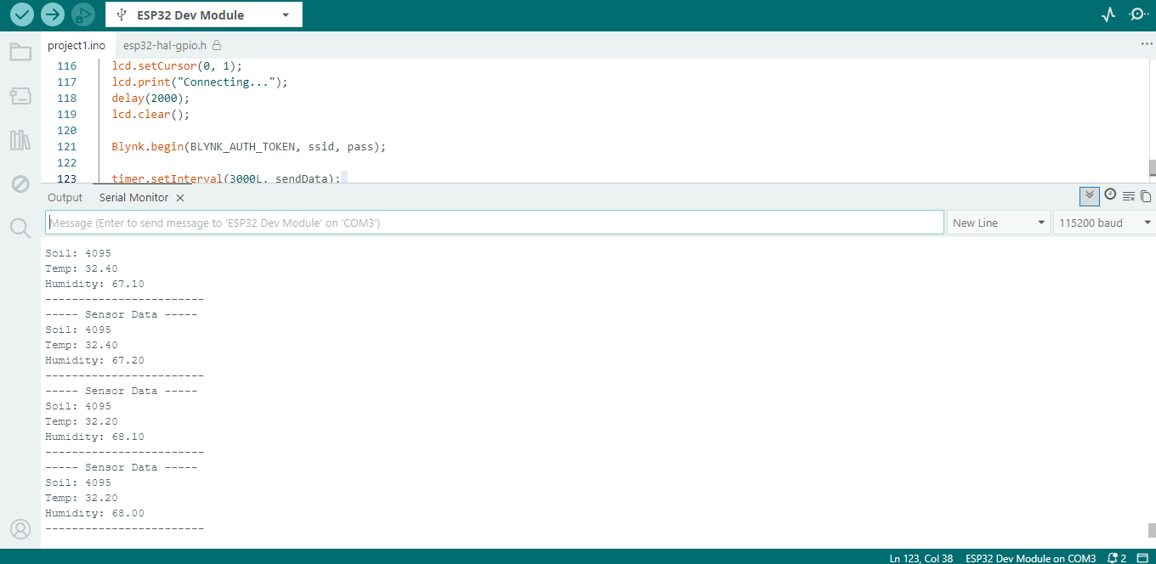

BLYNK DASHBOARD

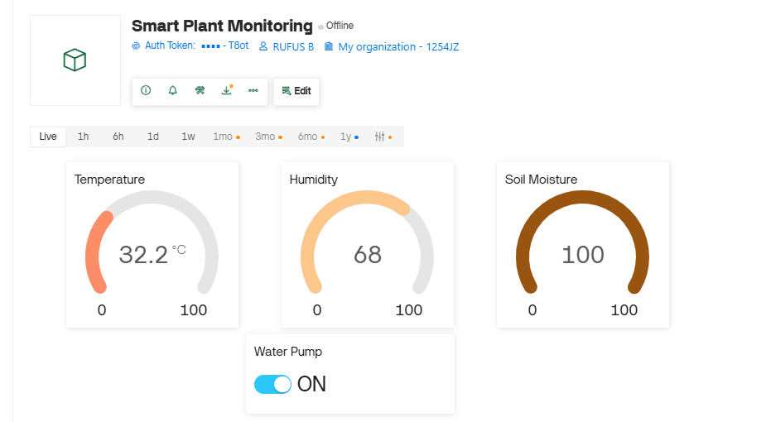

BLOCK DIAGRAM

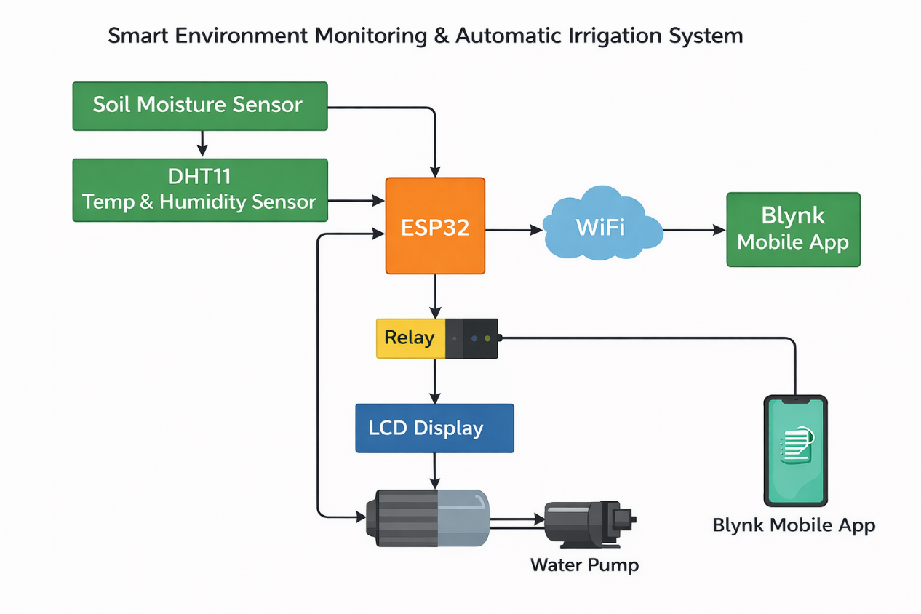

BLYNK IOT ( ANDROID )

