**Question 1:**

import numpy as py

arr_elements = []

for i in range(3):

row_elements = []

for j in range(4):

row_elements.append(np.random.randint(1, 101))

arr_elements.append(row_elements)

data = np.array(arr_elements)

required_row = data[1]

print(f”required_row: {required_row}”)

required_col = []

for i in range(3):

required_col.append(data[i][-1])

print(f”required_col: {required_col}”)

**Output:**



**Question 2:**

import pandas as pd

input_data = {

"Name": ["Emp A.", "Emp B.", "Emp C.", "Emp D.", "Emp E."],

"Age": [25, 28, 27, 29, 31],

"City": ["Down Street", "Up Street", "Wall Street", "New Road", "Green Circle"],

"Salary": [1000, 1000, 2500, 1500, 2000]

}

df = pd.DataFrame(input_data)

df["Bonus"] = df["Salary"] * 0.1

print(df)

sorted_df = df.sort_values(by="Salary", ascending=False)

print(sorted_df)

**Output:**

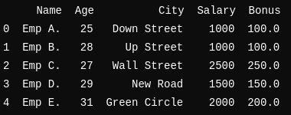

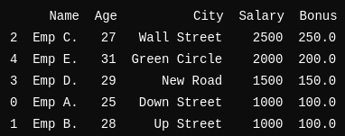

**Question 3:**

import matplotlib.pyplot as plt

x_values = []

y_values = []

for i in range(-10, 11):

x_values.append(i)

y_values.append(2*i**2 + 3*i + 5)

plt.plot(x_values, y_values, marker='o', label='y = 2x^2 + 3x + 5')

plt.xlabel("X Axis")

plt.ylabel("Y Axis")

plt.title("y = 2x^2 + 3x + 5")

plt.show()

**Output:**

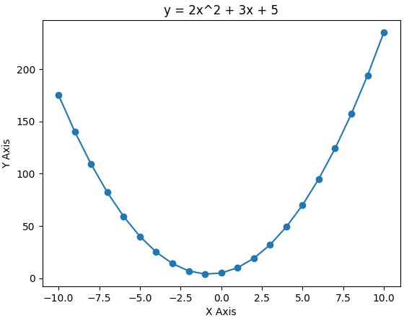

**Question 4:**

import matplotlib.pyplot as plt

x_values = list(range(1, 11))

y_values = [2 * x + 3 for x in x_values]

scatter_y_values = [5, 7, 8, 5, 6, 9, 10, 8, 7, 5]

hist_values = [1, 2, 2, 3, 3, 3, 4, 4, 5, 5, 5, 5, 6, 6, 7]

bar_labels = ["A", "B", "C", "D", "E"]

bar_values = [5, 7, 3, 8, 6]

fig, axs = plt.subplots(2, 2, figsize=(10, 8))

# Line graph

axs[0, 0].plot(x_values, y_values, marker='o', label='y = 2x + 3')

axs[0, 0].set_title("Line Graph")

axs[0, 0].set_xlabel("X Axis")

axs[0, 0].set_ylabel("Y Axis")

axs[0, 0].legend()

axs[0, 0].grid(True)

# Scatter plot

axs[0, 1].scatter(x_values, scatter_y_values, color='r', label='Scatter')

axs[0, 1].set_title("Scatter Plot")

axs[0, 1].set_xlabel("X Axis")

axs[0, 1].set_ylabel("Y Axis")

axs[0, 1].legend()

axs[0, 1].grid(True)

# Histogram

axs[1, 0].hist(hist_values, bins=6, color='g', alpha=0.7, label='Histogram')

axs[1, 0].set_title("Histogram")

axs[1, 0].set_xlabel("Value Ranges")

axs[1, 0].set_ylabel("Frequency")

axs[1, 0].legend()

# Bar chart

axs[1, 1].bar(bar_labels, bar_values, color='b', label='Bars')

axs[1, 1].set_title("Bar Chart")

axs[1, 1].set_xlabel("Categories")

axs[1, 1].set_ylabel("Values")

axs[1, 1].legend()

plt.tight_layout()

plt.show()

**Output:**

