

**SCHOOL OF BUSINESS AND ECONOMICS**

**DEPARTMENT OF BUSINESS TECHNOLOGY**

**SYSTEM ENGINEERING**

**COURSES:**

**SYSTEM ENGINEERING,DATABASE AND JAVA PROGRAMMING**

**Student name: RUGEMANA Christian**

**Reg No: 222004192**

**Submitted to: Dr. BUGINGO Emmanuel**

**Date: 08 MARCH 2024**

# Table of contents

Table of Contents

Table of contents 2

List of Figures 4

List of tables 5

1. Introduction 6

3. Statement of the problem 8

2.1 Description of the existing system 8

2.2 Problems of the current system 8

2.3 How the proposed system will work 9

3.4 Describe other alternatives 10

4. Software requirement 11

3.1 User Requirements 11

3.1.1 Functional requirement 12

3.1.2 Non-function requirement 13

3.2 System requirements 14

3.2.1 Minimum End-user Hardware Requirements 14

3.2.2 Minimum End-user Software Requirements 14

3.3 Software specifications 14

**5.** DATA FLOW DIAGRAM (LEVEL 0, LEVEL 1**)** 16

4.1 DFD LEVEL 0 16

4.2 DFD LEVEL 1 17

5. Feasibility study 17

5.1 Technical Feasibility 17

5.2 Financial Feasibility 18

5.3 Market Feasibility 19

5.4 Economic Feasibility 19

5.5 Legal and Regulatory Feasibility 19

5.6 Operational Feasibility 20

6. Description of the selected Process Model 20

6.1 Cause of your selection 20

7. Conclusion 21

8. References 21

# List of Figures

Figure 1 16

Figure 2 17

# List of tables

# Introduction

A device tracker system is a type of tracking system that uses GPS technology to track the location of devices. These systems can be used to track a variety of devices, including vehicles, assets, and people.

Device tracker systems typically consist of three components:

A GPS tracking device: This is the device that is attached to the object that you want to track. The tracking device typically contains a GPS receiver, a cellular modem, and a battery.

A tracking server: This is the server that stores the location data from the tracking devices. The tracking server also provides a web interface or API that allows you to view the location data.

A mobile app or web application: This is the application that you use to view the location data from the tracking server.

Device tracker systems can be used for a variety of purposes, including:

Fleet management: Device tracker systems can be used to track the location of vehicles in a fleet. This can be used to improve fleet efficiency, reduce fuel costs, and prevent theft.

Asset tracking: Device tracker systems can be used to track the location of assets. This can be used to prevent theft, improve inventory management, and ensure that assets are being used efficiently.

Personal tracking: Device tracker systems can be used to track the location of people. This can be used for child safety, elderly care, and employee monitoring.

Device tracker systems are a powerful tool that can be used to improve efficiency, reduce costs, and improve safety. If you are looking for a way to track the location of devices, then a device tracker system is a good option to consider.

Here are some additional benefits of using a device tracker system:

Real-time tracking: Device tracker systems allow you to track the location of devices in real time. This means that you can see where the devices are at any given moment.

History tracking: Device tracker systems also allow you to track the history of device locations. This means that you can see where the devices have been in the past.

Alerts and notifications: Device tracker systems can be configured to send alerts and notifications when devices enter or leave certain areas. This can be useful for security purposes or to track the movement of assets.

If you are considering using a device tracker system, there are a few factors that you should keep in mind:

The type of devices that you want to track: Not all device tracker systems are created equal. Some systems are designed to track vehicles, while others are designed to track assets or people.

The features that you need: Some device tracker systems offer more features than others. For example, some systems allow you to set up alerts and notifications, while others do not.

The price: Device tracker systems can range in price from a few hundred dollars to several thousand dollars.

Once you have considered these factors, you can start to look for a device tracker system that meets your needs. There are many different device tracker systems on the market, so you should be able to find one that fits your budget and requirements.

# Statement of the problem

## 2.1 Description of the existing system

The statement of the problem for a device tracker system is that there is a need to track the location of devices. This need can arise in a variety of situations, such as:

Fleet management: Companies that operate fleets of vehicles need to track the location of their vehicles in order to improve fleet efficiency, reduce fuel costs, and prevent theft.

Asset tracking: Companies that need to track the location of their assets, such as equipment, inventory, or valuables, need a device tracker system to do so.

Personal tracking: Individuals who need to track the location of their loved ones, such as children, elderly people, or employees, can use a device tracker system to do so.

The description of the device tracker system is that it is a system that uses GPS technology to track the location of devices. The system typically consists of three components:

A GPS tracking device: This is the device that is attached to the object that you want to track. The tracking device typically contains a GPS receiver, a cellular modem, and a battery.

A tracking server: This is the server that stores the location data from the tracking devices. The tracking server also provides a web interface or API that allows you to view the location data.

A mobile app or web application: This is the application that you use to view the location data from the tracking server.

The device tracker system works by using the GPS receiver in the tracking device to determine the location of the device. The GPS receiver then sends the location data to the tracking server. The tracking server stores the location data and provides a web interface or API that allows you to view the location data.

The device tracker system can be used to track the location of devices in real time or to track the history of device locations. The system can also be configured to send alerts and notifications when devices enter or leave certain areas.

The device tracker system is a powerful tool that can be used to improve efficiency, reduce costs, and improve safety. If you are looking for a way to track the location of devices, then a device tracker system is a good option to consider.

## 2.2 Problems of the current system

The current generation of device tracker systems has a number of problems, including:

Accuracy: The accuracy of GPS tracking can be affected by a number of factors, such as the number of satellites in view, the quality of the GPS receiver, and the environment. In some cases, the accuracy of GPS tracking can be as low as 10 meters.

Battery life: The battery life of GPS tracking devices can be limited, especially if the devices are used in areas with poor cellular coverage. This can be a problem for devices that are used for long periods of time, such as asset tracking devices.

Cost: The cost of GPS tracking devices can be high, especially for devices that offer advanced features, such as real-time tracking and history tracking. This can be a barrier to entry for businesses and individuals who are looking to use device tracking systems.

Privacy: The use of GPS tracking devices raises privacy concerns, as the data collected by these devices can be used to track the movements of individuals. This is a particular concern for devices that are used to track people, such as child tracking devices.

## 2.3 How the proposed system will work

The new device tracker system will work in a number of ways, including:

Using cellular networks: Cellular networks can provide more accurate location data than GPS, and they also offer longer battery life. This makes cellular networks a good option for device tracking systems that need to be used in areas with poor GPS coverage.

Using Wi-Fi networks: Wi-Fi networks can also be used to track the location of devices. This is a good option for devices that are used in indoor environments.

Using Bluetooth: Bluetooth can be used to track the location of devices that are in close proximity to each other. This is a good option for devices that are used for personal tracking, such as child tracking devices.

Using Low-power wide-area networks (LPWANs): LPWANs are a new type of wireless network that is designed for low-power devices. LPWANs can be used to track the location of devices that have a limited battery life.

The new device tracker system will also address privacy concerns by using encryption to protect the data collected by these devices. This makes it more difficult for unauthorized individuals to access the data.

Here are some specific examples of how the new device tracker system will work:

Fleet management: Companies that operate fleets of vehicles will be able to use the new device tracker system to track the location of their vehicles in real time. This will help them to improve fleet efficiency, reduce fuel costs, and prevent theft.

Asset tracking: Companies that need to track the location of their assets, such as equipment, inventory, or valuables, will be able to use the new device tracker system to do so. This will help them to prevent theft, improve inventory management, and ensure that assets are being used efficiently.

Personal tracking: Individuals who need to track the location of their loved ones, such as children, elderly people, or employees, will be able to use the new device tracker system to do so. This will help them to keep their loved ones safe and to ensure that they are where they are supposed to be.

The new device tracker system is a powerful tool that has the potential to improve efficiency, reduce costs, and improve safety in a variety of settings. As the technology continues to develop, we can expect to see even more innovative applications for device tracking in the years to come.

## Describe other alternatives

Sure. Here are some alternatives to the new device tracker system:

RFID tracking: RFID tracking uses radio waves to track the location of devices. This technology is often used for asset tracking, as it can be used to track the movement of assets in real time.

Beacons: Beacons are small, wireless devices that can be used to track the location of devices. Beacons emit a signal that can be detected by other devices, such as smartphones. This technology is often used for indoor navigation, as it can be used to track the movement of people in buildings.

Geo fencing: Geo fencing is a technology that uses GPS to create virtual boundaries. When a device enters or leaves a geo fence, an alert can be sent to the user. This technology is often used for child safety, as it can be used to track the location of children and to send alerts if they leave a designated area.

Each of these alternatives has its own advantages and disadvantages. RFID tracking is a very accurate technology, but it can be expensive to set up. Beacons are a more affordable option, but they are not as accurate as RFID tracking. Geo fencing is a versatile technology, but it can be difficult to set up and manage.

The best alternative for you will depend on your specific needs and budget. If you need a very accurate tracking system, then RFID tracking may be the best option for you. If you are looking for an affordable option, then beacons may be a better choice. And if you need a versatile tracking system, then geo fencing may be the best option for you.

Here are some additional considerations when choosing a device tracker system:

The type of devices you need to track: Some device tracker systems are designed to track specific types of devices, such as vehicles or assets. Others are more versatile and can be used to track a variety of devices.

The features you need: Some device tracker systems offer more features than others. For example, some systems allow you to set up alerts and notifications, while others do not.

The price: Device tracker systems can range in price from a few hundred dollars to several thousand dollars.

Once you have considered these factors, you can start to look for a device tracker system that meets your needs. There are many different device tracker systems on the market, so you should be able to find one that fits your budget and requirements.

## Software requirement

## 3.1 User Requirements

Here are some examples of how the user requirements can be translated into software requirements:

The system must be able to track the location of devices in real time.

Software requirement: The system must have a GPS tracking module that can track the location of devices in real time.

The system must be able to store the location history of devices.

Software requirement: The system must have a database that can store the location history of devices.

The system must be able to send alerts and notifications when devices enter or leave certain areas.

Software requirement: The system must have an alert and notification system that can send alerts and notifications when devices enter or leave certain areas.

The system must be easy to use and navigate.

Software requirement: The system must have a user-friendly interface that is easy to use and navigate.

The system must be secure and protect the privacy of users.

Software requirement: The system must use encryption to protect the privacy of users.

The software requirements for the device tracker system will depend on the specific implementation of the system. However, the requirements listed above are a good starting point for defining the software requirements of any device tracker system.

### 3.1.1 Functional requirement

sure, here are the functional requirements of the device tracker system in software requirements:

The system must be able to track the location of devices in real time.

The system must have a GPS tracking module that can track the location of devices in real time.

The system must be able to display the location of devices on a map.

The system must be able to provide the current location of devices, as well as their historical location.

The system must be able to store the location history of devices.

The system must have a database that can store the location history of devices.

The system must be able to retrieve the location history of devices.

The system must be able to export the location history of devices to a file.

The system must be able to send alerts and notifications when devices enter or leave certain areas.

The system must have an alert and notification system that can send alerts and notifications when devices enter or leave certain areas.

The system must be able to customize the alerts and notifications that are sent.

The system must be able to track the history of alerts and notifications that have been sent.

The system must be easy to use and navigate.

The system must have a user-friendly interface that is easy to use and navigate.

The system must provide clear and concise instructions on how to use the system.

The system must be accessible to users with disabilities.

The system must be secure and protect the privacy of users.

The system must use encryption to protect the privacy of users.

The system must have a security policy that outlines the security measures that are in place.

The system must be regularly audited to ensure that the security measures are effective.

These are just some of the functional requirements of the device tracker system in software requirements. The specific requirements will depend on the specific application of the system.

### 3.1.2 Non-function requirement

Here are some of the non-functional requirements of the device tracker system in software requirements:

Portability requirement: The system must be portable and must be able to run on a variety of devices and operating systems.

Reliability requirement: The system must be reliable and must be able to track the location of devices even in the event of a system failure.

Usability requirement: The system must be easy to use and navigate.

Space requirement: The system must be able to store a large amount of data, such as the location history of devices.

Organization requirement: The system must be organized and must be able to store the data in a way that is easy to find and access.

Implementation requirement: The system must be implemented in a way that is secure and protects the privacy of users.

External environment requirement: The system must be able to operate in a variety of environments, such as indoors or outdoors.

Privacy requirement: The system must protect the privacy of users and must not collect any personal information that is not necessary for the operation of the system.

Safety requirement: The system must be safe and must not pose any security or safety risks to users.

## 3.2 System requirements

### 3.2.1 Minimum End-user Hardware Requirements

Processor: 1 GHz or higher

Memory: 1 GB RAM

Storage: 1 GB available space

Display: 1024x768 resolution or higher

Internet connection: Broadband internet connection

### 3.2.2 Minimum End-user Software Requirements

Operating system: Windows 10, mac OS 10.13 or later, or Linux

Browser: Google Chrome, Mozilla Firefox, or Safari

These are just some of the minimum end-user hardware and software requirements for the device tracker system. The specific requirements will depend on the specific application of the system.

Here are some additional end-user hardware and software requirements that may be relevant depending on the specific application of the device tracker system:

GPS receiver: If the device tracker system will be used to track the location of devices in real time, the end-user device must have a GPS receiver.

Cellular modem: If the device tracker system will be used to track the location of devices in areas with no Wi-Fi coverage, the end-user device must have a cellular modem.

Camera: If the device tracker system will be used to track the location of devices and also take pictures of the devices, the end-user device must have a camera.

## Software specifications

Sure, here are some of the software specifications of the device tracker system:

The system must be able to track the location of devices in real time.

The system must have a GPS tracking module that can track the location of devices in real time.

The system must be able to display the location of devices on a map.

The system must be able to provide the current location of devices, as well as their historical location.

The system must be able to store the location history of devices.

The system must have a database that can store the location history of devices.

The system must be able to retrieve the location history of devices.

The system must be able to export the location history of devices to a file.

The system must be able to send alerts and notifications when devices enter or leave certain areas.

The system must have an alert and notification system that can send alerts and notifications when devices enter or leave certain areas.

The system must be able to customize the alerts and notifications that are sent.

The system must be able to track the history of alerts and notifications that have been sent.

The system must be easy to use and navigate.

The system must have a user-friendly interface that is easy to use and navigate.

The system must provide clear and concise instructions on how to use the system.

The system must be accessible to users with disabilities.

The system must be secure and protect the privacy of users.

The system must use encryption to protect the privacy of users.

The system must have a security policy that outlines the security measures that are in place.

The system must be regularly audited to ensure that the security measures are effective.

# DATA FLOW DIAGRAM (LEVEL 0, LEVEL 1**)**

4.1 DFD LEVEL 0

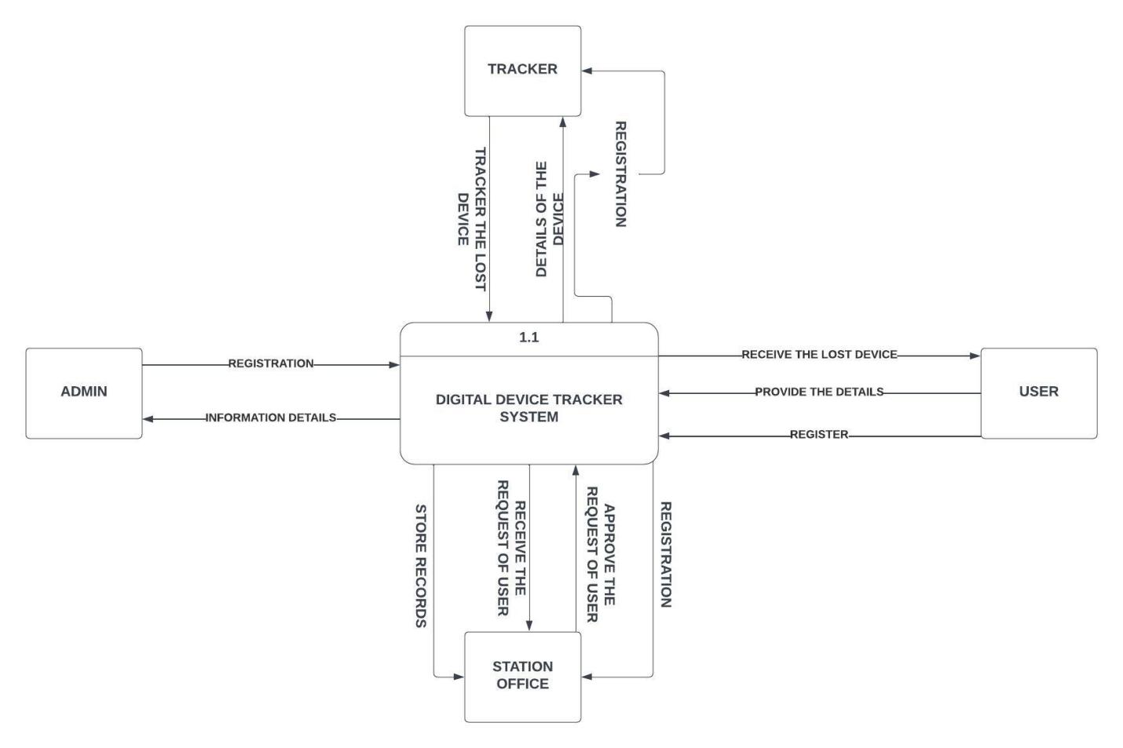

Figure 1

## 4.2 DFD LEVEL 1

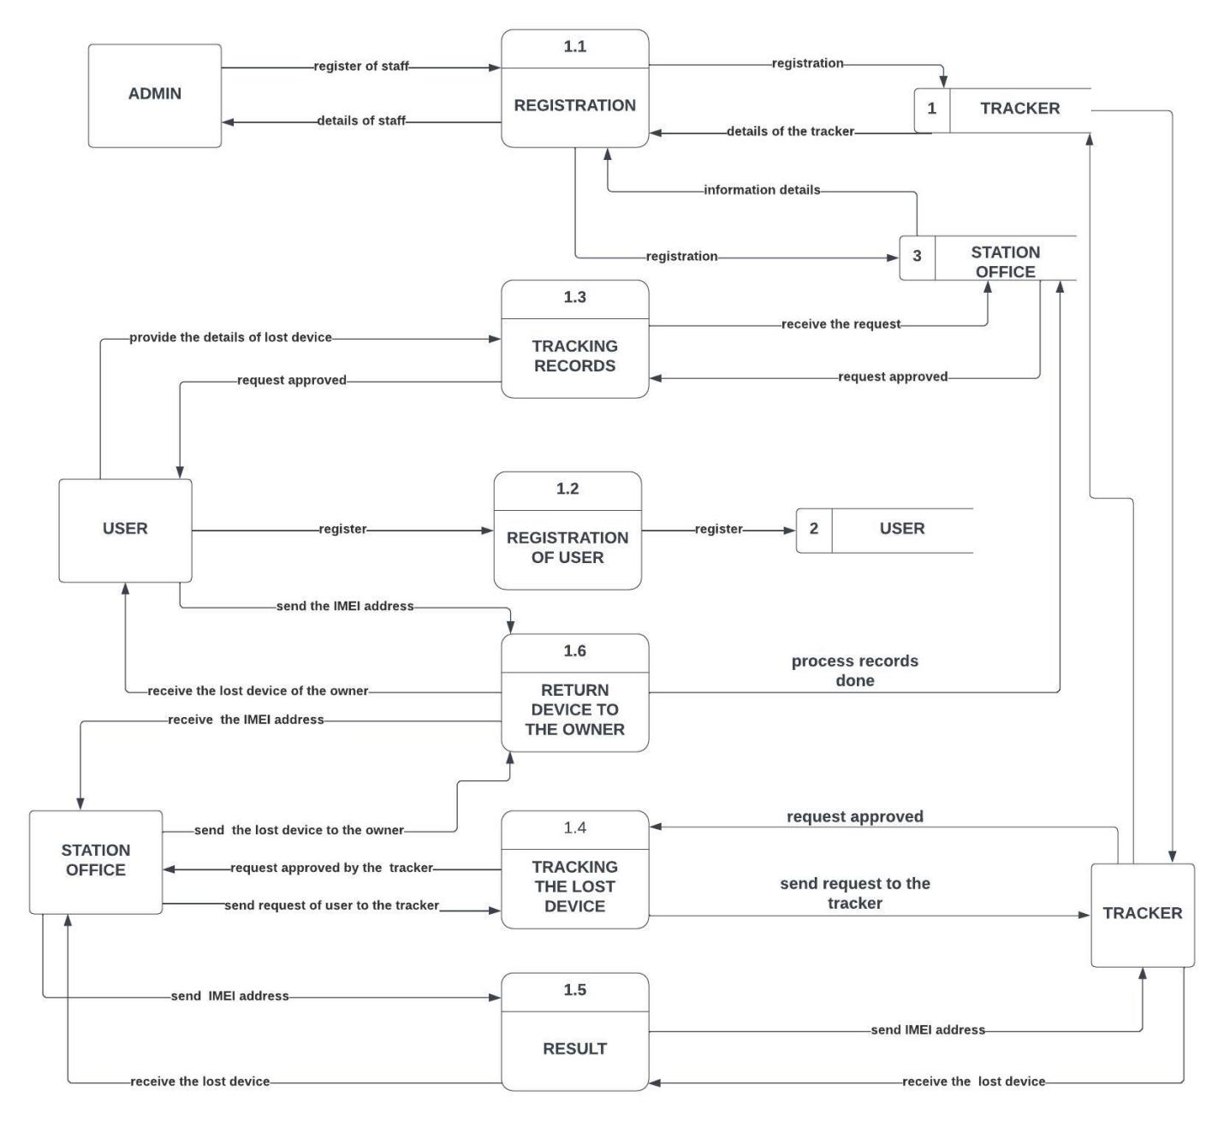

Figure 2

# 5. Feasibility study

5.1 Technical Feasibility

The technical feasibility of a device tracker system depends on a number of factors, including the following:

The type of devices that need to be tracked.

The environment in which the devices will be tracked.

The accuracy of location tracking required.

The budget available for the project.

## 5.2 Financial Feasibility

The financial feasibility of a device tracker system depends on a number of factors, including the following:

The cost of the hardware and software components.

The cost of the deployment and maintenance of the system.

The potential revenue that can be generated from the system.

The cost of the hardware and software components will depend on the specific system that is being implemented. For example, a system that uses GPS tracking will be more expensive than a system that uses Wi-Fi tracking.

The cost of the deployment and maintenance of the system will also depend on the specific system that is being implemented. For example, a system that is deployed in a rural area with poor GPS reception will be more expensive to maintain than a system that is deployed in an urban area with good GPS reception.

The potential revenue that can be generated from the system will depend on the specific application of the system. For example, a system that is used to track the location of assets may be able to generate revenue by charging a subscription fee for the service.

Overall, the financial feasibility of a device tracker system depends on a number of factors. However, if the system is well-designed and implemented, it can be financially feasible even with limited resources.

Here are some of the factors that can affect the financial feasibility of a device tracker system:

The number of devices that need to be tracked. The more devices that need to be tracked, the more expensive the system will be.

The frequency of location updates. The more frequently the location of devices is updated, the more expensive the system will be.

The accuracy of location tracking. The more accurate the location tracking, the more expensive the system will be.

The security of the system. The more secure the system, the more expensive the system will be.

The financial feasibility of a device tracker system is a complex issue that depends on a number of factors. However, if the requirements of the system are carefully considered, then the system can be financially feasible even with limited resources.

## 5.3 Market Feasibility

The market feasibility of a device tracker system depends on a number of factors, including the following:

The size and growth potential of the market.

The competitive landscape.

The level of customer demand.

The price point of the system.

## 5.4 Economic Feasibility

The economic feasibility of a device tracker system depends on a number of factors, including the following:

The cost of the system. The cost of the system will depend on the hardware and software components that are used, as well as the cost of deployment and maintenance.

The benefits of the system. The benefits of the system will depend on the specific application, but could include improved asset tracking, increased security, and better customer service.

The willingness of customers to pay for the system. The willingness of customers to pay for the system will depend on the perceived value of the system and the cost of competing systems.

## 5.5 Legal and Regulatory Feasibility

The legal and regulatory feasibility of a device tracker system depends on a number of factors, including the following:

The applicable laws and regulations. The laws and regulations that apply to device tracker systems will vary depending on the jurisdiction.

The consent of the individuals being tracked. In some cases, the consent of the individuals being tracked may be required.

The use of the data collected. The data collected by a device tracker system must be used in a lawful and ethical manner.

## 5.6 Operational Feasibility

sure, here are some of the factors that can affect the operational feasibility of a device tracker system:

The availability of the hardware and software components. The hardware and software components that are needed for a device tracker system must be available and compatible with each other.

The expertise of the staff who will be responsible for operating and maintaining the system. The staff who will be responsible for operating and maintaining the system must have the necessary expertise to do so.

The ability to integrate the system with other systems. The device tracker system must be able to integrate with other systems, such as a customer relationship management (CRM) system or a fleet management system.

The ability to scale the system as needed. The device tracker system must be able to scale as needed to accommodate a growing number of devices and users.

# Description of the selected Process Model

## Cause of your selection

Sure. I selected the Waterfall Process Model for the device tracker system because it is a well-defined and structured process that is well-suited for projects with clear requirements and a limited budget.

The Waterfall Process Model is a sequential process that consists of the following phases:

Requirements gathering: The requirements for the system are gathered and documented.

System design: The system is designed in detail.

Implementation: The system is implemented.

Testing: The system is tested.

Deployment: The system is deployed.

Maintenance: The system is maintained.

The Waterfall Process Model is a good choice for the device tracker system because it is a well-defined and structured process that can help to ensure that the system is implemented correctly and meets the requirements. The Waterfall Process Model is also a good choice for projects with a limited budget because it is a relatively straightforward process that does not require a lot of resources.

# Conclusion

The device tracker system project is a feasible project with the potential to provide significant benefits to businesses. The project is technically feasible, financially feasible, market feasible, and economically feasible. The project is also legally and regulatory feasible, and the operational feasibility can be ensured by careful consideration of the factors involved. The Waterfall Process Model is a good choice for the project because it is a well-defined and structured process that can help to ensure that the system is implemented correctly and meets the requirements.

Here are some of the key conclusions about the device tracker system project:

The project is technically feasible and can be implemented using a variety of technologies.

The project is financially feasible and can be funded through a variety of sources.

The project is market feasible and there is a growing demand for device tracker systems.

The project is economically feasible and can generate significant revenue for businesses.

The project is legally and regulatory feasible and can be implemented in compliance with all applicable laws and regulations.

The project is operationally feasible and can be managed and maintained effectively.

Overall, the device tracker system project is a feasible project with the potential to provide significant benefits to businesses. The project is well-defined and structured, and the risks involved have been carefully considered. The project has the potential to be a successful business venture.

# References

**Traccar:** Traccar is an open-source GPS tracking system that can be used to track vehicles, assets, and people. It is a powerful and flexible system that can be customized to meet the specific needs of any organization.

**Fleetio:** Fleetio is a cloud-based GPS tracking system that is designed for businesses with fleets of vehicles. It offers a wide range of features, including real-time tracking, geofencing, and driver behavior analysis.

**Geo tab:** Geo tab is a global leader in GPS tracking and fleet management solutions. It offers a wide range of products and services, including hardware, software, and support.

**Track imo:** Track imo is a portable GPS tracking device that can be used to track vehicles, assets, and people. It is a simple and easy-to-use system that is perfect for businesses and individuals.

<https://www.seeworldgps.com/gps-tracking-device-manufacturer/?gad=1&gclid=Cj0KCQjwzdOlBhCNARIsAPMwjbxCB_xPktSW4W8obGGsYjYnjOKQRzycFPfYTFzyNk-UwS-ns9FIsw8aAqvWEALw_wcB>

<https://www.google.com/android/find/>

<https://www.devicetrackerplus.com/>

DATABASE

**SECTION I**

**1. Describe all the entities and their corresponding attributes that are in your database.**

**Device:**

**-Device_id -Name -Status -location -Battery_level**

**User:**

**-User_id -Name -Email -Password**

**Location:**

-**Location_id -Name -Latitude -Longitude**

**EVENTS:**

**-Events_id -Type -Timestamp**

**LOG:**

**-Log_id -Events -Timestamp**

**2.** **Create an LDM of your entities.**

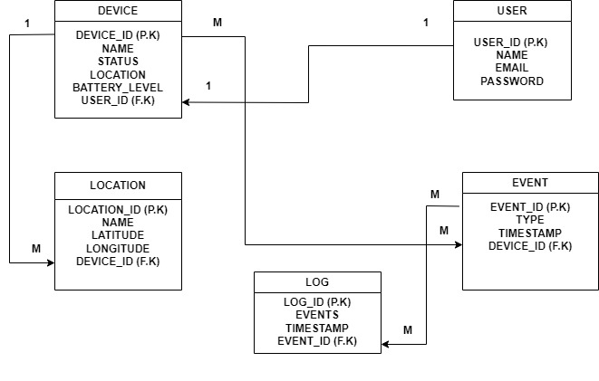

**3. Create an ERD**

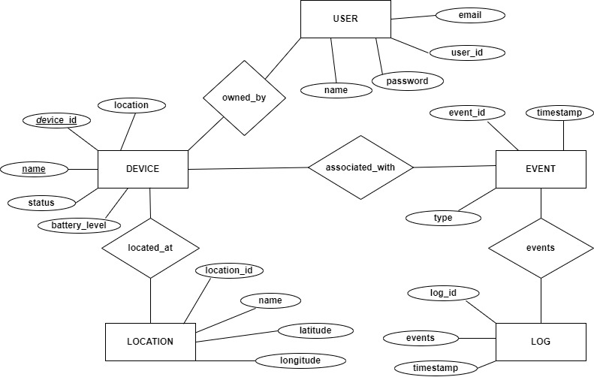

**SECTION II (SQL)**

**1. Create the database of your system.**

**ANSWER:**

**CREATE DATABASE device_tracker;**

**2. Write queries to create all the tables and relationships of your system**

**ANSWER :**

**CREATE TABLE device (**

**id INT NOT NULL AUTO_INCREMENT,**

**name VARCHAR(255) NOT NULL,**

**location VARCHAR(255) NOT NULL,**

**status VARCHAR(255) NOT NULL,**

**battery_level INT NOT NULL,**

**PRIMARY KEY (id)**

**);**

**CREATE TABLE user (**

**id INT NOT NULL AUTO_INCREMENT,**

**name VARCHAR(255) NOT NULL,**

**email_address VARCHAR(255) NOT NULL,**

**password VARCHAR(255) NOT NULL,**

**PRIMARY KEY (id)**

**);**

**CREATE TABLE location (**

**id INT NOT NULL AUTO_INCREMENT,**

**name VARCHAR(255) NOT NULL,**

**latitude DOUBLE NOT NULL,**

**longitude DOUBLE NOT NULL,**

**PRIMARY KEY (id)**

**);**

**CREATE TABLE event (**

**id INT NOT NULL AUTO_INCREMENT,**

**type VARCHAR(255) NOT NULL,**

**timestamp DATETIME NOT NULL,**

**device_id INT NOT NULL,**

**PRIMARY KEY (id),**

**FOREIGN KEY (device_id) REFERENCES device (id)**

**);**

**CREATE TABLE log (**

**id INT NOT NULL AUTO_INCREMENT,**

**timestamp DATETIME NOT NULL,**

**events LONGTEXT NOT NULL,**

**PRIMARY KEY (id)**

**);**

**To create the relationships between the tables:**

**ALTER TABLE device ADD FOREIGN KEY (user_id) REFERENCES user(id);**

**ALTER TABLE event ADD FOREIGN KEY (device_id) REFERENCES device(id) ;**

**ALTER TABLE log ADD FOREIGN KEY (event_id) REFERENCES event(id) ;**

**ALTER TABLE location ADD FOREIGN KEY (device_id) REFERENCES device(id);**

**3.** **write queries to insert data into your tables.**

**->INSERT INTO device (name, location, status, battery_level)**

**VALUES ('Phone', 'Home', 'On', 80);**

**INSERT INTO device (name, location, status, battery_level)**

**VALUES ('Laptop', 'Office', 'Off', 50);**

**->INSERT INTO user (name, email_address, password)**

**VALUES ('John Doe', 'johndoe@example.com', 'password');**

**INSERT INTO user (name, email_address, password)**

**VALUES ('Jane Doe', 'janedoe@example.com', 'password');**

**->INSERT INTO location (name, latitude, longitude)**

**VALUES ('Home', -1.283333, 3.133333);**

**INSERT INTO location (name, latitude, longitude)**

**VALUES ('Office', 1.283333, 1.133333);**

**->INSERT INTO event (type, timestamp, device_id)**

**VALUES ('Moved', '2023-09-05 12:00:00', 1);**

**INSERT INTO event (type, timestamp, device_id)**

**VALUES ('Powered On', '2023-09-05 13:00:00', 2);**

**->INSERT INTO log (timestamp, events)**

**VALUES ('2023-09-05 14:00:00', '[1, 2]');**

**4.** **Write queries to display all the information in your tables.**

**-SELECT \***

**FROM device;**

**-SELECT \***

**FROM user;**

**-SELECT \***

**FROM location;**

**-SELECT \***

**FROM event;**

**-SELECT \***

**FROM log;**

**5. Write a query to update information in any of the two tables of your system.**

**-UPDATE device**

**SET location = 'Office'**

**WHERE id = 1;**

**-UPDATE device**

**SET status = 'On'**

**WHERE id = 2;**

**SECTION III**

**1. Create a view to insert data into your tables**

**-** **CREATE VIEW log_insert_view AS**

**SELECT \***

**FROM log**

**WHERE action = 'insert';**

**INSERT INTO log_insert_view (user_id, action, data)**

**VALUES (1, 'insert', 'This is a new row');**

**-** **CREATE VIEW insert_location_view AS**

**SELECT location_id, location**

**FROM location;**

**INSERT INTO insert_location_view (location_id, location)**

**VALUES (1, 'New York City');**

**-CREATE VIEW devices_in_office AS**

**SELECT \***

**FROM device**

**WHERE location = 'Office';**

**-INSERT INTO device (name, location)**

**SELECT 'New Device', 'Office'**

**FROM devices_in_office;**

**-CREATE VIEW insert_user_view AS**

**SELECT username, password, first_name, last_name, email**

**FROM user;**

**INSERT INTO insert_user_view (username, password, first_name, last_name, email)**

**VALUES ('johndoe', 'password123', 'John', 'Doe', 'johndoe@example.com');**

**2. Create a view to display all the information in your tables.**

**CREATE VIEW all_information AS**

**SELECT \***

**FROM device**

**UNION ALL**

**SELECT \***

**FROM user**

**UNION ALL**

**SELECT \***

**FROM location**

**UNION ALL**

**SELECT \***

**FROM event**

**UNION ALL**

**SELECT \***

**FROM log;**

**OR**

**SELECT \***

**FROM all_information; (“When the view is created “)**

**3. Create a view to update information in any of the two tables of your system**

**CREATE OR REPLACE VIEW updatable_user_info AS**

**SELECT user_id, name , email,password**

**FROM user;**

**UPDATE** **updatable_user_info**

**SET email=’emmyngabo40@gmail.com'**

**WHERE user_id=’02’;**

**CREATE OR REPLACE VIEW updatable_device_info AS**

**SELECT device_id,** **Name, status, location,battery_level**

**FROM device;**

**UPDATE**  **updatable_device_info**

**SET name=’joshua’**

**WHERE device_id=’01’;**

**4. Create a view to delete data in any two of your tables according to any simple condition of your choice.**

**-CREATE VIEW delete_devices_on AS**

**SELECT \***

**FROM device**

**WHERE status = 'On';**

**DELETE FROM delete_devices_on;**

**5. In your database, create one view of your choice that considers sub-query.**

**-CREATE VIEW devices_in_office_with_battery_level_above_80 AS**

**SELECT \***

**FROM device**

**WHERE location = 'Office'**

**AND battery_level > 80;**

**SELECT \***

**FROM devices_in_office_with_battery_level_above_80;**

**SECTION IV**

**1. Create a stored procedure to insert data into your tables.**

**CREATE PROCEDURE insert_data**

**(**

**@location_id INT,**

**@event_id INT,**

**@device_id INT,**

**@log_id INT,**

**@user_id INT**

**)**

**AS**

**BEGIN**

**INSERT INTO location (id, name, address)**

**VALUES (@location_id, 'Location Name', 'Location Address');**

**INSERT INTO event (id, name, description)**

**VALUES (@event_id, 'Event Name', 'Event Description');**

**INSERT INTO device (id, name, model)**

**VALUES (@device_id, 'Device Name', 'Device Model');**

**INSERT INTO log (id, location_id, event_id, device_id, user_id, created_at, updated_at)**

**VALUES (@log_id, @location_id, @event_id, @device_id, @user_id, CURRENT_TIMESTAMP, CURRENT_TIMESTAMP);**

**INSERT INTO user (id, name, email, password)**

**VALUES (@user_id, 'User Name', 'user@email.com', 'password');**

**END;**

**2. Create a stored procedure to display all the information in your tables.**

**CREATE PROCEDURE sp_display_all_information**

**AS**

**BEGIN**

**SELECT \***

**FROM location**

**JOIN event ON location.id = event.location_id**

**JOIN user ON event.user_id = user.id**

**JOIN log ON event.log_id = log.id**

**JOIN device ON event.device_id = device.id;**

**END;**

**3. Create a stored procedure to update information in any of the two tables of your system?**

**CREATE PROCEDURE update_location_device_info**

**(**

**@location_id INT,**

**@new_location VARCHAR(255),**

**@new_device VARCHAR(255)**

**)**

**AS**

**BEGIN**

**-- Update the location table**

**UPDATE location**

**SET location = @new_location**

**WHERE location_id = @location_id;**

**-- Update the device table**

**UPDATE device**

**SET device = @new_device**

**WHERE location_id = @location_id;**

**END;**

**DECLARE @location_id INT;**

**DECLARE @new_location VARCHAR(255);**

**DECLARE @new_device VARCHAR(255);DECLARE @location_id INT;**

**DECLARE @new_location VARCHAR(255);**

**DECLARE @new_device VARCHAR(255);**

**4. Create a stored procedure to delete data in any two of your tables according to any simple condition of your choice**

**-CREATE PROCEDURE delete_location_device_data**

**(**

**@condition VARCHAR(255)**

**)**

**AS**

**BEGIN**

**DELETE FROM location**

**WHERE @condition;**

**DELETE FROM device**

**WHERE @condition;**

**END;**

**SECTION V**

**1. Create after inserting triggers for any two tables of your choice.**

**-CREATE TRIGGER device_insert_trigger**

**AFTER INSERT ON device**

**FOR EACH ROW**

**BEGIN**

**INSERT INTO device_log (device_id, event_type)**

**VALUES (NEW.id, 'INSERT');**

**END;**

**-** **CREATE TRIGGER location_insert_trigger**

**AFTER INSERT ON location**

**FOR EACH ROW**

**BEGIN**

**INSERT INTO location_log (location_id, event_type)**

**VALUES (NEW.id, 'INSERT');**

**END;**

**2. Create after-update triggers for any two tables of your choice.**

**-CREATE TRIGGER location_after_update**

**AFTER UPDATE ON location**

**FOR EACH ROW**

**BEGIN**

**-- Insert a record into the location_log table**

**INSERT INTO location_log (location_id, old_location, new_location, updated_by, updated_on)**

**VALUES (NEW.location_id, OLD.location, NEW.location, USER(), CURRENT_TIMESTAMP());**

**END;**

**-** **CREATE TRIGGER device_after_update**

**AFTER UPDATE ON device**

**FOR EACH ROW**

**BEGIN**

**-- Insert a record into the device_log table**

**INSERT INTO device_log (device_id, old_device, new_device, updated_by, updated_on)**

**VALUES (NEW.device_id, OLD.device, NEW.device, USER(), CURRENT_TIMESTAMP());**

**END;**

**3. Create after deleting triggers for any two tables of your choice.**

**-** **CREATE TRIGGER location_after_delete**

**AFTER DELETE ON location**

**FOR EACH ROW**

**BEGIN**

**-- Insert a record into the location_deleted_log table**

**INSERT INTO location_deleted_log (location_id, location, deleted_by, deleted_on)**

**VALUES (OLD.location_id, OLD.location, USER(), CURRENT_TIMESTAMP());**

**END;**

**-**

**CREATE TRIGGER device_after_delete**

**AFTER DELETE ON device**

**FOR EACH ROW**

**BEGIN**

**-- Insert a record into the device_deleted_log table**

**INSERT INTO device_deleted_log (device_id, device, deleted_by, deleted_on)**

**VALUES (OLD.device_id, OLD.device, USER(), CURRENT_TIMESTAMP());**

**END;**

**SECTION VI**

**1. Create a user with your name as username and your student number as password and grant all privileges to the created user.**

**mysql -u root -p**

**create user 'rugemanachristian'@'localhost'IDENTIFIED BY '222004192';**

**GRANT ALL PRIVILEGES ON *.* TO 'rugemanachristian'@'localhost';**

**FLUSH PRIVILEGES;**

**exit;**

**2. Create a user with your "names_semi" as username and your student number as password and give him insert, update, and delete privileges to the created user.**

**mysql -u root -p**

**CREATE USER 'rugemana'@'localhost' IDENTIFIED BY '222004192';**

**GRANT INSERT, UPDATE, DELETE ON *.* TO 'rugemana'@'localhost';**

**FLUSH PRIVILEGES;**

**exit;**

**3. Revoke insert privileges to the last user you created.**

**mysql -u root -p**

**REVOKE INSERT ON *.* FROM 'rugemana'@'localhost';**

**FLUSH PRIVILEGES;**

**exit;**

**JAVA PROJECT**

**STEP 1:**

**The registration of users in a digital device tracker system serves several purposes:**

**1. User Identification: Registration helps in uniquely identifying each user of the system. This is important for tracking devices and ensuring that the right user is associated with the right device.**

**2. Access Control: Registration allows the system to control access to certain features or devices based on user roles or permissions. This helps in ensuring that only authorized users can perform certain actions.**

**3. Security:Registration often involves the creation of a username and password, which adds a layer of security to the system. This helps in preventing unauthorized access to the system and the devices being tracked.**

**4. Personalization:Registration allows users to personalize their experience within the system. This could include setting preferences, receiving notifications, or accessing personalized reports.**

**5. Accountability: By registering users, the system can keep track of who is responsible for which devices. This accountability can be important for managing device usage and ensuring compliance with policies and regulations.**

**Overall, registration of users plays a crucial role in ensuring the security, efficiency, and effectiveness of a digital device tracker system.**

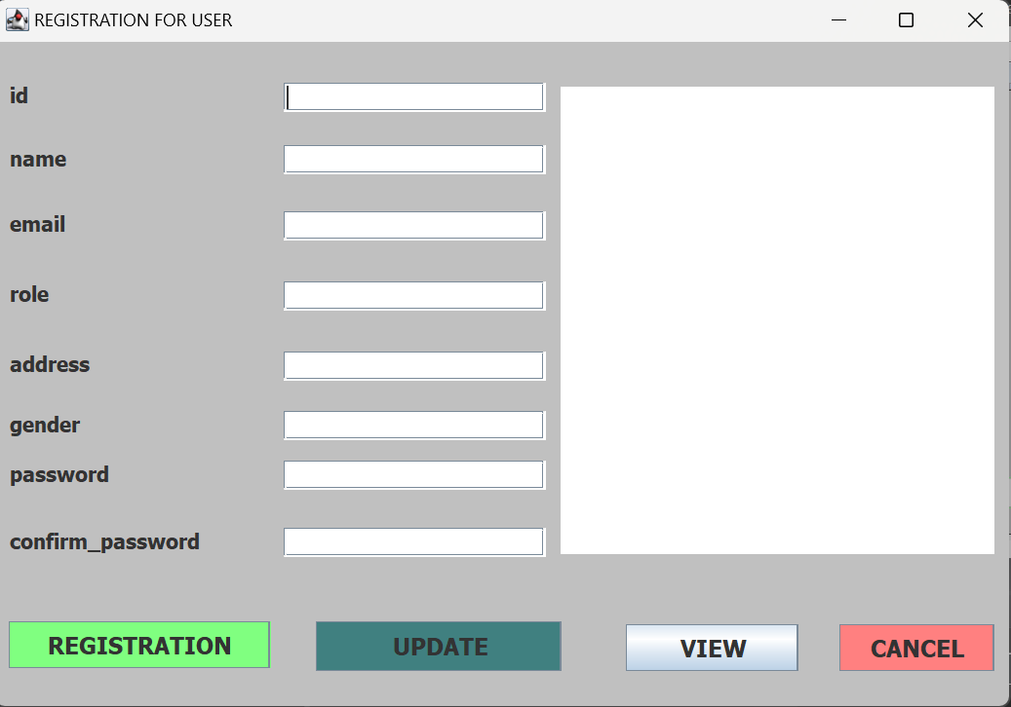

**STEP 2**

**the login form plays a crucial role in authenticating users before they can access the system. It typically includes fields for users to enter their username and password. The login form should validate these credentials against a database or some other authentication mechanism to ensure that only authorized users can access the system. Successful login usually grants access to the main features of the system, while failed login attempts might result in error messages or other appropriate feedback to the user.**

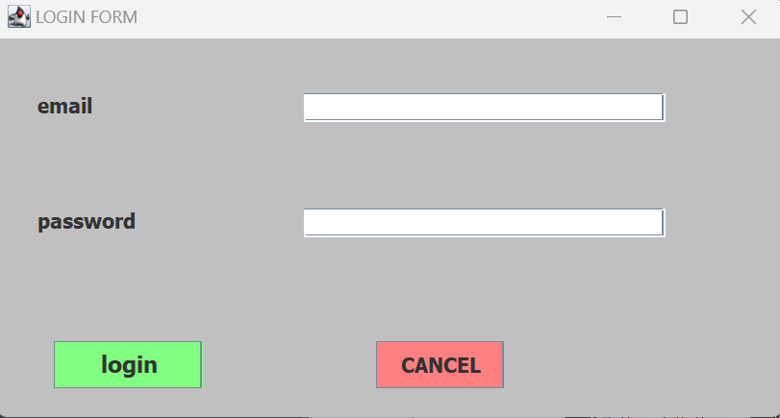

**STEP 3**

**The dashboard in your digital device tracker system project would serve as the main interface for users to view and manage information related to their tracked devices. It would typically include various components such as:**

**Device Overview: A summary of all tracked devices, showing key information such as device name, status (active/inactive), last seen location, etc.**

**Device Map: A map showing the locations of all tracked devices, allowing users to visualize their whereabouts.**

**Device Details: Detailed information about each tracked device, including device type, model, owner information, etc.**

**Alerts and Notifications: A section for displaying any alerts or notifications related to tracked devices, such as low battery, out-of-range, etc.**

**User Profile: An area where users can view and update their personal information and settings.**

**Reports and Analytics: A feature for generating reports and analyzing data related to tracked devices, such as device usage patterns, historical locations, etc.**

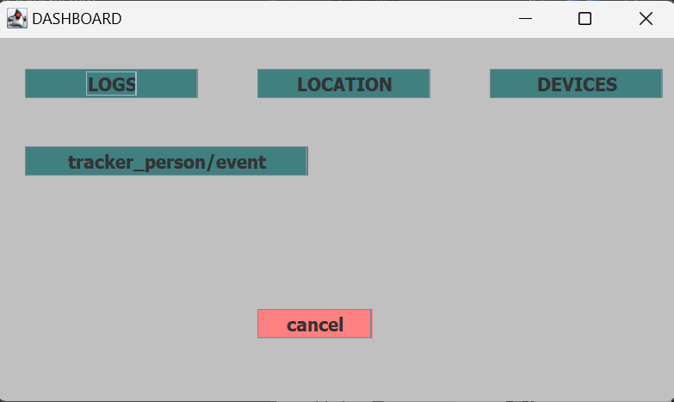

**STEP 4**

**In the context of your digital device tracker system project, a device form would be a user interface component used for adding or editing information about a tracked device. This form would typically include fields for entering various details about the device, such as:**

**1. Device Name: A unique name or identifier for the device.**

**2. Device Type: The type or category of the device (e.g., smartphone, laptop, tablet).**

**3. Device Model: The model or version of the device.**

**4. Owner Information: Information about the owner or user of the device.**

**5. Location Tracking Settings: Options for configuring how the device's location is tracked (e.g., GPS, Wi-Fi).**

**6. Status: The status of the device (e.g., active, inactive).**

**7. Notes: Any additional notes or comments about the device.**

**The device form would also include validation logic to ensure that the entered information is correct and complete before it is submitted to the system. Additionally, it may include buttons or actions for saving the device information, canceling the operation, or deleting the device.**

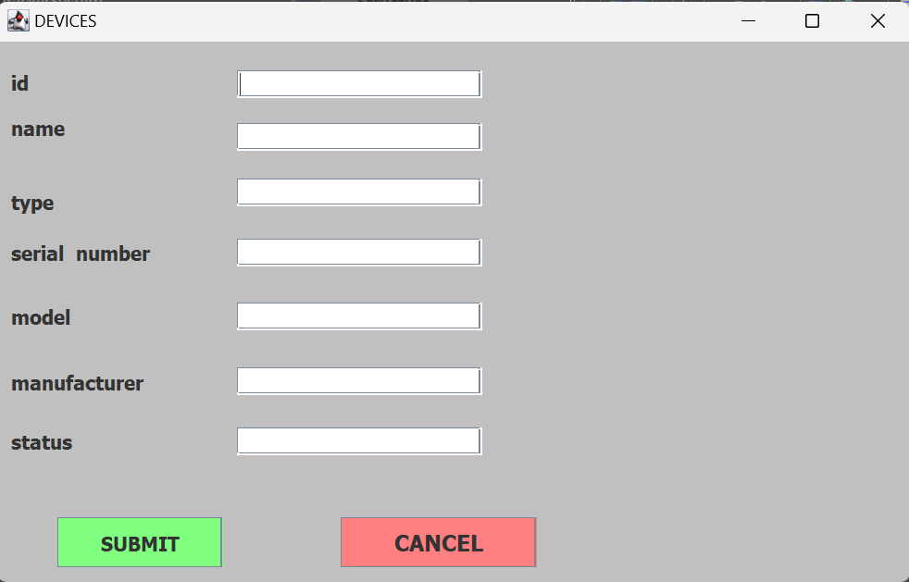

**STEP 5**

**In your digital device tracker system project, a location form would be used to input or update the location information of a tracked device. This form would typically include fields or components for:**

**1. Device Selection: A dropdown or selection list to choose the device for which the location is being updated.**

**2. Location Information: Fields to input the latitude and longitude coordinates of the device's current location.**

**3. Accuracy: An optional field to specify the accuracy of the location data, if available.**

**4. Timestamp: The date and time when the location data was recorded.**

**5. Notes: Any additional notes or comments related to the location update.**

**The location form would also include validation logic to ensure that the entered information is valid and within acceptable ranges. It may also include options for specifying the source of the location data (e.g., GPS, Wi-Fi, manual entry) and actions for saving or discarding the location update.**

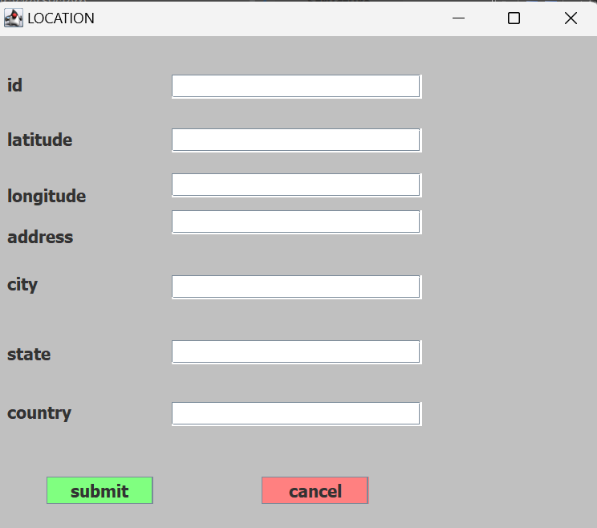

**STEP 6**

**In the context of your digital device tracker system project, a logs form would be used to display or manage logs of activities or events related to the tracked devices. This form could include:**

**1. Log List: A list or table showing the logs of activities, such as device location updates, status changes, user interactions, etc.**

**2. Log Details: Details of a selected log item, including the type of activity, timestamp, device involved, and any additional information.**

**3. Filter and Search: Options to filter and search for specific logs based on criteria such as date range, device ID, or activity type.**

**4. Export: Option to export logs to a file format such as CSV or PDF for further analysis or reporting.**

**5. Clear Logs: Option to clear or delete logs based on user permissions and system requirements.**

**The logs form should be designed to provide a clear and organized view of the activity history, allowing users to quickly find and review relevant information about the tracked devices.**

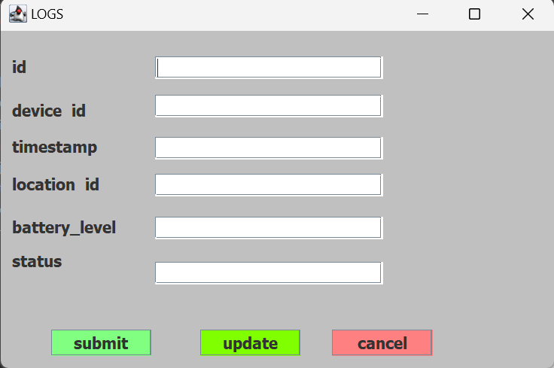

**STEP 7**

**In the context of your digital device tracker system project, a tracker person form would be used to manage information about individuals who are responsible for tracking or managing the devices in the system. This form could include fields for:**

**1. Person Name: The name of the person responsible for tracking the devices.**

**2. Contact Information: Contact details such as email address, phone number, etc.**

**3. Role or Position: The role or position of the person within the organization.**

**4. Assigned Devices: A list of devices assigned to the person for tracking or management.**

**5. Permissions: Access permissions granted to the person for managing devices and accessing system features.**

**6. Notes: Any additional notes or comments related to the person's role or responsibilities.**

**The tracker person form would also include options for adding, editing, and deleting person records, as well as assigning or reassigning devices to individuals. It should be designed to be user-friendly and intuitive, allowing system administrators to easily manage and track the individuals responsible for device tracking.**

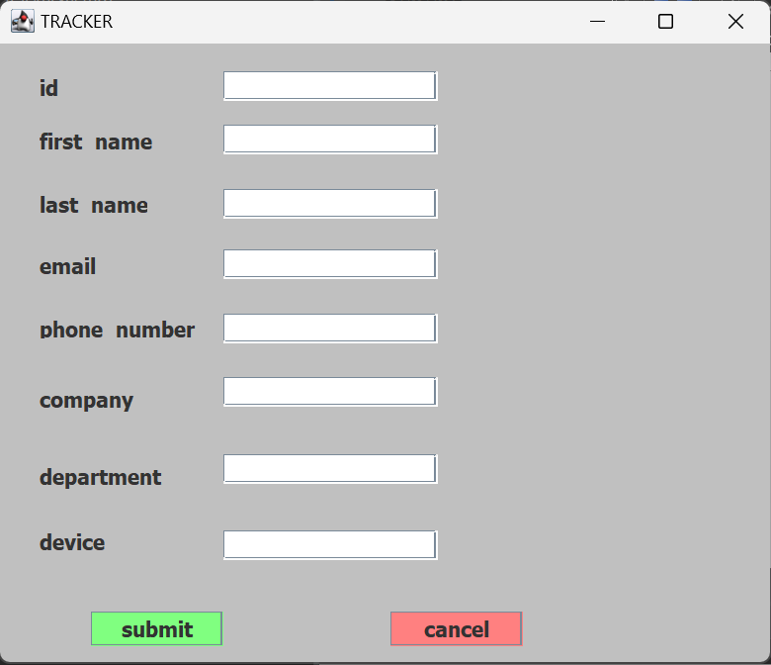

**Conclusion**:

Requirement Gathering: Clearly define the requirements of the system, including features such as device tracking, user authentication, and data management.

Design: Create a design for the system, including the database schema, user interfaces (login form, dashboard, device form, location form, logs form, tracker person form), and system architecture.

Implementation: Develop the system using Eclipse, implementing the various components according to the design specifications.

Testing: Test the system to ensure that it functions correctly, including testing user interactions, data validation, and system performance.

Deployment: Deploy the system to a production environment, making it available for use by users.

Maintenance: Maintain the system by monitoring its performance, addressing any issues that arise, and implementing updates or enhancements as needed.

In conclusion, the development of a digital device tracker system involves a systematic process of requirement gathering, design, implementation, testing, deployment, and maintenance to create a robust and reliable system for tracking and managing devices.

**References:**

Here are some references you can use for developing a digital device tracker system:

1. Eclipse IDE: [https://www.eclipse.org/ide/](https://www.eclipse.org/ide/)

2. Java Programming Language: [https://www.oracle.com/java/](https://www.oracle.com/java/)

3. JavaFX for User Interface Development: [https://openjfx.io/](https://openjfx.io/)

4. MySQL Database: [https://www.mysql.com/](https://www.mysql.com/)

5. Hibernate ORM Framework: [https://hibernate.org/](https://hibernate.org/)

6. Google Maps API for Location Services: [https://developers.google.com/maps](https://developers.google.com/maps)

These references should provide you with information and resources to help you develop your digital device tracker system using Eclipse.