

“PROJECT 1”
“Fitness Goal Tracking Dashboard : Workout logging + progress reports”

Done by:
Name: Rugved Dhaybar
Srn No.: 31231437
A.Y. 2024-2025

Programme Name: BBA-CA
Course Name: Software Project Management
Couse Code: BBACA23601

Under The Supervision of Prof.Umesh Patwardhan
Department of Commerce and Management
Faculty of Commerce and Management
1. Introduction
The Fitness Goal Tracking Dashboard is a web-based application designed to help individuals systematically monitor, manage, and achieve their fitness goals. In today’s fast-paced lifestyle, many people struggle to maintain consistency in their workouts and track their physical progress effectively. This project addresses that gap by providing a centralized platform where users can log their daily workouts and visualize their progress through structured reports and dashboards.
The system enables users to record key fitness activities such as exercises performed, sets, repetitions, duration, and calories burned. It further transforms this raw data into meaningful insights using charts and progress reports, helping users stay motivated and make informed decisions about their fitness routines.
This project follows the principles of Software Project Management, covering all phases from initiation and planning to execution, monitoring, and closure. It not only focuses on building a functional system but also emphasizes proper project governance, risk management, quality assurance, and stakeholder communication.
Overall, the Fitness Goal Tracking Dashboard aims to promote a disciplined and data-driven approach to fitness while demonstrating the practical application of project management concepts in software development.

2. Project Charter
The project titled “Fitness Goal Tracking Dashboard: Workout Logging + Progress Reports” focuses on developing a web-based system that helps users effectively track their fitness activities and monitor progress. Many individuals face difficulty in maintaining consistency in workouts due to the lack of proper tracking tools and meaningful insights. Traditional methods fail to provide visualization and structured reports, which reduces motivation. This project aims to solve this problem by offering a centralized dashboard for logging workouts and analyzing progress.
Project Objectives
- To design a user-friendly fitness tracking dashboard
- To enable users to log daily workout activities
- To generate weekly and monthly progress reports
- To help users set and achieve fitness goals
- To apply Software Project Management concepts in real implementation

High-Level Requirements
- User registration and login system
- Workout logging module (exercise, reps, sets, duration)
- Dashboard with charts and analytics
- Goal-setting feature
- Progress report generation (weekly/monthly)

Key Stakeholders
Stakeholder | Role | Interest
Users | End Users | High
Developer (Student) | Project Manager | High
Faculty | Evaluator | Medium

Assumptions
These are conditions considered to be true for the successful functioning of the project:
- Users will have access to internet-enabled devices such as laptops or smartphones
- Users will enter accurate and consistent workout data
- The system will be used by individuals for personal fitness tracking
- Basic technical infrastructure (browser, system compatibility) will be available
- Users have basic understanding of fitness activities
Constraints
These are limitations that may affect the project:
- Limited time duration (semester-based deadline)
- Limited budget (no advanced tools or paid services)
- Development restricted to basic technologies (HTML, CSS, JavaScript)
- No integration with external devices (like fitness bands or smartwatches)
- Limited features due to individual project scope

3. Feasibility Study (TELOS Framework)
The feasibility study evaluates whether the Fitness Goal Tracking Dashboard project is practical and achievable within the given constraints using the TELOS framework.

1. Technical Feasibility
The project is technically feasible as it can be developed using basic web technologies such as HTML, CSS, and JavaScript. A simple database (like MySQL or local storage) can be used to store user data and workout logs. The required tools and technologies are easily available and familiar at an academic level. No advanced infrastructure or complex integrations are needed, making the system easy to design, develop, and deploy.

2. Economic Feasibility
The project is economically viable as it requires minimal investment. Since it is a student project, most tools (such as code editors, browsers, and hosting platforms) are free or open-source. There are no significant hardware or software costs involved. Hence, the overall development cost remains very low and affordable.

3. Legal Feasibility
The project does not involve any legal complications as it does not handle sensitive personal or financial data. It is intended for academic purposes and follows standard ethical practices. Proper care will be taken to ensure that user data is handled responsibly and no copyrighted material is misused.

4. Operational Feasibility
The system is easy to operate and user-friendly. Users can easily log their workouts and view progress without requiring technical expertise. The interface will be simple and intuitive, ensuring smooth interaction. The system fulfills the intended purpose of helping users track fitness goals effectively.

5. Schedule Feasibility
The project can be completed within the given semester timeline. It will be developed in phases such as planning, design, development, testing, and deployment. Since the scope is limited and well-defined, the project is achievable within the allocated time frame.

4. Scope Statement
The Fitness Goal Tracking Dashboard: Workout Logging + Progress Reports project focuses on developing a web-based application that enables users to efficiently track their fitness activities and monitor their progress over time. The system will allow users to log workout details such as exercises, sets, repetitions, and duration, and present this data through a structured dashboard with visual reports. The primary goal is to provide a simple, user-friendly platform that helps individuals stay consistent with their fitness routines and achieve their goals through better tracking and analysis.
The scope of this project includes core functionalities such as user authentication, workout logging, progress visualization through charts, goal setting, and generation of weekly or monthly reports. The system will be designed using basic web technologies and will focus on usability and clarity rather than complex features.
However, the project excludes advanced functionalities such as integration with wearable fitness devices, AI-based recommendations, live coaching features, and mobile application development. By clearly defining these boundaries, the project ensures focused development, avoids scope creep, and remains achievable within the given time and resource constraints.
In-Scope Features
The following functionalities are included in the project:
- User registration and login system
- Workout logging (exercise name, sets, repetitions, duration)
- Dashboard for visualizing progress (charts, summaries)
- Goal setting (e.g., weight loss, muscle gain)
- Weekly and monthly progress reports
- Basic, user-friendly web interface (HTML, CSS, JavaScript)

Out-of-Scope Exclusions
The following functionalities are not included in the project:
- Integration with wearable devices (fitness bands, smartwatches)
- AI-based workout or diet recommendations
- Live coaching or trainer interaction features
- Mobile application development (only web-based system)
- Advanced analytics or real-time performance tracking

5. SMART Project Objectives
The objectives of the Fitness Goal Tracking Dashboard are defined using the SMART criteria (Specific, Measurable, Achievable, Relevant, Time-bound) to ensure clarity and successful project completion.
- Specific:
Develop a web-based dashboard that allows users to log workouts, set fitness goals, and track progress through visual reports.
- Measurable:
  - Enable logging of at least 10 types of exercises
  - Generate weekly and monthly progress reports
  - Ensure the system can handle multiple user entries without errors
- Achievable:
The project will be developed using basic technologies like HTML, CSS, and JavaScript, making it feasible within the available skills and resources of a student.
- Relevant:
The project addresses a real-world problem of fitness tracking and aligns with academic requirements of Software Project Management, ensuring practical application of concepts.
- Time-bound:
The project will be completed within 8 weeks, covering all phases including planning, design, development, testing, and final submission.

6. Work Breakdown Structure (WBS)
The Work Breakdown Structure (WBS) for the Fitness Goal Tracking Dashboard project divides the entire project into smaller, manageable components to ensure systematic planning and execution. The project begins with the Project Initiation phase, which includes requirement gathering, problem definition, feasibility study (covering technical, economic, legal, operational, and schedule aspects), and preparation of the project charter. This is followed by the Project Planning phase, where the scope is defined by identifying in-scope and out-of-scope features, setting SMART objectives, creating the WBS, and performing effort and cost estimation using techniques such as LOC and COCOMO.
Next is the System Design phase, which involves designing the user interface (UI/UX), creating wireframes and layouts, planning the database structure, and defining the overall system architecture. The Development phase includes frontend development (login page, dashboard interface, workout logging form), backend or logic development (data storage and processing), and implementation of key feature modules such as goal setting, progress tracking, and report generation. After development, the project moves to the Testing phase, which consists of unit testing, integration testing, system testing, and bug fixing to ensure the system functions correctly.
The Deployment phase involves code review, hosting setup, and final system deployment. This is followed by the Monitoring and Control phase, where project progress is tracked, weekly status reports are prepared, and system performance is monitored. Finally, the project concludes with the Project Closure phase, which includes documentation, final report submission, presentation preparation, and recording lessons learned. The lowest-level tasks in each phase represent the work packages, ensuring clear task allocation and effective project management.

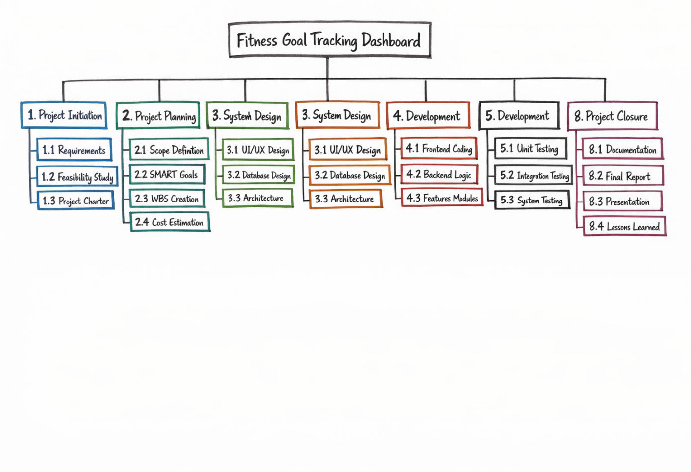

7. Effort & Cost Estimation (LOC + Basic COCOMO)
The effort and cost estimation for the Fitness Goal Tracking Dashboard project is calculated using the Lines of Code (LOC) approach and the Basic COCOMO model. Since this is a small-scale academic project, it falls under the Organic Mode of COCOMO.

Step 1: LOC Estimation
The estimated size of the project is approximately:
- Total LOC = 3000 lines of code
- Converted to KLOC:
KLOC = 3000 / 1000 = 3 KLOC

Step 2: Effort Estimation (COCOMO Model)
Using the Organic mode formula:
$$E=2.4×(KLOC)^{1.05}$$
- E = 2.4 × (3)^1.05 ≈ 7.5 Person-Months
Step 3: Development Time Estimation
Effort to time conversion formula:
$$T=2.5×(E)^{0.38}$$
- T ≈ 2.5 × (7.5)^0.38 ≈ 4 Months

Step 4: Cost Estimation
Assuming cost per person-month = ₹5,000 (student-level estimation):
- Total Cost = Effort × Cost per PM
- Total Cost = 7.5 × 5000 = ₹37,500

Final Estimation Summary
Parameter | Value
LOC | 3000
KLOC | 3
Effort | ~7.5 Person-Months
Development Time | ~4 Months
Total Cost | ₹37,500

8. Stakeholder Register
The stakeholder register for this project includes primary users who will interact with the system, the student developer responsible for designing and implementing the project, and the faculty who will guide and evaluate the work. Additional stakeholders such as test users help in identifying bugs and improving usability, while hosting platforms (if used) support system deployment. Each stakeholder has varying levels of interest and influence, which are important for effective communication and project success.

Stakeholder Register Table
Stakeholder | Role | Interest | Influence | Expectations
Users (Fitness Enthusiasts) | End Users | High | Medium | Easy workout tracking, accurate progress reports
Developer (Student) | Project Manager & Developer | High | High | Successful project completion, learning outcomes
Faculty/Guide | Evaluator & Mentor | Medium | High | Proper documentation, correct implementation
Test Users (Friends/Peers) | System Testers | Medium | Low | Smooth functionality, no bugs
Hosting Platform (if used) | Service Provider | Low | Low | Stable deployment and uptime

9. RACI Matrix (Responsibility Allocation)
The RACI Matrix defines the roles and responsibilities of stakeholders in the Fitness Goal Tracking Dashboard project by categorizing them as Responsible (R), Accountable (A), Consulted (C), and Informed (I).
In this project, the Developer (Student) is primarily responsible for executing most tasks, while the Faculty/Guide is accountable for reviewing and approving the work. Users are consulted during requirement gathering and design to ensure usability, and Test Users assist mainly during the testing phase. This clear distribution of roles ensures proper coordination, accountability, and smooth project execution.

RACI Matrix Table
Task / Activity | Developer (Student) | Faculty/Guide | Users | Test Users
Requirement Gathering | R | A | C | I
Feasibility Study | R | A | I | I
Project Charter | R | A | I | I
Scope & Planning | R | A | C | I
UI/UX Design | R | C | C | I
Development | R | A | I | I
Testing | R | C | I | R
Deployment | R | A | I | I
Monitoring & Reporting | R | A | I | I
Final Documentation | R | A | I | I

RACI Roles Meaning
- R (Responsible): Person who performs the task
- A (Accountable): Person who is answerable for the outcome
- C (Consulted): People who provide input or feedback
- I (Informed): People who are kept updated
.

10. Communication Plan (Who – What – When)
The Communication Plan defines how information will be shared among stakeholders in the Fitness Goal Tracking Dashboard project to ensure smooth coordination and timely updates.

Communication Plan Table
Who (Sender → Receiver) | What (Information) | When (Frequency)
Developer → Faculty | Project progress report | Weekly
Developer → Faculty | Issues / challenges faced | As required
Developer → Users | Feature updates / feedback requests | During development phases
Developer → Test Users | Testing instructions & bug reports | Testing phase
Test Users → Developer | Bug feedback / suggestions | During testing
Developer → All Stakeholders | Final project report & updates | End of project

11. Risk Management (Risk Register + Probability–Impact Matrix + Mitigation)
The Fitness Goal Tracking Dashboard project involves certain risks that may affect its successful completion. These risks are identified, analyzed, and mitigation strategies are proposed below.
Risk Register
Risk ID | Risk Description | Probability | Impact | Risk Level | Mitigation Strategy
R1 | Delay in project completion | High | Medium | High | Create proper schedule and follow deadlines
R2 | Bugs and errors in system | High | Medium | High | Perform regular testing and debugging
R3 | Data loss or incorrect data storage | Medium | High | High | Implement data backup and validation
R4 | Poor user interface design | Medium | Low | Medium | Take feedback and improve UI design
R5 | Scope creep (adding extra features) | Low | Medium | Medium | Clearly define scope and avoid changes

Probability–Impact Matrix
Impact ↓ / Probability → | Low | Medium | High
High Impact |  | R3
Medium Impact | R5 |  | R1, R2
Low Impact |  | R4

Mitigation Strategies (Explanation)
- Time Delay (R1): Proper planning and time management using a schedule or Gantt chart
- Bugs (R2): Continuous testing during development to reduce errors
- Data Issues (R3): Use validation and backup mechanisms to protect data
- UI Issues (R4): Collect user feedback and improve design accordingly
- Scope Creep (R5): Stick to defined scope and avoid unnecessary feature additions

12. Quality Assurance Checklist
The Quality Assurance Checklist ensures that the Fitness Goal Tracking Dashboard meets required quality standards, functions correctly, and satisfies user needs.
1. Standards
- Follow proper coding standards (clean, readable, and well-structured code)
- Use consistent naming conventions for variables and functions
- Ensure responsive design (works on mobile and desktop)
- Maintain proper documentation and comments in code
- Ensure data accuracy and validation
- Follow basic UI/UX design principles (simple and user-friendly interface)

2. Testing Plan
- Unit Testing:
Test individual modules such as login, workout logging, and dashboard
- Integration Testing:
Ensure different modules (frontend + backend) work together properly
- System Testing:
Test the complete system for overall functionality
- User Acceptance Testing (UAT):
Test users check usability and provide feedback
- Bug Fixing & Retesting:
Identify errors, fix them, and test again

3. Acceptance Criteria
- User should be able to register and log in successfully
- Workout data should be recorded without errors
- Dashboard should display accurate progress reports
- All features should work smoothly without crashes
- Interface should be user-friendly and easy to navigate
- Project should meet all academic requirements and deadlines

13. Configuration Management
Configuration Management ensures proper version control, tracking of changes, and systematic development of the Fitness Goal Tracking Dashboard project using tools like GitHub.
1. GitHub Repository
- A GitHub repository will be created for the project
- It will store all project files including HTML, CSS, JavaScript, and documentation
- Version control will be maintained to track all changes made during development
- Repository will include folders like:
  - /src (source code)
  - /docs (project documentation)
  - /assets (images, styles)

2. Minimum 5 Meaningful Commits
The project will include at least 5 meaningful commits to demonstrate proper version control:
- Initial Commit
  - Project setup with basic folder structure
- UI Design Commit
  - Added login page and dashboard layout
- Workout Module Commit
  - Implemented workout logging functionality
- Dashboard Features Commit
  - Added charts and progress tracking
- Final Commit
  - Bug fixes, testing improvements, and final version

3. Change Request Template
A change request template is used to manage any modifications in the project.
Change Request Format:
- Change ID: CR001
- Date: [DD/MM/YYYY]
- Requested By: [Name]
- Description of Change: (What needs to be changed)
- Reason for Change: (Why the change is required)
- Impact Analysis: (Effect on time, cost, scope)
- Approval Status: Approved / Rejected
- Implemented By: [Developer Name]

15. Project Closure Report
The Fitness Goal Tracking Dashboard: Workout Logging + Progress Reports project has been successfully completed as per the defined objectives, scope, and timeline. The project followed a structured Software Project Management approach, covering all phases from initiation and planning to development, testing, and final deployment. The system was designed to help users log their workouts and track their fitness progress through a simple and user-friendly dashboard.
Deliverables Summary
The project has delivered all the planned outputs successfully. These include a functional web-based dashboard that allows users to register and log in, record workout details such as exercises, sets, repetitions, and duration, and view their progress through charts and reports. The system also includes a goal-setting feature and generates weekly or monthly progress summaries. In addition to the working application, all required documentation such as the project charter, feasibility study, scope statement, WBS, estimation, stakeholder analysis, risk management, quality assurance checklist, and status reports have been completed and compiled as part of the project portfolio.
Lessons Learned
During the execution of the project, several important lessons were learned. Proper planning and clear scope definition are essential to avoid confusion and delays. Time management plays a critical role in completing tasks within deadlines. Regular testing helps in identifying and fixing errors early, which improves the overall quality of the system. Effective communication with stakeholders ensures better understanding of requirements and smoother project execution. Additionally, maintaining version control using tools like GitHub is important for tracking changes and managing the project efficiently.
Future Enhancements
Although the project has achieved its objectives, there is scope for further improvements. Future enhancements may include developing a mobile application version of the system for better accessibility, integrating wearable fitness devices such as smartwatches for automatic data tracking, and adding AI-based recommendations for personalized workout plans. Advanced analytics and real-time performance tracking can also be implemented to provide deeper insights. These enhancements can further improve the functionality and usability of the system.

