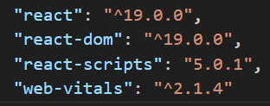

Here in package.json we have included react-scripts so it automatically loads the js script even if you have not loaded in the html code  
  
when we make components then we use .jsx  
single page application = ek hi div hai ek hi root hai ek hi page hai